第八次实验 K-Means
实验内容：
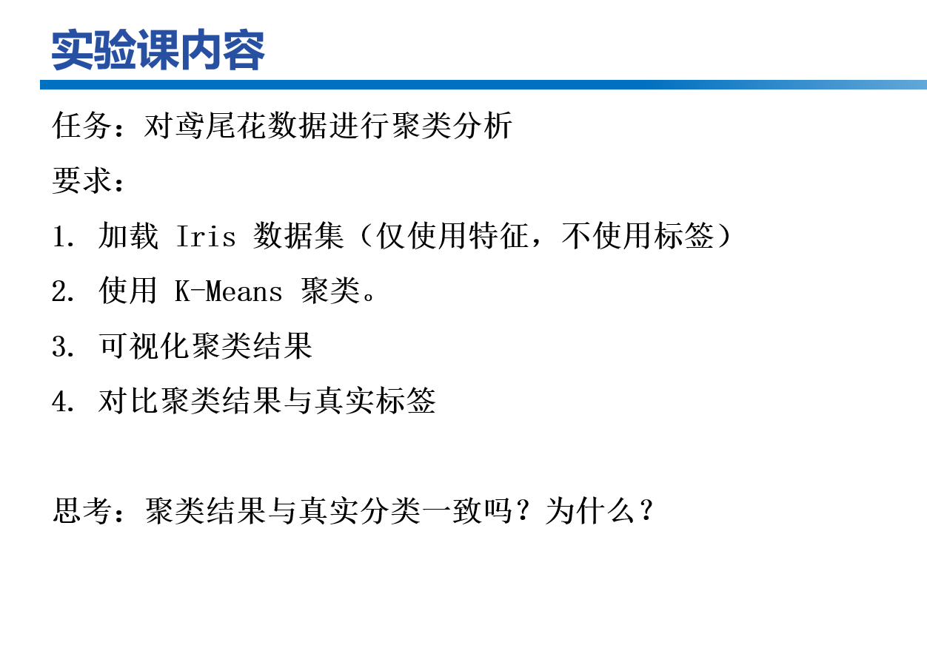
对 Iris 数据集进行 K-Means 聚类分析。聚类时仅使用 4 维特征（花萼长度、花萼宽度、花瓣长度、花瓣宽度），不使用类别标签.

实验原理：
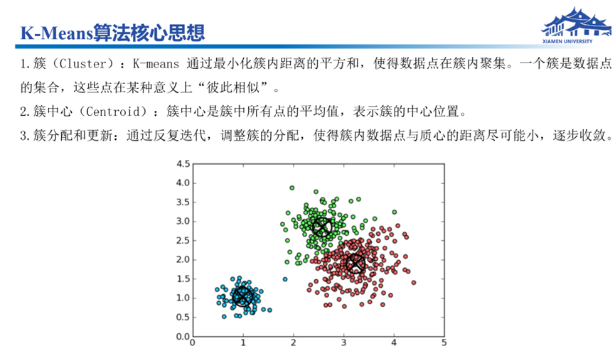
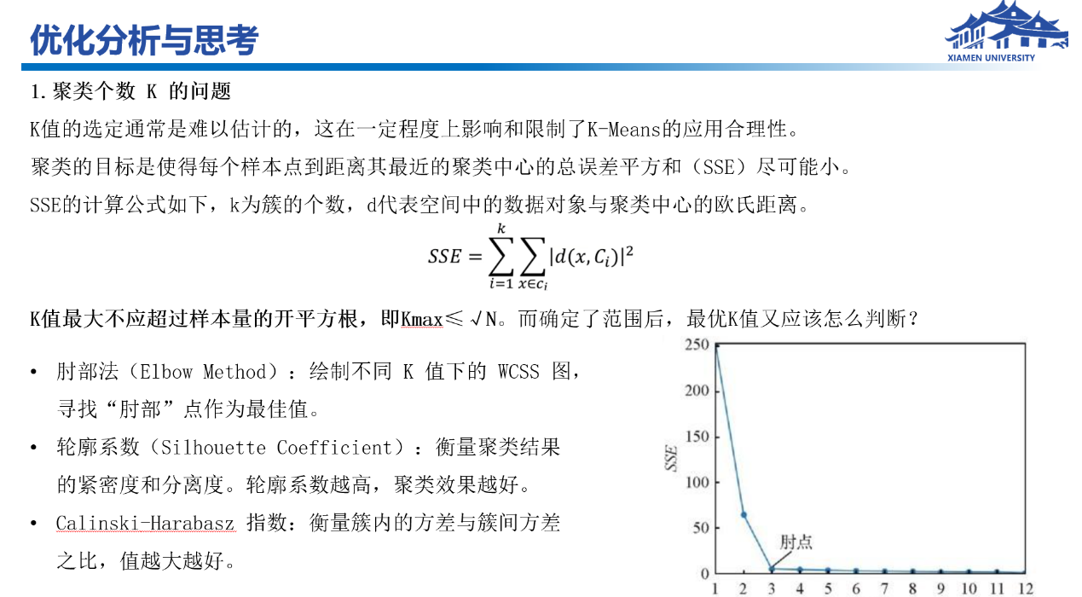

指标 | 结果
簇数量 K | 3
SSE（簇内误差平方和） | 78.9451
聚类准确率 | 88.67%
簇标签与真实类别映射：
Cluster 0 → Iris-versicolor
Cluster 1 → Iris-setosa
Cluster 2 → Iris-virginica
簇中心：
簇 | 花萼长度 | 花萼宽度 | 花瓣长度 | 花瓣宽度
0 | 5.88 | 2.74 | 4.39 | 1.43
1 | 5.01 | 3.42 | 1.46 | 0.24
2 | 6.85 | 3.08 | 5.72 | 2.05
混淆矩阵：
 | Iris-setosa | Iris-versicolor | Iris-virginica
Iris-setosa | 50 | 0 | 0
Iris-versicolor | 0 | 47 | 14
Iris-virginica | 0 | 3 | 36

运行结果：
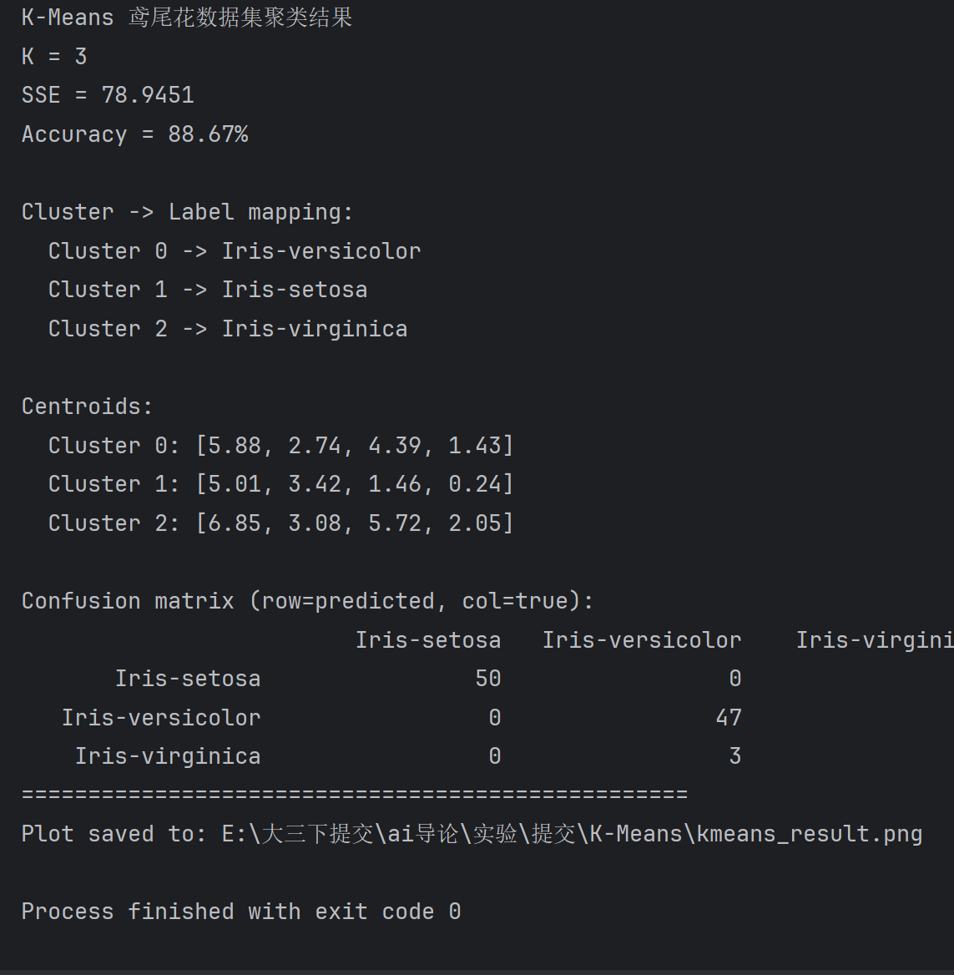
可视化结果如下：
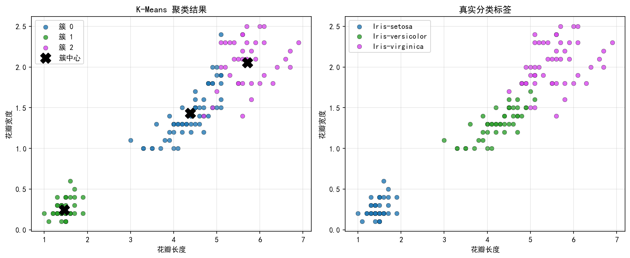
思考:聚类结果与真实分类一致吗？为什么？

整体基本一致，但存在少量偏差。
Iris-setosa 在特征空间中与其他两类区分明显，150 个样本中该类别 50 个全部聚类正确。Iris-versicolor 与 Iris-virginica 在边界区域存在重叠，K-Means 假设各簇呈球形且大小相近，无法完全刻画这两类的分布差异，因此产生 17 个误分样本（14 个 virginica 被分为 versicolor，3 个 versicolor 被分为 virginica）。在未知标签的无监督场景下，88.67% 的吻合率说明 K-Means 能较好地反映数据的自然簇结构。

源码：
1. import os
2. import sys
3.
4. import matplotlib.pyplot as plt
5. import numpy as np
6. from itertools import permutations
7. from matplotlib import rcParams
8.
9. ATTR_NAMES = ["花萼长度", "花萼宽度", "花瓣长度", "花瓣宽度"]
10. SPECIES = ["Iris-setosa", "Iris-versicolor", "Iris-virginica"]
11.
12.
13. def get_base_dir():
14. if getattr(sys, "frozen", False):
15. return os.path.dirname(sys.executable)
16. return os.path.dirname(os.path.abspath(__file__))
17.
18.
19. def load_iris(path):
20. features, labels = [], []
21. with open(path, encoding="utf-8") as f:
22. for line in f:
23. line = line.strip()
24. if not line:
25. continue
26. parts = line.split(",")
27. features.append([float(x) for x in parts[:4]])
28. labels.append(parts[4])
29. X = np.array(features)
30. label_to_id = {name: i for i, name in enumerate(SPECIES)}
31. y = np.array([label_to_id[name] for name in labels])
32. return X, y
33.
34.
35. class KMeans:
36. def __init__(self, k=3, max_iter=300, tol=1e-4, random_state=42):
37. self.k = k
38. self.max_iter = max_iter
39. self.tol = tol
40. self.random_state = random_state
41. self.centroids = None
42. self.labels_ = None
43.
44. def _assign(self, X):
45. diff = X[:, np.newaxis, :] - self.centroids[np.newaxis, :, :]
46. distances = np.sqrt((diff ** 2).sum(axis=2))
47. return np.argmin(distances, axis=1)
48.
49. def fit(self, X):
50. rng = np.random.default_rng(self.random_state)
51. n_samples = X.shape[0]
52. init_idx = rng.choice(n_samples, self.k, replace=False)
53. self.centroids = X[init_idx].copy()
54.
55. for _ in range(self.max_iter):
56. labels = self._assign(X)
57. new_centroids = np.zeros_like(self.centroids)
58. for i in range(self.k):
59. cluster_points = X[labels == i]
60. if len(cluster_points) == 0:
61. new_centroids[i] = X[rng.integers(n_samples)]
62. else:
63. new_centroids[i] = cluster_points.mean(axis=0)
64.
65. shift = np.linalg.norm(new_centroids - self.centroids)
66. self.centroids = new_centroids
67. if shift < self.tol:
68. break
69.
70. self.labels_ = self._assign(X)
71. return self
72.
73. def sse(self, X):
74. total = 0.0
75. for i in range(self.k):
76. points = X[self.labels_ == i]
77. if len(points) == 0:
78. continue
79. total += np.sum((points - self.centroids[i]) ** 2)
80. return total
81.
82.
83. def best_label_mapping(cluster_labels, true_labels, k):
84. best_mapping = {i: i for i in range(k)}
85. best_score = -1
86. for perm in permutations(range(k)):
87. mapping = {cluster_id: true_id for cluster_id, true_id in enumerate(perm)}
88. mapped = np.array([mapping[c] for c in cluster_labels])
89. score = np.sum(mapped == true_labels)
90. if score > best_score:
91. best_score = score
92. best_mapping = mapping
93. return best_mapping
94.
95.
96. def clustering_accuracy(cluster_labels, true_labels, k):
97. mapping = best_label_mapping(cluster_labels, true_labels, k)
98. mapped = np.array([mapping[c] for c in cluster_labels])
99. return np.mean(mapped == true_labels), mapping
100.
101.
102. def confusion_matrix(cluster_labels, true_labels, k):
103. mapping = best_label_mapping(cluster_labels, true_labels, k)
104. mapped = np.array([mapping[c] for c in cluster_labels])
105. matrix = np.zeros((k, k), dtype=int)
106. for pred, actual in zip(mapped, true_labels):
107. matrix[pred, actual] += 1
108. return matrix, mapping
109.
110.
111. def setup_plot_style():
112. rcParams["font.sans-serif"] = ["SimHei", "Microsoft YaHei", "DejaVu Sans"]
113. rcParams["axes.unicode_minus"] = False
114.
115.
116. def plot_results(X, cluster_labels, true_labels, centroids, save_path):
117. setup_plot_style()
118. fig, axes = plt.subplots(1, 2, figsize=(12, 5))
119.
120. x_idx, y_idx = 2, 3
121. x_name, y_name = ATTR_NAMES[x_idx], ATTR_NAMES[y_idx]
122. colors = ["#1f77b4", "#2ca02c", "#d946ef"]
123.
124. ax = axes[0]
125. for i in range(3):
126. mask = cluster_labels == i
127. ax.scatter(
128. X[mask, x_idx],
129. X[mask, y_idx],
130. c=colors[i],
131. label=f"簇 {i}",
132. alpha=0.8,
133. edgecolors="k",
134. linewidths=0.3,
135. )
136. ax.scatter(
137. centroids[:, x_idx],
138. centroids[:, y_idx],
139. c="black",
140. marker="X",
141. s=180,
142. linewidths=1.5,
143. label="簇中心",
144. zorder=5,
145. )
146. ax.set_xlabel(x_name)
147. ax.set_ylabel(y_name)
148. ax.set_title("K-Means 聚类结果")
149. ax.legend()
150. ax.grid(True, alpha=0.3)
151.
152. ax = axes[1]
153. for i in range(3):
154. mask = true_labels == i
155. ax.scatter(
156. X[mask, x_idx],
157. X[mask, y_idx],
158. c=colors[i],
159. label=SPECIES[i],
160. alpha=0.8,
161. edgecolors="k",
162. linewidths=0.3,
163. )
164. ax.set_xlabel(x_name)
165. ax.set_ylabel(y_name)
166. ax.set_title("真实分类标签")
167. ax.legend()
168. ax.grid(True, alpha=0.3)
169.
170. plt.tight_layout()
171. plt.savefig(save_path, dpi=150, bbox_inches="tight")
172. plt.close()
173.
174.
175. def print_results(acc, matrix, mapping, sse, centroids):
176. print("=" * 50)
177. print("K-Means 鸢尾花数据集聚类结果")
178. print("=" * 50)
179. print(f"K = 3")
180. print(f"SSE = {sse:.4f}")
181. print(f"Accuracy = {acc * 100:.2f}%")
182.
183. print("\nCluster -> Label mapping:")
184. for cluster_id, true_id in sorted(mapping.items()):
185. print(f" Cluster {cluster_id} -> {SPECIES[true_id]}")
186.
187. print("\nCentroids:")
188. for i, c in enumerate(centroids):
189. values = ", ".join(f"{v:.2f}" for v in c)
190. print(f" Cluster {i}: [{values}]")
191.
192. print("\nConfusion matrix (row=predicted, col=true):")
193. header = " " * 18 + "".join(f"{name:>18}" for name in SPECIES)
194. print(header)
195. for i in range(len(SPECIES)):
196. row = "".join(f"{matrix[i, j]:>18}" for j in range(len(SPECIES)))
197. print(f"{SPECIES[i]:>18}{row}")
198. print("=" * 50)
199.
200.
201. def main():
202. base_dir = get_base_dir()
203. data_path = os.path.join(base_dir, "Iris.txt")
204. plot_path = os.path.join(base_dir, "kmeans_result.png")
205.
206. X, y = load_iris(data_path)
207.
208. kmeans = KMeans(k=3, random_state=42)
209. kmeans.fit(X)
210.
211. acc, mapping = clustering_accuracy(kmeans.labels_, y, 3)
212. matrix, _ = confusion_matrix(kmeans.labels_, y, 3)
213. sse = kmeans.sse(X)
214.
215. plot_results(X, kmeans.labels_, y, kmeans.centroids, plot_path)
216. print_results(acc, matrix, mapping, sse, kmeans.centroids)
217. print(f"Plot saved to: {plot_path}")
218.
219.
220. if __name__ == "__main__":
221. main()
222.

