源码：
展示包划分：抽象层 framework，两套具体实现 idcard 与 ticket。
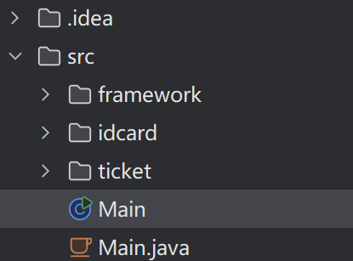
工厂方法骨架：固定流程 create → createProduct / registerProduct，产品抽象 use()。
1. package framework;
2.
3. import java.util.Vector;
4.
5. public abstract class Factory {
6. public final Product create(String owner) {
7. Product p = createProduct(owner);
8. registerProduct(p);
9. return p;
10. }
11.
12. protected abstract Product createProduct(String owner);
13.
14. protected abstract void registerProduct(Product p);
15.
16. public abstract Vector getOwners();
17. }
18.

1. package framework;
2.
3. public abstract class Product {
4. public abstract void use();
5. }
6.

具体产品 IDCard，具体工厂 IDCardFactory，登记持卡人。

1. package idcard;
2.
3. import framework.Product;
4.
5. public class IDCard extends Product {
6. private final String owner;
7.
8. public IDCard(String owner) {
9. this.owner = owner;
10. System.out.println("Create " + owner + "'s card.");
11. }
12.
13. @Override
14. public void use() {
15. System.out.println("Use " + owner + "'s card.");
16. }
17.
18. public String getOwner() {
19. return owner;
20. }
21. }
22.
1. package idcard;
2.
3. import framework.Factory;
4. import framework.Product;
5.
6. import java.util.Vector;
7.
8. public class IDCardFactory extends Factory {
9. private final Vector owners = new Vector();
10.
11. @Override
12. protected Product createProduct(String owner) {
13. return new IDCard(owner);
14. }
15.
16. @Override
17. protected void registerProduct(Product product) {
18. IDCard card = (IDCard) product;
19. owners.add(card.getOwner());
20. }
21.
22. @Override
23. public Vector getOwners() {
24. return owners;
25. }
26. }
27.

第二套具体产品 Ticket 与具体工厂 TicketFactory，与身份证并列，同一套 Factory/Product 协议。
1. package ticket;
2.
3. import framework.Product;
4.
5. public class Ticket extends Product {
6. private final String holder;
7.
8. public Ticket(String holder) {
9. this.holder = holder;
10. System.out.println("Print ticket for " + holder + ".");
11. }
12.
13. @Override
14. public void use() {
15. System.out.println("Check in: " + holder + ".");
16. }
17.
18. public String getHolder() {
19. return holder;
20. }
21. }
22.
1. package ticket;
2.
3. import framework.Factory;
4. import framework.Product;
5.
6. import java.util.Vector;
7.
8. public class TicketFactory extends Factory {
9. private final Vector owners = new Vector();
10.
11. @Override
12. protected Product createProduct(String owner) {
13. return new Ticket(owner);
14. }
15.
16. @Override
17. protected void registerProduct(Product product) {
18. Ticket ticket = (Ticket) product;
19. owners.add(ticket.getHolder());
20. }
21.
22. @Override
23. public Vector getOwners() {
24. return owners;
25. }
26. }
27.

运行结果：
