运行截图：
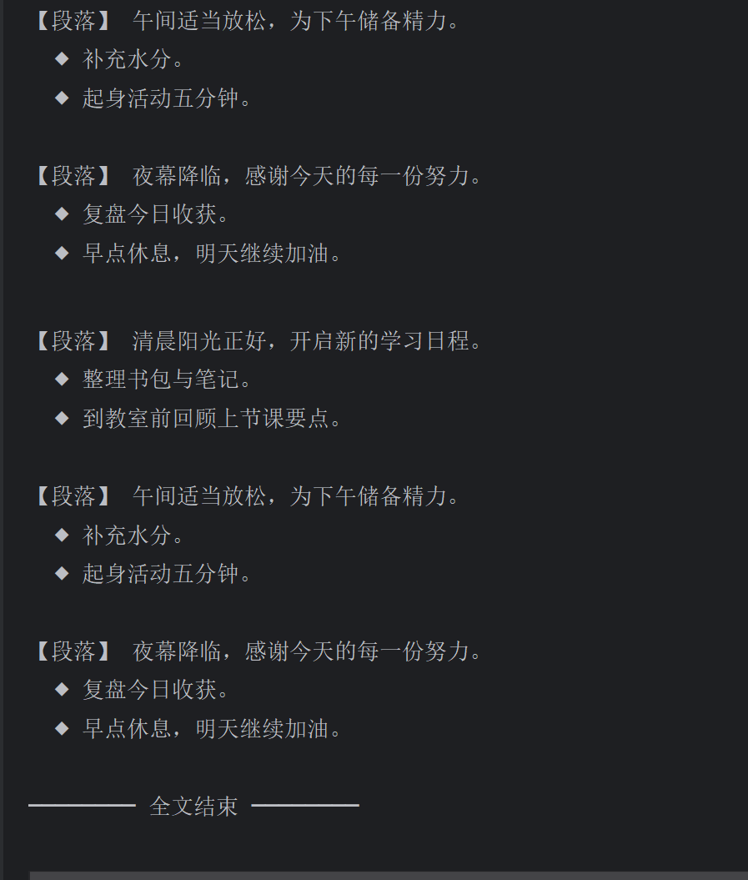
源码：
新增MarkdownBuilder
src/
├── Builder.java 抽象建造者
├── TextBuilder.java 具体建造者（纯文本）
├── HTMLBuilder.java 具体建造者（HTML 文件）
├── MarkdownBuilder.java 具体建造者（Markdown，本次新增）
├── Director.java 指挥者
└── Main.java 客户端入口
Main 根据参数创建具体建造者 → 交给 Director → construct() 依次调用 makeTitle、多次 makeString/makeItems → getResult() 返回结果。
Builder.java
1. public abstract class Builder {
2. public abstract void makeTitle(String title);
3.
4. public abstract void makeString(String str);
5.
6. public abstract void makeItems(String[] items);
7.
8. public abstract Object getResult();
9. }
10.
TextBuilder.java
1. public class TextBuilder extends Builder {
2. private final StringBuilder buffer = new StringBuilder();
3.
4. @Override
5. public void makeTitle(String title) {
6. buffer.append("┌──────────────────────────────┐\n");
7. buffer.append("│ ").append(title).append('\n');
8. buffer.append("└──────────────────────────────┘\n\n");
9. }
10.
11. @Override
12. public void makeString(String str) {
13. buffer.append("【段落】 ").append(str).append('\n');
14. }
15.
16. @Override
17. public void makeItems(String[] items) {
18. for (String item : items) {
19. buffer.append(" ◆ ").append(item).append('\n');
20. }
21. buffer.append('\n');
22. }
23.
24. @Override
25. public Object getResult() {
26. buffer.append("──────── 全文结束 ────────\n");
27. return buffer.toString();
28. }
29. }
30.
HTMLBuilder.java
1. import java.io.IOException;
2. import java.io.PrintWriter;
3. import java.nio.charset.StandardCharsets;
4.
5. public class HTMLBuilder extends Builder {
6. private String filename;
7. private PrintWriter writer;
8.
9. @Override
10. public void makeTitle(String title) {
11. filename = "daily_message.html";
12. try {
13. writer = new PrintWriter(filename, StandardCharsets.UTF_8);
14. } catch (IOException e) {
15. throw new RuntimeException("无法创建 HTML 文件", e);
16. }
17. writer.println("<!DOCTYPE html>");
18. writer.println("<html lang=\"zh-CN\">");
19. writer.println("<head>");
20. writer.println("<meta charset=\"UTF-8\">");
21. writer.println("<title>" + escape(title) + "</title>");
22. writer.println("</head>");
23. writer.println("<body>");
24. writer.println("<h1>" + escape(title) + "</h1>");
25. }
26.
27. @Override
28. public void makeString(String str) {
29. writer.println("<p class=\"text\">" + escape(str) + "</p>");
30. }
31.
32. @Override
33. public void makeItems(String[] items) {
34. writer.println("<ul class=\"list\">");
35. for (String item : items) {
36. writer.println("<li>" + escape(item) + "</li>");
37. }
38. writer.println("</ul>");
39. }
40.
41. @Override
42. public Object getResult() {
43. writer.println("</body>");
44. writer.println("</html>");
45. writer.close();
46. return filename;
47. }
48.
49. private static String escape(String raw) {
50. return raw.replace("&", "&")
51. .replace("<", "<")
52. .replace(">", ">")
53. .replace("\"", """);
54. }
55. }
56.
MarkdownBuilder.java
1. public class MarkdownBuilder extends Builder {
2. private final StringBuilder md = new StringBuilder();
3.
4. @Override
5. public void makeTitle(String title) {
6. md.append("# ").append(title).append("\n\n");
7. }
8.
9. @Override
10. public void makeString(String str) {
11. md.append("> ").append(str).append("\n\n");
12. }
13.
14. @Override
15. public void makeItems(String[] items) {
16. for (int i = 0; i < items.length; i++) {
17. md.append(i + 1).append(". ").append(items[i]).append('\n');
18. }
19. md.append('\n');
20. }
21.
22. @Override
23. public Object getResult() {
24. md.append("---\n*由 MarkdownBuilder 生成*\n");
25. return md.toString();
26. }
27. }
28.
Director.java
1. public class Director {
2. private final Builder builder;
3.
4. public Director(Builder builder) {
5. this.builder = builder;
6. }
7.
8. public Object construct() {
9. builder.makeTitle("校园一日");
10. builder.makeString("清晨阳光正好，开启新的学习日程。");
11. builder.makeItems(new String[]{
12. "整理书包与笔记。",
13. "到教室前回顾上节课要点。"
14. });
15. builder.makeString("午间适当放松，为下午储备精力。");
16. builder.makeItems(new String[]{
17. "补充水分。",
18. "起身活动五分钟。"
19. });
20. builder.makeString("夜幕降临，感谢今天的每一份努力。");
21. builder.makeItems(new String[]{
22. "复盘今日收获。",
23. "早点休息，明天继续加油。"
24. });
25. return builder.getResult();
26. }
27. }
28.
Main.java
1. public class Main {
2. public static void main(String[] args) {
3. if (args.length != 1) {
4. usage();
5. return;
6. }
7.
8. Builder builder;
9. switch (args[0]) {
10. case "plain":
11. builder = new TextBuilder();
12. break;
13. case "html":
14. builder = new HTMLBuilder();
15. break;
16. case "markdown":
17. builder = new MarkdownBuilder();
18. break;
19. default:
20. usage();
21. return;
22. }
23.
24. Director director = new Director(builder);
25. Object result = director.construct();
26.
27. switch (args[0]) {
28. case "plain":
29. System.out.println(result);
30. break;
31. case "html":
32. System.out.println("已生成 HTML 文件：" + result);
33. break;
34. case "markdown":
35. System.out.println("Markdown 内容：\n" + result);
36. break;
37. default:
38. usage();
39. }
40. }
41.
42. private static void usage() {
43. System.out.println("用法示例：");
44. System.out.println(" java Main plain 输出纯文本");
45. System.out.println(" java Main html 生成 daily_message.html");
46. System.out.println(" java Main markdown 输出 Markdown（新增建造者）");
47. }
48. }
49.

