运行截图：
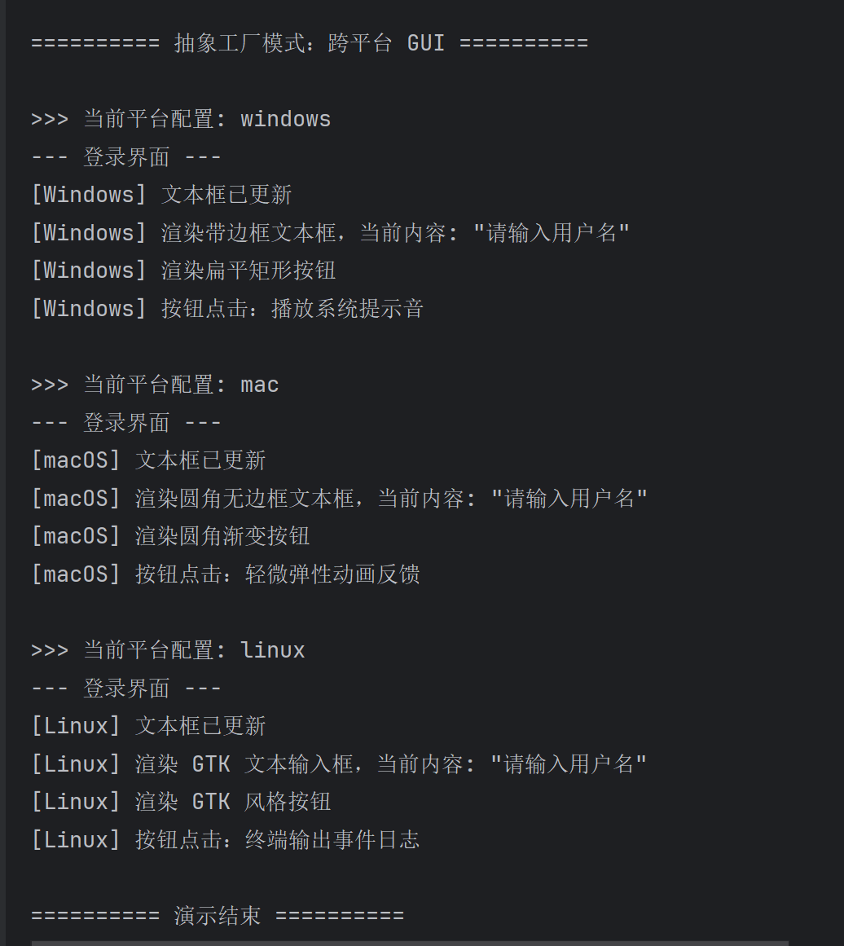
代码：
应用背景：
跨平台 GUI 组件。不同操作系统需要风格统一的界面控件；若由客户端直接 new 具体类，切换平台时要改大量代码。抽象工厂将「按钮 + 文本框」作为产品族，由同一工厂保证风格一致。
三、模式结构
角色 | 本项目中类
抽象工厂 | GUIFactory
具体工厂 | WindowsFactory、MacFactory、LinuxFactory
抽象产品 | Button、TextField
具体产品 | WindowsButton、MacButton等
客户端 | Application、Client
客户端只依赖抽象接口；通过 GUIFactoryProvider 读取 gui.properties，用反射加载具体工厂类名，再创建对应产品族。
GUIFactory.java
1. package ui;
2. public interface GUIFactory {
3. Button createButton();
4. TextField createTextField();
5. }
6.
Button.java
1. package ui;
2. public interface Button {
3. void render();
4. void onClick();
5. }
6.
TextField.java
1. package ui;
2. public interface TextField {
3. void render();
4. void setText(String text);
5. }
6.
WindowsFactory.java
1. import ui.Button;
2. import ui.GUIFactory;
3. import ui.TextField;
4.
5.
6. public class WindowsFactory implements GUIFactory {
7. @Override
8. public Button createButton() {
9. return new WindowsButton();
10. }
11.
12. @Override
13. public TextField createTextField() {
14. return new WindowsTextField();
15. }
16. }
17.
WindowsButton.java
1. package ui.windows;
2.
3. import ui.Button;
4.
5. public class WindowsButton implements Button {
6. @Override
7. public void render() {
8. System.out.println("[Windows] 渲染扁平矩形按钮");
9. }
10.
11. @Override
12. public void onClick() {
13. System.out.println("[Windows] 按钮点击：播放系统提示音");
14. }
15. }
16.
WindowsTextField.java
1. package ui.windows;
2.
3. import ui.TextField;
4.
5. public class WindowsTextField implements TextField {
6. private String text = "";
7.
8. @Override
9. public void render() {
10. System.out.println("[Windows] 渲染带边框文本框，当前内容: \"" + text + "\"");
11. }
12.
13. @Override
14. public void setText(String text) {
15. this.text = text;
16. System.out.println("[Windows] 文本框已更新");
17. }
18. }
19.
Application.java
1. package ui;
2.
3. public class Application {
4. private final Button button;
5. private final TextField textField;
6.
7. public Application(GUIFactory factory) {
8. this.button = factory.createButton();
9. this.textField = factory.createTextField();
10. }
11.
12. public void paintLoginForm() {
13. System.out.println("--- 登录界面 ---");
14. textField.setText("请输入用户名");
15. textField.render();
16. button.render();
17. button.onClick();
18. System.out.println();
19. }
20. }
21.
Client.java
1. import factory.GUIFactoryProvider;
2. import ui.Application;
3. import ui.GUIFactory;
4.
5.
6. public class Client {
7. public static void main(String[] args) {
8. System.out.println("========== 抽象工厂模式：跨平台 GUI ==========\n");
9.
10. String[] platforms = {"windows", "mac", "linux"};
11. for (String platform : platforms) {
12. System.out.println(">>> 当前平台配置: " + platform);
13. GUIFactory factory = GUIFactoryProvider.getFactory(platform);
14. Application app = new Application(factory);
15. app.paintLoginForm();
16. }
17.
18. System.out.println("========== 演示结束 ==========");
19. }
20. }
21.
…

