运行结果
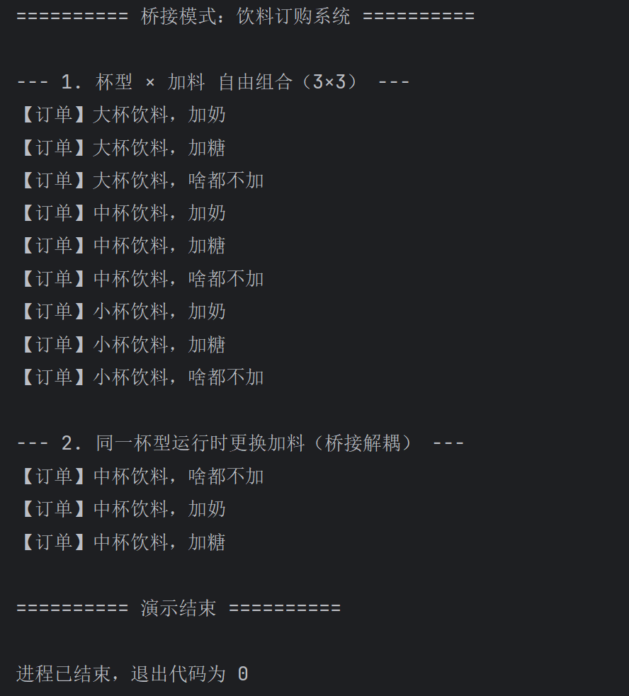
代码：
作业14/
├── src/
│ ├── Client.java
│ └── bridge/
│ ├── DrinkAdditive.java # 实现化接口（加料）
│ ├── MilkAdditive.java # 加奶
│ ├── SugarAdditive.java # 加糖
│ ├── PlainAdditive.java # 啥都不加
│ ├── Beverage.java # 抽象化（杯型 + 桥接引用）
│ ├── LargeCup.java # 大杯
│ ├── MediumCup.java # 中杯
│ └── SmallCup.java # 小杯
src/bridge/DrinkAdditive.java 实现化接口（加料）
1. package bridge;
2. public interface DrinkAdditive {
3. String describe();
4. }
5.
src/bridge/MilkAdditive.java 加奶
1. package bridge;
2.
3. /** 加奶 */
4. public class MilkAdditive implements DrinkAdditive {
5. @Override
6. public String describe() {
7. return "加奶";
8. }
9. }
10.
src/bridge/SugarAdditive.java 加糖
1. package bridge;
2.
3. /** 加糖 */
4. public class SugarAdditive implements DrinkAdditive {
5. @Override
6. public String describe() {
7. return "加糖";
8. }
9. }
10.
src/bridge/PlainAdditive.java 啥都不加
1. package bridge;
2.
3. /** 啥都不加 */
4. public class PlainAdditive implements DrinkAdditive {
5. @Override
6. public String describe() {
7. return "啥都不加";
8. }
9. }
10.
src/bridge/Beverage.java 抽象化类（含桥接、setAdditive）
1. package bridge;
2.
3. /**
4. * 抽象化类：饮料订单（桥接模式 - 抽象化部分）
5. */
6. public abstract class Beverage {
7. protected DrinkAdditive additive;
8.
9. public Beverage(DrinkAdditive additive) {
10. this.additive = additive;
11. }
12.
13. /** 运行时更换加料方式 */
14. public void setAdditive(DrinkAdditive additive) {
15. this.additive = additive;
16. }
17.
18. protected abstract String cupSize();
19.
20. public void serve() {
21. System.out.println("【订单】" + cupSize() + "杯饮料，" + additive.describe());
22. }
23. }
24.
src/bridge/LargeCup.java 大杯
1. package bridge;
2.
3. /** 大杯 */
4. public class LargeCup extends Beverage {
5. public LargeCup(DrinkAdditive additive) {
6. super(additive);
7. }
8.
9. @Override
10. protected String cupSize() {
11. return "大";
12. }
13. }
14.
src/bridge/MediumCup.java 中杯
1. package bridge;
2.
3. /** 中杯 */
4. public class MediumCup extends Beverage {
5. public MediumCup(DrinkAdditive additive) {
6. super(additive);
7. }
8.
9. @Override
10. protected String cupSize() {
11. return "中";
12. }
13. }
14.
src/bridge/SmallCup.java 小杯
1. package bridge;
2.
3. /** 小杯 */
4. public class SmallCup extends Beverage {
5. public SmallCup(DrinkAdditive additive) {
6. super(additive);
7. }
8.
9. @Override
10. protected String cupSize() {
11. return "小";
12. }
13. }
14.
src/Client.java 主程序
1. import bridge.*;
2.
3.
4. public class Client {
5. public static void main(String[] args) {
6. System.out.println("========== 桥接模式：饮料订购系统 ==========\n");
7.
8. System.out.println("--- 1. 杯型 × 加料 自由组合（3×3） ---");
9. Beverage[] orders = {
10. new LargeCup(new MilkAdditive()),
11. new LargeCup(new SugarAdditive()),
12. new LargeCup(new PlainAdditive()),
13. new MediumCup(new MilkAdditive()),
14. new MediumCup(new SugarAdditive()),
15. new MediumCup(new PlainAdditive()),
16. new SmallCup(new MilkAdditive()),
17. new SmallCup(new SugarAdditive()),
18. new SmallCup(new PlainAdditive())
19. };
20. for (Beverage order : orders) {
21. order.serve();
22. }
23.
24. System.out.println("\n--- 2. 同一杯型运行时更换加料（桥接解耦） ---");
25. Beverage cup = new MediumCup(new PlainAdditive());
26. cup.serve();
27. cup.setAdditive(new MilkAdditive());
28. cup.serve();
29. cup.setAdditive(new SugarAdditive());
30. cup.serve();
31.
32. System.out.println("\n========== 演示结束 ==========");
33. }
34. }
35.

