运行结果：
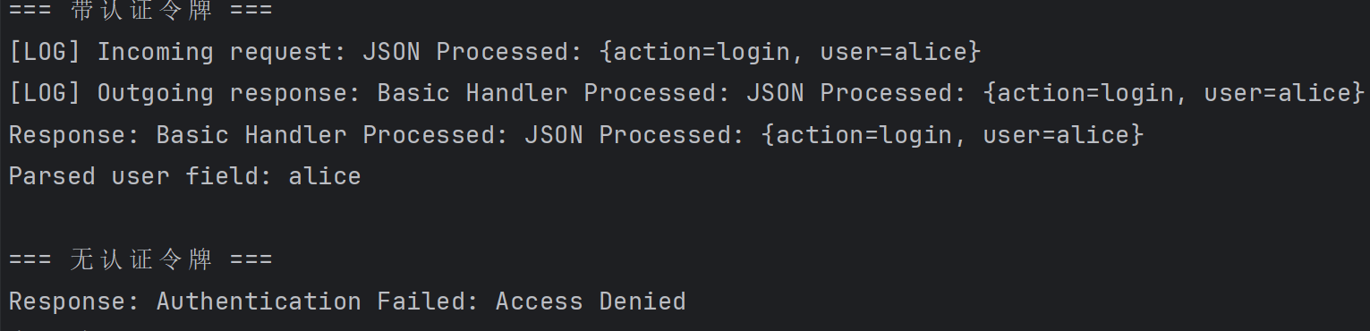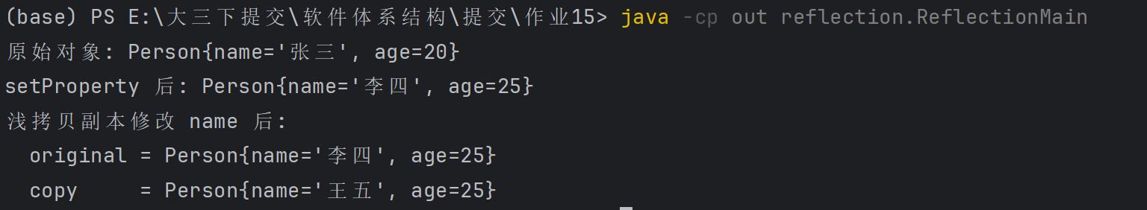
代码：
透明装饰：组件与装饰器同一抽象类型，客户端只用抽象接口，不依赖具体装饰器类：transparent 包：咖啡 + 牛奶 + 糖，全程Beverage引用
半透明装饰 ：实现组件接口，但装饰器有专有方法，客户端需持有具体类型：decorator 包：JsonParsingDecorator.getJsonField()
src/
│ ├── decorator/ # 半透明：HTTP 请求装饰链
│ ├── transparent/ # 透明：饮品加料
│ └── reflection/ # 反射：setProperty、浅拷贝
半透明装饰 — src/decorator/
HttpRequestHandler.java
1. package decorator;
2.
3. public interface HttpRequestHandler {
4. String handleRequest(String request);
5. }
6.
BasicRequestHandler.java
1. package decorator;
2.
3. public class BasicRequestHandler implements HttpRequestHandler {
4.
5. @Override
6. public String handleRequest(String request) {
7. return "Basic Handler Processed: " + request;
8. }
9. }
10.
RequestHandlerDecorator.java
1. package decorator;
2.
3. /**
4. * 抽象装饰器：持有被包装对象，并将请求委托给它。
5. */
6. public abstract class RequestHandlerDecorator implements HttpRequestHandler {
7.
8. protected final HttpRequestHandler wrapped;
9.
10. public RequestHandlerDecorator(HttpRequestHandler wrapped) {
11. this.wrapped = wrapped;
12. }
13.
14. @Override
15. public String handleRequest(String request) {
16. return wrapped.handleRequest(request);
17. }
18. }
19.
LoggingDecorator.java
1. package decorator;
2.
3. public class LoggingDecorator extends RequestHandlerDecorator {
4.
5. public LoggingDecorator(HttpRequestHandler wrapped) {
6. super(wrapped);
7. }
8.
9. @Override
10. public String handleRequest(String request) {
11. System.out.println("[LOG] Incoming request: " + request);
12. String result = super.handleRequest(request);
13. System.out.println("[LOG] Outgoing response: " + result);
14. return result;
15. }
16. }
17.
AuthenticationDecorator.java
1. package decorator;
2.
3. public class AuthenticationDecorator extends RequestHandlerDecorator {
4.
5. public AuthenticationDecorator(HttpRequestHandler wrapped) {
6. super(wrapped);
7. }
8.
9. @Override
10. public String handleRequest(String request) {
11. if (!authenticate(request)) {
12. return "Authentication Failed: Access Denied";
13. }
14. return super.handleRequest(request);
15. }
16.
17. private boolean authenticate(String request) {
18. return request != null && request.contains("auth_token");
19. }
20. }
21.
JsonParsingDecorator.java
1. import java.util.Collections;
2. import java.util.HashMap;
3. import java.util.Map;
4.
5. /**
6. * 半透明装饰器示例：除 handleRequest 外，还提供 getJsonField 等装饰器特有方法。
7. */
8. public class JsonParsingDecorator extends RequestHandlerDecorator {
9.
10. private final Map<String, String> parsedData = new HashMap<>();
11.
12. public JsonParsingDecorator(HttpRequestHandler wrapped) {
13. super(wrapped);
14. }
15.
16. @Override
17. public String handleRequest(String request) {
18. extractKeyValuePairs(request);
19. String enriched = "JSON Processed: " + formatEntries();
20. return super.handleRequest(enriched);
21. }
22.
23. /** 装饰器特有接口，客户端需向下转型或持有具体类型才能调用。 */
24. public String getJsonField(String field) {
25. return parsedData.getOrDefault(field, "Field not found");
26. }
27.
28. public Map<String, String> getParsedData() {
29. return Collections.unmodifiableMap(parsedData);
30. }
31.
32. private void extractKeyValuePairs(String raw) {
33. parsedData.clear();
34. if (raw == null || raw.isBlank()) {
35. return;
36. }
37. String body = extractJsonBody(raw);
38. if (body == null) {
39. return;
40. }
41. if (body.startsWith("{")) {
42. body = body.substring(1);
43. }
44. if (body.endsWith("}")) {
45. body = body.substring(0, body.length() - 1);
46. }
47. if (body.isEmpty()) {
48. return;
49. }
50. int start = 0;
51. while (start < body.length()) {
52. int comma = body.indexOf(',', start);
53. String segment = comma < 0 ? body.substring(start) : body.substring(start, comma);
54. putSegment(segment.trim());
55. if (comma < 0) {
56. break;
57. }
58. start = comma + 1;
59. }
60. }
61.
62. private void putSegment(String segment) {
63. int colon = segment.indexOf(':');
64. if (colon <= 0) {
65. return;
66. }
67. String key = stripQuotes(segment.substring(0, colon).trim());
68. String value = stripQuotes(segment.substring(colon + 1).trim());
69. parsedData.put(key, value);
70. }
71.
72. /** 从混合请求中提取 {...} 片段，便于与认证前缀共存。 */
73. private String extractJsonBody(String raw) {
74. int left = raw.indexOf('{');
75. int right = raw.lastIndexOf('}');
76. if (left >= 0 && right > left) {
77. return raw.substring(left, right + 1);
78. }
79. return raw.trim();
80. }
81.
82. private String stripQuotes(String text) {
83. if (text.length() >= 2 && text.startsWith("\"") && text.endsWith("\"")) {
84. return text.substring(1, text.length() - 1);
85. }
86. return text;
87. }
88.
89. private String formatEntries() {
90. StringBuilder sb = new StringBuilder("{");
91. boolean first = true;
92. for (Map.Entry<String, String> entry : parsedData.entrySet()) {
93. if (!first) {
94. sb.append(", ");
95. }
96. sb.append(entry.getKey()).append('=').append(entry.getValue());
97. first = false;
98. }
99. sb.append('}');
100. return sb.toString();
101. }
102. }
103.
DecoratorMain.java
1. package decorator;
2.
3. public class DecoratorMain {
4.
5. public static void main(String[] args) {
6. HttpRequestHandler handler = new BasicRequestHandler();
7. handler = new LoggingDecorator(handler);
8. JsonParsingDecorator jsonHandler = new JsonParsingDecorator(handler);
9. AuthenticationDecorator authHandler = new AuthenticationDecorator(jsonHandler);
10.
11. String jsonBody = "{\"user\":\"alice\",\"action\":\"login\"}";
12. String withToken = "auth_token=xyz " + jsonBody; // 认证前缀 + JSON 正文
13. String withoutToken = jsonBody;
14.
15. System.out.println("=== 带认证令牌 ===");
16. String ok = authHandler.handleRequest(withToken);
17. System.out.println("Response: " + ok);
18. System.out.println("Parsed user field: " + jsonHandler.getJsonField("user"));
19.
20. System.out.println("\n=== 无认证令牌 ===");
21. String denied = authHandler.handleRequest(withoutToken);
22. System.out.println("Response: " + denied);
23. }
24. }
25.
透明装饰 — src/transparent/
Beverage.java
1. package transparent;
2.
3. /**
4. * 透明装饰模式：组件与装饰器继承同一抽象类，对外只通过 Beverage 类型交互。
5. */
6. public abstract class Beverage {
7. protected String description = "未知饮品";
8.
9. public String getDescription() {
10. return description;
11. }
12.
13. public abstract double cost();
14. }
15.
Espresso.java
1. package transparent;
2.
3. public class Espresso extends Beverage {
4.
5. public Espresso() {
6. description = "浓缩咖啡";
7. }
8.
9. @Override
10. public double cost() {
11. return 12.0;
12. }
13. }
14.
CondimentDecorator.java
1. package transparent;
2.
3. public abstract class CondimentDecorator extends Beverage {
4. protected Beverage beverage;
5.
6. protected CondimentDecorator(Beverage beverage) {
7. this.beverage = beverage;
8. }
9. }
10.
Milk.java、Sugar.java
1. ackage transparent;
2.
3. public class Milk extends CondimentDecorator {
4.
5. public Milk(Beverage beverage) {
6. super(beverage);
7. }
8.
9. @Override
10. public String getDescription() {
11. return beverage.getDescription() + " + 牛奶";
12. }
13.
14. @Override
15. public double cost() {
16. return beverage.cost() + 2.0;
17. }
18. }
19.
1. package transparent;
2.
3. public class Sugar extends CondimentDecorator {
4.
5. public Sugar(Beverage beverage) {
6. super(beverage);
7. }
8.
9. @Override
10. public String getDescription() {
11. return beverage.getDescription() + " + 糖";
12. }
13.
14. @Override
15. public double cost() {
16. return beverage.cost() + 1.0;
17. }
18. }
19.
TransparentMain.java
1. package transparent;
2.
3. public class TransparentMain {
4.
5. public static void main(String[] args) {
6. // 客户端始终用 Beverage 引用，无需知道具体装饰器类型
7. Beverage drink = new Espresso();
8. drink = new Milk(drink);
9. drink = new Sugar(drink);
10.
11. System.out.println("饮品: " + drink.getDescription());
12. System.out.println("价格: " + drink.cost() + " 元");
13. }
14. }
15.

