运行结果：
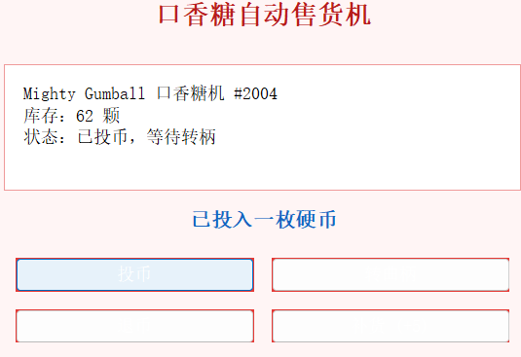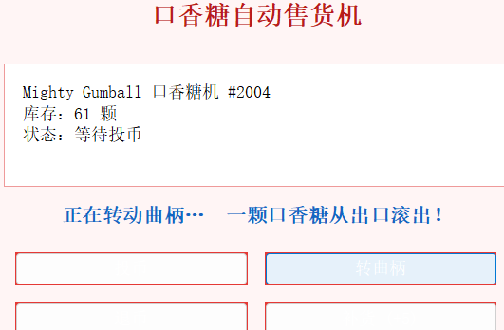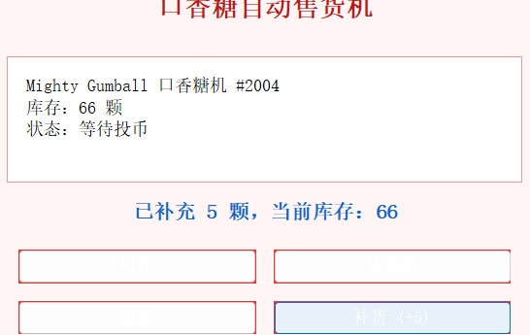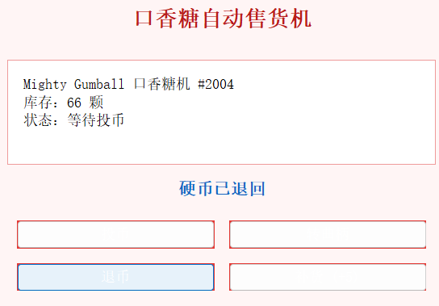
代码：
在 Head First口香糖机 状态模式 示例基础上，将原控制台程序改写为 Swing 图形界面。
保留State接口及NoQuarterState、HasQuarterState、SoldState、SoldOutState 等状态类，由 GumballMachine 根据当前状态响应操作。
界面提供：投币、转曲柄、退币、补货；上方显示库存与状态，下方显示操作反馈。
状态模式：状态相关行为放在各状态类中，GumballMachine 只委托给当前 state。
与原版区别：原用 System.out.println，现改为方法返回 String，由界面 JLabel 显示。
界面：JFrame + BorderLayout，按钮用 lambda 处理事件。

GumballMachine.java
1. public class GumballMachine {
2.
3. private final State soldOutState;
4. private final State noQuarterState;
5. private final State hasQuarterState;
6. private final State soldState;
7.
8. private State state;
9. private int count;
10.
11. public GumballMachine(int numberGumballs) {
12. soldOutState = new SoldOutState(this);
13. noQuarterState = new NoQuarterState(this);
14. hasQuarterState = new HasQuarterState(this);
15. soldState = new SoldState(this);
16.
17. count = numberGumballs;
18. state = numberGumballs > 0 ? noQuarterState : soldOutState;
19. }
20.
21. public String insertQuarter() {
22. return state.insertQuarter();
23. }
24.
25. public String ejectQuarter() {
26. return state.ejectQuarter();
27. }
28.
29. public String turnCrank() {
30. String crankMsg = state.turnCrank();
31. String dispenseMsg = state.dispense();
32. if (dispenseMsg == null || dispenseMsg.isEmpty()) {
33. return crankMsg;
34. }
35. if (crankMsg == null || crankMsg.isEmpty()) {
36. return dispenseMsg;
37. }
38. return crankMsg + "\n" + dispenseMsg;
39. }
40.
41. String releaseBall() {
42. if (count > 0) {
43. count--;
44. }
45. return "一颗口香糖从出口滚出！";
46. }
47.
48. int getCount() {
49. return count;
50. }
51.
52. public String refill(int numGumballs) {
53. count += numGumballs;
54. String stateMsg = state.refill();
55. String base = "已补充 " + numGumballs + " 颗，当前库存：" + count;
56. if (stateMsg == null || stateMsg.isEmpty()) {
57. return base;
58. }
59. return base + "\n" + stateMsg;
60. }
61.
62. void setState(State state) {
63. this.state = state;
64. }
65.
66. State getState() {
67. return state;
68. }
69.
70. State getSoldOutState() {
71. return soldOutState;
72. }
73.
74. State getNoQuarterState() {
75. return noQuarterState;
76. }
77.
78. State getHasQuarterState() {
79. return hasQuarterState;
80. }
81.
82. State getSoldState() {
83. return soldState;
84. }
85.
86. @Override
87. public String toString() {
88. return "Mighty Gumball 口香糖机 #2004\n"
89. + "库存：" + count + " 颗\n"
90. + "状态：" + state;
91. }
92. }
93.
HasQuarterState.java
1. public class HasQuarterState implements State {
2.
3. private final GumballMachine gumballMachine;
4.
5. public HasQuarterState(GumballMachine gumballMachine) {
6. this.gumballMachine = gumballMachine;
7. }
8.
9. @Override
10. public String insertQuarter() {
11. return "不能再投第二枚硬币";
12. }
13.
14. @Override
15. public String ejectQuarter() {
16. gumballMachine.setState(gumballMachine.getNoQuarterState());
17. return "硬币已退回";
18. }
19.
20. @Override
21. public String turnCrank() {
22. gumballMachine.setState(gumballMachine.getSoldState());
23. return "正在转动曲柄…";
24. }
25.
26. @Override
27. public String dispense() {
28. return "尚未完成出货";
29. }
30.
31. @Override
32. public String refill() {
33. return "";
34. }
35.
36. @Override
37. public String toString() {
38. return "已投币，等待转柄";
39. }
40. }
41.
State.java
1. public interface State {
2.
3. String insertQuarter();
4.
5. String ejectQuarter();
6.
7. String turnCrank();
8.
9. String dispense();
10.
11. String refill();
12. }
13.
NoQuarterState.java
1. public class NoQuarterState implements State {
2.
3. private final GumballMachine gumballMachine;
4.
5. public NoQuarterState(GumballMachine gumballMachine) {
6. this.gumballMachine = gumballMachine;
7. }
8.
9. @Override
10. public String insertQuarter() {
11. gumballMachine.setState(gumballMachine.getHasQuarterState());
12. return "已投入一枚硬币";
13. }
14.
15. @Override
16. public String ejectQuarter() {
17. return "尚未投入硬币，无法退币";
18. }
19.
20. @Override
21. public String turnCrank() {
22. return "请先投入硬币再转曲柄";
23. }
24.
25. @Override
26. public String dispense() {
27. return "请先付款";
28. }
29.
30. @Override
31. public String refill() {
32. return "";
33. }
34.
35. @Override
36. public String toString() {
37. return "等待投币";
38. }
39. }
40.
SoldState.java
1. public class SoldState implements State {
2.
3. private final GumballMachine gumballMachine;
4.
5. public SoldState(GumballMachine gumballMachine) {
6. this.gumballMachine = gumballMachine;
7. }
8.
9. @Override
10. public String insertQuarter() {
11. return "正在出货，请稍候再投币";
12. }
13.
14. @Override
15. public String ejectQuarter() {
16. return "已转柄，无法退币";
17. }
18.
19. @Override
20. public String turnCrank() {
21. return "不能连续转两次曲柄";
22. }
23.
24. @Override
25. public String dispense() {
26. String ballMsg = gumballMachine.releaseBall();
27. if (gumballMachine.getCount() > 0) {
28. gumballMachine.setState(gumballMachine.getNoQuarterState());
29. return ballMsg;
30. }
31. gumballMachine.setState(gumballMachine.getSoldOutState());
32. return ballMsg + "\n糟糕，口香糖已售罄！";
33. }
34.
35. @Override
36. public String refill() {
37. return "";
38. }
39.
40. @Override
41. public String toString() {
42. return "正在出货";
43. }
44. }
45.
SoldOutState.java
1. public class SoldOutState implements State {
2.
3. private final GumballMachine gumballMachine;
4.
5. public SoldOutState(GumballMachine gumballMachine) {
6. this.gumballMachine = gumballMachine;
7. }
8.
9. @Override
10. public String insertQuarter() {
11. return "机器已售罄，无法投币";
12. }
13.
14. @Override
15. public String ejectQuarter() {
16. return "尚未投币，无法退币";
17. }
18.
19. @Override
20. public String turnCrank() {
21. return "没有口香糖，转柄无效";
22. }
23.
24. @Override
25. public String dispense() {
26. return "没有口香糖可出";
27. }
28.
29. @Override
30. public String refill() {
31. gumballMachine.setState(gumballMachine.getNoQuarterState());
32. return "补货完成，机器恢复待机";
33. }
34.
35. @Override
36. public String toString() {
37. return "售罄";
38. }
39. }
40.
Main.java
1. import java.awt.BorderLayout;
2. import java.awt.Color;
3. import java.awt.Dimension;
4. import java.awt.Font;
5. import java.awt.GridLayout;
6. import java.awt.event.ActionEvent;
7.
8. import javax.swing.BorderFactory;
9. import javax.swing.JButton;
10. import javax.swing.JFrame;
11. import javax.swing.JLabel;
12. import javax.swing.JPanel;
13. import javax.swing.SwingConstants;
14. import javax.swing.SwingUtilities;
15. import javax.swing.UIManager;
16.
17. /**
18. * 口香糖机状态模式 — Swing 图形界面
19. */
20. public class Main {
21.
22. private JLabel statusLabel;
23. private JLabel feedbackLabel;
24. private GumballMachine machine;
25.
26. private void buildUi() {
27. machine = new GumballMachine(5);
28.
29. JFrame frame = new JFrame("口香糖机 — 状态模式");
30. frame.setDefaultCloseOperation(JFrame.EXIT_ON_CLOSE);
31. frame.setLayout(new BorderLayout(10, 10));
32.
33. JLabel title = new JLabel("口香糖自动售货机", SwingConstants.CENTER);
34. title.setFont(title.getFont().deriveFont(Font.BOLD, 18f));
35. title.setForeground(new Color(183, 28, 28));
36. title.setBorder(BorderFactory.createEmptyBorder(12, 0, 4, 0));
37.
38. statusLabel = new JLabel("<html>" + formatStatus(machine.toString()) + "</html>");
39. statusLabel.setVerticalAlignment(SwingConstants.TOP);
40. statusLabel.setOpaque(true);
41. statusLabel.setBackground(Color.WHITE);
42. statusLabel.setBorder(BorderFactory.createCompoundBorder(
43. BorderFactory.createLineBorder(new Color(239, 154, 154)),
44. BorderFactory.createEmptyBorder(10, 12, 10, 12)));
45.
46. feedbackLabel = new JLabel("欢迎使用！请点击下方按钮操作。", SwingConstants.CENTER);
47. feedbackLabel.setFont(feedbackLabel.getFont().deriveFont(Font.BOLD, 14f));
48. feedbackLabel.setForeground(new Color(21, 101, 192));
49.
50. JPanel center = new JPanel(new BorderLayout(0, 12));
51. center.setBorder(BorderFactory.createEmptyBorder(8, 16, 8, 16));
52. center.setBackground(new Color(255, 245, 245));
53. center.add(statusLabel, BorderLayout.CENTER);
54. center.add(feedbackLabel, BorderLayout.SOUTH);
55.
56. JPanel buttonPanel = new JPanel(new GridLayout(2, 2, 12, 12));
57. buttonPanel.setBorder(BorderFactory.createEmptyBorder(0, 24, 16, 24));
58. buttonPanel.setBackground(new Color(255, 245, 245));
59.
60. buttonPanel.add(makeButton("投币", e -> applyAction(machine.insertQuarter())));
61. buttonPanel.add(makeButton("转曲柄", e -> applyAction(machine.turnCrank())));
62. buttonPanel.add(makeButton("退币", e -> applyAction(machine.ejectQuarter())));
63. buttonPanel.add(makeButton("补货 (+5)", e -> applyAction(machine.refill(5))));
64.
65. frame.add(title, BorderLayout.NORTH);
66. frame.add(center, BorderLayout.CENTER);
67. frame.add(buttonPanel, BorderLayout.SOUTH);
68. frame.getContentPane().setBackground(new Color(255, 245, 245));
69. frame.setMinimumSize(new Dimension(400, 300));
70. frame.pack();
71. frame.setLocationRelativeTo(null);
72. frame.setVisible(true);
73. }
74.
75. private JButton makeButton(String text, java.util.function.Consumer<ActionEvent> handler) {
76. JButton button = new JButton(text);
77. button.setBackground(new Color(229, 57, 53));
78. button.setForeground(Color.WHITE);
79. button.setFocusPainted(false);
80. button.addActionListener(handler::accept);
81. return button;
82. }
83.
84. private void applyAction(String message) {
85. statusLabel.setText("<html>" + formatStatus(machine.toString()) + "</html>");
86. feedbackLabel.setText(message.replace("\n", " "));
87. }
88.
89. private static String formatStatus(String text) {
90. return text.replace("\n", "<br/>");
91. }
92.
93. public static void main(String[] args) {
94. try {
95. UIManager.setLookAndFeel(UIManager.getSystemLookAndFeelClassName());
96. } catch (Exception ignored) {
97. }
98. SwingUtilities.invokeLater(() -> new Main().buildUi());
99. }
100. }
101.

