运行结果：
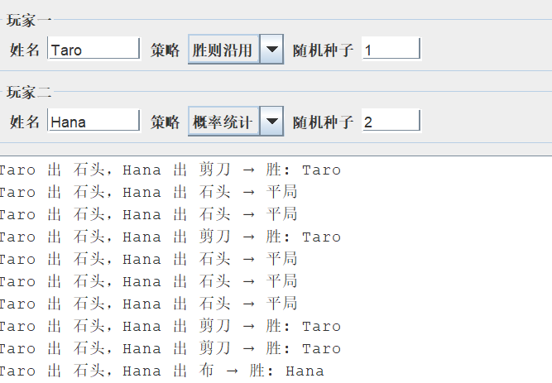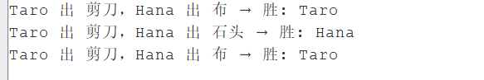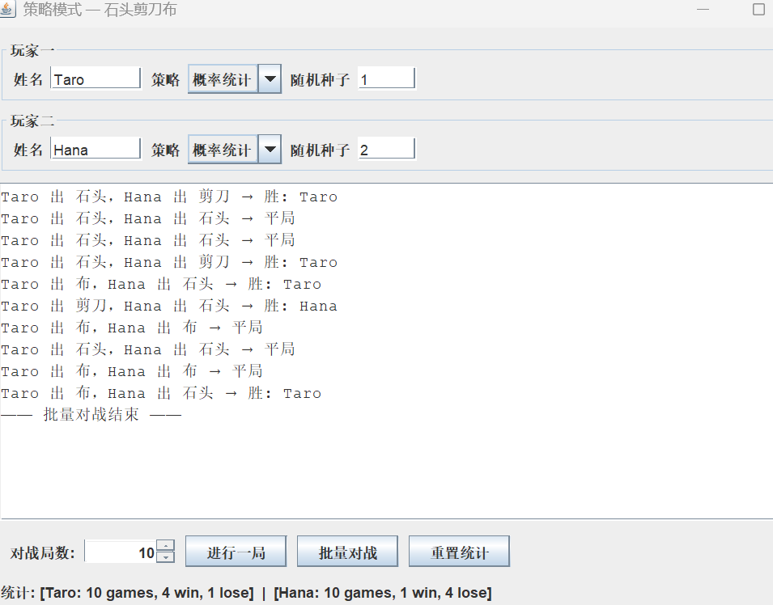
代码：
模式结构
Strategy 为策略接口，声明 nextHand() 与 study(boolean)；WinningStrategy 与 ProbStrategy 为具体策略；Player 为上下文，持有 Strategy 引用并委托其决定下一手势；Hand 表示石头、剪刀、布及胜负关系。客户端（GUI）通过为不同玩家设置不同 Strategy 实例，在运行时切换算法，无需修改 Player 类。
GUI 功能
用户可在界面设置两名玩家的姓名、策略类型和随机种子，通过「进行一局」「批量对战」触发游戏逻辑，在文本区域查看每局出招与结果，在底部查看累计胜负统计。

Hand.java
1. package strategy;
2.
3. /**
4. * 手势：石头、剪刀、布（策略模式示例中的领域对象）
5. */
6. public class Hand {
7.
8. public static final int ROCK = 0;
9. public static final int SCISSORS = 1;
10. public static final int PAPER = 2;
11.
12. private static final Hand[] INSTANCES = {
13. new Hand(ROCK),
14. new Hand(SCISSORS),
15. new Hand(PAPER)
16. };
17.
18. private static final String[] LABELS = {"石头", "剪刀", "布"};
19.
20. private final int value;
21.
22. private Hand(int value) {
23. this.value = value;
24. }
25.
26. public static Hand of(int value) {
27. if (value < 0 || value > 2) {
28. throw new IllegalArgumentException("无效手势: " + value);
29. }
30. return INSTANCES[value];
31. }
32.
33. public boolean beats(Hand other) {
34. return compare(other) > 0;
35. }
36.
37. public boolean losesTo(Hand other) {
38. return compare(other) < 0;
39. }
40.
41. /** @return 1 胜，0 平，-1 负 */
42. private int compare(Hand other) {
43. if (this == other) {
44. return 0;
45. }
46. if ((this.value + 1) % 3 == other.value) {
47. return 1;
48. }
49. return -1;
50. }
51.
52. @Override
53. public String toString() {
54. return LABELS[value];
55. }
56. }
57.
Main.java
1. package strategy;
2.
3. import javax.swing.SwingUtilities;
4.
5. public class Main {
6.
7. public static void main(String[] args) {
8. SwingUtilities.invokeLater(() -> new RpsGameWindow().setVisible(true));
9. }
10. }
11.
Player.java
1. package strategy;
2.
3. /**
4. * 上下文：持有策略并统计战绩
5. */
6. public class Player {
7.
8. private final String name;
9. private Strategy strategy;
10. private int wins;
11. private int losses;
12. private int rounds;
13.
14. public Player(String name, Strategy strategy) {
15. this.name = name;
16. this.strategy = strategy;
17. }
18.
19. public void setStrategy(Strategy strategy) {
20. this.strategy = strategy;
21. }
22.
23. public String getName() {
24. return name;
25. }
26.
27. public Hand play() {
28. return strategy.nextHand();
29. }
30.
31. public void recordWin() {
32. strategy.study(true);
33. wins++;
34. rounds++;
35. }
36.
37. public void recordLoss() {
38. strategy.study(false);
39. losses++;
40. rounds++;
41. }
42.
43. public void recordDraw() {
44. rounds++;
45. }
46.
47. public void resetStats() {
48. wins = 0;
49. losses = 0;
50. rounds = 0;
51. }
52.
53. @Override
54. public String toString() {
55. return "[" + name + ": " + rounds + " games, " + wins + " win, " + losses + " lose]";
56. }
57. }
58.
ProbStrategy.java
1. package strategy;
2.
3. import java.util.Random;
4.
5. /**
6. * 基于历史统计的概率策略
7. */
8. public class ProbStrategy implements Strategy {
9.
10. private final Random rng;
11. private int prevValue;
12. private int currValue;
13. private final int[][] weights;
14.
15. public ProbStrategy(int seed) {
16. this.rng = new Random(seed);
17. this.weights = new int[][]{
18. {1, 1, 1},
19. {1, 1, 1},
20. {1, 1, 1}
21. };
22. }
23.
24. @Override
25. public Hand nextHand() {
26. int rowSum = rowTotal(currValue);
27. int pick = rng.nextInt(rowSum);
28. int choice = 0;
29. while (pick >= weights[currValue][choice]) {
30. pick -= weights[currValue][choice];
31. choice++;
32. }
33. prevValue = currValue;
34. currValue = choice;
35. return Hand.of(choice);
36. }
37.
38. private int rowTotal(int row) {
39. int sum = 0;
40. for (int c = 0; c < 3; c++) {
41. sum += weights[row][c];
42. }
43. return sum;
44. }
45.
46. @Override
47. public void study(boolean wonLastRound) {
48. if (wonLastRound) {
49. weights[prevValue][currValue]++;
50. } else {
51. weights[prevValue][(currValue + 1) % 3]++;
52. weights[prevValue][(currValue + 2) % 3]++;
53. }
54. }
55. }
56.
RpsGameWindow,java
1. package strategy;
2.
3. import javax.swing.*;
4. import java.awt.*;
5. import java.awt.event.ActionEvent;
6.
7. /**
8. * 用 Swing GUI 演示策略模式：两位玩家可选用不同出招策略进行对战
9. */
10. public class RpsGameWindow extends JFrame {
11.
12. private final JTextField nameField1 = new JTextField("Taro", 8);
13. private final JTextField nameField2 = new JTextField("Hana", 8);
14. private final JTextField seedField1 = new JTextField("1", 5);
15. private final JTextField seedField2 = new JTextField("2", 5);
16. private final JComboBox<String> strategyBox1 = new JComboBox<>(new String[]{"胜则沿用", "概率统计"});
17. private final JComboBox<String> strategyBox2 = new JComboBox<>(new String[]{"胜则沿用", "概率统计"});
18. private final JSpinner roundSpinner = new JSpinner(new SpinnerNumberModel(10, 1, 1000, 1));
19. private final JTextArea logArea = new JTextArea(14, 50);
20. private final JLabel statsLabel = new JLabel(" ");
21.
22. private Player player1;
23. private Player player2;
24.
25. public RpsGameWindow() {
26. super("策略模式 — 石头剪刀布");
27. setDefaultCloseOperation(WindowConstants.EXIT_ON_CLOSE);
28. buildUi();
29. rebuildPlayers();
30. refreshStats();
31. setMinimumSize(new Dimension(620, 480));
32. pack();
33. setSize(720, 520);
34. setLocationRelativeTo(null);
35. }
36.
37. private void buildUi() {
38. JPanel config = new JPanel(new GridLayout(2, 1, 0, 6));
39. config.add(buildPlayerRow("玩家一", nameField1, strategyBox1, seedField1));
40. config.add(buildPlayerRow("玩家二", nameField2, strategyBox2, seedField2));
41.
42. JPanel control = new JPanel(new FlowLayout(FlowLayout.LEFT, 8, 4));
43. control.add(new JLabel("对战局数:"));
44. control.add(roundSpinner);
45. JButton oneRoundBtn = new JButton("进行一局");
46. JButton multiBtn = new JButton("批量对战");
47. JButton resetBtn = new JButton("重置统计");
48. control.add(oneRoundBtn);
49. control.add(multiBtn);
50. control.add(resetBtn);
51.
52. logArea.setEditable(false);
53. logArea.setLineWrap(true);
54. logArea.setWrapStyleWord(true);
55. logArea.setFont(new Font(Font.MONOSPACED, Font.PLAIN, 13));
56. JScrollPane scroll = new JScrollPane(logArea);
57. scroll.setPreferredSize(new Dimension(680, 280));
58.
59. JPanel footer = new JPanel(new BorderLayout(4, 4));
60. footer.add(control, BorderLayout.NORTH);
61. footer.add(statsLabel, BorderLayout.SOUTH);
62.
63. JPanel root = new JPanel(new BorderLayout(8, 8));
64. root.setBorder(BorderFactory.createEmptyBorder(10, 10, 10, 10));
65. root.add(config, BorderLayout.NORTH);
66. root.add(scroll, BorderLayout.CENTER);
67. root.add(footer, BorderLayout.SOUTH);
68.
69. setContentPane(root);
70.
71. oneRoundBtn.addActionListener(this::onOneRound);
72. multiBtn.addActionListener(this::onMultiRound);
73. resetBtn.addActionListener(e -> {
74. rebuildPlayers();
75. logArea.setText("");
76. refreshStats();
77. });
78. }
79.
80. private JPanel buildPlayerRow(String title, JTextField nameField,
81. JComboBox<String> strategyBox, JTextField seedField) {
82. JPanel row = new JPanel(new FlowLayout(FlowLayout.LEFT, 6, 2));
83. row.setBorder(BorderFactory.createTitledBorder(title));
84. row.add(new JLabel("姓名"));
85. row.add(nameField);
86. row.add(new JLabel("策略"));
87. row.add(strategyBox);
88. row.add(new JLabel("随机种子"));
89. row.add(seedField);
90. return row;
91. }
92.
93. private void onOneRound(ActionEvent e) {
94. ensurePlayers();
95. playSingleRound();
96. refreshStats();
97. }
98.
99. private void onMultiRound(ActionEvent e) {
100. rebuildPlayers();
101. logArea.setText("");
102. int n = (Integer) roundSpinner.getValue();
103. for (int i = 0; i < n; i++) {
104. playSingleRound();
105. }
106. appendLog("—— 批量对战结束 ——");
107. refreshStats();
108. }
109.
110. private void playSingleRound() {
111. Hand h1 = player1.play();
112. Hand h2 = player2.play();
113. String line = player1.getName() + " 出 " + h1 + "，"
114. + player2.getName() + " 出 " + h2 + " → ";
115.
116. if (h1.beats(h2)) {
117. player1.recordWin();
118. player2.recordLoss();
119. line += "胜: " + player1.getName();
120. } else if (h2.beats(h1)) {
121. player1.recordLoss();
122. player2.recordWin();
123. line += "胜: " + player2.getName();
124. } else {
125. player1.recordDraw();
126. player2.recordDraw();
127. line += "平局";
128. }
129. appendLog(line);
130. }
131.
132. private void appendLog(String text) {
133. logArea.append(text + "\n");
134. logArea.setCaretPosition(logArea.getDocument().getLength());
135. }
136.
137. private void refreshStats() {
138. statsLabel.setText("统计: " + player1 + " | " + player2);
139. }
140.
141. private void ensurePlayers() {
142. if (player1 == null || player2 == null) {
143. rebuildPlayers();
144. }
145. }
146.
147. private void rebuildPlayers() {
148. try {
149. int seed1 = Integer.parseInt(seedField1.getText().trim());
150. int seed2 = Integer.parseInt(seedField2.getText().trim());
151. player1 = new Player(nameField1.getText().trim(), createStrategy(strategyBox1, seed1));
152. player2 = new Player(nameField2.getText().trim(), createStrategy(strategyBox2, seed2));
153. } catch (NumberFormatException ex) {
154. JOptionPane.showMessageDialog(this, "随机种子必须是整数", "输入错误", JOptionPane.WARNING_MESSAGE);
155. player1 = new Player("Taro", new WinningStrategy(1));
156. player2 = new Player("Hana", new ProbStrategy(2));
157. }
158. }
159.
160. private Strategy createStrategy(JComboBox<String> box, int seed) {
161. if (box.getSelectedIndex() == 0) {
162. return new WinningStrategy(seed);
163. }
164. return new ProbStrategy(seed);
165. }
166. }
167.
Strategy.java
1. package strategy;
2.
3. /**
4. * 策略接口：决定下一出手势，并根据胜负学习
5. */
6. public interface Strategy {
7.
8. Hand nextHand();
9.
10. void study(boolean wonLastRound);
11. }
12.
WinningStrategy,java
1. package strategy;
2.
3. import java.util.Random;
4.
5. /**
6. * 胜则沿用、负则随机换招
7. */
8. public class WinningStrategy implements Strategy {
9.
10. private final Random rng;
11. private boolean lastWon;
12. private Hand lastHand;
13.
14. public WinningStrategy(int seed) {
15. this.rng = new Random(seed);
16. this.lastWon = false;
17. }
18.
19. @Override
20. public Hand nextHand() {
21. if (!lastWon) {
22. lastHand = Hand.of(rng.nextInt(3));
23. }
24. return lastHand;
25. }
26.
27. @Override
28. public void study(boolean wonLastRound) {
29. this.lastWon = wonLastRound;
30. }
31. }
32.

