运行结果
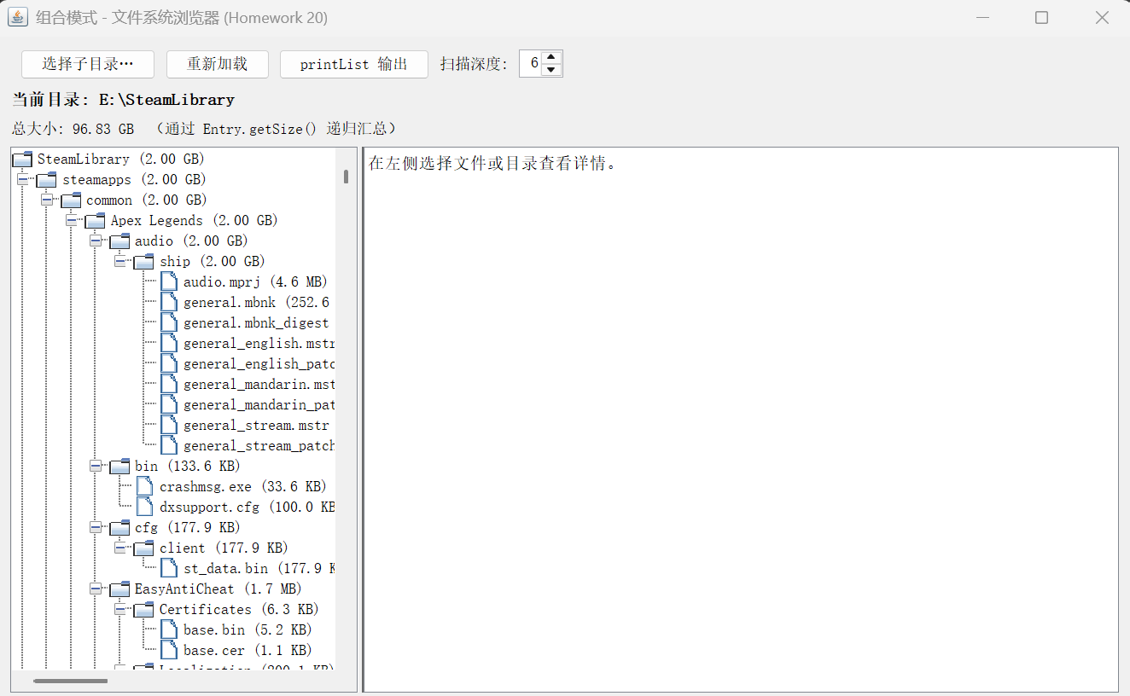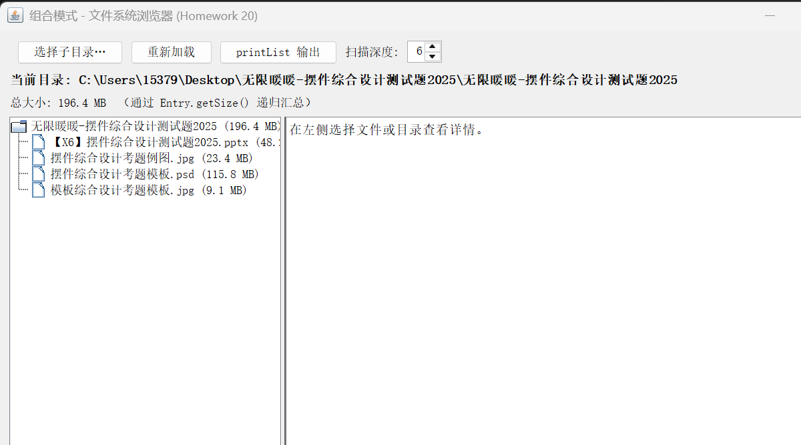

代码：
src/fs/Entry.java 抽象组件（getName / getSize / add / printList）
1. package fs;
2.
3. /**
4. * 组合模式中的 Component：对文件与目录一视同仁。
5. */
6. public abstract class Entry {
7.
8. public abstract String getName();
9.
10. public abstract int getSize();
11.
12. /**
13. * 默认实现：叶子（文件）不支持添加子项。
14. */
15. public Entry add(Entry child) {
16. throw new FileTreatmentException(
17. "无法在文件 \"" + getName() + "\" 中添加: " + child.getName());
18. }
19.
20. public void printList() {
21. printList("");
22. }
23.
24. protected abstract void printList(String prefix);
25.
26. @Override
27. public String toString() {
28. return getName() + " (" + formatSize(getSize()) + ")";
29. }
30.
31. public static String formatSize(long bytes) {
32. if (bytes < 1024) {
33. return bytes + " B";
34. }
35. if (bytes < 1024 * 1024) {
36. return String.format("%.1f KB", bytes / 1024.0);
37. }
38. if (bytes < 1024L * 1024 * 1024) {
39. return String.format("%.1f MB", bytes / (1024.0 * 1024));
40. }
41. return String.format("%.2f GB", bytes / (1024.0 * 1024 * 1024));
42. }
43. }
44.
src/fs/FsFile.java 叶子节点（文件）
1. package fs;
2.
3. /**
4. * 组合模式中的 Component：对文件与目录一视同仁。
5. */
6. public abstract class Entry {
7.
8. public abstract String getName();
9.
10. public abstract int getSize();
11.
12. /**
13. * 默认实现：叶子（文件）不支持添加子项。
14. */
15. public Entry add(Entry child) {
16. throw new FileTreatmentException(
17. "无法在文件 \"" + getName() + "\" 中添加: " + child.getName());
18. }
19.
20. public void printList() {
21. printList("");
22. }
23.
24. protected abstract void printList(String prefix);
25.
26. @Override
27. public String toString() {
28. return getName() + " (" + formatSize(getSize()) + ")";
29. }
30.
31. public static String formatSize(long bytes) {
32. if (bytes < 1024) {
33. return bytes + " B";
34. }
35. if (bytes < 1024 * 1024) {
36. return String.format("%.1f KB", bytes / 1024.0);
37. }
38. if (bytes < 1024L * 1024 * 1024) {
39. return String.format("%.1f MB", bytes / (1024.0 * 1024));
40. }
41. return String.format("%.2f GB", bytes / (1024.0 * 1024 * 1024));
42. }
43. }
44.
src/fs/Directory.java 组合节点（目录，递归汇总大小）
1. package fs;
2.
3. import java.util.ArrayList;
4. import java.util.Collections;
5. import java.util.List;
6.
7. /**
8. * 组合模式中的 Composite：目录可包含文件或其它目录。
9. */
10. public class Directory extends Entry {
11.
12. private final String name;
13. private final List<Entry> children = new ArrayList<>();
14.
15. public Directory(String name) {
16. this.name = name;
17. }
18.
19. @Override
20. public String getName() {
21. return name;
22. }
23.
24. @Override
25. public int getSize() {
26. long total = 0;
27. for (Entry child : children) {
28. if (child instanceof FsFile file) {
29. total += file.getSizeLong();
30. } else if (child instanceof Directory dir) {
31. total += dir.getSizeLong();
32. } else {
33. total += child.getSize();
34. }
35. if (total > Integer.MAX_VALUE) {
36. return Integer.MAX_VALUE;
37. }
38. }
39. return (int) total;
40. }
41.
42. public long getSizeLong() {
43. long total = 0;
44. for (Entry child : children) {
45. if (child instanceof FsFile file) {
46. total += file.getSizeLong();
47. } else if (child instanceof Directory dir) {
48. total += dir.getSizeLong();
49. } else {
50. total += child.getSize();
51. }
52. }
53. return total;
54. }
55.
56. @Override
57. public Directory add(Entry entry) {
58. children.add(entry);
59. return this;
60. }
61.
62. public List<Entry> getChildren() {
63. return Collections.unmodifiableList(children);
64. }
65.
66. @Override
67. protected void printList(String prefix) {
68. System.out.println(prefix + "/" + this);
69. String childPrefix = prefix.isEmpty() ? name : prefix + "/" + name;
70. for (Entry child : children) {
71. child.printList(childPrefix);
72. }
73. }
74.
75. public boolean isDirectory() {
76. return true;
77. }
78. }
79.
src/fs/FileTreatmentException.java 对文件执行 add 时抛异常
1. package fs;
2.
3. /**
4. * 对文件（叶子节点）执行“添加子项”等目录专属操作时抛出。
5. */
6. public class FileTreatmentException extends RuntimeException {
7.
8. public FileTreatmentException() {
9. super("不能在文件上执行该操作。");
10. }
11.
12. public FileTreatmentException(String message) {
13. super(message);
14. }
15. }
16.
src/fs/FileSystemLoader.java 从本机目录构建组合树
1. package fs;
2.
3. import java.io.IOException;
4. import java.nio.file.Files;
5. import java.nio.file.Path;
6. import java.util.Comparator;
7. import java.util.stream.Stream;
8.
9. /**
10. * 将本机真实目录结构转换为组合模式对象树。
11. */
12. public final class FileSystemLoader {
13.
14. private FileSystemLoader() {
15. }
16.
17. public static Directory load(Path rootDir, int maxDepth) throws IOException {
18. if (!Files.isDirectory(rootDir)) {
19. throw new IllegalArgumentException("路径不是目录: " + rootDir);
20. }
21. Directory root = new Directory(rootDir.getFileName().toString());
22. loadChildren(rootDir, root, 0, maxDepth);
23. return root;
24. }
25.
26. private static void loadChildren(Path dirPath, Directory parent, int depth, int maxDepth)
27. throws IOException {
28. if (depth >= maxDepth) {
29. return;
30. }
31. try (Stream<Path> stream = Files.list(dirPath)) {
32. stream.sorted(Comparator
33. .comparing((Path p) -> !Files.isDirectory(p))
34. .thenComparing(p -> p.getFileName().toString().toLowerCase()))
35. .forEach(child -> {
36. try {
37. if (Files.isDirectory(child)) {
38. Directory sub = new Directory(child.getFileName().toString());
39. parent.add(sub);
40. loadChildren(child, sub, depth + 1, maxDepth);
41. } else if (Files.isRegularFile(child)) {
42. long size = Files.size(child);
43. parent.add(new FsFile(child.getFileName().toString(), size));
44. }
45. } catch (IOException ignored) {
46. // 无权限或临时文件不可读时跳过
47. }
48. });
49. }
50. }
51. }
52.
src/fs/Main.java 控制台演示（对应课件 Main 逻辑）
1. package fs;
2.
3.
4. public class Main {
5.
6. public static void main(String[] args) {
7. Directory root = new Directory("root");
8.
9. Directory bin = new Directory("bin");
10. Directory tmp = new Directory("tmp");
11. Directory usr = new Directory("usr");
12. root.add(bin).add(tmp).add(usr);
13.
14. bin.add(new FsFile("vi", 10_000));
15. bin.add(new FsFile("latex", 20_000));
16.
17. System.out.println("=== 第一次 printList ===");
18. root.printList();
19.
20. Directory lee = new Directory("Lee");
21. Directory wang = new Directory("Wang");
22. Directory liu = new Directory("Liu");
23. usr.add(lee).add(wang).add(liu);
24.
25. lee.add(new FsFile("diary.html", 100));
26. wang.add(new FsFile("Composite.java", 200));
27. liu.add(new FsFile("memo.tex", 300));
28.
29. System.out.println();
30. System.out.println("=== 第二次 printList ===");
31. root.printList();
32.
33. System.out.println();
34. System.out.println("root 递归总大小: " + root.getSizeLong() + " 字节");
35.
36. try {
37. new FsFile("test.txt", 1).add(new FsFile("x", 1));
38. } catch (FileTreatmentException ex) {
39. System.out.println("预期异常: " + ex.getMessage());
40. }
41. }
42. }
43.
src/gui/FileSystemGUI.java GUI 主程序
1. package gui;
2.
3. import fs.Directory;
4. import fs.Entry;
5. import fs.FileSystemLoader;
6. import fs.FsFile;
7.
8. import javax.swing.*;
9. import javax.swing.border.EmptyBorder;
10. import javax.swing.tree.DefaultTreeCellRenderer;
11. import java.awt.*;
12. import java.io.ByteArrayOutputStream;
13. import java.io.IOException;
14. import java.io.PrintStream;
15. import java.nio.charset.StandardCharsets;
16. import java.nio.file.Path;
17.
18. public class FileSystemGUI extends JFrame {
19.
20. private static final int DEFAULT_MAX_DEPTH = 6;
21.
22. private final JLabel pathLabel = new JLabel("尚未选择目录");
23. private final JLabel sizeLabel = new JLabel("总大小: -");
24. private final JTree tree = new JTree();
25. private final JTextArea detailArea = new JTextArea(12, 40);
26. private final JSpinner depthSpinner = new JSpinner(
27. new SpinnerNumberModel(DEFAULT_MAX_DEPTH, 1, 20, 1));
28.
29. private Directory currentRoot;
30.
31. public FileSystemGUI() {
32. super("组合模式 - 文件系统浏览器 (Homework 20)");
33. setDefaultCloseOperation(WindowConstants.EXIT_ON_CLOSE);
34. setMinimumSize(new Dimension(900, 560));
35. setLocationRelativeTo(null);
36.
37. pathLabel.setFont(pathLabel.getFont().deriveFont(Font.BOLD, 13f));
38. detailArea.setEditable(false);
39. detailArea.setFont(new Font(Font.MONOSPACED, Font.PLAIN, 13));
40.
41. tree.setCellRenderer(new EntryRenderer());
42. tree.addTreeSelectionListener(e -> updateDetail());
43.
44. JButton openBtn = new JButton("选择子目录…");
45. openBtn.addActionListener(e -> chooseDirectory());
46.
47. JButton refreshBtn = new JButton("重新加载");
48. refreshBtn.addActionListener(e -> reloadCurrent());
49.
50. JButton printBtn = new JButton("printList 输出");
51. printBtn.addActionListener(e -> showPrintList());
52.
53. JPanel top = new JPanel(new BorderLayout(8, 8));
54. top.setBorder(new EmptyBorder(10, 10, 6, 10));
55. JPanel topButtons = new JPanel(new FlowLayout(FlowLayout.LEFT, 8, 0));
56. topButtons.add(openBtn);
57. topButtons.add(refreshBtn);
58. topButtons.add(printBtn);
59. topButtons.add(new JLabel("扫描深度:"));
60. topButtons.add(depthSpinner);
61. top.add(topButtons, BorderLayout.NORTH);
62. top.add(pathLabel, BorderLayout.CENTER);
63. top.add(sizeLabel, BorderLayout.SOUTH);
64.
65. JSplitPane split = new JSplitPane(
66. JSplitPane.HORIZONTAL_SPLIT,
67. new JScrollPane(tree),
68. new JScrollPane(detailArea));
69. split.setResizeWeight(0.42);
70. split.setBorder(new EmptyBorder(0, 10, 10, 10));
71.
72. getContentPane().setLayout(new BorderLayout());
73. getContentPane().add(top, BorderLayout.NORTH);
74. getContentPane().add(split, BorderLayout.CENTER);
75. }
76.
77. private void chooseDirectory() {
78. JFileChooser chooser = new JFileChooser();
79. chooser.setFileSelectionMode(JFileChooser.DIRECTORIES_ONLY);
80. chooser.setDialogTitle("选择要浏览的子目录");
81. if (chooser.showOpenDialog(this) != JFileChooser.APPROVE_OPTION) {
82. return;
83. }
84. loadDirectory(chooser.getSelectedFile().toPath());
85. }
86.
87. private void reloadCurrent() {
88. if (currentRoot == null) {
89. JOptionPane.showMessageDialog(this, "请先选择一个目录。", "提示",
90. JOptionPane.INFORMATION_MESSAGE);
91. return;
92. }
93. Path path = Path.of(pathLabel.getToolTipText());
94. loadDirectory(path);
95. }
96.
97. private void loadDirectory(Path path) {
98. int depth = (Integer) depthSpinner.getValue();
99. try {
100. setCursor(Cursor.getPredefinedCursor(Cursor.WAIT_CURSOR));
101. currentRoot = FileSystemLoader.load(path, depth);
102. tree.setModel(new EntryTreeModel(currentRoot));
103. for (int i = 0; i < tree.getRowCount(); i++) {
104. tree.expandRow(i);
105. }
106. pathLabel.setText("当前目录: " + path.toAbsolutePath());
107. pathLabel.setToolTipText(path.toAbsolutePath().toString());
108. sizeLabel.setText("总大小: " + Entry.formatSize(currentRoot.getSizeLong())
109. + " （通过 Entry.getSize() 递归汇总）");
110. updateDetail();
111. } catch (IOException ex) {
112. JOptionPane.showMessageDialog(this,
113. "加载失败: " + ex.getMessage(),
114. "错误",
115. JOptionPane.ERROR_MESSAGE);
116. } finally {
117. setCursor(Cursor.getDefaultCursor());
118. }
119. }
120.
121. private void updateDetail() {
122. Object node = tree.getLastSelectedPathComponent();
123. if (node == null) {
124. detailArea.setText("在左侧选择文件或目录查看详情。");
125. return;
126. }
127. Entry entry = (Entry) node;
128. StringBuilder sb = new StringBuilder();
129. sb.append("名称: ").append(entry.getName()).append('\n');
130. if (entry instanceof FsFile file) {
131. sb.append("类型: 文件 (Leaf)\n");
132. sb.append("大小: ").append(Entry.formatSize(file.getSizeLong())).append('\n');
133. } else if (entry instanceof Directory dir) {
134. sb.append("类型: 目录 (Composite)\n");
135. sb.append("直接子项: ").append(dir.getChildren().size()).append('\n');
136. sb.append("递归总大小: ").append(Entry.formatSize(dir.getSizeLong())).append('\n');
137. }
138. sb.append("\n组合模式说明:\n");
139. sb.append("客户端通过 Entry 接口统一访问文件与目录，\n");
140. sb.append("无需区分 Leaf 与 Composite 即可完成 getSize() 等操作。\n");
141. detailArea.setText(sb.toString());
142. detailArea.setCaretPosition(0);
143. }
144.
145. private void showPrintList() {
146. if (currentRoot == null) {
147. JOptionPane.showMessageDialog(this, "请先加载目录。", "提示",
148. JOptionPane.INFORMATION_MESSAGE);
149. return;
150. }
151. ByteArrayOutputStream buffer = new ByteArrayOutputStream();
152. PrintStream old = System.out;
153. try (PrintStream capture = new PrintStream(buffer, true, StandardCharsets.UTF_8)) {
154. System.setOut(capture);
155. currentRoot.printList();
156. } finally {
157. System.setOut(old);
158. }
159. String text = buffer.toString(StandardCharsets.UTF_8);
160. JTextArea area = new JTextArea(text, 22, 50);
161. area.setEditable(false);
162. area.setFont(new Font(Font.MONOSPACED, Font.PLAIN, 13));
163. JOptionPane.showMessageDialog(this, new JScrollPane(area),
164. "printList() 递归列表", JOptionPane.PLAIN_MESSAGE);
165. }
166.
167. private static class EntryRenderer extends DefaultTreeCellRenderer {
168. @Override
169. public Component getTreeCellRendererComponent(JTree tree, Object value,
170. boolean selected, boolean expanded, boolean leaf, int row,
171. boolean hasFocus) {
172. super.getTreeCellRendererComponent(tree, value, selected, expanded, leaf, row, hasFocus);
173. if (value instanceof FsFile) {
174. setIcon(UIManager.getIcon("FileView.fileIcon"));
175. } else if (value instanceof Directory) {
176. setIcon(UIManager.getIcon("FileView.directoryIcon"));
177. }
178. if (value instanceof Entry entry) {
179. setText(entry.toString());
180. }
181. return this;
182. }
183. }
184.
185. public static void main(String[] args) {
186. SwingUtilities.invokeLater(() -> {
187. try {
188. UIManager.setLookAndFeel(UIManager.getSystemLookAndFeelClassName());
189. } catch (Exception ignored) {
190. }
191. FileSystemGUI gui = new FileSystemGUI();
192. gui.setVisible(true);
193. if (args.length > 0) {
194. gui.loadDirectory(Path.of(args[0]));
195. }
196. });
197. }
198. }
199.
src/gui/EntryTreeModel.java 将 Entry 树绑定到 JTree
1. package gui;
2.
3. import fs.Directory;
4. import fs.Entry;
5. import fs.FsFile;
6.
7. import javax.swing.event.TreeModelListener;
8. import javax.swing.tree.TreeModel;
9. import javax.swing.tree.TreePath;
10.
11. /**
12. * 将组合模式 Entry 树绑定到 JTree。
13. */
14. public class EntryTreeModel implements TreeModel {
15.
16. private final Entry root;
17.
18. public EntryTreeModel(Entry root) {
19. this.root = root;
20. }
21.
22. @Override
23. public Object getRoot() {
24. return root;
25. }
26.
27. @Override
28. public Object getChild(Object parent, int index) {
29. if (parent instanceof Directory dir) {
30. return dir.getChildren().get(index);
31. }
32. return null;
33. }
34.
35. @Override
36. public int getChildCount(Object parent) {
37. if (parent instanceof Directory dir) {
38. return dir.getChildren().size();
39. }
40. return 0;
41. }
42.
43. @Override
44. public boolean isLeaf(Object node) {
45. return node instanceof FsFile;
46. }
47.
48. @Override
49. public void valueForPathChanged(TreePath path, Object newValue) {
50. // 只读浏览
51. }
52.
53. @Override
54. public int getIndexOfChild(Object parent, Object child) {
55. if (parent instanceof Directory dir) {
56. return dir.getChildren().indexOf(child);
57. }
58. return -1;
59. }
60.
61. @Override
62. public void addTreeModelListener(TreeModelListener l) {
63. }
64.
65. @Override
66. public void removeTreeModelListener(TreeModelListener l) {
67. }
68. }
69.

叶子类命名为 FsFile，避免与 java.io.File 冲突
用 ArrayList 管理子项（非 Vector）
增加 FileSystemLoader，把真实磁盘目录转成 Entry 树
Swing 界面：选目录、树形浏览、详情面板、printList() 弹窗、可调扫描深度

