Environment:
Grid of 64x64 Cells. Player see a window of 9x7 cell
Lakes -> Shores ; Grassland -> Forst ; Montain -> Caves, Ores and Lava
During the night, they are more monsters and view is restricted and noisy

About player:
Health -> Don't be attacked or stay with other level above 0 ; Food -> Chase cows or grow fruits to eat;
Water -> Drinking for lake; Rest -> Sleep in safe place
Health points are regenerate over time if all good

Ressources:
Sapling; Wood; Stone; Coal; Iron; Diamond

Episode = Game session; Each episode terminates when the player dies (hp to 0 or jump into lava)
Observation:
The agent needs to learn to read it’s inventory state out of the image
When the limit of 10.000 steps is reached, the episode arrives to his end.

Actions : 17 actions
Move in all 4 directions, interact with object in front of it, sleep, place objects, make tools

Rewards:
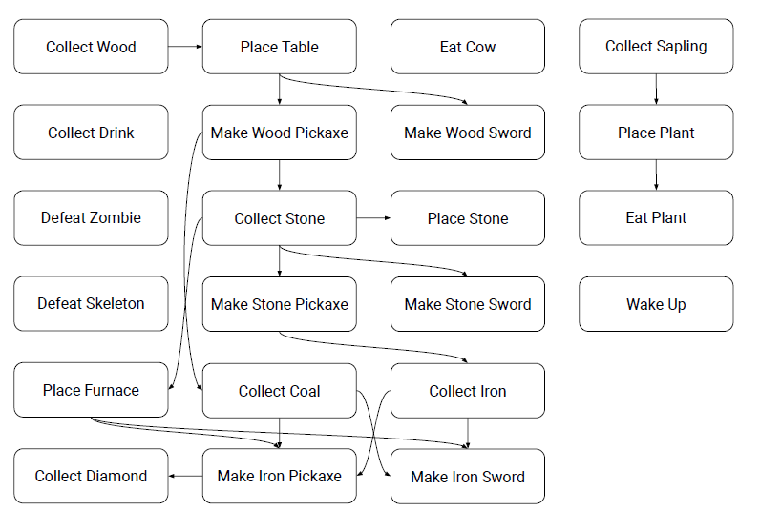
22 achievements
A reward is only given when an achievement is unlocked for the first time during episode
+1 reward every time the agent unlocks each achievement for the first time
-0.1 for every health point lost and +0.1 for every health point that is regenerated.
