20140040 Keonil Kim

[Problem 1.]

1. 5/2.5 = 2 (users)
2. two or fewer users transmit at the same time, each user requires 2.5Mbps. Total 5Mbps is available through shared link, there will be no queueing delay. However, if three users transmit at the same time, it require 7.5Mbps bandwidth, which is not available through 5Mbps link, thus, queueing delay occurs.
3. Probability would be 0.15^3 = 0.003375. The queue will grow when all three users transmit at the same time, the fraction of time will be 0.003375.

[Problem 2.]

1. dprop = m/s
2. dtrans = L/R
3. dprop+ dtrans = m/s + L/R
4. Just being transmitted from A
5. Still in the link
6. Already arrived at Host B
7. m = s\*L/R = 2.5\*10^8 \* 120/56 \* 10^3 = 5.36\*10^5(meter)

[Problem 3.]

1. Average delay is 166.10, 168.05, 166.429 for each trial.

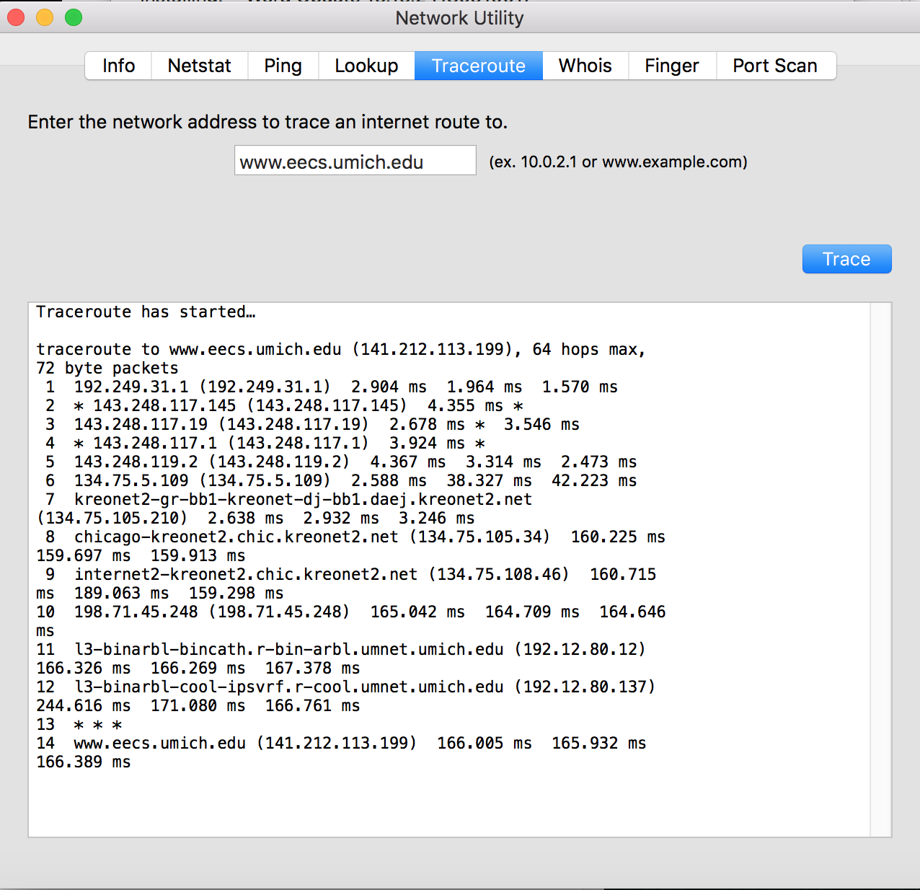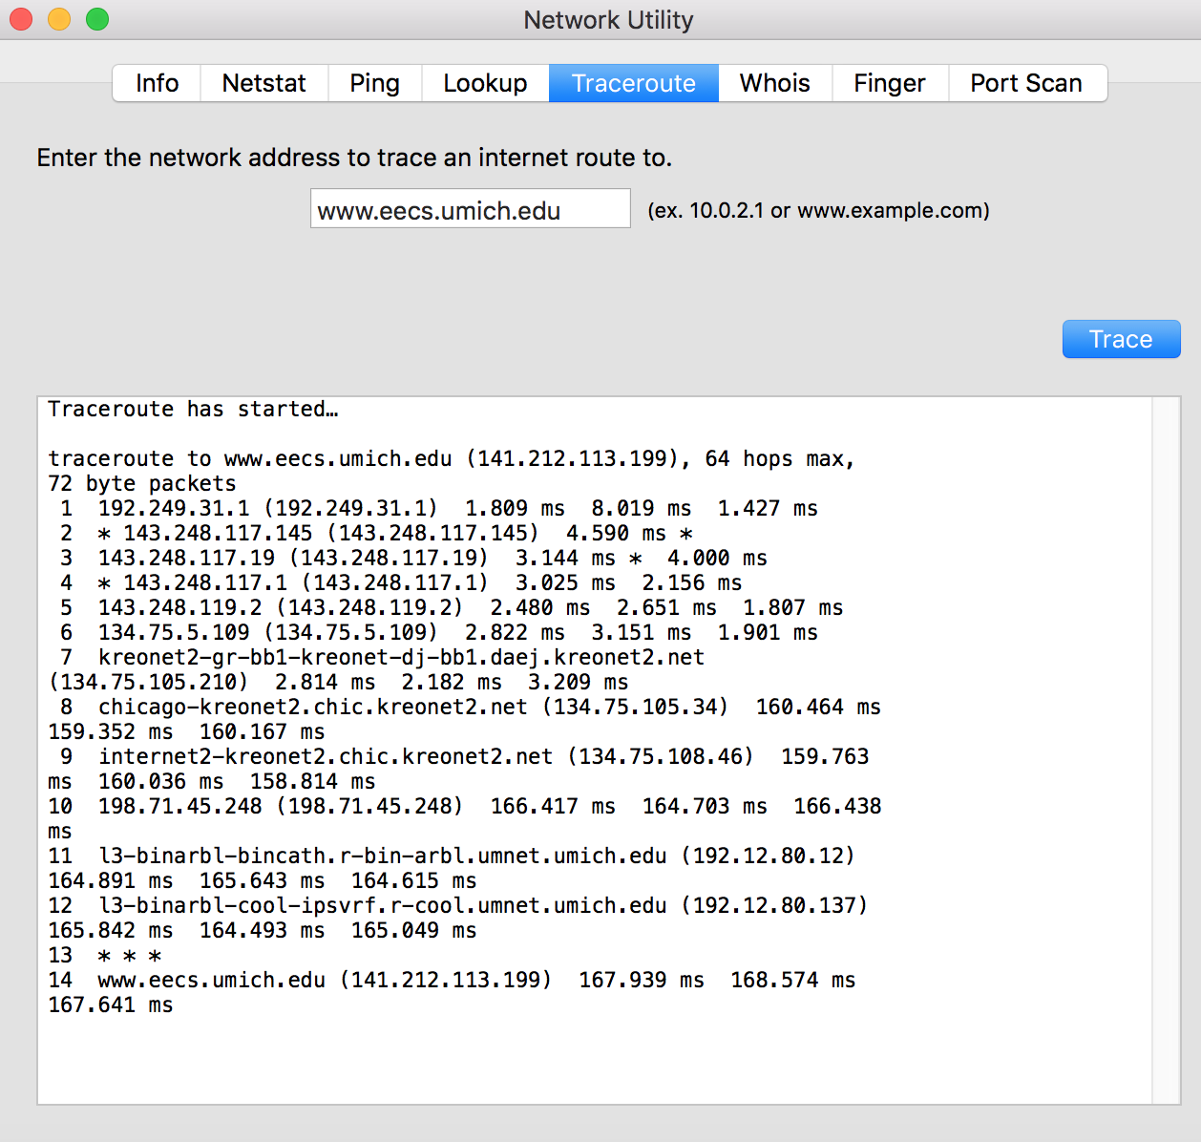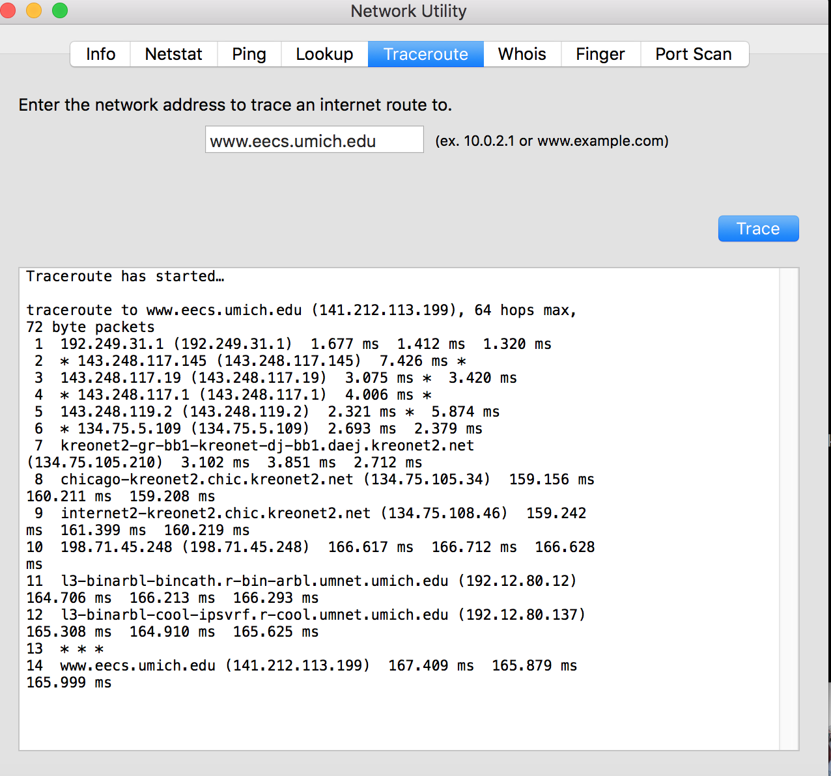

1. All three trial results in 13 routers in the path without change.
2. It looks like 9, 10 routers are ISPs.

[Problem 4.]

1. 8\*10^6bits = 8\*10^3Kb = 8Mb, since link is 2Mbps, it takes 8/2=4 seconds from the source to the first packet switch. Totally, it takes 4\*3 = 12 seconds from the source to the destination.
2. 10Kb/2Mbps = 5ms, second packet will be fully received at the first switch at 2\*5=10ms
3. It takes 15ms + 799\*5ms = 4010ms = 4.01 seconds. It is much faster to use segmentation , comparing to the answer in part (a).

[Problem 5.]

1. <http://gaia.cs.umass.edu/cs341/index.html> (Host is the server name, /cs341/index.html is the file name)
2. 1.1 (HTTP/1.1)
3. Persistent (Connection:keep-alive)
4. Can’t be found in the message
5. Mozilla/5.0 (User-Agent:Mozilla/5.0) For Server to deal with different types of browsers with sending the object with different versions.

[Problem 6.]

1. Δ = average time required to send an object over the access link = average object size / transmission rate = 850000b/15Mbps = 0.85Mb/15Mbps = 0.056 seconds

β = the arrival rate of objects to the access link = the average request rate = 16/sec

1. When cache hit, response time could be considered as 0. Also β =16\*0.4 = 6.4since cache hits doesn’t require to servers. The total average response time = 3 + 0.056/(1-0.056\*6.4) = 3 + 0.09 seconds = 3.09 seconds, when cahche missed. Therefore, the total average response time will be 0.4\*3.09 = 1.24 seconds.

[Problem 7.] My favorite human protocol is to decide the lunch menu. Suppose there are two people. First one of them suggests his/her choice. If the other satisfies with that or feels so-so while nothing really coming to mind, he/she accepts it and the protocol is done. If not, the other suggests a new menu and the same process is going. The point of this process is that it is sometimes really difficult to start at first if no one gives any suggestion.

[Problem 8.]

FingerIO uses SONAR, SkinTrack uses electric pulse. SkinTrack needs an ring emitting the electric pulses. Personally FingerIO is better owing to the requirement of an additional ring of SkinTrack. Even though FingerIO has comparatively lower accuracy issue, it is definitely handy to implement same function without additional gadgets or subsystem.

[Essay]

1. Hire lecturer: At least for CS major, most important courses are offered very rarely(such as Automata class) and honestly, some classes are really unhelpful, disorganized and some professors are not motivated at all to improve it. If hiring lecturer is not feasible, I still believe it is necessary to provide the core courses once a year.
2. Stop forcing English lecture: Of course it is important to study and debate in English. However, at least some basic courses and concepts is better to be delivered with Korean, which is easier for student, and more importantly, for professors. Honestly, quite many professors are not fluent with English. It results in inefficient lecture even if professors’ knowledge and teaching skill is good enough. I saw many professors who gave great explanation only in Korean. English lecture should be provided and I agree that we all should be familiar with English when we graduate. However, just forcing English lecture is definitely the worst policy for both students and professors.
3. More meeting with advisors: The regular meeting with advisors should be encouraged more, since many students and professors only have meeting for paperwork or getting signatures of advisors. Although some professors make a lot of efforts to be friendly with students, most professors, and of course students do not even try to meet each other, other than official st uffs. Some forced meeting should be organized for them to at least know each other.