Matlab标定结果：

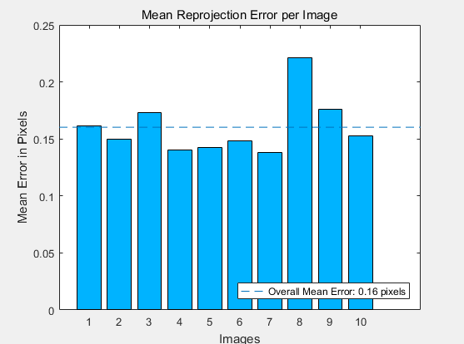

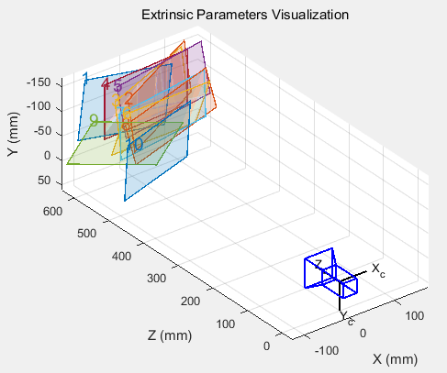

Standard Errors of Estimated Camera Parameters

----------------------------------------------

Intrinsics

----------

Focal length (pixels): [ 725.3181 +/- 3.9064 726.9567 +/- 3.7956 ]

Principal point (pixels):[ 313.7647 +/- 0.9370 236.0145 +/- 1.9591 ]

Radial distortion: [ 0.0014 +/- 0.0089 -0.1731 +/- 0.0625 ]

Opencv标定：

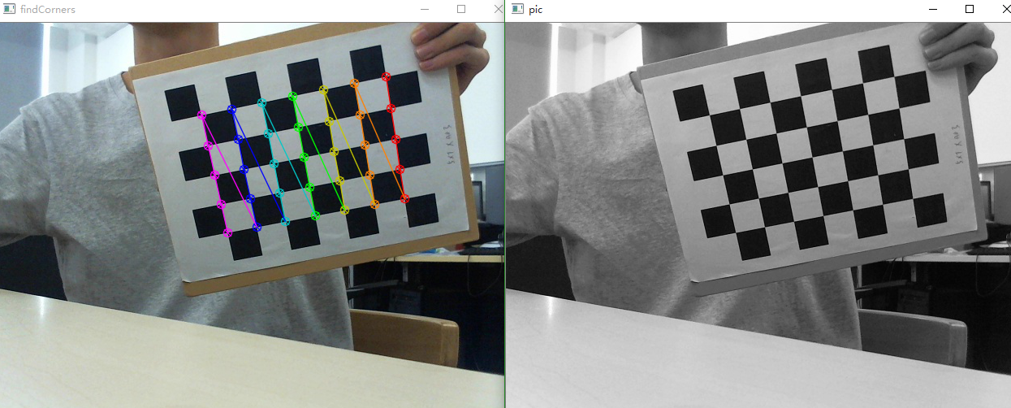

内参矩阵

[[728.97571788 0. 310.08497498]

[ 0. 730.5764702 238.21487131]

[ 0. 0. 1. ]]

畸变

[[-3.54744111e-02 6.07436081e-01 1.36986484e-03 -1.50088118e-03

-3.82286964e+00]]