An Explainable Prolog-Based Conversational Expert
System for Preliminary Disease Screening
Lavanya Murugesan and Haiping Xu
University of Massachusetts Dartmouth, Dartmouth, MA 02747, USA
{lmurugesan,hxu}@umassd.edu
Corresponding author: Haiping Xu (hxu@umassd.edu)
Abstract. Explainability is important in medical decision support because users need to understand both the screening result and the reasoning behind it. This paper presents a Prolog-based conversational prototype for preliminary disease screening that combines free-text symptom recognition with transparent symbolic reasoning. The system maps a patient’s description to a fixed vocabulary of 19 symptom codes and uses a goal-directed SWI-Prolog engine to identify candidate conditions, ask follow-up questions, and apply explicit screening rules and confirmation thresholds. An optional language model is used only for symptom recognition and does not generate screening decisions or explanations, so the final reasoning remains transparent and auditable. The current prototype supports six conditions and reports the confirmed symptoms and rule threshold behind each positive result. The case-study evaluation demonstrates the advantages of the approach, including consistent symbolic reasoning, traceable screening decisions, safe abstention when no relevant symptom is recognized, and the ability to distinguish conditions with overlapping symptoms through explicit follow-up questions.
Keywords: Explainable AI, Prolog, Expert Systems, Medical Decision Support, Symbolic Reasoning.
- Introduction
Artificial intelligence (AI) is becoming an important part of medical diagnosis and clinical decision support. Machine-learning and deep-learning methods can identify complex patterns in large amounts of medical data and have shown promise in areas such as medical imaging and clinical text analysis. As these models become more complex, however, it can be difficult to understand how they reach a particular decision. In medicine, an accurate prediction is often not enough. Healthcare professionals and patients also need to know what evidence supports a result and how that evidence leads to the final conclusion. This makes explainability an important requirement for AI-based medical decision-support systems. Classical expert systems such as MYCIN [1, 2] and DXplain [3] address this need by representing medical knowledge through explicit, auditable rules, while Miller [4] provides a broader review of this approach. More recent machine-learning and language-model systems can process free-text input more flexibly [5–8], but their internal reasoning is generally harder to inspect. Post hoc methods such as LIME [9] can explain individual black-box predictions, but these explanations approximate the model’s behavior rather than reproduce the reasoning that produced the prediction. Rudin [10] therefore argues that inherently interpretable models should be preferred in high-stakes settings when their performance is comparable. Rule-based systems offer this kind of transparency, but they also have an important limitation: they can reason only about findings that are represented in the knowledge base and recognized from the user’s input. This creates a practical challenge for conversational screening. Symbolic reasoning is transparent and traceable, but it can be sensitive to how symptoms are expressed. Language models are much more flexible in understanding natural language, but their reasoning is less transparent. Our approach addresses this tradeoff by separating natural-language recognition from the symbolic reasoning process.

In this work, we present an explainable, Prolog-based conversational expert system for preliminary disease screening. The system combines a natural-language conversational interface with deterministic symbolic reasoning. A patient describes symptoms in free text, the system maps the description to recognized symptom concepts and asks follow-up questions, and a goal-directed backward-chaining engine implemented in SWI-Prolog evaluates the confirmed symptoms against explicit disease-specific rules. The design focuses on making every screening result understandable and traceable. Each result can be linked directly to the symptoms and rules that produced it, while the disease knowledge base is kept separate from the reasoning mechanism so that the system can be extended without redesigning the core engine. The main contributions of this work are as follows:

- An explainable conversational framework for preliminary disease screening that combines free-text symptom recognition with a Prolog-based symbolic reasoning engine, allowing each screening result to be traced to the explicit symptom facts and disease-specific rules that produced it.
- A constrained language-model recognition layer designed to improve free-text coverage while limiting the model to a fixed symptom vocabulary and keeping it outside the diagnostic trust boundary, so that screening decisions remain entirely symbolic and auditable.
- An extensible knowledge-based architecture that separates the disease knowledge base from the core reasoning mechanism, allowing new diseases, symptoms, and screening rules to be added without retraining or redesigning the reasoning engine.

The remainder of this paper is organized as follows. Section 2 reviews related work on rule-based medical expert systems, symptom-checker evaluation, explainable AI, and clinical natural language processing. Section 3 describes the system architecture and the symptom-recognition and confirmation algorithms. Section 4 presents three case studies that evaluate the system end to end. Section 5 concludes the paper, discusses the current limitations, and outlines directions for future work.
- Related Work
Rule-based medical decision support began with a simple idea: represent expert reasoning in a form that physicians could inspect and challenge. MYCIN [1, 2] used backward-chaining rules with certainty factors to recommend antimicrobial therapy and became an early model of auditable reasoning. INTERNIST-I [11] and DXplain [3] extended this approach to broader areas of internal medicine. As Miller [4] observed, however, these systems became harder to maintain as their knowledge bases grew. A more fundamental limitation was that symbolic systems could reason only about findings that had already been defined in the knowledge base. As a result, users often had to select symptoms from predefined menus rather than describe them in their own words. Our system preserves the transparency of rule-based reasoning while adding a recognition layer that maps free-text input to the closed symptom vocabulary used by the rules. This mapping can be performed either by a keyword lexicon or by a language-model parser constrained to the same vocabulary.

Another line of research has focused on evaluating symptom checkers in practice. Semigran et al. [12] tested 23 applications using 45 standardized clinical vignettes and found that the correct diagnosis was ranked first in only 34% of cases. Baker et al. [13] compared an AI triage system with physicians, while Meyer et al. [14] examined how patients understood and responded to symptom-checker recommendations. These studies provide useful evaluation methods and realistic performance baselines, but they offer little insight into why an individual system succeeds or fails because the systems being evaluated are proprietary. A failed case can show that something went wrong, but not where the failure occurred. Our work uses a similar vignette-based evaluation approach, but applies it to a system whose reasoning process is fully visible. Symptom recognition, disease routing, and rule-based confirmation are implemented as separate stages, making it possible to identify where an error occurs.

The interpretability literature also helps clarify the design goals of this work. Lipton [15] distinguishes between simulatability, whether a person can mentally follow a model’s computation, and decomposability, whether the individual components of the model are understandable. Doshi-Velez and Kim [16] discuss how such interpretability claims can be evaluated. Ribeiro et al. [9] introduced LIME to provide local explanations for black-box predictions, while Rudin [10] argues that high-stakes applications should favor inherently interpretable models when comparable performance is available. These perspectives support the use of transparent symbolic reasoning, but they do not address how an interpretable system can also handle the variety of expressions found in natural-language input. Language models help address this free-text limitation. Med-PaLM [17] and GPT-4 [18] demonstrate strong performance on medical language tasks, while Thirunavukarasu et al. [5] review both their potential and their risks. Agrawal et al. [6] show that general-purpose language models can perform few-shot clinical information extraction when restricted to a fixed label set. PubMedBERT [7] addresses related problems through biomedical pretraining, and Bhat et al. [8] combine symbolic and learned components in an augmented decision tree. These approaches improve the ability to handle varied language, but the learned model still participates in the decision process.

Our design takes a different approach. The language model is used only to map free-text input to symptom codes already defined in the symbolic knowledge base. It receives the allowed symptom codes and returns only a JSON array drawn from that list. The output is then checked against the same vocabulary expected by the Prolog engine, and any invalid value is discarded. As a result, the language model acts as a replaceable recognition component rather than as a second reasoning engine. Disease routing, threshold evaluation, and explanation remain entirely within the same Prolog logic, regardless of whether symptom recognition comes from the language model or from the keyword lexicon. If the model call fails or produces an invalid response, the system falls back to the deterministic lexicon. Compared with Bhat et al. [8], our approach keeps the language model outside the screening decision process. This separation allows the system to combine flexible free-text input with transparent symbolic reasoning and an editable knowledge base that can be extended without retraining.
- System Architecture and Reasoning Process
The system consists of three separate stages: symptom recognition, disease routing, and threshold-based confirmation. These stages work together in a single conversational pipeline. This design allows patients to describe their symptoms in their own words, while ensuring that the final screening result is determined only by explicit symbolic rules. As a result, the reasoning process remains transparent and consistent regardless of which symptom-recognition method is used.

  - Architecture Overview
Fig. 1 shows the overall system architecture and how information moves through its three stages. Patients interact with the system through a web chat interface. Each screening session maintains its own conversation state, allowing multiple patients to use the system at the same time without interfering with one another. The Symptom Recognition and Answer Classification layer connects the chat interface to the reasoning backend. It maps the patient’s initial free text description to a fixed set of symptom codes. By default, this mapping is performed using a keyword lexicon, although the LLM-based parser described in Section 3.2 can also be used. During the follow-up conversation, the same layer classifies each response as affirmative, negative, uncertain, or unrecognized. If an answer cannot be recognized, the system asks the question again instead of incorrectly treating the response as negative.

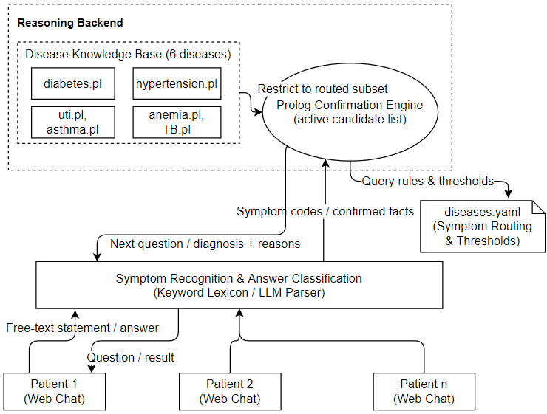
Fig. 1. Architecture of the conversational expert system, showing the symptom recognition, disease routing, and threshold-based confirmation stages.
The reasoning backend has two main components: the Disease Knowledge Base and the Prolog Confirmation Engine. The Disease Knowledge Base defines the six conditions supported by the current prototype. For each condition, it stores the screening questions, the fact confirmed by each question, and the number of confirmed facts required for a positive screening result. These definitions are compiled from a single configuration file into the Prolog facts and rules used by the reasoning engine. The symptom sets, screening questions, and confirmation thresholds were manually specified to demonstrate the reasoning architecture. They have not been derived from clinically validated diagnostic guidelines or calibrated using patient data, and they should not be interpreted as medical diagnostic criteria. The Prolog Confirmation Engine performs the goal-directed, backward chaining reasoning. Based on the symptom codes recognized so far, it narrows the search to the conditions that those symptoms may indicate. It then asks the next unanswered question for the current candidate condition. Once the number of confirmed facts reaches the required threshold, the system returns a positive screening result. If the threshold is not reached, the engine moves to the next candidate. If no candidate reaches its threshold, the system reports no screening result rather than making a guess.

The connections between the three stages are intentionally simple. The recognition layer produces a set $F$ of symptom codes from the vocabulary $V$. The routing table uses $F$ to create an ordered candidate list $C$. The confirmation engine then evaluates $C$ using the disease definitions $D$ and builds a reasoning trace $T$. The original free text and any explanation produced by the language model are not used in rule evaluation. During a screening session, $F$, $C$, the classified answers, and $T$ belong only to that conversation, while the disease definitions are shared. This separation keeps patient sessions independent and makes each result reproducible from its recorded symbolic inputs.

The architecture is also designed to be easy to extend. Adding a new condition requires only a new knowledge base entry with its questions, facts, threshold, and routing symptoms. The Prolog engine does not need to change because it works with any condition defined in the knowledge base. The recognition layer also remains unchanged because its role is independent of the number of supported conditions. Since the reasoning process is rule based rather than learned, adding new conditions does not require retraining.
  - Constrained LLM for Symptom Recognition
The default symptom recognizer uses a keyword lexicon based on exact substring matching. It works well when a patient uses one of the phrases already included in the lexicon, but it may fail when the same symptom is described in a different way. The LLM-based recognition layer is designed to improve this flexibility while preserving the transparency of the overall system. When the LLM is enabled, it receives the patient’s free text statement together with the 19 symptom codes defined in the system’s fixed vocabulary and used by the Prolog rules. Each code is accompanied by a short clinical description. The model is instructed to return only a JSON array containing codes from this predefined list. It is not allowed to generate a diagnosis or introduce new symptom codes. Because the model output is checked against the same fixed vocabulary used by the keyword lexicon, the LLM serves only as an alternative recognition method rather than as a second reasoning engine. The current implementation supports Claude, GPT, and DeepSeek through a common interface.

The system enforces this trust boundary in two ways. First, the prompt limits the model to the predefined symptom vocabulary. Second, deterministic post processing checks every returned code against the valid set $V$, removes duplicates, and discards any invalid output. Only a valid, nonempty set of symptom codes is passed to the next stage. These safeguards prevent the model from adding new labels or producing a diagnosis, although they cannot eliminate recognition errors completely. A patient statement could still be mapped to the wrong valid symptom code. For this reason, recognized symptoms are used only to narrow the search. The final screening result is still determined by the disease specific questions, rules, and confirmation thresholds. If the LLM is unavailable because of a missing API key, network error, timeout, or invalid response, the system automatically falls back to the keyword lexicon. The system therefore remains usable even without an external language model, although its ability to recognize varied free text may be more limited. Sections 4 and 5 evaluate the keyword-based path and discuss future evaluation of the LLM-based recognizer.
  - Symptom Recognition and Disease Confirmation
Recognition and confirmation are connected through the fixed symptom set $F⊆V$. Algorithm 1 extracts $F$ from the patient’s free text input. Algorithm 2 then uses only $F$, the routing table $R$, and the disease definitions $D$. It does not use the original text or any explanation produced by the language model. This separation means that the recognition method can be changed, or can fall back to the keyword lexicon, without changing the symbolic reasoning process that determines the screening result. For each candidate condition, the system keeps track of the confirmed facts. An affirmative answer adds the corresponding fact, while a negative or uncertain answer does not. If an answer is unrecognized, the system asks the same question again. A fact that has already been confirmed is not asked about again. Candidate conditions are evaluated in a fixed order, and the first one to reach its confirmation threshold is returned. If no candidate condition is identified, the system returns NO_RECOGNIZED_SYMPTOM. If candidates are identified but none reaches its threshold, the system returns NO_DIAGNOSIS. This process is deterministic and returns at most one screening result.

Algorithm 1: Natural Language Symptom Recognition with Deterministic Fallback
Input: Patient free text statement $s$; provider option $p∈\left\{\text{none} , \text{local} , \text{api}\right\}$; fixed symptom vocabulary
Output: Set $F$ of recognized symptom codes, where $F⊆V$
1: | F ← ∅
2: | if p ≠ none then
3: | Create a prompt containing s and the symptom vocabulary V, including a short de  scription of each code
4: | Ask the selected language model to return only symptom codes from V
5: | Parse the response as a JSON array, and remove any code that is not in V
6: | if the result is valid and nonempty then
7: | F ← returned symptom codes
8: | return F
9: | for each symptom code c in V
10: | if any keyword associated with c appears in s then
11: | Add c to F
12: | return F

Because the symptom vocabulary and disease definitions are finite, the symbolic reasoning process will terminate as long as repeated questions eventually receive a recognizable answer. Keyword-based recognition requires more processing as the vocabulary grows and as patient input becomes longer, while the LLM-based approach also introduces model response time. Each candidate condition is evaluated only once, although an unrecognized response may cause the same question to be asked again. The reasoning trace records the recognized symptoms, candidate list, questions, answer classifications, and threshold decisions. This provides a clear record of how each screening result was reached. Algorithm 1 always returns a set $F⊆V$. When an LLM is used, its output is parsed and checked against the valid vocabulary $V$. If the response is malformed or empty, the system falls back to keyword matching. The returned set may still be empty if no symptom is recognized, but its meaning remains the same regardless of which recognition method is used.

Algorithm 2: Threshold-Based Screening Confirmation with Reasoning Trace
Input: Recognized symptom set $F$ from Algorithm 1; routing table $R$; disease definitions $D$, where each $D\left[d\right]$ contains the ordered questions for disease $d$, the fact confirmed by each question, and the confirmation threshold θ
Output: A screened positive condition $d$ with reasoning trace $T$, NO_DIAGNOSIS, or NO_RECOGNIZED_SYMPTOM
1: | C ← ordered candidate list obtained by routing F through R
2: | if C is empty then
3: | return NO_RECOGNIZED_SYMPTOM and request clarification
4: | Initialize $T$ with the recognized symptoms $F$ and candidate list C
5: | for each disease $d∈C$ do
6: | confirmed ← F ∩ facts(D[d]); count ← |confirmed|
7: | for each (question, fact) in D[d] that has not already been asked do
8: | if count ≥ θ_{d} then
9: | break
10: | Ask the patient the question, and classify the answer as affirmative, negative,  uncertain, or unrecognized
11: | while the answer is unrecognized do
12: | Ask the same question again and reclassify the answer
13: | if the answer is affirmative then
14: | Add fact to confirmed; count ← count + 1
15: | append (question, fact, answer) to T
16: | if count ≥ θ_{d} then
17: | Append (d, confirmed, θ_{d}, “confirmed”) to T
18: | return (d, T)
19: | else
20: | Append (d, count, θ_{d}, “ruled out”) to T
21: | return NO_DIAGNOSIS

Algorithm 2 uses the recognized symptom set $F$ to generate an ordered list of candidate conditions $C$. If no candidate is identified, the system abstains and requests clarification. For each candidate, the algorithm starts with any facts already recognized from the patient’s input and does not ask about those facts again. New facts are added only when the patient gives an affirmative response. The first condition that reaches its confirmation threshold is returned as the screening result. Candidates that do not meet their thresholds are recorded in the reasoning trace $T$. If no candidate satisfies its threshold, the algorithm returns NO_DIAGNOSIS.
- Evaluation and Case Studies
To demonstrate both the strengths and limitations of the approach, we evaluate the system using three case studies for a prototype that supports six conditions and 20 symptom codes. Sections 4.1 and 4.2 use scripted dialogues to examine disease routing, follow up question selection, threshold-based confirmation, and reasoning trace generation. Section 4.3 evaluates the deterministic keyword recognizer using 12 opening statements, with one canonical expression and one natural paraphrase for each condition. The recognized symptom codes are then passed to Algorithm 2 for routing. If no routing symptom is recognized, the system abstains. For each test case, the expected result is based on the intended routing symptom in the prototype knowledge base rather than on clinical ground truth. No patient data are used in the evaluation.
  - Straightforward Screening Conversation
In this case study, we follow a complete diabetes screening conversation from the patient’s initial free-text message to the final screening result and reasoning trace. Instead of selecting symptoms from a predefined menu, the patient begins by describing the problem in their own words: “My blood sugar has been running high and I’ve been going to the bathroom constantly.” The symptom-recognition layer described in Section 3.2 maps this statement to the system’s fixed symptom vocabulary and identifies elevated_glucose and polyuria. Because elevated_glucose is associated with the candidate set {diabetes, hypertension}, with diabetes evaluated first, the reasoning engine narrows the search to these conditions and asks the remaining diabetes-related questions. The resulting conversation is shown in Fig. 2.

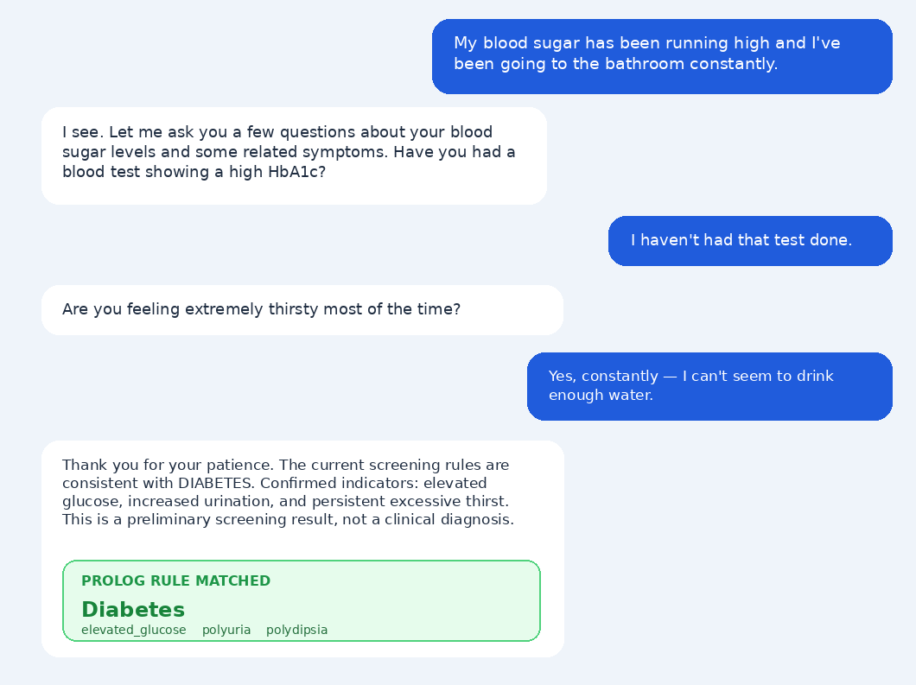
Fig. 2. Screening dialogue for the diabetes case, showing the system’s follow-up questions and the patient’s answers.
The response to the HbA1c question is classified as uncertain, so it does not add a confirmed fact. The patient then answers yes to the thirst question, which confirms polydipsia. Together with the two symptoms identified in the opening statement, elevated_glucose and polyuria, the system now has three confirmed facts. This meets the prototype threshold of three and produces a positive screening result. Fig. 3 shows the full conversation together with the system state after each turn.

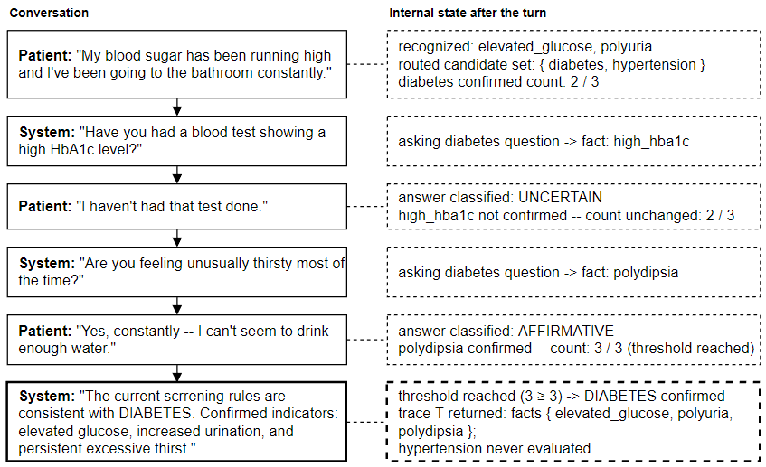
Fig. 3. Annotated transcript of the screening dialogue, showing recognized symptom codes, the active candidate set, and the running confirmed-fact count.
The patient does not need to know which conditions are being considered or which questions are most important. The system accepts the patient’s description in natural language, asks follow up questions, and uses the confirmed facts to reach a result. Each step in the reasoning trace corresponds to an explicit fact or rule in the knowledge base. Rather than reporting only a confidence score, the final message explains which three facts satisfied the screening rule.
  - Disambiguating Conditions with Overlapping Symptoms
This case study considers a situation in which the patient’s initial symptom is not enough to distinguish between two possible conditions. Both asthma and tuberculosis can begin with a cough, but the additional symptoms used to confirm them are quite different. Asthma is associated with signs of reversible airway obstruction, while tuberculosis is associated with signs of a chronic systemic infection. In our system, the follow-up questions and their order are determined by explicit condition-specific rules rather than generated dynamically by a language model. For the patient input, “I’ve had this cough for a while now, and it’s really been getting to me,” the recognition layer extracts cough, which routes to the candidate set {asthma, tuberculosis}, with asthma evaluated first. The engine then asks the four asthma-related questions in sequence, as shown in Fig. 4. None of the asthma-related facts are confirmed, so the threshold of two is not reached. The engine then moves to the next candidate without requiring the patient to know that tuberculosis is also being considered. The subsequent tuberculosis exchange is shown in Fig. 5.

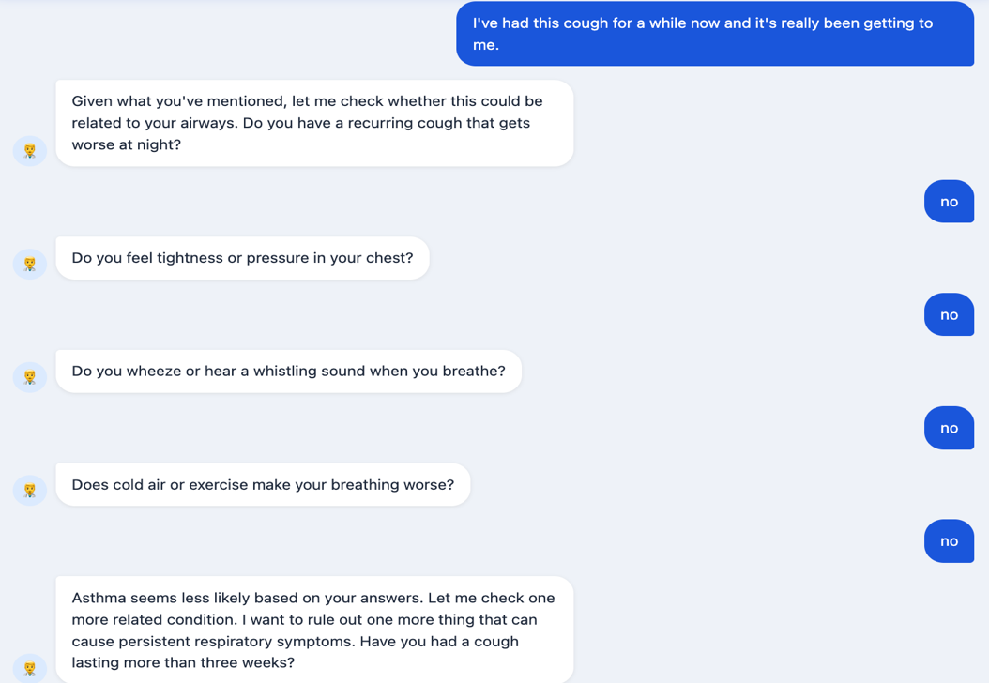
Fig. 4. Screening dialogue for the asthma case, showing the system’s questions and the patient’s negative responses.
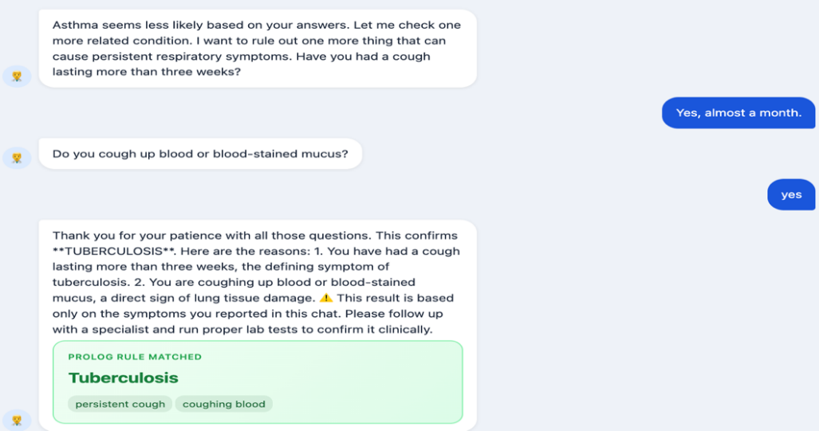
Fig. 5. Screening dialogue for the tuberculosis case, showing the system’s questions and the patient’s affirmative responses.
Two tuberculosis related facts, persistent_cough and coughing_blood, are confirmed, which meets the prototype threshold of two and produces a positive screening result. Although the patient’s initial cough was not enough to distinguish asthma from tuberculosis, the system reaches the intended outcome by asking the follow-up questions defined for each candidate condition. The choice of questions comes directly from the condition-specific rules rather than from a learned model. This makes the reasoning process explicit and traceable. In contrast, a general-purpose language model does not provide the same structural guarantee that its questions or conclusions follow a predefined rule set. Fig. 6 shows the resulting reasoning trace as a two-branch tree.

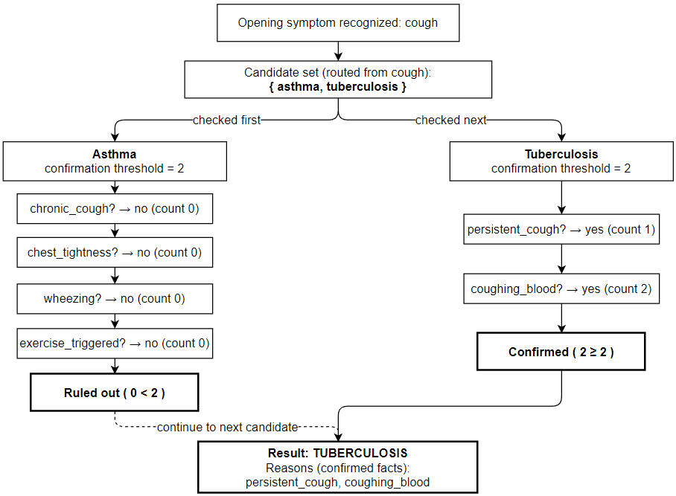
Fig. 6. Reasoning trace for the tuberculosis dialogue as a two-branch tree, with each node labeled by the fact it tests and the running count.
  - Robustness to Natural-Language Variation
The earlier dialogues use wording that is close to the keyword vocabulary recognized by the system. In practice, however, patients may describe the same symptom in many ways. To examine this issue, we test each of the six supported conditions with two opening statements: one based on a known keyword phrase and one written as a natural paraphrase. Table 1 summarizes the results for the keyword-based recognition method. The system correctly recognizes all six canonical inputs and routes them to the intended conditions. For the natural paraphrases, however, it recognizes only three of the six inputs. In the other three cases, no keyword in the lexicon matches the patient’s wording. Under the current safety policy, the system returns NO_RECOGNIZED_SYMPTOM and asks for clarification rather than continuing with an unsupported candidate list. As a result, the recognition rate for these paraphrases is 50%, but the system fails safely by abstaining instead of producing a false positive screening result. This limitation motivates the constrained LLM-based recognition layer described in Section 3.2, which is intended to improve paraphrase recognition while keeping the final screening decision entirely within the symbolic reasoning process.
Table 1. Keyword-recognition results for 12 canonical and paraphrased opening statements
Condition | Canonical input → code; route | Natural paraphrase → code; route/action
Diabetes | “I have high blood sugar.” → elevated_glucose; diabetes | “I cannot stop drinking water because I am very thirsty.” → polydipsia; diabetes
Hypertension | “I have high blood pressure.” → elevated_bp; hypertension | “A recent reading was 165 over 100.” → none; abstain
Anemia | “My skin looks pale.” → pale_skin; anemia | “I feel lightheaded whenever I stand up.” → dizziness; anemia
UTI | “I have burning urination.” → dysuria; UTI | “Passing urine gives me a sharp sting.” → none; abstain
Asthma | “I have a cough.” → cough; asthma | “I have been coughing lately.” → cough; asthma
Tuberculosis | “I have night sweats.” → night_sweats; tuberculosis | “I wake up with my bedclothes soaked in sweat.” → none; abstain

The case studies help distinguish errors in symptom recognition from the behavior of the symbolic reasoning engine. Once a relevant symptom is recognized, the engine follows the predefined candidate order, applies the specified thresholds, and records the facts used to reach each result. The robustness test is small, so it does not demonstrate clinical accuracy or broad natural language understanding. Instead, it shows that exact keyword matching can fail when the same symptom is expressed in different ways. In these cases, returning NO_RECOGNIZED_SYMPTOM prevents the system from following an unrelated screening path. Future work will evaluate the optional language model-based recognizer and validate the medical rules using clinically reviewed cases.
- Interface Design
The reasoning architecture described in Sections 3 and 4 is deliberately independent of any particular front end. This section describes two interface prototypes built on top of that architecture: a patient-facing screening interface and a doctor-facing interface for proposing new production rules. Both are illustrative prototypes intended to demonstrate the interaction design; only the patient-facing interface is currently connected to the live reasoning engine described earlier in this paper.

  - Patient Screening Interface

The patient interacts with the system through a single conversational view. Each screening result is shown together with a collapsed disclosure labeled "See exactly how this was decided," which expands into the confirmed facts and the threshold count that produced the result (for example, "2 of 2 required facts were confirmed"). This disclosure is populated directly from the reasoning trace T produced by Algorithm 2, so the explanation shown to the patient cannot drift from the facts and threshold that actually determined the result. The interface avoids clinical framing that could be read as a diagnosis: results are labeled as what they are, and every result is accompanied by a fixed disclaimer directing the patient to a clinician for confirmatory testing. The professor's review of the running prototype identified two respects in which the current implementation does not yet match this intended design, and both are treated as open implementation issues rather than resolved: first, a patient's clarifying question about a term used in a screening question (for example, asking what HbA1c means) is not yet answered in place, and instead the current keyword-based answer classifier reports the input as unrecognized and re-asks the pending question; second, a hedged response such as "sometimes" to a question asking whether a symptom occurs most of the time is currently treated as an unconditional affirmative by the answer classifier, which is a stronger claim than the patient's wording supports.

  - Doctor Knowledge-Acquisition Interface

A second interface prototype allows a domain expert to propose new or revised production rules through a natural-language description rather than by editing the knowledge base configuration directly. The doctor describes, in their own words, which symptoms indicate a condition and how many should be present to confirm it; the interface returns a structured draft — a candidate threshold, a candidate fact for each symptom mentioned, and any change to the symptom-routing table implied by the new condition — for the doctor to review before it is added to the knowledge base. Nothing the doctor describes is written to the knowledge base automatically: the interface distinguishes a draft rule, which the doctor may edit or discard, from a confirmed rule, which is added to the knowledge base only after explicit confirmation. This mirrors the same separation described in Section 3.2 for the patient-facing recognition layer: a natural-language input proposes a candidate, and a separate, explicit step determines what is actually committed to the symbolic knowledge base. The current implementation of this interface is a prototype only; the natural-language-to-draft-rule step is not yet connected to a language model or to the live knowledge base used by the reasoning engine, and integrating it is left as future work.
- Prolog and Logic Programming
Prolog (short for “Programmation en Logique”) is a declarative logic programming language originally developed by Colmerauer and Kowalski in the early 1970s. Unlike imperative languages such as Python or Java, in which a program is a sequence of instructions telling the computer how to compute an answer, a Prolog program instead states what is true, in the form of facts and rules, and leaves the question of how to derive an answer to Prolog's own built-in inference engine. A Prolog program is a knowledge base of clauses of two kinds: facts, which assert that some relationship holds unconditionally (for example, fact(fatigue)), and rules, which state that a relationship holds whenever a set of conditions is satisfied (for example, a rule stating that a disease is confirmed whenever at least a threshold number of its associated symptom facts hold). A user or program interacts with this knowledge base by posing a query, and Prolog answers it through unification — matching the query against the head of each applicable clause — and resolution, systematically working through the clauses that could satisfy the query and automatically backtracking to try alternative clauses if a given line of reasoning fails to produce an answer. This process, known as SLD resolution, is deterministic given the same knowledge base and query: Prolog explores clauses in a fixed order using depth-first search, so it will always attempt them in the same sequence and reach the same conclusion when one is found. This strategy is not exhaustive in general — a depth-first search can descend into an infinite branch and never backtrack to try alternative clauses that would have succeeded — so termination depends on the structure of the specific program, not on a guarantee SLD resolution provides on its own.
This declarative, rule-based structure is what makes Prolog a natural fit for a system whose central design goal is auditable, explainable reasoning. Because a disease's confirmation logic is expressed directly as Prolog facts and rules rather than as a sequence of imperative steps or a set of learned numerical weights, the knowledge base itself is the specification of the system's behavior: reading the rule for a given disease tells a reader exactly what evidence is required to confirm it, without needing to trace through procedural code to reconstruct that logic. Fig. Z illustrates this concretely with a simplified interactive session: two symptom facts are asserted, and a query checks whether they satisfy the Anemia confirmation rule, returning the exact threshold, the exact confirmed facts, and the count that satisfied it. This is also what makes the reasoning trace-back demonstrated in the case studies possible in the first place — because Prolog's resolution process already tracks which facts and clauses were used to satisfy a query, the system can report the exact facts and threshold that produced a given diagnosis simply by inspecting the derivation Prolog already performed, rather than needing a separate mechanism to reconstruct or approximate an explanation after the fact. The implementation in this paper uses SWI-Prolog, a widely used, actively maintained open-source Prolog implementation, to host the disease knowledge base and execute the goal-directed, backward-chaining confirmation logic described in section 3.1.

Fig. Z. A simplified SWI-Prolog session
?- assertz(fact(fatigue)).
true.

?- assertz(fact(pale_skin)).
true.

% anemia (threshold = 2) confirmed once 2 of its facts hold
?- disease(anemia, Threshold, Questions),
findall(F, (member(Q,Questions),
split_string(Q,"|","",[_,F]),
fact(F)), Confirmed),
length(Confirmed, Count),
Count >= Threshold.
Threshold = 2,
Confirmed = ["fatigue", "pale_skin"],
Count = 2.
- Conclusions and Future Work
We present a conversational prototype that maps free text to a fixed symptom vocabulary and uses goal-directed Prolog rules for preliminary disease screening. When enabled, the language model is used only for symptom recognition, while disease routing, confirmation, and explanation remain entirely symbolic. The case studies show that the system applies its rules consistently, provides a clear reasoning trace, and can distinguish between conditions that share an initial symptom. The keyword recognizer correctly handles all six canonical inputs but only three of six natural paraphrases. When no relevant routing symptoms are recognized, the system abstains rather than following an unsupported screening path. Within the cases evaluated here, the main observed limitation lies in symptom recognition rather than in the symbolic reasoning process. The system remains a research prototype, and its six-condition knowledge base and manually defined thresholds have not been clinically validated and should not be used for medical decision making.

Future work will evaluate the language model-based recognition layer using larger sets of paraphrased inputs and compare locally hosted and API-based models in terms of recognition accuracy, response time, and cost. We also plan to expand the knowledge base to include conditions with greater symptom overlap and study whether the current question selection approach continues to work well as the system grows. Another direction is to develop a doctor-facing interface that can translate natural language descriptions into proposed production rules, with all proposed rules reviewed by a human before being added to the knowledge base. Finally, the manually defined thresholds will need to be calibrated using labeled data and evaluated with clinically reviewed screening scenarios.

Disclosure of Interests. The authors have no competing interests to declare that are relevant to the content of this article.

References
- E. H. Shortliffe, Computer-Based Medical Consultations: MYCIN. New York, NY, USA: Elsevier, 1976, doi: 10.1016/B978-0-444-00179-5.X5001-X.
- B. G. Buchanan and E. H. Shortliffe, Eds., Rule-Based Expert Systems: The MYCIN Experiments of the Stanford Heuristic Programming Project. Reading, MA, USA: Addison-Wesley, 1984.
- G. O. Barnett, J. J. Cimino, J. A. Hupp, and E. P. Hoffer, “DXplain: An evolving diagnostic decision-support system,” JAMA, vol. 258, no. 1, pp. 67-74, Jul. 1987, doi: 10.1001/jama.1987.03400010071030.
- R. A. Miller, “Medical diagnostic decision support systems—past, present, and future: A threaded bibliography and brief commentary,” Journal of the American Medical Informatics Association, vol. 1, no. 1, pp. 8-27, Jan.–Feb. 1994, doi: 10.1136/jamia.1994.95236141.
- A. J. Thirunavukarasu, D. S. J. Ting, K. Elangovan, L. Gutierrez, T. F. Tan, and D. S. W. Ting, “Large language models in medicine,” Nature Medicine, vol. 29, pp. 1930-1940, Aug. 2023, doi: 10.1038/s41591-023-02448-8.
- M. Agrawal, S. Hegselmann, H. Lang, Y. Kim, and D. Sontag, “Large language models are few-shot clinical information extractors,” in Proc. 2022 Conf. Empirical Methods in Natural Language Processing (EMNLP), Abu Dhabi, UAE, 2022, pp. 1998-2022, doi: 10.18653/v1/2022.emnlp-main.130.
- Y. Gu, R. Tinn, H. Cheng, et al., “Domain-specific language model pretraining for biomedical natural language processing,” ACM Transactions on Computing for Healthcare, vol. 3, no. 1, Art. no. 2, pp. 1-23, 2022, doi: 10.1145/3458754.
- S. Bhat, V. S. Bandi, H. Xu, and J. Carberry, “Integrating deep learning nodes into an augmented decision tree for automated medical coding,” Analytics, vol. 5, no. 1, Art. no. 11, 2026, doi: 10.3390/analytics5010011.
- M. T. Ribeiro, S. Singh, and C. Guestrin, “Why should I trust you: Explaining the predictions of any classifier,” in Proc. 22nd ACM SIGKDD Int. Conf. Knowledge Discovery and Data Mining, San Francisco, CA, USA, 2016, pp. 1135-1144, doi: 10.1145/2939672.2939778.
- C. Rudin, “Stop explaining black box machine learning models for high stakes decisions and use interpretable models instead,” Nature Machine Intelligence, vol. 1, no. 5, pp. 206-215, May 2019, doi: 10.1038/s42256-019-0048-x.
- R. A. Miller, H. E. Pople, and J. D. Myers, “Internist-I, an experimental computer-based diagnostic consultant for general internal medicine,” New England Journal of Medicine, vol. 307, no. 8, pp. 468-476, Aug. 1982, doi: 10.1056/NEJM198208193070803.
- H. L. Semigran, J. A. Linder, C. Gidengil, and A. Mehrotra, “Evaluation of symptom checkers for self diagnosis and triage: Audit study,” BMJ, vol. 351, Art. no. h3480, Jul. 2015, doi: 10.1136/bmj.h3480.
- A. Baker, Y. Perov, K. Middleton, et al., “A comparison of artificial intelligence and human doctors for the purpose of triage and diagnosis,” Frontiers in Artificial Intelligence, vol. 3, Art. no. 543405, Nov. 2020, doi: 10.3389/frai.2020.543405.
- A. N. D. Meyer, T. D. Giardina, C. Spitzmueller, U. Shahid, T. M. T. Scott, and H. Singh, “Patient perspectives on the usefulness of an artificial intelligence-assisted symptom checker: Cross-sectional survey study,” Journal of Medical Internet Research, vol. 22, no. 1, Art. no. e14679, Jan. 2020, doi: 10.2196/14679.
- Z. C. Lipton, “The mythos of model interpretability,” Communications of the ACM, vol. 61, no. 10, pp. 36-43, Oct. 2018, doi: 10.1145/3233231.
- F. Doshi-Velez and B. Kim, “Towards a rigorous science of interpretable machine learning,” arXiv:1702.08608, 2017, doi: 10.48550/arXiv.1702.08608.
- K. Singhal, S. Azizi, T. Tu, et al., “Large language models encode clinical knowledge,” Nature, vol. 620, pp. 172-180, Aug. 2023, doi: 10.1038/s41586-023-06291-2.
- H. Nori, N. King, S. M. McKinney, D. Carignan, and E. Horvitz, “Capabilities of GPT-4 on medical challenge problems,” arXiv:2303.13375, 2023, doi: 10.48550/arXiv.2303.13375.

