Round 1 — Feature Sets and Idle Handling
Re-annotated corpus (Lift removed, “No Related Task” labelled)
ITECH M.Sc. Thesis · Recognition Layer · 27 September 2026 · 5 arms × 15-fold leave-one-subject-out
Summary
This round answers two questions from the annotation team, on their re-annotated corpus: can the model use a reduced feature set, and should idle time be a separate output or a seventh class.
- The reduced six-panel set costs accuracy: macro-F1 0.499 → 0.464, worse on 13 of 15 subjects (p = 0.0015).
- Adding velocity x/y/z recovers almost none of it: +0.006 (p = 0.49). The six-panel-plus-velocity set is still 0.028 below the full set (p = 0.0026).
- The reason is measurable: the per-axis velocity panels are among the least-used inputs, while the speed and acceleration magnitudes that the reduced set omits are among the most-used.
- Idle as a separate head vs idle as a seventh class makes no difference once both are scored identically (−0.011, p = 0.12; −0.003, p = 0.93). An apparent large gap in the first evaluation was a scoring artefact, corrected here.
- Idle F1 (0.62) is not comparable with the old corpus (0.51): idle is derived, not annotated, and the two corpora define it differently. See Section 7 — this corpus also mislabels part of the lifting motion as idle.
1. Setup
Corpus: hrc_communication/other — 93 takes, 15 subjects, 3 camera views. The annotation team removed Lift (lane 1 is empty in every take) and added an explicit “No Related Task” label covering 18.2% of frames. The six task classes are numerically identical to the previous corpus.
Arm | Feature panels | Dims | Idle handling
N1 | all 16 | 251 | separate bg head
N3 | 6 (position x/y/z, elevation, joint angles, distance) | 89 | separate bg head
N4 | same 6 | 89 | 7th class
N5 | same 6 + velocity x/y/z | 137 | separate bg head
N6 | same 6 + velocity x/y/z | 137 | 7th class

All arms: GRU (hidden 128), 120-frame windows at 30 fps, peak-vector targets, mirror augmentation (one copy per recording), pos_weight capped at 2.0, 12 epochs with the best epoch chosen on two validation subjects, 15-fold leave-one-subject-out. N2 (all panels, idle as class) was dropped at the team’s request.
2. Feature sets
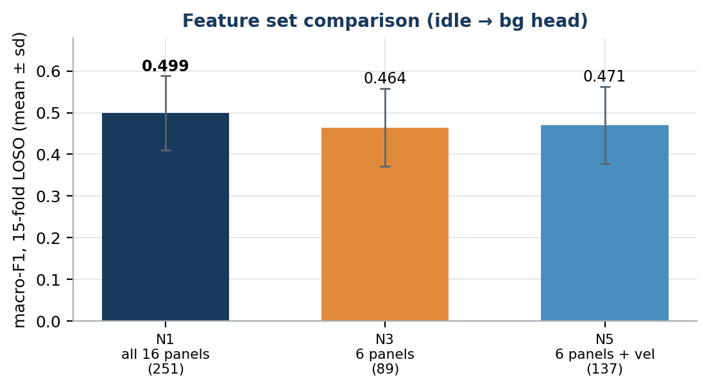
Figure 1. Macro-F1 over the six task classes, mean ± sd across 15 held-out subjects.
Arm | macro-F1 | idle F1 | progress MAE
N1 all 16 panels | 0.499 ± 0.089 | 0.621 | 23.5
N3 6 panels | 0.464 ± 0.093 | 0.612 | 24.2
N5 6 panels + velocity | 0.471 ± 0.093 | 0.622 | 23.7

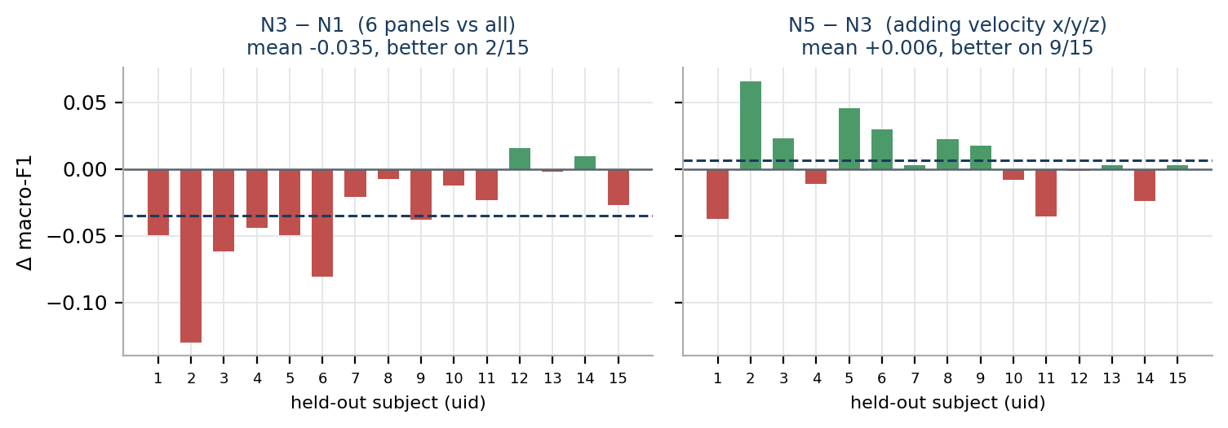
Figure 2. Per-subject differences. Every arm holds out the same 15 subjects, so the comparison is paired.
Comparison | Δ macro-F1 | Subjects improved | Wilcoxon p
N1 → N3 (reduce to 6 panels) | −0.035 | 2 / 15 | 0.0015
N3 → N5 (add velocity x/y/z) | +0.006 | 9 / 15 | 0.49
N1 → N5 (6 panels + velocity vs all) | −0.028 | 3 / 15 | 0.0026

Reading. The reduced set is reliably worse, not a noise effect: 13 of 15 subjects lose. Adding the per-axis velocity panels does not close the gap.
Per class
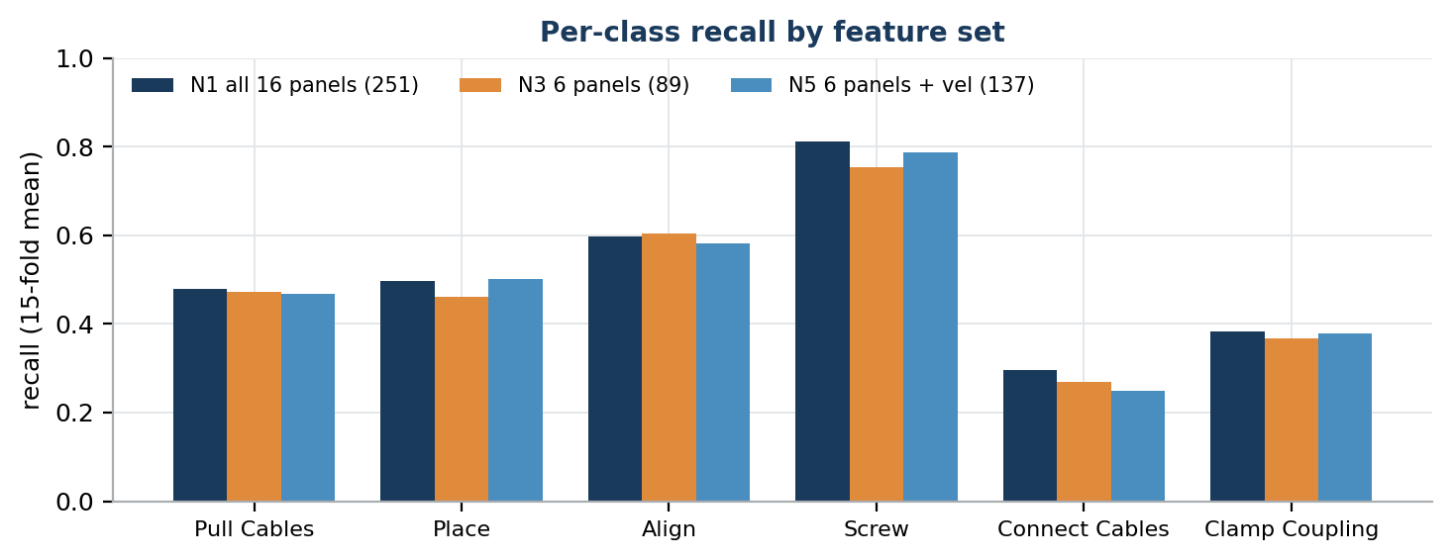
Figure 3. Recall per class, 15-fold mean.
Class | N1 | N3 | N5
Pull Cables | 0.48 | 0.47 | 0.47
Place | 0.50 | 0.46 | 0.50
Align | 0.60 | 0.60 | 0.58
Screw | 0.81 | 0.75 | 0.79
Connect Cables | 0.30 | 0.27 | 0.25
Clamp Coupling | 0.38 | 0.37 | 0.38

The losses from reducing the feature set concentrate on Screw (−0.06) and Place (−0.04), the two classes defined by motion rather than posture. Velocity partly restores both (Screw 0.79, Place 0.50) but costs Connect (0.25).
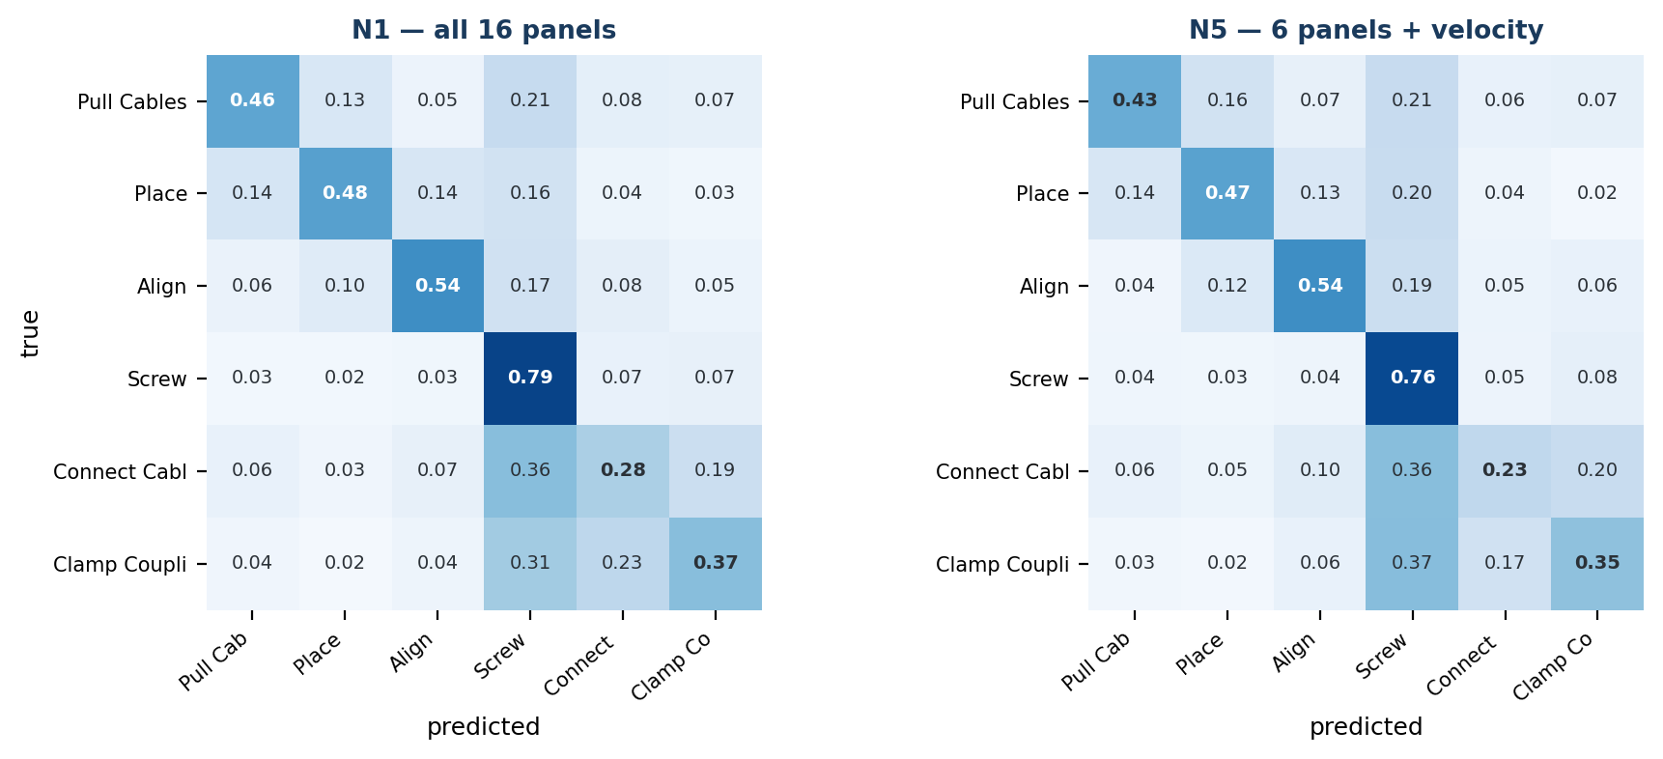
Figure 4. Confusion matrices pooled over all 15 held-out subjects, row-normalised.
The dominant error is unchanged across feature sets: Connect Cables, Clamp Coupling and Screw are confused with one another. All three are performed standing at the panel with the hands near chest height.
3. Why: which features the model uses
Each panel of the trained N1 models was shuffled across windows in turn, and the loss in F1 measured per class. A panel whose shuffling costs nothing is not being used.
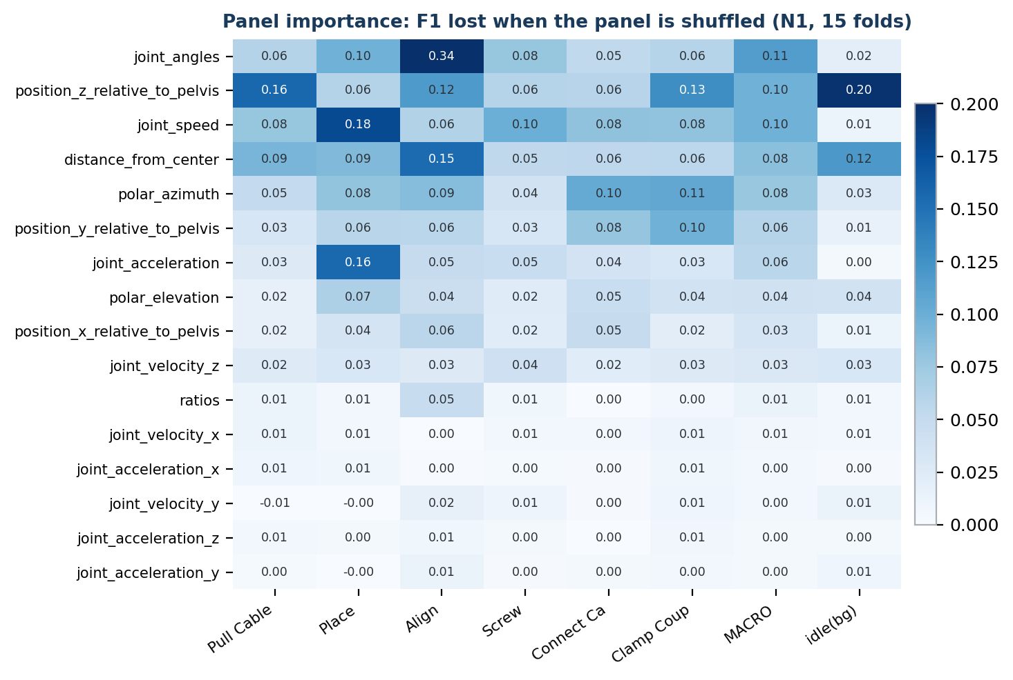
Figure 5. F1 lost when each panel is shuffled. Rows sorted by macro-F1 loss.
Magnitudes matter, per-axis components barely do. joint_speed (0.097) and joint_acceleration (0.057) are among the seven most-used panels. The six per-axis velocity and acceleration panels — 96 of the 251 input columns — each cost at most 0.028. This is why N5 does not recover N3’s loss: it adds the least-used panels while the reduced set still lacks the most-used ones.
Motion | Most-used features | Interpretation
Screw | speed, joint angles, height (z) | repetitive hand motion, fixed posture
Clamp | height (z), azimuth, depth (y) | where the hands are
Place | speed, acceleration, joint angles | a burst of motion upward
Align | joint angles (0.34), distance | arms-raised posture
Connect | azimuth, speed, depth (y) | hand direction relative to the body
Idle | height (z), distance | arms down, at rest

Body parts
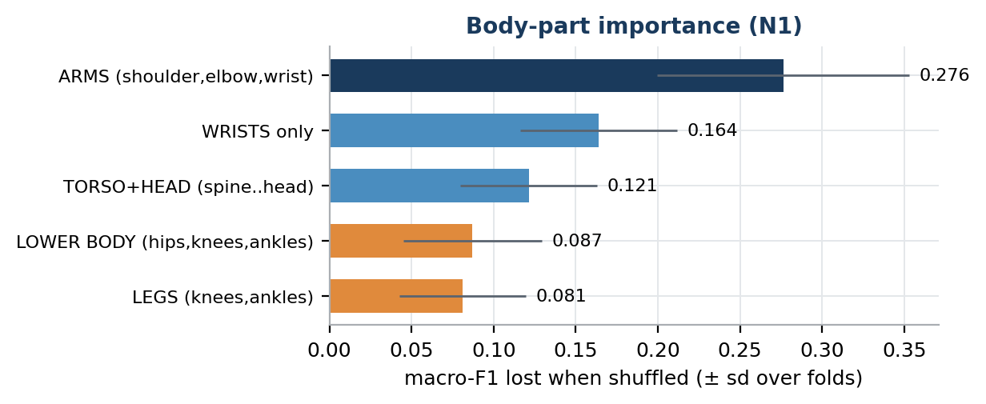
Figure 6. Macro-F1 lost when every feature of a body part is shuffled together.
The arms dominate (0.276), but the lower body is not negligible: shuffling hips, knees and ankles costs 0.087, about three-quarters of the torso and head. The legs matter most for Place (0.130), Clamp (0.113) and Connect (0.095) — the push uses the legs, and stance distinguishes the chest-height tasks. The lower body is therefore kept.
Individually each leg joint costs only 0.016–0.028: they are redundant with each other but not with the upper body.
4. Idle handling
A first evaluation showed the seventh-class arms far behind (N4 0.404 vs N3 0.464). That gap was a scoring artefact. The bg-head arms excluded idle frames from the task score and were never penalised when the bg head wrongly called a task frame idle; the seventh-class arms were. Both were therefore converted to the same seven-way decision and scored on every window.
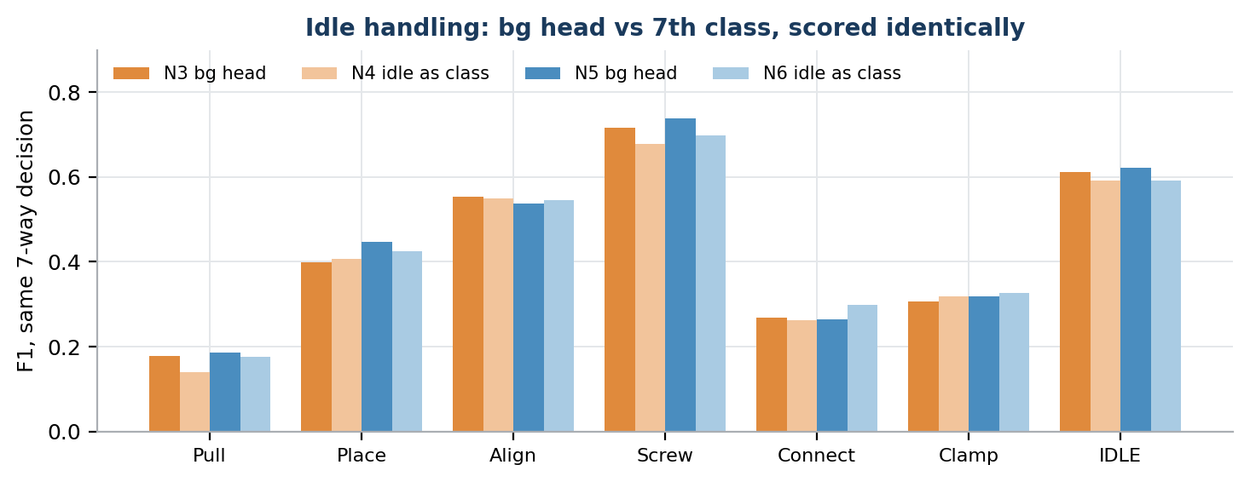
Figure 7. Seven-way F1 with identical scoring for both idle strategies.
Comparison | Δ six-task F1 | 7th-class arm better | Wilcoxon p
N3 (head) → N4 (class) | −0.011 | 4 / 15 | 0.12
N5 (head) → N6 (class) | −0.003 | 8 / 15 | 0.93

Neither difference is significant. Idle F1 is 0.61–0.62 for the head and 0.59 for the class. The separate head is kept because it is marginally ahead and lets the runtime tune the idle threshold independently of the task decision.
Pull Cables is weak in the seven-way view (F1 0.14–0.20). It is most often confused with idle: pulling cables is a low-motion, arms-down posture similar to standing at rest.
5. Recommendations
- Keep all 16 panels for now. The six-panel set loses 0.035 reliably.
- If a smaller input is required, reduce by importance, not by panel type. A seven-panel set chosen from Figure 5 (121 dims, including speed and acceleration magnitudes) is queued tonight as F1.
- Keep the lower body. It carries 0.087 macro-F1, concentrated on the weak classes.
- Keep idle as a separate head. Equivalent accuracy, more control at runtime.
- Add participants. Measured earlier: each additional real subject is worth about +0.011, and the curve has not saturated. No feature choice in this round moved the score by more than that of three subjects.
6. Next: tonight’s runs, and a deployment mismatch
The training data is 30 fps; the live loop feeds the model at about 10 Hz. The recurrent model counts samples, not seconds, so a 120-sample window covers 4 s in training but 12 s live, and each step is three times longer. Every number in this report is at 30 fps. A --stride option now trains at the live rate; S1 retrains N1 at 10 fps to measure the cost.
Arm | Tests
F1 | data-driven 7-panel set, 121 dims
C1 | Screw and Clamp Coupling weighted 2× in the loss
S1 | N1 retrained at 10 fps, 4 s window (40 samples)
S2 | 10 fps, 8 s window (80 samples)
S3 | S2 with the idle-head loss weight raised 0.2 → 0.5
L1 | LSTM with N1’s settings (runtime and team code use LSTM)

Two further settings are defined in frames rather than seconds and also differ live: velocity smoothing (0.3 s offline, 0.9 s live) and the MotionBERT clip (2.7 s offline, 8.1 s live). Fixing these requires regenerating the dataset at 10 fps.
7. Correction: how the idle label is made, and a labelling problem
An earlier draft described “No Related Task” as a human annotation and credited it for the rise in idle F1. That was wrong. Idle is derived: every frame no ELAN annotation covers is scored as idle, with the smoothing ramp placed inside the gap. The 0.51 and 0.62 figures are measured against two different definitions of idle and cannot be compared.
More importantly, the corpus used in this round (hrc_communication/other) was built by a labeller that removed Lift entirely. The annotation team’s current labeller (LSTM_HRC commit f30a14d) instead trims each Lift span to the part before Place or Align begins and keeps it as a class. Comparing the two on the same annotations:
 | commit f30a14d | other/ (this round)
Lift frames | 6.8% | 0.0%
Idle frames | 15.2% | 18.1%
Real lifting frames labelled idle | — | 41.6%

In the data this round trained on, a large share of picking up and raising the panel is labelled “nobody is working” — immediately before Place and Align, which is when the robot most needs to anticipate. The feature-set comparison is still valid, because all arms shared the same labels. The idle-related numbers are not reliable. The corpus has been relabelled with f30a14d (data_f30a14d/, features unchanged) and all further runs use it, starting with a new baseline, B0.
Appendix A: incidents during this round
- Memory exhaustion. The first N1 run started on the old data path, which materialised every overlapping window (28.4 GB requested on a 31.4 GB machine). It slowed from ~5 min to ~3–4 h per fold at fold 11. Windows are now gathered per batch (1.8 GB, bit-identical output) and N1 was rerun.
- Crash after training. N1 finished all 15 folds, then crashed printing its summary (a stale class name). The results were rebuilt from the 15 saved fold checkpoints and match the training log exactly (0.499 ± 0.089).
- Scoring artefact. Described in Section 4; corrected before reporting.
Appendix B: files
Path | Contents
bench/results/loso_N*.json | per-fold metrics and run configuration
bench/results/folds/N*_uid*.pth | trained weights, one per held-out subject
bench/eval_round1/<arm>/ | metrics.csv, confusion_matrix.csv, per_class.csv
bench/results/fair_idle_round1.json | seven-way comparison, per fold
bench/results/feat_importance_*.json | panel and joint importance, per fold
archive_round1_colleague/ | all of the above plus source code and MANIFEST.json

