Round 2 — Relabelled Corpus, Live Frame Rate, Export
Labels from LSTM_HRC commit f30a14d (Lift kept), first deployable model
ITECH M.Sc. Thesis · Recognition Layer · 28 September 2026 · 7 arms × 15-fold leave-one-subject-out
Summary
Round 1 found that its corpus labelled 41.6% of real lifting frames as idle. This round retrains on the same features relabelled with the annotation team’s current labeller (Lift kept as a class), tests the changes queued in Round 1, and exports the first model that can run in the live loop.
- Training at the live rate (10 fps) costs nothing: S1 vs B0 +0.007, better on 11 of 15 subjects (p = 0.17). The frame-rate mismatch identified in Round 1 can be removed without an accuracy penalty.
- A longer window helps: 8 s instead of 4 s at 10 fps, +0.018 (S1 → S2, 10 / 15, p = 0.035). S2 is +0.025 over the baseline, better on 13 of 15 subjects (p = 0.0003).
- Raising the idle-head weight to 0.5 gives no measurable gain: S2 → S3 +0.009, 7 / 15, p = 0.45; idle F1 unchanged (0.623 → 0.620).
- No effect: the data-driven 7-panel set (F1, −0.002), Screw/Clamp loss weighting (C1, +0.007) and the LSTM (L1, −0.008). None is significant.
- Exported: S3, macro-F1 0.499 ± 0.086. Chosen by a rule fixed before the runs: highest LOSO score among the 10 fps arms. S2 is statistically equivalent; the choice between them does not matter for accuracy.
1. Setup
Corpus: data_f30a14d/ — the Round 1 features (93 takes, 15 subjects), labels regenerated with LSTM_HRC commit f30a14d. Lift is trimmed to the part before Place/Align and kept as a class; idle (“No Related Task”) is every frame no annotation covers and goes to the separate bg head. Seven task classes.
Arm | Change from B0 | Rate | Window
B0 | baseline: all 16 panels (251 dims), GRU | 30 fps | 4 s (120)
F1 | 7 panels chosen by importance (121 dims) | 30 fps | 4 s (120)
C1 | Screw and Clamp Coupling weighted 2× in the loss | 30 fps | 4 s (120)
L1 | LSTM instead of GRU | 30 fps | 4 s (120)
S1 | every 3rd frame | 10 fps | 4 s (40)
S2 | every 3rd frame, 10 epochs | 10 fps | 8 s (80)
S3 | S2 + idle-head loss weight 0.2 → 0.5 | 10 fps | 8 s (80)

Common to all: peak-vector targets, mirror augmentation, pos_weight cap 2.0, best epoch chosen on two validation subjects, 15-fold leave-one-subject-out. Macro-F1 is over the seven task classes on windows whose true label is a task.
Not comparable with Round 1. Round 1 scored six classes on different labels. B0 (0.465) is the baseline for this round; Round 1’s 0.499 is not.
2. Results
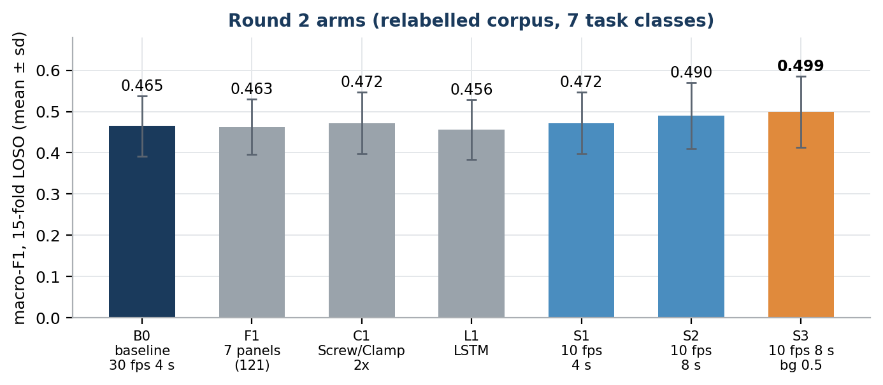
Figure 1. Macro-F1, mean ± sd across 15 held-out subjects. Orange: exported model.
Arm | macro-F1 | bal. acc. | idle F1 | lane AP | progress MAE
B0 baseline | 0.465 ± 0.074 | 0.479 | 0.612 | 0.509 | 24.2
F1 7 panels | 0.463 ± 0.067 | 0.482 | 0.607 | 0.516 | 24.1
C1 Screw/Clamp 2× | 0.472 ± 0.075 | 0.487 | 0.616 | 0.511 | 24.3
L1 LSTM | 0.456 ± 0.072 | 0.470 | 0.604 | 0.501 | 24.4
S1 10 fps, 4 s | 0.472 ± 0.075 | 0.485 | 0.605 | 0.517 | 24.0
S2 10 fps, 8 s | 0.490 ± 0.081 | 0.502 | 0.623 | 0.541 | 24.1
S3 S2 + bg 0.5 | 0.499 ± 0.086 | 0.514 | 0.620 | 0.559 | 24.1

Comparison | Δ macro-F1 | Subjects improved | Wilcoxon p
B0 → F1 (7 panels) | −0.002 | 4 / 15 | 0.60
B0 → C1 (class weights) | +0.007 | 8 / 15 | 0.45
B0 → L1 (LSTM) | −0.008 | 6 / 15 | 0.19
B0 → S1 (10 fps) | +0.007 | 11 / 15 | 0.17
S1 → S2 (8 s window) | +0.018 | 10 / 15 | 0.035
S2 → S3 (bg weight 0.5) | +0.009 | 7 / 15 | 0.45
B0 → S2 | +0.025 | 13 / 15 | 0.0003
B0 → S3 | +0.034 | 12 / 15 | 0.0034

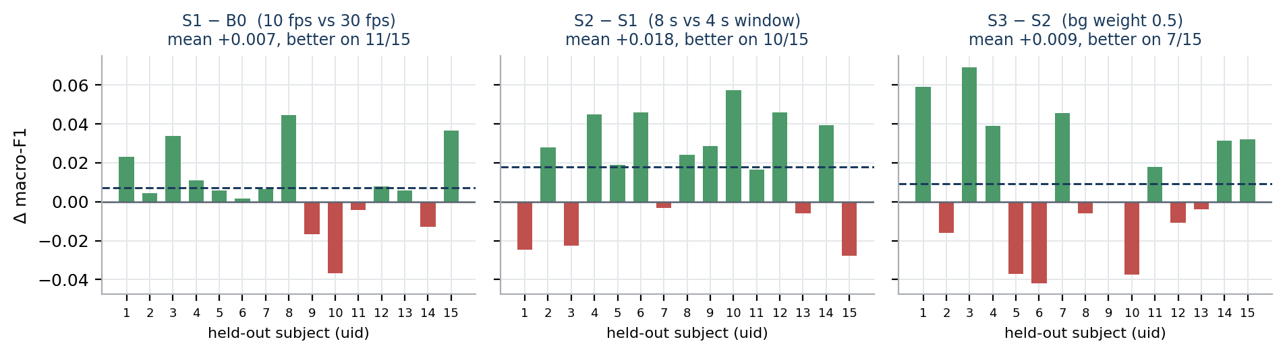
Figure 2. Per-subject differences along the 10 fps path. Same 15 held-out subjects in every arm, so the comparison is paired.
Reading. Only the window length reliably moves the score. At 10 fps an 8 s window is 80 recurrent steps — fewer than B0’s 120 — so the longer context comes at no extra runtime cost.
Per class
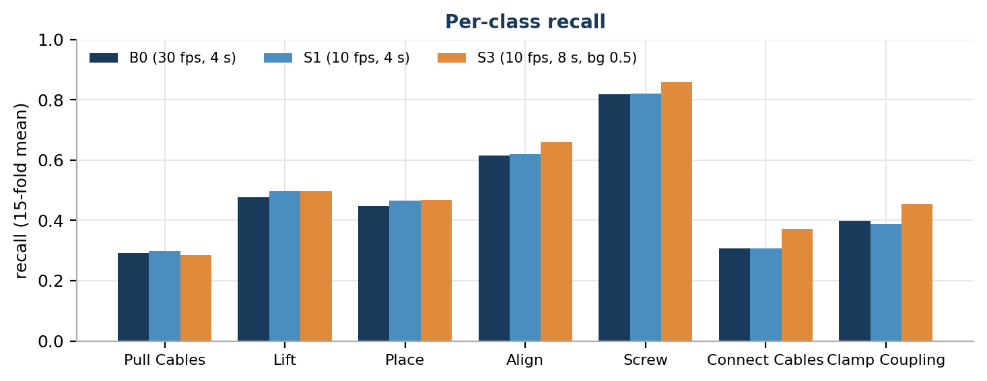
Figure 3. Recall per class, 15-fold mean.
Class | B0 | S1 | S2 | S3
Pull Cables | 0.29 | 0.30 | 0.31 | 0.28
Lift | 0.48 | 0.50 | 0.45 | 0.50
Place | 0.45 | 0.47 | 0.46 | 0.47
Align | 0.62 | 0.62 | 0.62 | 0.66
Screw | 0.82 | 0.82 | 0.85 | 0.86
Connect Cables | 0.31 | 0.31 | 0.38 | 0.37
Clamp Coupling | 0.40 | 0.39 | 0.44 | 0.45

The 8 s window’s gain is concentrated on Connect Cables (+0.07) and Clamp Coupling (+0.05) — the chest-height tasks Round 1 found the model confuses. Longer context helps separate them; loss weighting (C1) did not. Pull Cables remains the weakest class (0.28–0.33 in every arm).
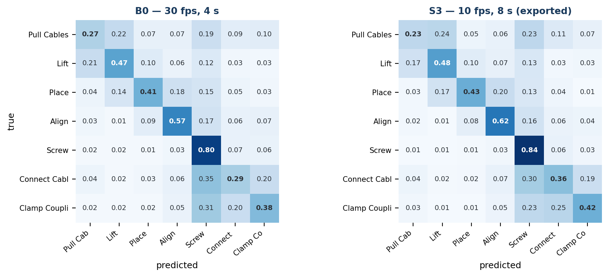
Figure 4. Confusion matrices pooled over all 15 held-out subjects, row-normalised.
Largest confusions in S3 (true → predicted): Connect Cables → Screw 0.30; Clamp Coupling → Connect Cables 0.25; Pull Cables → Lift 0.24; Pull Cables → Screw 0.23.
Lift is now learnable: recall 0.45–0.50 in every arm. In Round 1 the class did not exist and its frames were labelled idle.
3. Exported model
The export rule was fixed before the runs: the live loop runs at 10 Hz, so only S1–S3 are deployable, and the one with the highest LOSO macro-F1 is exported. That is S3. The deployed weights are not taken from any single fold:
- Stage 1: train on 13 subjects, choose the epoch count on subjects 2 and 7 → 4 epochs (validation macro-F1 0.448).
- Stage 2: retrain on all 15 subjects for 4 epochs (208,598 windows).
File (models/S3_10fps_8s_bg05/) | Contents
model_weights.pth | GRU state_dict, 251 inputs, 7 task classes
standardization.npz | mean and std per input column, with column names
standardization_by_panel.npz | same, grouped by panel (layout norm_feat_rlt.py reads)
feature_selection.json | panels, joints, column order, transforms, window 80 / stride 3
config.json | classes, heads, training settings, trigger, expected accuracy
model_bundle.pt | all of the above in one file
README.md | how to feed the model and read its outputs

The export pipeline was checked before the runs on a throwaway configuration: the model input rebuilt from a raw take using only the exported files matched the training pipeline exactly (max difference 0), and model outputs were identical.
Before it can run live
- Trigger threshold. The trigger formula was tuned on earlier models; config.json marks it unvalidated with no threshold. The event-level trigger evaluation must be re-run on this model.
- Runtime loader. recognition_manager.py still loads the 2-output AssistLSTM. The new model has four heads (task, progress, mistake, idle) and multi-label task scores (independent sigmoids, not softmax).
- Feed rate. The model expects one sample every 100 ms and an 80-sample (8 s) window.
4. Recommendations
- Deploy at 10 fps with an 8 s window. Matches the live loop, and is the only change this round that reliably improved accuracy.
- Keep all 16 panels and the GRU. The 7-panel set and the LSTM are no better. If a smaller input is needed, the 7-panel set costs nothing measurable (−0.002).
- Drop class weighting and the idle-weight change as levers. Neither moved the score beyond noise.
- Next: test longer windows (12–16 s at 10 fps), since the gain from 4 s to 8 s shows no sign of flattening yet; and regenerate the dataset at 10 fps so velocity smoothing and the MotionBERT clip match the live loop (Round 1, Section 6).
- Add participants. Subject-to-subject spread (sd 0.086) is still larger than every effect measured here.
Appendix: files
Path | Contents
bench/results/loso_<arm>.json | per-fold metrics and run configuration
bench/results/folds/<arm>_uid*.pth | trained weights, one per held-out subject
bench/eval_round2/<arm>/ | metrics.csv, confusion_matrix.csv, per_class.csv
bench/logs/<arm>.log, deploy.log | training and export logs
models/S3_10fps_8s_bg05/ | exported model
archive_round2/ | all of the above plus source code, figures and MANIFEST.json

