

**Tribhuvan University**

**Faculty of Humanities and Social Sciences**

**Online Food Ordering System**

**A PROJECT REPORT**

**Submitted To**

**Department Of Computer Applications**

**Ratna Rajyalaxmi Campus**

**Pradarshanimarga, Kathmandu**

In partial fulfillment of the requirements for the Bachelors in Computer Application

**Submitted By**

**Lokendra Joshi (Reg no : 6-2-40-29-2020)**

Under the Supervision of

**Mr. Ananda KC**

August 2024



**Tribhuvan University**

**Faculty of Humanities and Social Sciences**

**Ratna Rajyalaxmi Campus**

**SUPERVISOR RECOMMENDATION**

I hereby recommend that this project prepared under my supervision by **“Lokendra Joshi”** entitled **“ONLINE FOOD ORDERING SYSTEM”** in partial fulfillment of the requirements for the degree of Bachelor of Computer Application is recommended for the final evaluation.

……………………

**Mr. Ananda KC**

**SUPERVISOR**



**Tribhuvan University**

**Faculty of Humanities and Social Sciences**

**Ratna Rajyalaxmi Campus**

**Pradarshani Marga, Kathmandu**

**LETTER OF APPROVAL**

This is to certify that this project prepared by **“Lokendra joshi”** entitled **“Online Food Ordering System”** in partial fulfillment of the requirements for the degree of Bachelor in Computer Application has been evaluated. In our opinion it is satisfactory in the scope and quality as a project for the required degree.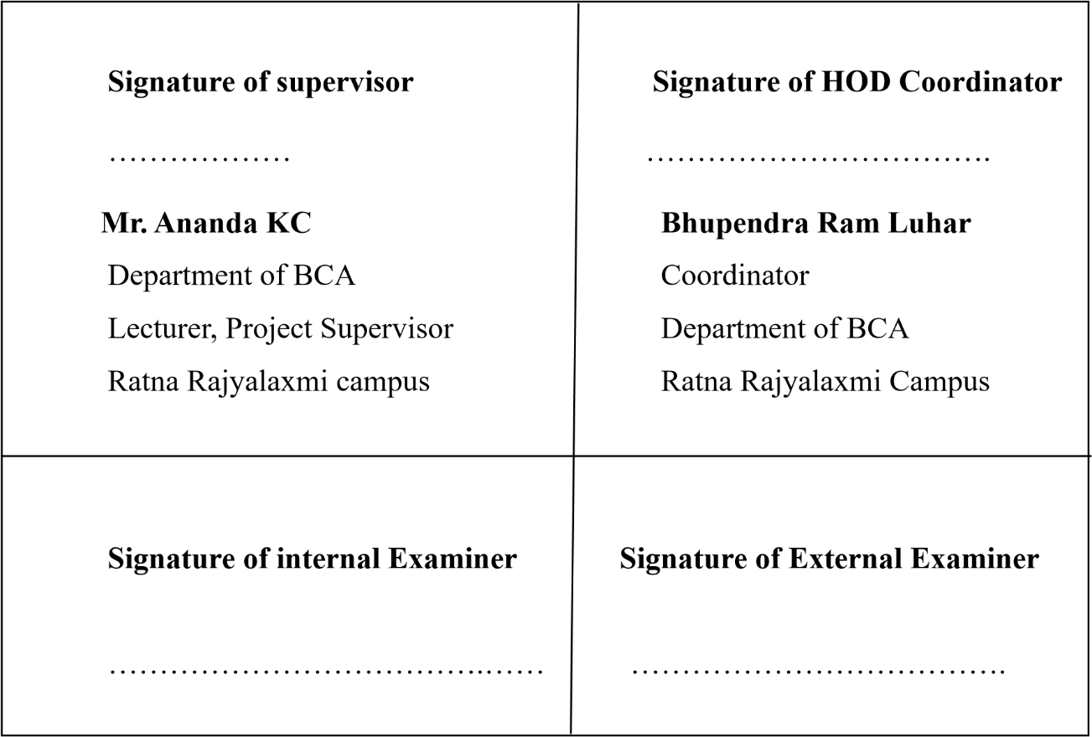

# ACKNOWLEDGEMENT

The project work presented in this report has been carried out and presented at Ratna Rajya Laxmi Campus, Faculty of Humanities and Social Sciences Tribhuvan University of Technology as a part of Bachelors of Arts in Computer Application. Project is a test of not only technical skills but also team work and performance under various constraints. This journey cannot be successfully accomplished without help from experts. Furthermore, we would like to thank our lecturers of the Department of Computer Application for their kindness in sharing their knowledge with us which in different ways has helped us in coming up with this project and being there for us when we needed them, our friends who have always been there to support us and our respondents who gave us feedbacks on improving our project work.

We will be ever grateful to our supervisor **Mr. Ananda KC** without whose guidance, this project would not have become successful.

We are also grateful to our department coordinator **Mr. Bhupendra Ram Luhar**. Finally, our greatest appreciation and love goes to our families, friends and mentors and for sure this would not have happened without their unconditional love, care and support.

# ABSTRACT

An online food ordering system revolutionizes the way customers interact with restaurants by offering a seamless, convenient, and efficient platform for ordering meals. This digital solution enables users to browse menus, customize orders, and make payments from the comfort of their homes or offices. It incorporates features like real-time order tracking, customer reviews, and personalized recommendations, enhancing the overall dining experience. For restaurants, it streamlines operations by automating order processing, reducing errors, and optimizing delivery routes. The system also provides valuable data analytics, helping businesses understand customer preferences and improve service. In the current digital age, an online food ordering system is essential for meeting the demands of tech-savvy consumers, fostering customer loyalty, and staying competitive in the dynamic food industry.Moreover, it supports contactless delivery options, which have become increasingly popular in recent times. The system is scalable, allowing restaurants of all sizes to adopt it and grow their customer base. Integration with mobile apps further enhances accessibility, making it easy for customers to place orders on the go. With multi-language support and various payment gateways, the system ensures a user-friendly experience for diverse customer demographics.

***Keywords: e-commerce, food ordering system.***

# Table of Contents

**ACKNOWLEDGEMENT i**

**ABSTRACT ii**

**Table of Contents iii**

**CHAPTER 1: INTRODUCTION 1**

1.1 Introduction 1

1.3 Objectives 2

1.4. Scope and Limitations 2

1.5.Development Methodology 3

1.6 Report Organization 4

**CHAPTER 2 5**

**BACKGROUND STUDY AND LITERATURE REVIEW 5**

2.1 Background Study 5

2.2 Literature Review 5

**CHAPTER 3: SYSTEM ANALYSIS AND DESIGN 8**

3.1 System Analysis 8

3.1.1 Requirement Analysis 9

3.1.3 Object Modeling Object and Class Diagram 12

3.1.4 Dynamic modeling State and Sequence Diagram 13

3.1.5 Process Modeling Activity Diagram 14

3.2.1 Refinement of class and Object Diagram 15

3.2.3 Deployment Diagram 17

3.2.4 Algorithm Explanation 18

**CHAPTER 4: IMPLEMENTATION AND TESTING 20**

4.1 Implementation 20

4.1.1 Tools Used (CASE tools, Programming languages, Database platforms) 20

4.2.2 Test case for system testing 24

**CHAPTER 5: CONCLUSION AND FUTURE RECOMMENDATIONS 26**

5.1 Conclusion 26

5.2 Future Recommendations 26

**References 27**

**APPENDICES 28**

# CHAPTER 1: INTRODUCTION

## **Introduction**

The development of an online food ordering system involves integrating various technologies to create a robust, efficient, and user-friendly platform. This system allows customers to order food from their favorite restaurants through a website or mobile application, enhancing convenience and accessibility. The backend development of this system employs Java, a versatile programming language known for its reliability and performance. SQL is used for database management, ensuring secure and efficient storage and retrieval of customer, menu, and order data.

The system is built using the Spring Boot framework, a powerful tool that simplifies the creation of stand-alone, production-grade Spring-based applications. Spring Boot's extensive libraries and features make it easier to develop and deploy the backend services required for the online food ordering system. Apache Server is used to host the application, ensuring it can handle numerous concurrent users and provide a seamless experience. The front end is developed using HTML and CSS, which are essential for designing an intuitive and responsive user interface.

By leveraging these technologies, the online food ordering system can deliver a seamless user experience from browsing menus to completing transactions. The combination of Java, SQL, and Spring Boot ensures a reliable and scalable backend, while Apache Server provides the necessary infrastructure for hosting. HTML and CSS contribute to a visually appealing and easy-to-navigate front end, making the entire process of ordering food online efficient and enjoyable for customers.

* 1. **Problem statement**

1. Some of the major problems reported by the customers surveyed revolved around late deliveries
2. because of network problem o incorrect orders being delivered due to communication problem.
3. orders not being delivered at all, rude customer service.
4. cold food being delivered, and the driver requiring a lot of guidance to find the delivery location.
5. Sometime payment issue is occurred.

## **Objectives**

Main Objectives of an Online Food Ordering System:

• To enable customers to order their desire food through online.

• To make all the work easier and computerized.

• Chouse different categories food and order.

## **1.4. Scope and Limitations**

The scope of an online food ordering website system encompasses providing a seamless platform for users to browse restaurant menus, place orders, and make payments online. It aims to enhance customer convenience by offering various features such as real-time order tracking, customer reviews, and personalized recommendations. Additionally, it supports restaurant operations by automating order processing, reducing manual errors, and optimizing delivery routes. The system also facilitates better inventory management and offers valuable insights through data analytics, helping businesses understand customer preferences and improve services. However, there are limitations to consider.

Dependence on Internet Connectivity: The system's functionality is heavily reliant on a stable internet connection, which may not be available in all areas.

Technical Issues: The website may face technical glitches, server downtimes, or cybersecurity threats, which can disrupt service and impact user experience.

User Accessibility: Not all customers may be comfortable using online systems, particularly older adults or those without access to digital devices.

## **1.5.Development Methodology**

Figure 1. 1: Iterative Waterfall model

The development of our system follows the Iterative Waterfall model. The iterative waterfall model is a software development approach that combine the sequential nature of the waterfall model with iterative and incremental development practices. It aims to address some of the limitations of the traditional waterfall model by allowing for feedback, flexibility, and continuous improvement throughout the development process. In the Iterative waterfall model, the software development lifecycle is divided into multiple iterations or phases. Each iteration follows a mini-waterfall approach, where requirements are gathered, design is created, implementation is carried out, and testing is conducted. At the end of each iteration, there is an evaluation and feedback phase, where stakeholder provide input and suggestions for improvement. Based on the feedback received, changes, enhancements, and bugs fixes are incorporated into subsequent iterations. The process of requirement gathering, design implementation, testing, and evaluation is repeated for each iteration.

## **1.6 Report Organization**

Report Organization for Online Food Ordering System

The report is organized into five chapters, which are outlined as follows:

**Chapter 1:** Introduction

This chapter provides a brief introduction to the online food ordering system, including the statement of the problem, objectives, scope, and limitations. It sets the foundation for the report by explaining the necessity and goals of the system.

**Chapter 2:** Background Study and Literature Review

This chapter includes a comprehensive review of previous work related to online food ordering systems and similar projects. It summarizes various studies, research papers, and existing solutions to provide a theoretical background and context for the current project.

**Chapter 3:** System Analysis and Design

This chapter covers the detailed analysis and design of the system. It includes different feasibility analyses, the designed system architecture, system flow diagrams, and data flow diagrams. This section explains the conceptual and technical framework of the system.

**Chapter 4:** Implementation and Testing

This chapter details the implementation process and the tools used in developing the online food ordering system explanation of the testing procedures, including test cases, results, and analysis.

**Chapter 5:** Conclusion and Future Recommendations This chapter summarizes the outcomes of the system, providing a conclusion to the project.

# CHAPTER 2

# BACKGROUND STUDY AND LITERATURE REVIEW

# 2.1 Background Study

The online food ordering system has emerged as a significant innovation in the e-commerce sector, driven by advancements in technology and changing consumer preferences. The evolution of the internet and mobile technologies has made it possible for consumers to access a variety of food options with just a few clicks. Studies show that the convenience, time-saving benefits, and personalized experiences offered by online food ordering systems are major factors contributing to their widespread adoption. Previous research has highlighted the critical role of user interface design, payment security, and reliable delivery services in enhancing customer satisfaction. Additionally, the integration of data analytics and AI has allowed businesses to offer personalized recommendations, further improving user engagement. The COVID-19 pandemic accelerated the shift towards online food ordering, as people sought safer alternatives to dining out. However, challenges such as maintaining food quality during delivery, managing logistics, and ensuring cybersecurity remain pivotal areas of focus for continuous improvement and innovation in this domain.

## **2.2 Literature Review**

The evolution of online food ordering systems has been extensively documented in the literature, reflecting the rapid technological advancements and changing consumer behaviors in the digital age. Early studies focused on the transition from traditional phonebased orders to web-based platforms, highlighting the convenience and efficiency brought by digital interfaces. Researchers emphasized how these systems reduced the margin for human error and provided a streamlined process for both customers and restaurants. Key factors such as user interface design, ease of navigation, and the inclusion of detailed menus with customization options were identified as crucial elements for successful online ordering platforms.

Subsequent research delved into the impact of mobile technologies on food ordering systems. With the proliferation of smartphones and mobile applications, the scope of online food ordering expanded significantly. Studies revealed that mobile apps enhanced user engagement through features like push notifications, loyalty programs, and real-time order tracking. The integration of GPS technology also improved delivery accuracy and efficiency. Researchers noted a significant increase in user satisfaction and repeat business due to the convenience and personalized experience offered by mobile food ordering apps.[1]

The role of data analytics and artificial intelligence (AI) in online food ordering systems has also been a prominent topic in recent literature. By analyzing customer data, businesses can gain insights into consumer preferences and purchasing patterns, allowing them to tailor their offerings and marketing strategies. Furthermore, predictive analytics helps in inventory management and demand forecasting, thereby optimizing supply chain operations and reducing food wastage.[2]

An online food ordering system has become an essential tool in the modern food service industry, streamlining the process of ordering food through web and mobile applications. Recent literature highlights its significance in enhancing customer convenience, improving operational efficiency, and expanding market reach for restaurants. Such systems integrate user authentication, shopping cart functionality, and order management, offering a seamless experience for both users and businesses. Studies emphasize the role of user-friendly interfaces, personalized recommendations (e.g., collaborative filtering), and secure payment gateways as crucial components of a successful platform. Furthermore, non-functional requirements like performance, scalability, and security play a vital role in ensuring a robust system that meets the growing demands of the food service market. Despite the numerous advantages, several challenges associated with online food ordering systems have been highlighted in the literature. Issues such as cybersecurity, data privacy, and the reliability of delivery services are critical concerns.[3]

An online food ordering system has become an essential tool in the modern food service industry, streamlining the process of ordering food through web and mobile applications. Such systems integrate user authentication, shopping cart functionality, and order management, offering a seamless experience for both users and businesses. Studies emphasize the role of user-friendly interfaces, personalized recommendations (e.g., collaborative filtering), and secure payment gateways as crucial components of a successful platform. Furthermore, non-functional requirements like performance, scalability, and security play a vital role in ensuring a robust system that meets the growing demands of the food service market.[4]

**i)Foodmandu**

One of the pioneers of the online food delivery business in Nepal, Foodmandu has become a household name for food ordering, especially in Kathmandu. It offers a curated list of restaurants, allowing users to order from high-end as well as local eateries. The platform also focuses on providing excellent customer service and timely delivery. Foodmandu’s unique selling point is its inclusion of popular local foods, bringing Nepalese culinary options to the digital marketplace.

**ii) Zomato**

Zomato is one of the leading food delivery services globally, offering an online platform where users can search for restaurants, browse menus, place orders, and get food delivered to their location. It has grown to become a major player due to its user-friendly interface, extensive restaurant partnerships, and user reviews system. Zomato also offers recommendations based on customer preferences, leveraging data-driven algorithms. The platform has expanded into new services, including restaurant reviews, food delivery, and subscription models for discounts and perks.

**iii)PathaoFood(Nepal)**  
Pathao Food is a food delivery service integrated into the Pathao app, a Nepalese platform initially known for ride-hailing. It allows users to order food from a variety of local restaurants in Nepal, offering a convenient way to access food from home. With a focus on local cuisine, Pathao Food has grown in popularity, especially in urban areas like Kathmandu. The app provides real-time tracking and easy online payment options. It stands out for supporting smaller, local businesses and contributing to the digitalization of the food sector in Nepal.

**iv)Bhoj**  
Bhoj is a popular food delivery app in Nepal, operating mainly in Kathmandu, Pokhara, and other major cities. The platform offers users the ability to order food from local restaurants and cafes, with features like real-time tracking and various payment methods.

**v)Foodpanda**  
Foodpanda operates in several countries, offering an online platform for users to order food from local restaurants. It emphasizes a wide range of restaurant options and quick delivery, often targeting urban customers. Its interface is straightforward, allowing users to search by cuisine or specific restaurant, view ratings, and complete payments online.

# CHAPTER 3: SYSTEM ANALYSIS AND DESIGN

## **3.1 System Analysis**

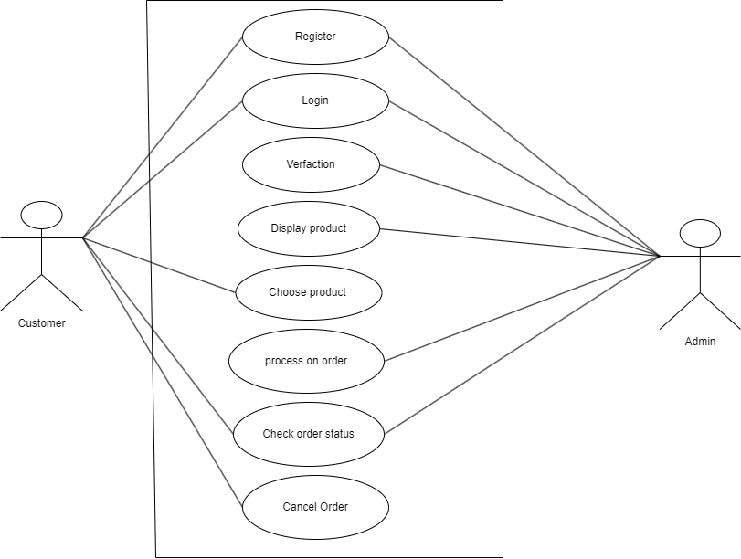The system analysis phase of the online food ordering system involves a comprehensive examination of functional requirements, user roles, and system interactions. It includes defining use cases, identifying system constraints, and specifying data flows between users, restaurants, and delivery services. This phase aims to establish clear objectives for system performance, scalability, and security, laying the groundwork for effective system design and development.

*Figure 3. 1 Use Case Diagram of Online food ordering System*

## **3.1.1 Requirement Analysis**

Requirement analysis is a crucial step in determining the success of a system or software project. Requirements are typically divided into two categories:

1)Functional Requirements This section provides an overview of the system's core functional modules:

User Module: This module allows customers to register, log in, browse food items, add items to their cart, place orders, track delivery status, and leave reviews.

Admin Module: This module enables administrators to manage user accounts, food items, orders, and deliveries, and handle system settings and reports.

2)Non-Functional Requirements:

The non-functional requirements ensure the system performs well and offers a great user experience. Key non-functional aspects include:

Performance and Response Time: The system should respond quickly to user actions like browsing the menu, placing orders, and processing payments. Pages must load quickly, and order-related actions must be processed without significant delays to prevent user frustration.

Scalability: The system must be able to handle high user traffic, especially during peak times like holidays or special events. It should scale efficiently, ensuring smooth functionality without performance degradation as the number of users or orders increases.

Security and Privacy: Strong security protocols should be in place to safeguard user data, payment details, and other sensitive information. Encryption must be used for data transmission, and authentication and authorization mechanisms should ensure that only authorized users can access and modify the system.

This structure should meet the needs of your food ordering system while ensuring high performance and security.

# 

**3.1.2 Feasibility Analysis**

**i. Technical Feasibility**

This aspect evaluates whether the technology and resources needed to develop the food ordering system are available and practical. Key considerations include:

* The availability of skilled developers proficient in relevant programming languages, frameworks, and tools.
* Compatibility with the organization's existing systems, ensuring seamless integration.
* The feasibility of incorporating third-party tools or APIs, such as payment gateways, delivery tracking systems, and mapping services for order delivery.

**ii. Economic Feasibility**

Economic feasibility focuses on the cost-effectiveness of developing and maintaining the food ordering system. This includes:

* Estimating initial development costs, including software, hardware, and human resources.
* Ongoing operational expenses, such as server maintenance, security measures, and updates.
* Conducting a cost-benefit analysis to evaluate potential returns, such as increased sales, improved customer satisfaction, and reduced operational costs, ensuring the benefits outweigh the costs.

**iii. Operational Feasibility**

Operational feasibility examines whether the food ordering system aligns with the organization’s operational workflows and goals. Key factors include:

* Assessing the impact on existing business processes, such as order fulfillment, inventory management, and customer service.
* Ensuring that the staff can efficiently adapt to new processes introduced by the system.
* Determining if any restructuring or additional training is necessary to ensure a smooth transition and optimal system usage.

**iv. Schedule Feasibility**

Schedule feasibility analyzes whether the food ordering system can be developed and deployed within the desired timeframe. Key considerations include:

* Establishing a clear project timeline with specific milestones, such as system design, development, testing, and deployment phases.
* Identifying potential delays and risks, such as resource availability, third-party dependencies, or regulatory compliance.

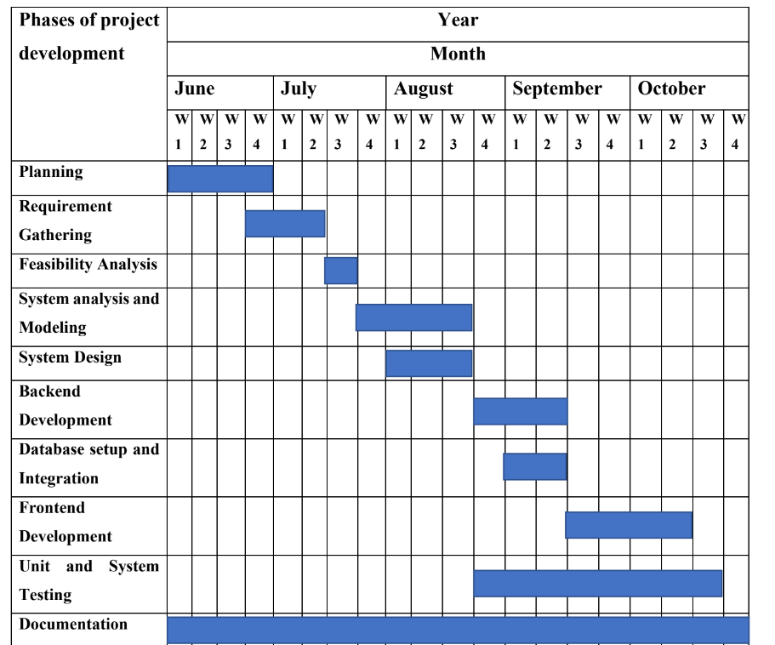 **Gantt Chart of Online Food Ordering System**

*Figure 3.2 Gantt Chart of Online Food Ordering System*

### **3.1.3 Object Modeling Object and Class Diagram**

In the object and class diagram, entities such as "Customer," "Order," "Food Item," "Address," and "Payment" are represented as classes, each with their respective attributes and methods. For instance, the "Customer" class might have attributes like "Customer ID" and "Name," while the "Order" class includes attributes like "Order Date" and methods for managing orders. Relationships between these classes are depicted using lines, with multiplicity indicators showing how many instances of one class are associated with another. This diagram helps to model the structure and interactions within the food ordering system, providing a clear visual representation of data flow and object relationships.

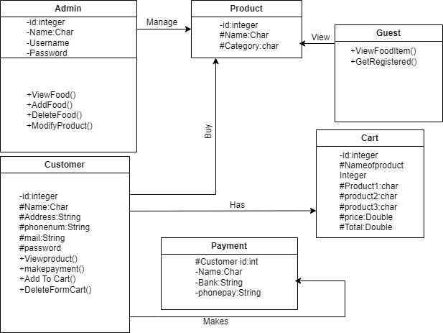

*Figure 3.3 Object Modeling class Diagram of online food ordering system*

### **3.1.4 Dynamic modeling State and Sequence Diagram**

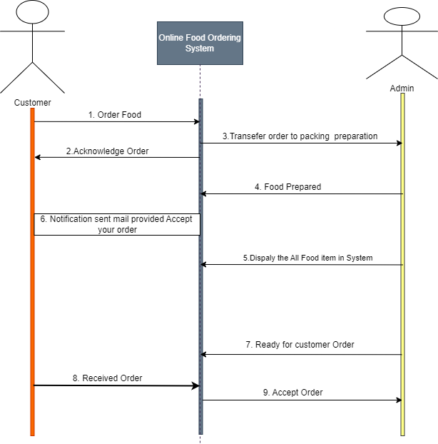The state and sequence diagrams for the food ordering system depict the dynamic behavior, showing how the system transitions between states (e.g., "Order Placed" to "Order Delivered") and the sequence of interactions between objects like Customer, Order, and Payment Gateway during the ordering process.

*Figure 3.4 Sequence diagram of Online Food Ordering System*

### **3.1.5 Process Modeling Activity Diagram**

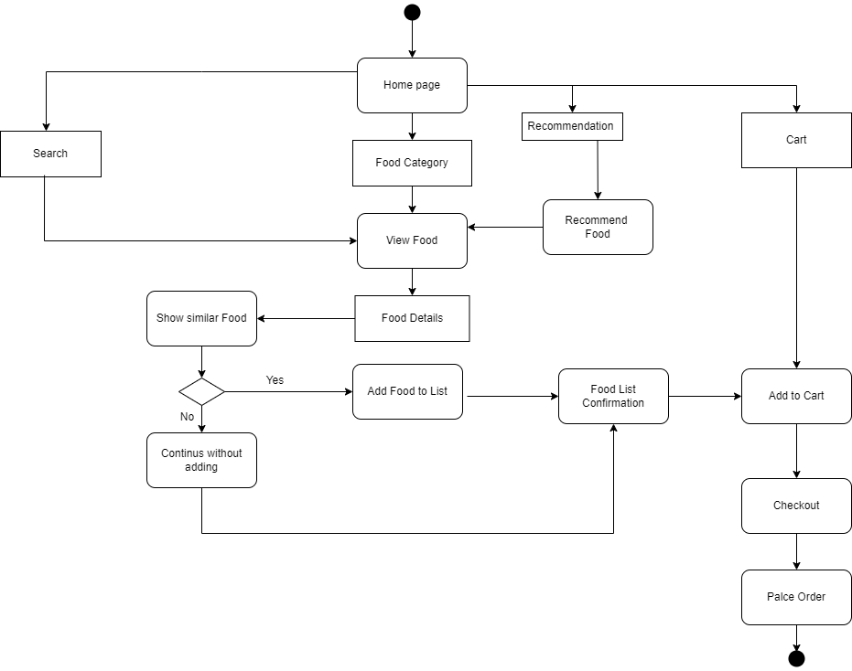The activity diagram for the online food ordering system visually maps the step-by-step process of actions, from browsing the menu and placing an order to payment processing and order confirmation, capturing the flow of control between system activities.

*Figure 3.5 Activity Diagram of Online Food Ordering System*

**3.2 System design**

in the object modeling approach, the system design includes architectural design, class and object relationships, database schema design, user interface design, and object interaction diagrams, as illustrated below:

### **3.2.1 Refinement of class and Object Diagram**

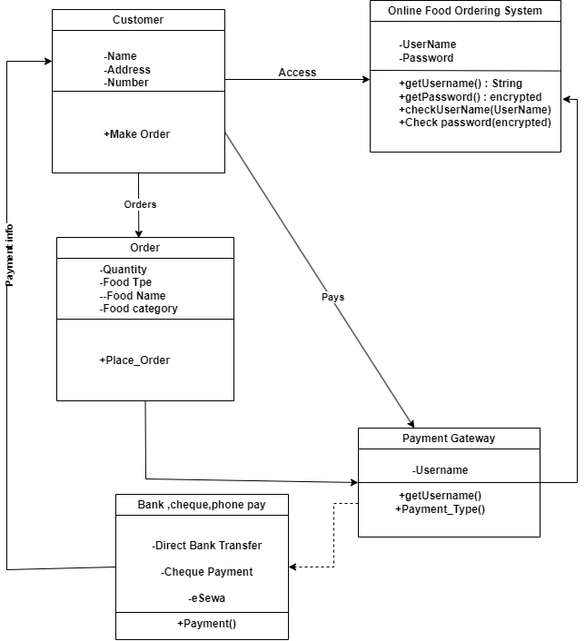The refinement of the class and object diagram for the online food ordering system involves detailing class attributes, methods, and relationships more precisely. For instance, the "Customer" class may include refined attributes like "email" and "loyaltyPoints," while the "Order" class might include methods for "calculateTotal" and "updateStatus." Additionally, relationships between classes such as "Order" and "Food Item" are refined with specific cardinalities and navigability to better represent real-world interactions.

*Figure 3.6 Refinement of class and Object Diagram*

**3.2.2 Component Diagram**

The component diagram for an online food ordering system illustrates the interaction between key components such as the "User Interface," "Order Processing," "Payment Gateway," and "Database." The "User Interface" component handles user inputs for browsing menus and placing orders, while "Order Processing" manages order validation and preparation. The "Payment Gateway" processes transactions, and the "Database" stores information on customers, food items, orders, and payments. The "Customer Order" component handles the submission and management of customer orders, interfacing with both the "Order Processing" and "Database" components. The "Security" component ensures secure data transmission and authentication, integrating with the "Payment Gateway" to safeguard sensitive payment information.

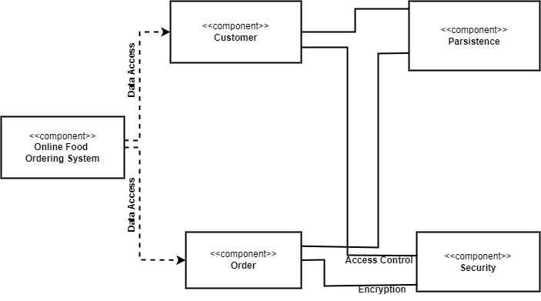

*Figure 3.7 Component Diagram of Online food ordering system*

### **3.2.3 Deployment Diagram**

The deployment diagram for an online food ordering system showcases the physical architecture of the system, including the distribution of software components across various hardware nodes. Typically, it includes nodes such as the "Client Device," where users access the system via web or mobile applications, and the "Web Server," which hosts the user interface and business logic. The "Application Server" handles order processing, authentication, and communication between components, while the "Database Server" stores persistent data, such as customer information, orders, food items, and payment details. Additionally, a "Payment Gateway Server" is deployed for handling secure financial transactions, and a "Firewall" ensures security between the servers and external networks. This diagram helps visualize the overall infrastructure and deployment strategy.

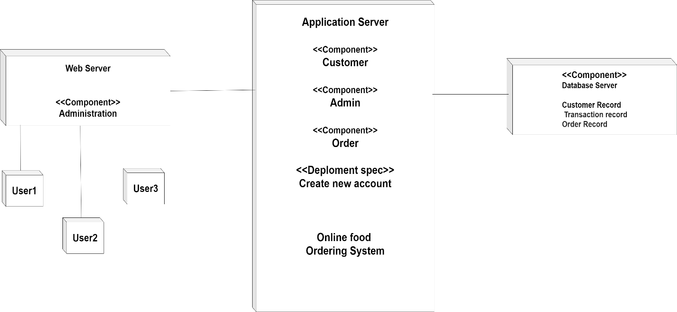

*Figure 3.9 Deployment Diagram of online food ordering system*

### **3.2.4 Algorithm Explanation**



The **Category-Based Recommendation Algorithm** The Category-Based Recommendation Algorithm is an unsupervised learning approach, as it does not involve a labeled dataset for training. Instead, it uses a rule-based logic to make recommendations based on product categories in the user's cart. This algorithm focuses on filtering products by category similarity rather than predicting based on historical data or learning from a labeled dataset, which is typical of unsupervised approaches. To implement the Category-Based Recommendation Algorithm described in create a stepwise breakdown of the algorithm and implement a Java-based function to carry it out. Here's the structured approach.

Reference for Recommendation Algorithms:

Author: Ricci Francesco

Book Title: "Recommender Systems Handbook"

This book offers a comprehensive overview of recommendation algorithms, including collaborative filtering, content-based, and hybrid systems. It provides an in-depth exploration of category-based and other algorithms in recommendation systems.

Website: Towards Data Science

This website contains numerous articles and tutorials on implementing recommendation algorithms, including category-based and collaborative filtering algorithms. It covers both theory and practical implementation in various programming languages like Python and Java.

Stepwise Breakdown of the Category-Based Recommendation Algorithm:

i)Identify Categories in the User's Cart

ii)Create a List of Products by Category

iii)Filter Products Based on Category Similarity

iv)Rank Products by Category Type

v)Generate a Recommendation List

Here is the flowchart illustrating the **Category-Based Recommendation Algorithm**

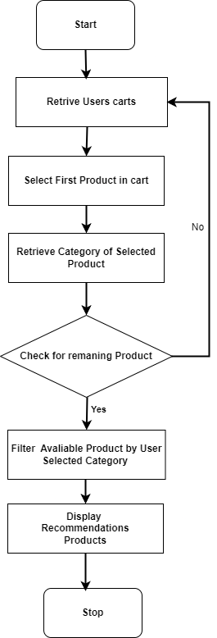

*Figure 3.10 flowchart of Category-Based Recommendation Algorithm*

# CHAPTER 4: IMPLEMENTATION AND TESTING

# 4.1 Implementation

The implementation phase involves the application of the design specifications done before. The implementation involves coding of the system designs if this project, systems testing and live running.

In the testing phase, the login functionality is thoroughly validated for both admin and user roles. For admin login, tests ensure proper access control and the ability to manage the platform. User login and registration are tested to confirm that account creation, authentication, and profile management work seamlessly. The add-to-cart feature is tested to verify that items can be successfully added, updated, and removed. Lastly, the place order functionality is tested to ensure orders are placed accurately, with proper processing of payments and order confirmations.

## **4.1.1 Tools Used (CASE tools, Programming languages, Database platforms)**

Diagramming tools such as draw.io, chart, and Dia were used for the graphical representation of data and systems. These tools helped create flowcharts, object and class digram , component digram , Gantt charts, and more. MS Word was utilized for documentation purposes. Spring Suite 4 was write, edit, and compile code. HTML, Java Spring boot framework used, CSS, and Bootstrap were used to develop the web application. MySQLyog was used to design and manage the database for data storage.

**4.1.2 Implementation Details of Modules**

**i)Admin**

The admin module is responsible for overseeing the entire application, providing administrative capabilities and control over system operations. The main features typically include.

User Management: Admins can view, edit, and delete customer profiles as necessary.

Order Management: Admins can view order histories, track order statuses, and manage any issues related to customer orders.

Product Management: Admins have the ability to add, update, or remove products available for customers to order.

**ii)Customer**

The customer module allows customers to register, log in, and manage their personal profiles within the system. It provides the following capabilities.

Account Creation: Customers can register with their personal details, such as name, email.

Order: Customers purchases food and re-order food item.

Cart Management: Customers can add, remove, and modify items in their cart before placing an order.

**iii)Customer Login**

The Customer Login module provides a secure way for registered customers to access the application.

**iv)Order**

The Order module handles all aspects of order placement, tracking, and processing. Key features include.

Order Placement: Allows customers to place orders by selecting items from their cart.

Order Management for Admin: Enables admin access to monitor, modify, or cancel orders if necessary.

**v)Admin Dashboard Panel**

User Management Interface: A centralized view for managing customers and other users, including access to add, edit, and delete customer.

Product Management Interface: A section dedicated to adding, updating, or removing products, as well as managing inventory levels.

Order Management Dashboard: Provides an overview of orders, with options for tracking status, resolving issues, and managing cancellations or refunds.

Table 4.1: Test Case 1-Registration Form

|  |  |  |  |  |  |
| --- | --- | --- | --- | --- | --- |
| Test Test Case Case Name  Pass/Fail TC  ID | Test Case  Description  Status | Step | Expected  Result | Actual Result | Test Case |
| Input Input  TC  01 Form  Password  Validation | Display  Unmatched  Password | Display  Unmatched  Password | Alert  Message  “Confirom  Password  does not  match.” | Alert  Message  “password  don’t match  Please try  again.” | Pass |
| TC  Registration  02 Form  Validation | Entire form  validation | Input  Every  detail | If same  Details then  Display  Message  ‘’A user  with same  email or  contact  already  exists’’ else  register | When entered  existing user’s  details error  Message  displays saying  “A user with  same email or  already exists’’ and when new details are entered account creates. | Fail |
| TC  03  Pane | Registration  Form  Validation | Provide provide valid  username username  Password password  Email email | Login to the  valid | Logged in to  Customer  Home | pass |

Table 4.2: : Test Case Login Page

|  |  |  |  |  |  |  |  |
| --- | --- | --- | --- | --- | --- | --- | --- |
| Test  Case  Id | Test  Name | Test  User | Test Case  Description | Step | Expected  Result | Actual  Result | TestCase Case  Case  Status  Pass/Fail |
| TC  04 | Validate  Login | Admin  invalid | Enter  Invalid  Username  Or  Password | Enter  Invalid  Username  Or  password | An error  Messages  “Invalid  Username  Or  Password...  ” Must be  displayed. | An error  Messages  “Invalid  Username  Or  Password…  Please Try  again.” Is  displayed. | Pass |
| TC  05 | Validate  Login | Admin | Enter valid  Username  And  Password  Password | Enter  Valid  Username  And  Password. | Log in  Successfully  and direct  user to the  Admin  panel. | Logs in  Successfully  and user is  directed to  the admin  panel. | Pass |
| TC  06 | Validate  Login | Patient  invalid | Enter  Invalid  Username  Or  Password | Enter  Messages  Username  Or  Password | An error  Messages  “Invalid  Email  Or  Password...  ” Must be  Displayed | An error  “Invalid  Username  Or  Password...  Try again.”  Is  displayed | Pass |

## **4.2.2 Test case for system testing**

System testing is done after integration testing in order to ensure that the whole system functions properly. After the integration testing, the entire system working process was checked. The output was as per the system specifications and hence the system was found to work properly.

Table 4.3: Test Case for Admin Panel and system

|  |  |  |  |  |  |  |
| --- | --- | --- | --- | --- | --- | --- |
| Test  Case  id | Test  Case  Name | Test case  Description | Step | Expected  Result | Actual  Result | Test Case  status Pass/Fail |
| TC  07 | Security  Testing | Checking  Security to  access system | Login with  Your  Registered  Username  And  password | Successful  Login  Directed to  Admin  dashboard | Successful  Login Owner to  Admin dashboard. | Pass |
| TC 08 | Delete and update | Checking Owner search function or products | Click on manage user and then click delete to delete selected user | Delete And update selected user request details | Update and Deleted successfully | Pass |
| Tc 09 | Edit User | Edit selected User Data | Click on manage User and then click edit to edit selected User | Display form to edit User details and then Updated successfully message should be displayed | Updated successfully | Pass |
| Tc 10 | Delete User | Delete selected user data | Click on manage user and then click delete to delete selected user | Delete selected user details | Deleted successfully | Fail |
| Tc 11 | Logout | To exit from the dashboard | Click on logout | Direct to index page | Directed to index page | Pass |

# CHAPTER 5: CONCLUSION AND FUTURE RECOMMENDATIONS

## **5.1 Conclusion**

The online food ordering system represents a significant advancement in the realm of ecommerce and customer convenience. Through this platform, customers can effortlessly browse a wide variety of food items, place orders, and have them delivered directly to their doorsteps. This streamlined process eliminates the need for in-person visits to restaurants and offers a diverse range of food options at one's fingertips. Additionally, the system's integration with secure payment gateways ensures seamless and safe transactions. However, while online food ordering offers undeniable benefits such as time savings and access to a broader selection, challenges like maintaining food quality during transit and handling delivery issues must be efficiently addressed. In conclusion, the online food ordering system harmonizes technological innovation with culinary convenience, providing a promising solution for those seeking a hassle-free and enjoyable dining experience at home.

## **5.2 Future Recommendations**

The online food ordering system has a promising future, but there are areas where improvements and innovations can further enhance the customer experience. Firstly, investing in advanced packaging techniques and temperature control solutions will be vital to ensure that food arrives in optimal condition, even during extended delivery times. Secondly, incorporating AI-driven customization options could allow customers to personalize their orders with specific preferences such as portion sizes, ingredients, and dietary restrictions. Moreover, integrating real-time delivery tracking and notifications will provide customers with greater transparency and control over their orders. Collaborations with local restaurants and promoting sustainable sourcing practices can add a personalized touch while supporting ethical and eco-friendly initiatives. Lastly, maintaining a responsive customer support system to address any concerns promptly will help build trust and foster customer loyalty. By embracing these innovations, the online food ordering system can continue to evolve and succeed in the competitive e-commerce landscape of the future.

# References

1. “Online Shopping in Nepal | Best Deals, Prices & Discounts - Daraz.com.np,” [www.daraz.com.np](http://www.daraz.com.np/)
2. Amazon, “Amazon.com: Online Shopping for Electronics, Apparel, Computers, Books,

DVDs & more,” *Amazon.com*, 2023. https://www.amazon.com <https://www.daraz.com.np/>

1. https://foodmandu.com/restaurant/index, “Foodmandu.com: Think. Tap. Eat!,” Foodmandu Main, Jan. 12, 2019. https://foodmandu.com/
2. “Bhojdeals | Online Food Delivery in Nepal,” Bhojdeals, Feb. 23, 2021. <https://bhojdeals.com>  
   [5] “Pathao Food | Ride Sharing and Food Delivery in Nepal,” Pathao Food, Nov. 10, 2020. <https://pathao.com/np/food>
3. “Zomato: Restaurant Reviews, Delivery & Dining,” Zomato, Jan. 10, 2022. <https://www.zomato.com>
4. [9] “Uber Eats | Food Delivery and Takeout,” Uber Eats, Nov. 20, 2022. <https://www.ubereats.com>
5. [10] “Swiggy | Order Food Online,” Swiggy, Mar. 15, 2022. <https://www.swiggy.com>
6. “Foodmandu.com: Think. Tap. Eat!,” Foodmandu Main, Jan. 12, 2019. <https://foodmandu.com/restaurant/index>
7. “Online Shopping in Nepal | Best Deals, Prices & Discounts - Daraz.com.np,”[www.daraz.com.np](http://www.daraz.com.np).
8. [12] “Cheerz | Best Online Liquor Store and Food Delivery in Nepal,” Cheerz,Jun.30,2021.<https://www.cheerz.com.np>

# APPENDICES

