
Tribhuvan University
Faculty of Humanities and Social Sciences
Ratna Rajyalaxmi Campus

AN
INTERNSHIP REPORT
ON

Web Development Intern
(Java Backend Developer)
SUBMITTED TO
Department of Computer Application Ratna Rajyalaxmi Campus

In partial fulfillment of the requirements for the Bachelors in Computer Application

SUBMITTED BY
Lokendra Joshi
TU-Reg no :( 6-2-40-29-2020)
April, 2024

Under the Supervision of
Mr. Shreekrishna Maharjan

ACKNOWLEDGEMENT
I would like to express my sincere gratitude to everyone who has contributed to the successful completion of my internship and the preparation of this report.
First and foremost, I extend my heartfelt appreciation to my Supervisor, Shreekrishna Maharjan, for his invaluable guidance, support, and expertise throughout the duration of my internship. His encouragement and constructive feedback have been instrumental in shaping my understanding and enhancing my skills.
I am also deeply thankful to Ananda Kc, the Coordinator of the internship program, for his continuous assistance and coordination, which ensured a smooth and enriching experience during my internship tenure. His efforts in overseeing the program are greatly appreciated.
Furthermore, I am indebted to Sandesh Dc, my Mentor, whose wisdom, encouragement, and mentorship have been pivotal in helping me navigate through the challenges and opportunities presented during my internship. His insights and advice have been invaluable in shaping my professional development.
I am also grateful to all the staff members at Echo Innovators Pvt Ltd who provided me with the necessary resources, assistance, and encouragement during my internship period.
Lastly, I extend my heartfelt thanks to my family and friends for their unwavering support, understanding, and encouragement throughout this journey.

Thank you all for your invaluable contributions.

With Respect,
Lokendra Joshi

ABSTRACT
This report summarizes a two-month internship focused on mastering backend web development using Java and Spring Boot. Under the mentorship of industry professionals, the intern transitioned from theoretical knowledge to practical application of Spring Boot’s features. Initially, the intern learned about fundamental concepts such as designing controllers for CRUD operations and implementing authentication and authorization using Spring Security with JWT. The experience enhanced the intern’s problem-solving skills and deepened their understanding of scalable web architectures. Collaboration with the team further refined their ability to write clean, efficient code.
As the internship progressed, the intern developed key components, including user management, feedback system, order and payment processing, invoice generation, inventory tracking, and role-based access control. This involved managing database interactions using Hibernate and JPA and implementing microservices architecture for scalability. The internship culminated in a fully functional web application with robust backend functionality. Throughout the process, the intern honed problem-solving skills and adopted best practices for building and deploying production-ready backend systems, solidifying their proficiency in Java and Spring Boot while gaining expertise in complex management systems. The collaborative environment fostered teamwork and communication skills. Regular code reviews ensured adherence to high coding standards.

Keywords: Java, Spring Boot, Hibernate, Web Development

TABLE OF CONTENTS

ACKNOWLEDGEMENT ....................................................................................................i
ABSTRACT ........................................................................................................................ii
LIST OF FIGURES ............................................................................................................ iv
LIST OF TABLES ...............................................................................................................v
LIST OF ABBREVIATION ............................................................................................... vi
CHAPTER 1: INTRODUCTION ........................................................................................ 1
1.1 Introduction (Introduce the project/ work done during internship) ..................... 1
1.2 Problem Statement ............................................................................................... 1
1.3 Objectives ............................................................................................................ 2
1.4 Scope and Limitation ........................................................................................... 2
1.4.1 Scope ................................................................................................................... 2
1.4.2 Limitations .......................................................................................................... 2
1.5 Report Organization ............................................................................................. 3
CHAPTER 2: INTRODUCTION TO ORGANIZATION .................................................. 4
2.2 Organization Hierarchy ............................................................................................. 5
2.3 Working Domains of Organization ............................................................................ 5
2.4 Description of the Intern Department ........................................................................ 6
CHAPTER 3: BACKGROUND STUDY AND LITERATURE REVIEW ........................ 7
3.1 Background Study ..................................................................................................... 7
3.2 Literature Review....................................................................................................... 7
CHAPTER 4: INTERNSHIP ACTIVITIES ........................................................................ 8
4.1 Roles and Responsibilities ......................................................................................... 8
4.2. Weekly log ................................................................................................................ 9
4.3. Description of the Project(s) Involved During Internship ...................................... 11
4.4. Tasks / Activities Performed ................................................................................... 12
CHAPTER 5: CONCLUSION AND LEARNING OUTCOME....................................... 13
5.1 Conclusion ............................................................................................................... 14
5.2 Learning Outcome ................................................................................................... 14
References ..........................................................................................................................15
Appendices.........................................................................................................................16

LIST OF FIGURES
Figure 3. 1 Organizational hierarchy 5
Figure 3. 2 Security configuration or google auth 14
Figure 3. 3 User Cart Management Fruits Shop Project 15
Figure 3. 4 Sign up page 18
Figure 3. 5 login page 18
Figure 3. 6 landing pages for clients 19
Figure 3. 7 add cart 19
Figure 3. 8 view cart 20
Figure 3. 9 checkout section 20
Figure 3. 10 order section 21
Figure 3. 11 admin site to add fruits item owner 21
Figure 3. 12 view order details owner 22
Figure 3. 13 User List 22

LIST OF TABLES

Table 2.1: Organizational Details ........................................................................................ 4
Table 2.4: Description of Intern Department ....................................................................... 6

LIST OF ABBREVIATION
- IDE - Integrated Development Environment
- API - Application Programming Interface
- ORM - Object-Relational Mapper

CHAPTER 1: INTRODUCTION

1.1 Introduction (Introduce the project/ work done during internship)
The project revolves around outlining the scope and objectives of learning backend development using Java and Spring Boot in real-world applications. Throughout the internship, the primary focus was on constructing a robust backend infrastructure, leveraging the powerful features provided by Spring Boot. To gain hands-on experience, an e-commerce project was developed, allowing for the practical application of Java web comprehensive understanding of Spring Boot’s functionalities was acquired. This included developing models, controllers, and database migrations using Hibernate and JPA for efficient data handling, as well as implementing authentication and authorization mechanisms with Spring Security and JWT to ensure system security.
The internship progressed from theoretical knowledge to practical application, with the objective of understanding how real-world projects are developed using Spring Boot. This involved designing well-structured RESTful API endpoints, integrating database systems for persistent storage, and implementing key backend functionalities such as user management, order processing, and role-based access control.
This report serves as a detailed account of the internship journey, highlighting the projects undertaken, the concepts mastered in Spring Boot, and the challenges faced. Through this narrative, the practical application of Java and Spring Boot in building scalable and secure backend systems is demonstrated.

1.2 Problem Statement
The were several critical challenges for developing a system. These challenges include:
• Complex Order and Payment Processing (For E-commerce Websites)
- User Authentication and Authorization or google Auth.
- To Enhance Inventory and Supply Management (For E-commerce Systems).

1.3 Objectives
- To perform API Development and Integration for seamless interaction with external systems.
- To implement User Authentication and Authorization, ensuring secure access to the system.

1.4 Scope and Limitation

1.4.1 Scope
Backend Development: Design and implement a high-performance backend architecture, ensuring efficient data processing, security, and scalability.
Database Design and Management: Develop and optimize a relational database schema using Hibernate and JPA, ensuring efficient storage, retrieval, and integrity of data for products, users, orders (for e-commerce).
API Development: Build RESTful APIs to enable seamless communication between the frontend and backend, supporting operations like user authentication, order management, content management, and transactions.
User Authentication and Authorization: Implement Spring Security with JWT-based authentication, ensuring role-based access control (RBAC) to protect sensitive data and enforce user permissions.

1.4.2 Limitations
While the backend system successfully delivers core functionalities, certain limitations exist.
Technology Limitations: The use of specific frameworks and third-party libraries may impose constraints on scalability, performance, or flexibility of the backend system.
Data Complexity: Handling large-scale data models for orders, inventory, transactions (ecommerce) requires efficient indexing and query optimization to avoid performance bottlenecks.
Integration Challenges: Integrating the backend system with external services, such as payment gateways, third-party authentication providers, or analytics tools, may pose compatibility issues or require additional configuration and development effort, potentially affecting project timelines.
Resource Constraints: Limited access to advanced development tools, libraries, cloud resources, or experienced personnel may impact the efficiency and speed of backend development, leading to delays in achieving project milestones.
Security Concerns: Protecting user data, financial transactions (e-commerce) requires robust security measures, including data encryption, secure API access, and compliance with industry standards (e.g., GDPR, PCI-DSS, or OWASP guidelines), which can introduce complexities in implementation. Report Organization.

Chapter 1: Introduction
Provides an overview of the internship, articulating the purpose, problem statement, objectives, and outlining the scope and limitations of the project. Concludes with a summary of the report's organization.

Chapter 2: Introduction to Organization
Describes the organization's background, its hierarchical structure, primary working domains, and an in-depth look at the intern's department or unit, highlighting its role and significance within the larger organization.

Chapter 3: Background Study and Literature Review / Related Works
Presents foundational theories and concepts relevant to the internship project, followed by a review of related works, including similar projects and research that contextualize the intern's contributions and learning.

Chapter 4: Internship Activities
Details the intern's roles, responsibilities, a log of weekly activities, and descriptions of projects undertaken. This chapter focuses on tasks performed, showcasing the practical application of learned skills and theoretical knowledge.

Chapter 5: Conclusion and Learning Outcomes
Concludes the report by summarizing the internship experience, achievements, and the key learning outcomes, reflecting on the internship's impact on the intern's professional development and future aspirations.

CHAPTER 2: INTRODUCTION TO ORGANIZATION

2.1 Organizational Details
Echo Innovators is an IT company established in 2023, based in Sankhamul, Kathmandu Nepal. They specialize in developing modern websites and useful software. The company also offers reliable web hosting services. They help businesses grow through digital marketing solutions. Echo Innovators aims to provide quality IT services to meet customer needs.
Table 2.1: Organizational Details
Name: | Echo Innovators Pvt Ltd
Logo: | 
Website: | https://echoinnovators.com.np/
Email: | echoinnovators@gmail.com
Phone Number: | 9851113965
Opening Hours: | 7 hours
Opening Days: | 6 days
Location: | Sankhamul, Kathmandu Nepal

2.2 Organization Hierarchy
The organizational structure of Echo Innovators is designed to facilitate efficient communication and operations within the company.
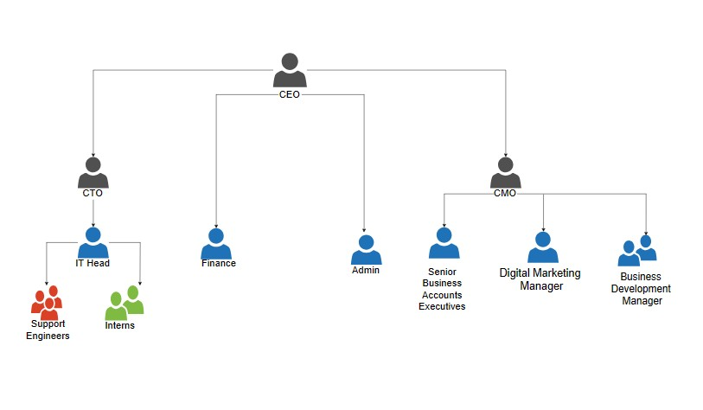
Figure 3. 1 Organizational hierarchy

2.3 Working Domains of Organization
Echo Innovators is an IT company based in Sankhamul, Kathmandu Nepal. They specialize in developing modern websites and useful software. The company also offers reliable web hosting services. The key services they provide include: • Web Design and Development Creating responsive and user-friendly websites using modern technologies.

• Software Consulting & QA
Providing expert software consulting and rigorous quality assurance to ensure high standards.

• Domain and Hosting
We offer hosting services that allow websites to be accessible via the internet, with features like email, backups, and support UI/UX Design.

2.4 Description of the Intern Department
Table 2.4: Description of Intern Department

Internship | Web Developer Intern
Organization | Echo Innovators Pvt Ltd
Mentor | Sandesh Dc
Designation of Mentor | IT Head
Internship Duration | 2 Months
Working hours | 10 AM to 5 PM
Working days | Sunday to Friday
Start day | 2th febuary
End day

CHAPTER 3: BACKGROUND STUDY AND LITERATURE REVIEW

3.1 Background Study
In a modern ecommerce website need to be dynamic and efficient. The internship focuses on designing and optimizing the system's infrastructure to manage data of organization.
Interns work on developing robust facilitate smooth communication between the front-end and backend systems, enabling seamless data exchange and interaction. Implementing secure user authentication mechanisms is crucial to safeguarding sensitive data and functionalities, requiring the creation of features like login systems and role-based access controls.
The internship also involves automating workflows to improve operational efficiency, focusing on scalability, performance optimization, error handling, documentation, and thorough testing. These aspects ensure the reliability, stability, and scalability of the backend system. Through this comprehensive background study, interns gain invaluable insights and hands-on experience in backend development practices, preparing them to make significant contributions to the enhancement of the hotel management system.

3.2 Literature Review
The use of Spring Boot and ASP.NET Core for developing microservices architecture is compared in Md. Saiful Islam, et al.'s [2] study. The ease of use, performance, scalability, and maintainability of the frameworks are all evaluated by the writers. (SparshAggarwal, 2023).
The Spring Boot Framework is a well-known and widely used framework for web and corporate application development. Spring boot uses dependency injection that allows you to create beans via XML, annotations, and Java code. It describes the design and implementation of the Spring and Spring Boot frameworks in the development of Web applications, which reduces the development process and burden of the system, allowing for easier growth and deployment. (Singhal, June 2022).
This book offers a practical introduction to developing applications using Spring Boot. Walls emphasizes the simplification of configuration and setup in Java enterprise applications. He explains how Spring Boot leverages the Spring ecosystem to allow developers to build production-ready applications with minimal effort. The book covers topics such as dependency injection, RESTful APIs, Spring Data JPA, and embedded servers. It is an essential resource for both beginner and intermediate Java developers seeking to understand the core functionalities and benefits of Spring Boot. (Walls, 2016)
Greg Turnquist’s book dives into modern web application development using Spring Boot 2.0. The literature explores reactive programming, building RESTful services, and integrating databases with Spring Data. Turnquist's focus on Spring Boot 2.0 highlights improvements in speed and simplicity for enterprise applications. He provides real-world scenarios and code snippets, making it easier for readers to understand the architecture of Spring Boot applications and its seamless integration with microservices, testing, and security features. (Turnquist, December 2017).
John Carnell’s book provides in-depth knowledge of how Spring Boot is used in building microservices architecturesThe literature is valuable for developers aiming to build scalable, resilient, and distributed systems using Java and Spring Boot. (Carnell, July 2017).
"Pro Spring Boot" is an advanced-level book that delves into the internals of the Spring Boot framework. The literature covers integrating Spring Boot with databases, security modules, monitoring tools (like Actuator), and cloud deployment techniques. This resource is suitable for experienced Java developers who wish to build complex applications with a deep understanding of how Spring Boot automates configurations and improves performance. (Gutierrez, February 2016).
Dinesh Rajput’s book on Spring Boot 3.0 explores the latest features introduced in the newest version of the framework. The literature highlights improvements in AOT (Ahead-of-Time) compilation, native image support, and GraalVM compatibility. It provides examples of building cloud-native Java applications using Spring Boot 3.0 and showcases how the framework evolves to match modern deployment strategies like containers and Kubernetes. The book is vital for developers transitioning to Spring Boot 3.x and looking to take advantage of its cutting-edge capabilities. (Rajput, 2023).

CHAPTER 4: INTERNSHIP ACTIVITIES

4.1 Roles and Responsibilities
During my internship as a Web Developer Intern under the guidance of Mr. Sandesh Dc at Echo Innovators, I gained valuable experience in various aspects of web development using Laravel framework. My key responsibilities encompassed:
Frontend Development
- Collaborated in developing backend features using Java Spring Boot, focusing on building scalable, efficient, and secure RESTful APIs.
- Worked with database management using JPA and Hibernate, ensuring smooth interaction with relational databases and optimizing data queries for better performance.
- Integrated Spring Boot with front-end frameworks by designing APIs to retrieve and display dynamic data, enabling seamless communication between the front-end and back-end systems.
- Implemented authentication and authorization using Spring Security, ensuring secure access to sensitive data based on user roles and permissions.
- Optimized backend performance by applying best practices in caching, optimizing database queries, and managing the system's scalability to handle high traffic loads efficiently.
Backend Development:
During my internship as a Java Spring Boot Backend Developer, I actively contributed to the development of scalable and secure backend systems. focused on writing clean, maintainable Java code following the MVC architecture and developed RESTful APIs to facilitate communication between the front-end and back-end. My role involved using Spring Data JPA to manage database interactions and optimize data queries for performance and implemented Spring Security for user authentication and authorization, ensuring secure access to critical resources.

Database Interaction and Management:
  - worked on database interaction and management using Spring Data JPA, optimizing queries and ensuring smooth communication with the database. focused on database migrations and query optimization, improving performance and scalability. Implementing data validation techniques, ensured accuracy and consistency across the application and leveraged Hibernate for efficient objectrelational mapping, enhancing database interaction. Best practices in database design, such as indexing and normalization, were applied to maintain efficiency. Additionally, collaborated with the team to manage transactions and ensure data integrity.
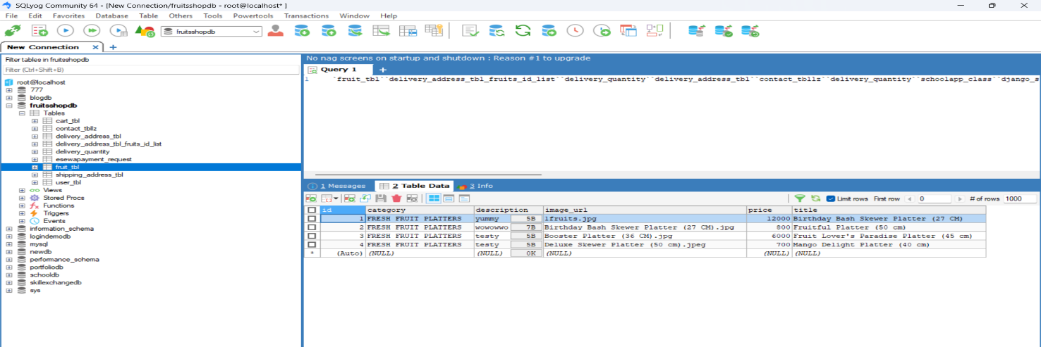
Figure 2. 1 : Database connection or manage

  - Testing and Debugging:
  - Assisted in the testing process by writing unit tests to ensure individual components of the backend code function were as expected.
  - Gained experience in debugging and troubleshooting backend issues, identifying, and resolving errors that may arise during development or deployment.
Continuous Learning and Professional Development:
  - Actively sought opportunities to expand my knowledge of Spring Boot, Java, and related backend development technologies, such as participating in online courses, attending workshops, and reading technical documentation.

4.2. Weekly log

Week | Objective | Tasks Completed | Summary
Week  1 | Project Setup and  Initial Planning | -Installed Java, Spring Boot, an dependencies.  -Created a base Spring Boot project and initialized Git repository. Explored project structure and configurations.  -Designed a responsive backend architecture for scalability. user management, cart, and product management. | The project was successfully set up with a scalable architecture.
Week  2 | User  Management  Implementation | -Developed user management functionalities using Spring Boot. Created database tables using JPA migrations.  - Implemented registration and login functionaly.  authentication.Configured API routing for user requests.Tested user management. | User management was successfully implemented with secure authentication. Database tables were set up, and thorough testing ensured the correctness of endpoints.
Week  3 | Authentication and Permissions | -Implemented authentication. Defined custom permissions for different user roles. Conducted extensive testing of authentication and authorization systems. | Security was strengthened through role-based permissions. Rigorous testing ensured a robust authentication system.

Week | Objective | Tasks Completed | Summary
Week  4 | Product  Management | -Designed product entity and database schema.  - Implemented CRUD operations for products. Integrated image upload functionality. | Product management system was developed, allowing secure CRUD operations.
Week  5 | Cart and Order  Management | -Created shopping cart functionality.  -Developed order processing logic.  -Implemented payment gateway integration.  -Tested order-related endpoints. | Shopping cart and order management features were integrated with secure payments.
Week  6 | Admin Dashboard and Analytics | -Developed an admin panel for managing users, products, and orders.  -Implemented analytics and reporting features.  -Secured google auth APIs with authentication.. | Admin functionalities and analytics were implemented to manage system operations.
Week  7 | Testing and  Debugging | - Conducted end-to-end testing of all modules. Identified and fixed critical bugs. Optimized responses for better performance. Enhanced error handling mechanisms. | Comprehensive testing ensured system stability and improved performance.
Week  8 | Performance  Optimization and  Deployment | - Optimized database queries for better performance. Deployed the application on a cloud server. Conducted final security checks and performance testing. | The application was optimized and successfully deployed with enhanced security.

4.3. Description of the Project(s) Involved During Internship
During my internship as a Java Backend Developer at Echo Innovators, I actively participated in the development of an eCommerce website. This project aimed to enhance the operations of the system by providing a comprehensive platform for managing product categories, brands, user data, and order processing for the website. Additionally, I worked on designing the frontend for various features like services, blogs, and the team section.
Backend API Development: I focused on building core backend functionalities using Spring Boot. This involved developing API endpoints for CRUD (Create, Read, Update, Delete) operations, managing product data, and ensuring secure handling of user interactions.
operations on user profiles. I also worked on APIs for managing ensuring that all necessary operations were covered.
- Authentication and Authorization: Implementing secure user authentication and authorization mechanisms was a key part of my role. I developed functionalities for user registration, login, and role-based access control to ensure that sensitive information was protected and accessible only to authorized users.
- API Testing: To ensure the reliability and functionality of the backend API, I conducted extensive testing using tools like Postman.
- Invoice and Billing Management: I developed functionalities for generating invoices for reservations, calculating total amounts based on room rates and duration of stay, and integrating this with the reservation system to provide a seamless billing experience for guests.
This project not only honed my technical skills in Spring Boot and API development but also provided valuable insights into best practices for developing robust, scalable, and secure backend systems in a real-world context.

4.4. Tasks / Activities Performed
During my internship at Echo Innovators Pvt. Ltd, I engaged in a variety of tasks and activities, including:
- Software Proficiency:
  - Familiarization with Development Tools: Gained proficiency in using essential backend development tools such as Spring Boot, Eclipse, Spring Tools Suit 4, and Maven. Explored Postman for API testing and Git for version control.
  - Software Training: Participated in online tutorials and Spring Boot workshops to deepen my knowledge of building and optimizing backend systems.
- Backend Development Skills & Techniques:
  - Spring Boot Framework: Developed an understanding of Spring Boot and its features, including dependency injection, configuration management, and autoconfiguration. API Development, Database Design & Management, Authentication & Security.
- Project-Based Learning:
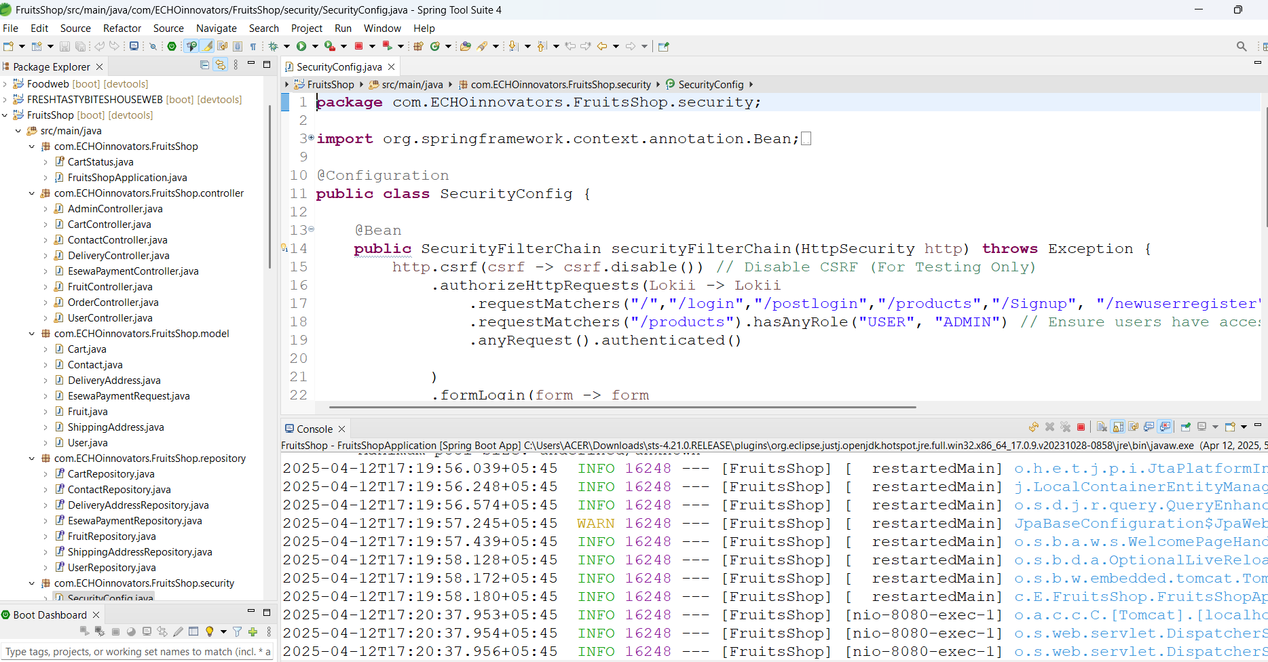
  - E-commerce Project: Designed user management functionalities, including registration and login. Developed backend APIs for shopping cart management, order placement, and inventory tracking. Implemented payment gateway integration using eSewa for secure transactions. Focused on scalability and performance optimization for handling large traffic and data load.
Figure 3. 2 Security configuration or google auth

  - Demo provided (Internship-specific): Participated in the backend development of an e-commerce platform, focusing on user management, payment integration, and order processing. Assisted in designing database schemas for user transactions, product catalogs, and inventory management.

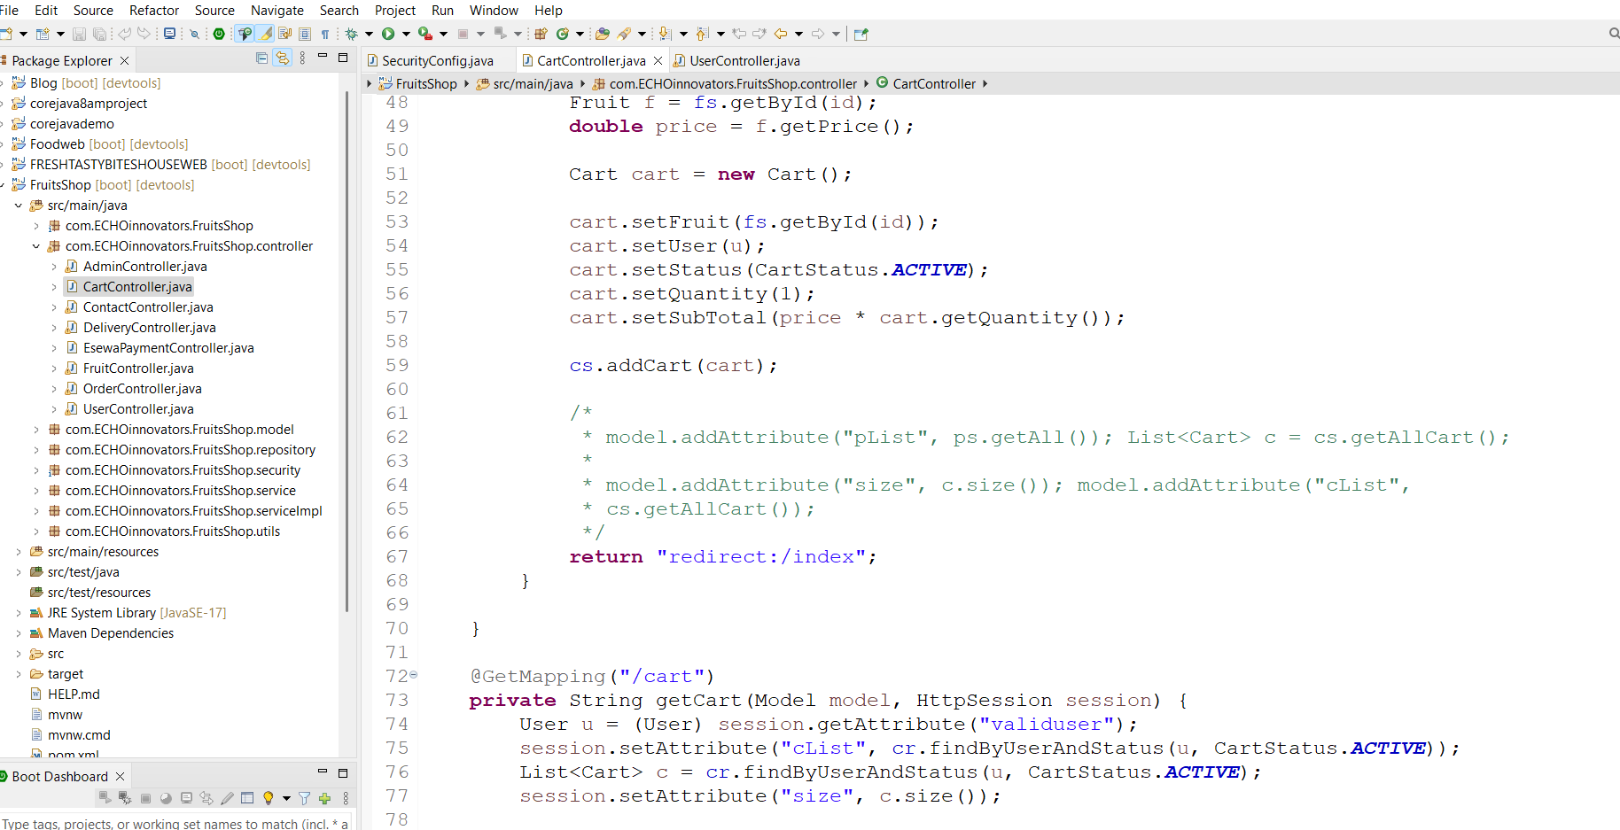
Figure 3. 3 User Cart Management Fruits Shop Project

- Professional Development:
  - Industry Research: Stayed updated on the latest trends in Spring Boot, microservices architecture, and cloud-based deployment.

CHAPTER 5: CONCLUSION AND LEARNING OUTCOME

5.1 Conclusion
In conclusion, my internship as a Java Spring Boot Backend Developer at Echo Innovators has been a highly transformative experience. I gained hands-on experience in building robust backend systems, mastering Java, Spring Boot, and honing my skills in developing scalable APIs and managing databases. Beyond technical expertise, I developed effective collaboration and communication skills through teamwork and mentorship. This experience has provided me with a solid foundation for my career in backend development, and I look forward to contributing to future projects. I am grateful to Echo Innovators and my mentors for this invaluable opportunity.

5.2 Learning Outcome
Working as a Java Spring Boot Backend Developer Intern at Echo Innovators provided me with an extensive learning experience. I honed my skills in various aspects of backend development, focusing on Java and Spring Boot. I gained a solid understanding of data modeling, database interactions, and the creation of scalable web APIs. Throughout the internship, I was actively involved in the development of an e-commerce system, applying these principles to solve practical problems. This hands-on experience allowed me to write clean, maintainable, and testable Java code. Additionally, I gained valuable experience in collaborating with a development team, improving my communication and teamwork skills, which are essential in the software development industry. This internship has strengthened my interest in pursuing a career in backend development and has provided me with the technical skills and practical experience to excel in this field.

References
Carnell, J. ( July 2017). Spring Microservices in Action.
Gutierrez, F. (February 2016). Pro Spring Boot.
Rajput, D. (2023). Mastering Spring Boot 3.0.
Singhal, R. (June 2022). Spring Boot Backend Development.
SparshAggarwal. (2023). Spring Boot Application Modularity.
Turnquist, G. L. (December 2017). Learning Spring Boot 2.0.
Walls, C. (2016). Spring Boot in Action.

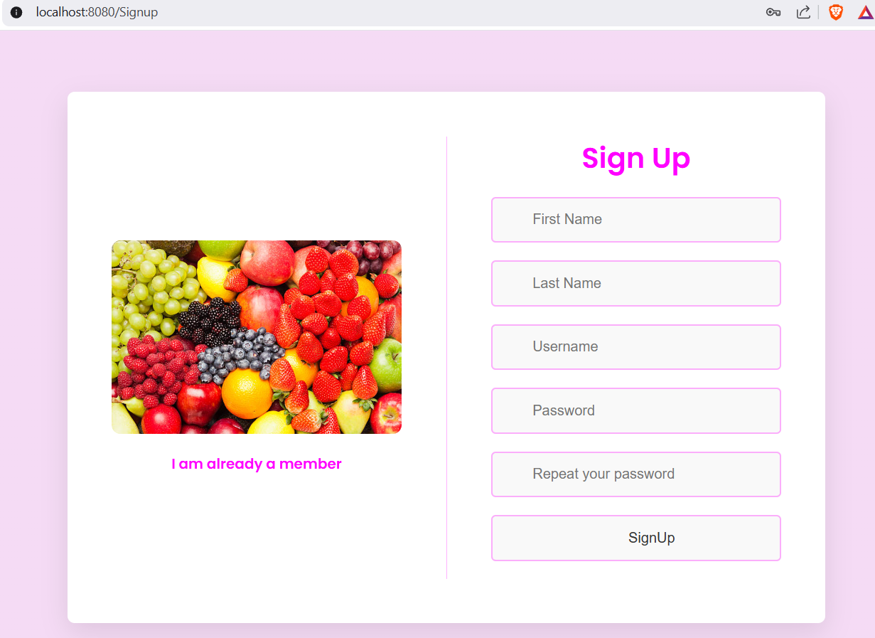
Appendices
Figure 3. 4 Sign up page

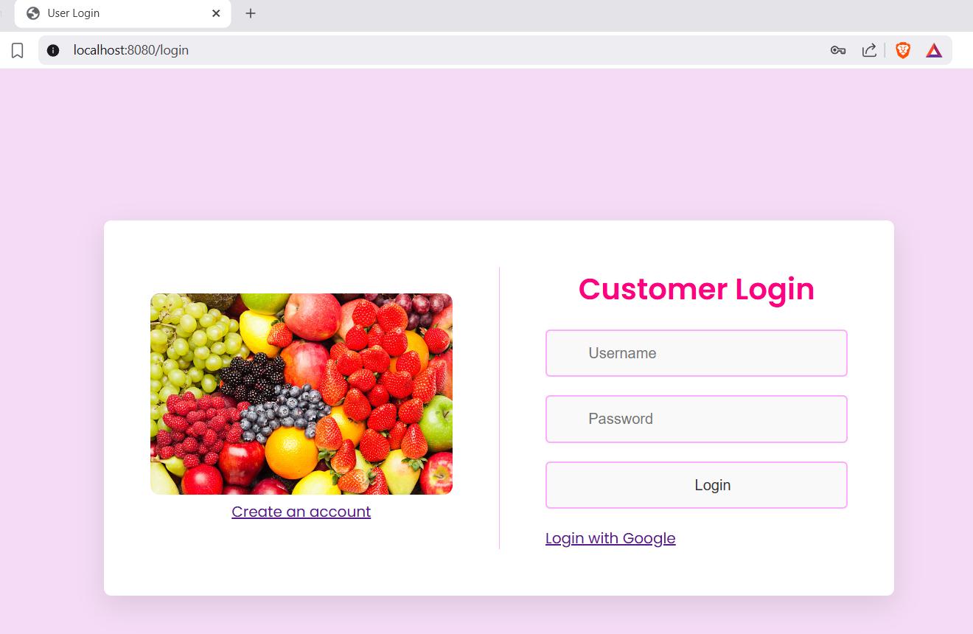

Figure 3. 5 login page

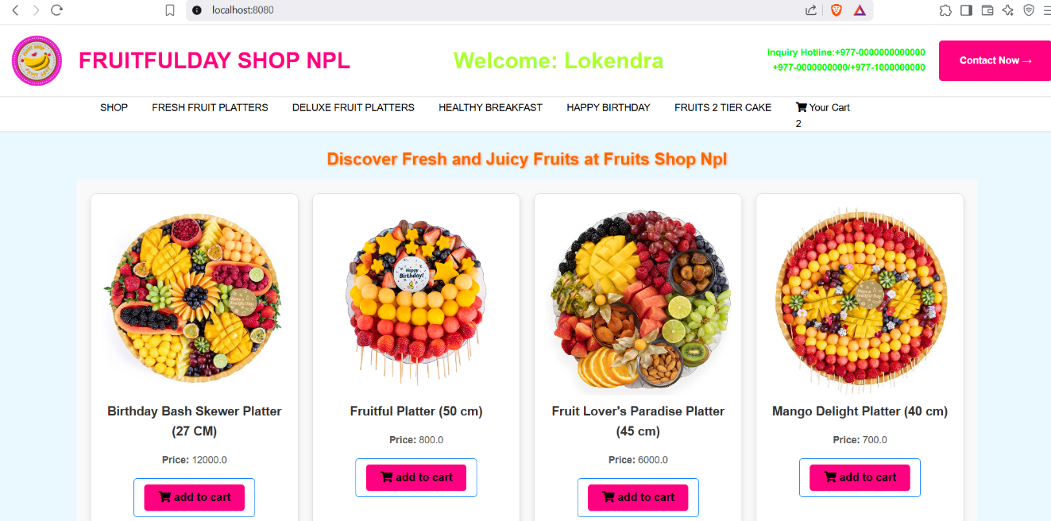
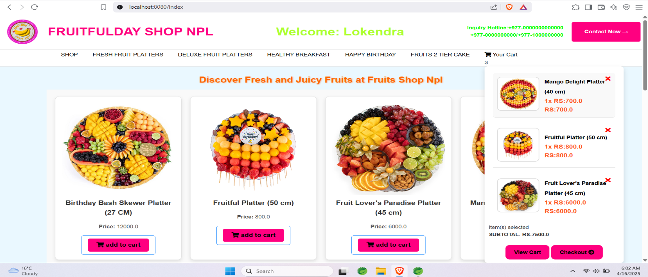
Figure 3. 6 landing pages for clients

Figure 3. 7 add cart

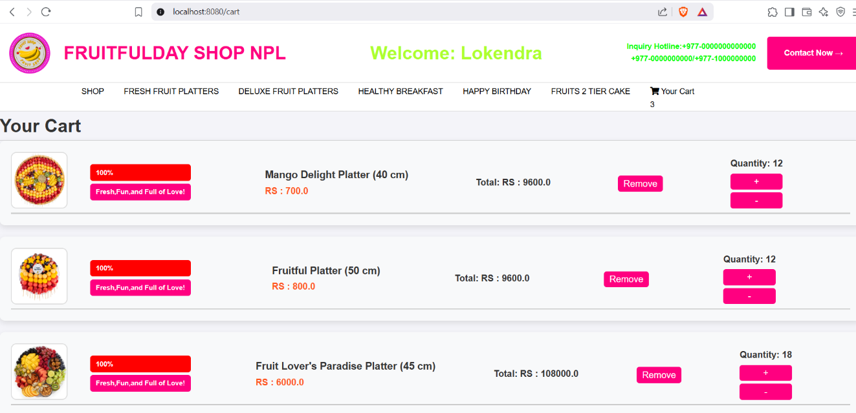
Figure 3. 8 view cart
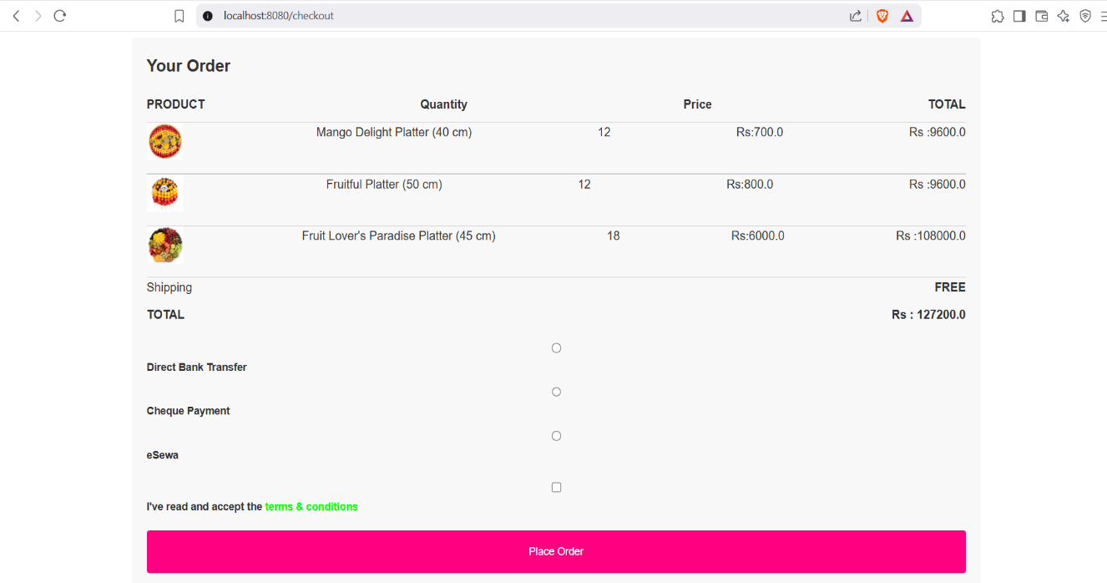

Figure 3. 9 checkout section
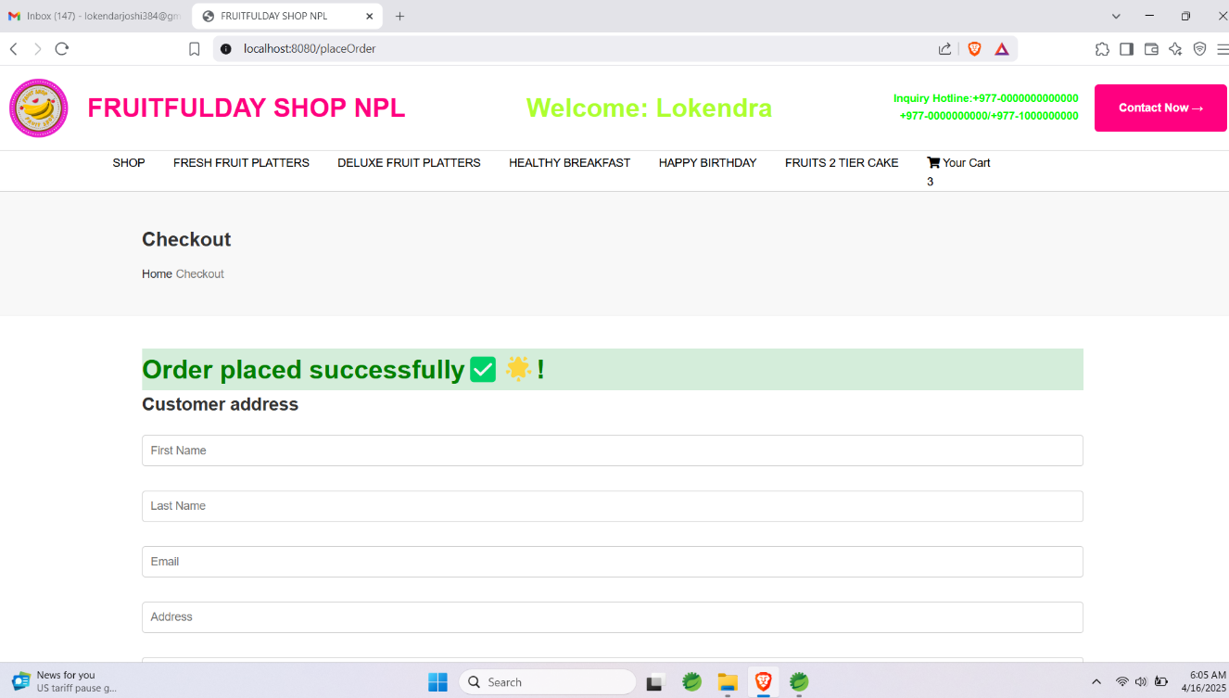
Figure 3. 10 order section

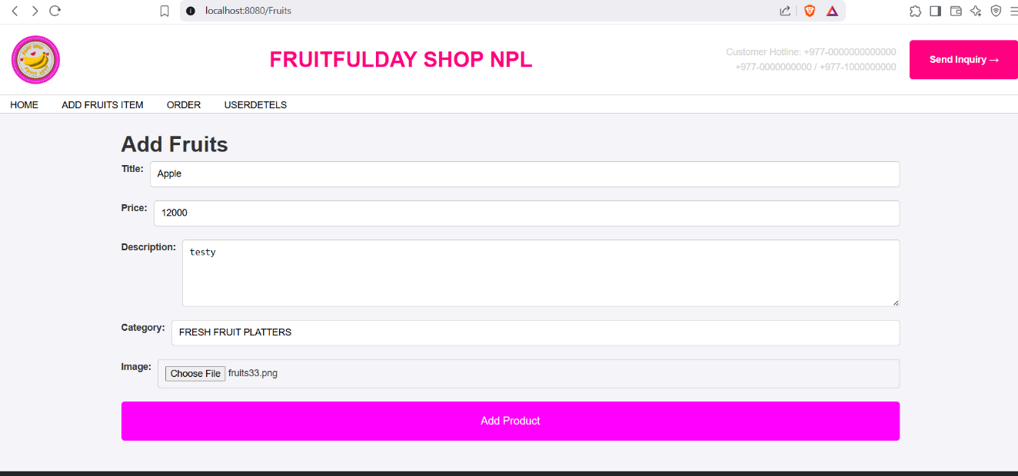
Figure 3. 11 admin site to add fruits item owner

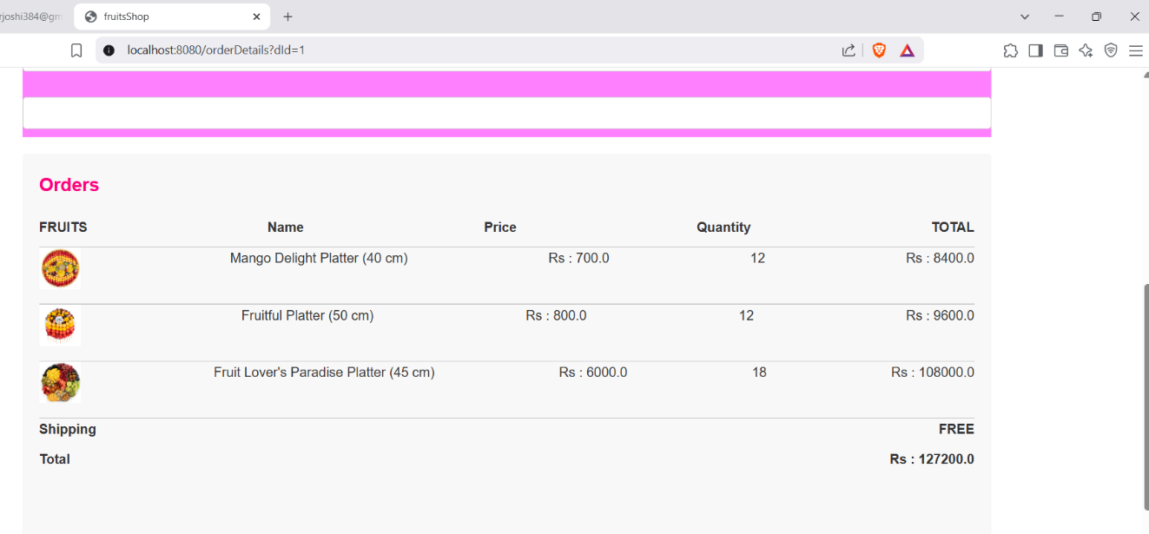
Figure 3. 12 view order details owner
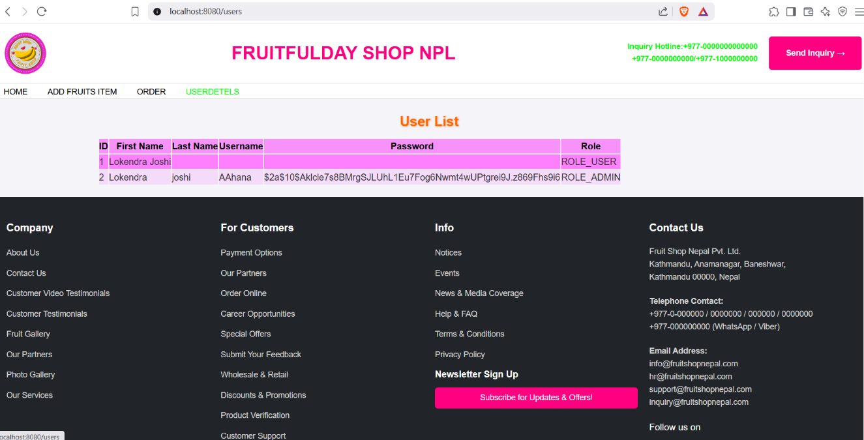
Figure 3. 13 User List

