Automobile Company (Option 2) Report

Course Project Group #1

William Brown,

Jason Harris,

Peyton Whitten

**Abstract:** Our group project focused on creating a database for a fictitious automobile company. The problem for this project was that the hypothetical manager is unable to provide a detailed specification at a technical level. Utilizing the skills and information we learned in the “CSC 411 Database Management Systems Design” course, we were able to meet the “clients” requests, as well as construct a database and website to the best of our abilities. This project report discusses the problem’s description, the database design including our E-R diagram and relational schema, the details on implementation, running results with analysis, and a conclusion on what we have learned throughout working on this project.

**Problem Description:** We chose option two for our course project, which focuses on making a database for an automobile company. The goal for this course project was to practice a realistic experience in creating a relational database, as well as the associated applications, for a hypothetical company. We are supposed to redesign a significant part of the database that underlies the hypothetical company’s operations. The problem is that the hypothetical automobile company manager that was assigned to solicit the database design proposals is unable to provide a detailed specification for the database redesign, so this is our task. There are also client requests which include creating an E-R and relational model, populating the relations, constructing test queries, creating interfaces, as well as providing concurrency for the database.

**Database Design:**  
 We worked on our database design throughout the course, adding what we were currently learning in the course to our project. We used SQL and PHP to develop our online database system and interface. We also used XAMPP, which is a simple open-source web server solution, to test our database in a server environment. In this section, we have included the E-R diagram and relational schema that we used in designing our database. Figure 1 is the E-R diagram after we added to and adjusted according to the feedback that the instructor gave us. Figure 2 is the relational schema that we implemented into the project.

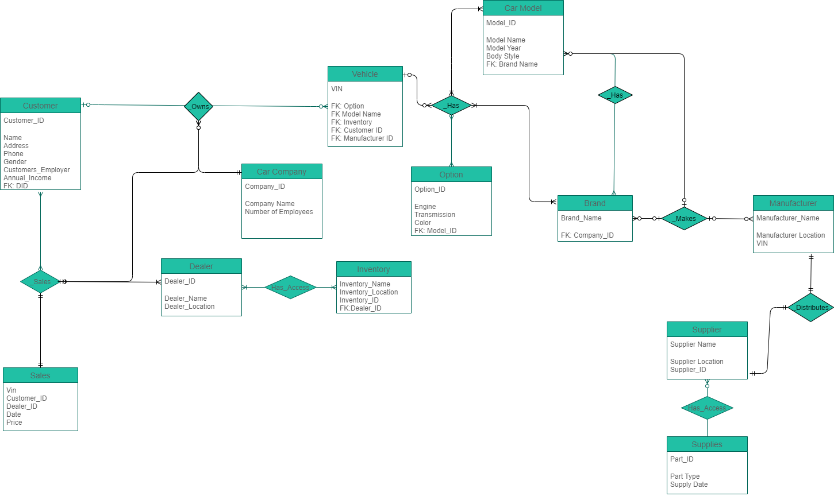

**Figure 1: E-R Diagram**

brands(id, Name, CompanyOwned)

customers(Id, Name, Email, Phone, Address)

dealers(id, Name, Email, Phone, Address)

models(id, Name, BrandId,  
 **foreign key** BrandID **references** brands(id))

options(id, VehicleId, Property, Value) VALUES

sales(Id, VehicleId, CustomerId, SellingPrice, DateSold,  
 **foreign key** CustomerID **references** customers(ID),

**foreign key** VehicleId **references** vehicles(id))

vehicles(id, Name, Vin, ModelId, DealerId, Sold, BuyingPrice,

**foreign key** ModelId **references** models (id),

**foreign key** DealerId **references** dealers (id))

**Figure 2: Relational Schema**

**Implementation Details:**  
 For implementation, we created a separate table for each category of information and used a simple insert function to add to the table.

**CREATE TABLE** `brands` (

`id` **int** (11) NOT NULL,

`Name` **text** NOT NULL,

`CompayOwned` tinyint(1) **NOT NULL** DEFAULT 0

)

This function creates the table for Brands, then to add the Data into the Brands Table we used simple Insert function

**INSERT INTO** `brands` (`id`, `Name`, `CompayOwned`) VALUES

This function allowed us to easily add in new information on whenever needed into the database without interfering with previous or later added information.

We repeated this simple yet effective process through the entirety of the project. For the website portion of the project, we used a software named XAMPP to upload and process the database to a local webserver and make a simple user interface that allows the user to search for specific cars by brand, model, dealership, transmission. The user interface was created using mainly PHP for pulling the information from our database, CSS for design and JavaScript for some added features making it more fluid and streamline.

**Running Results & Analysis:**  
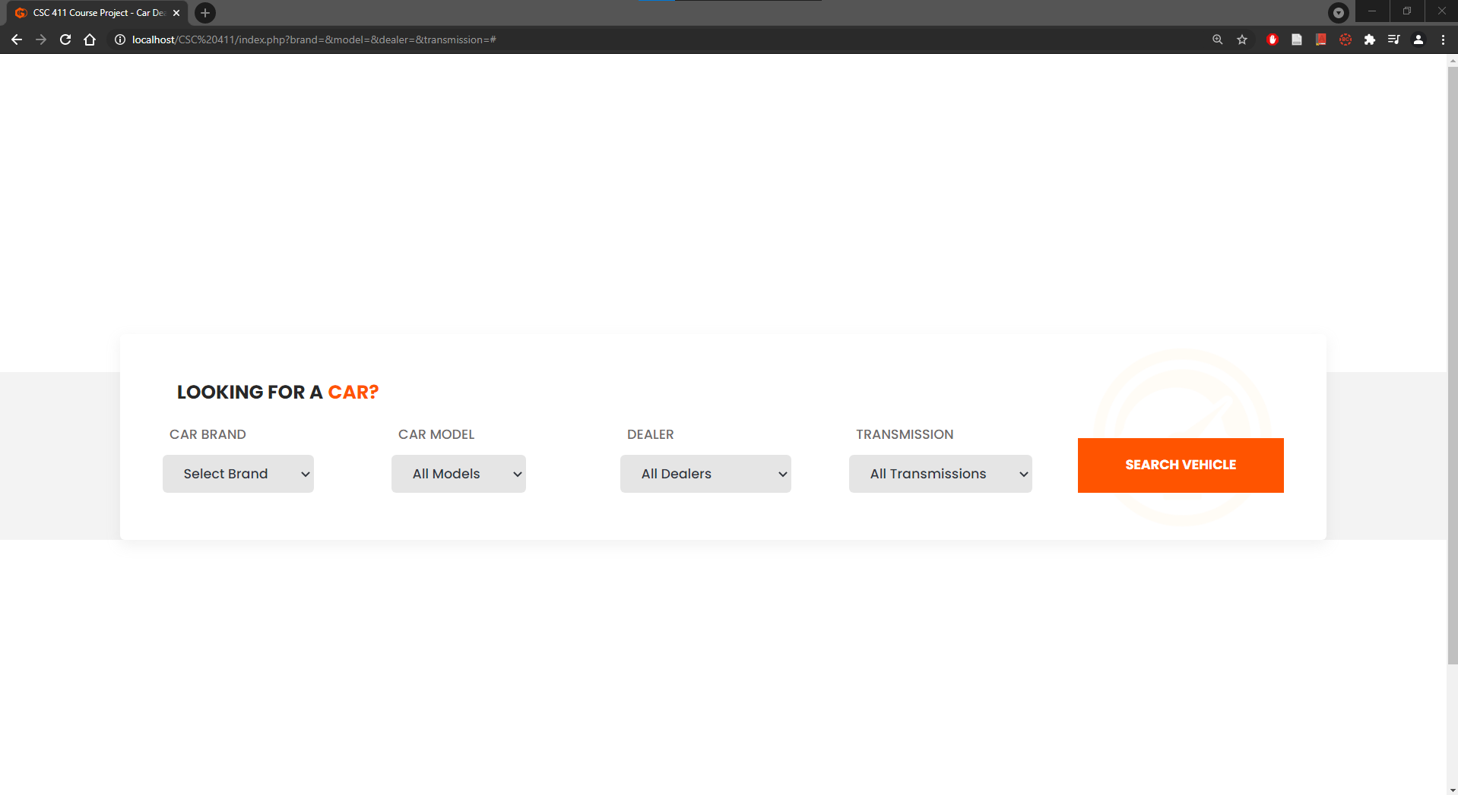

**Figure 3: Initial Website View**

Figure 3 is what the user initially views when accessing the website. We made an elegant web interface for the vehicle locator which allows the dealer or customer to find a vehicle that matches their preferences. After selecting a brand, you can search for all cars with that make. You can further refine your search by selecting a car model, dealer, or transmission type. Figure 4 is what a user sees after searching for a vehicle.

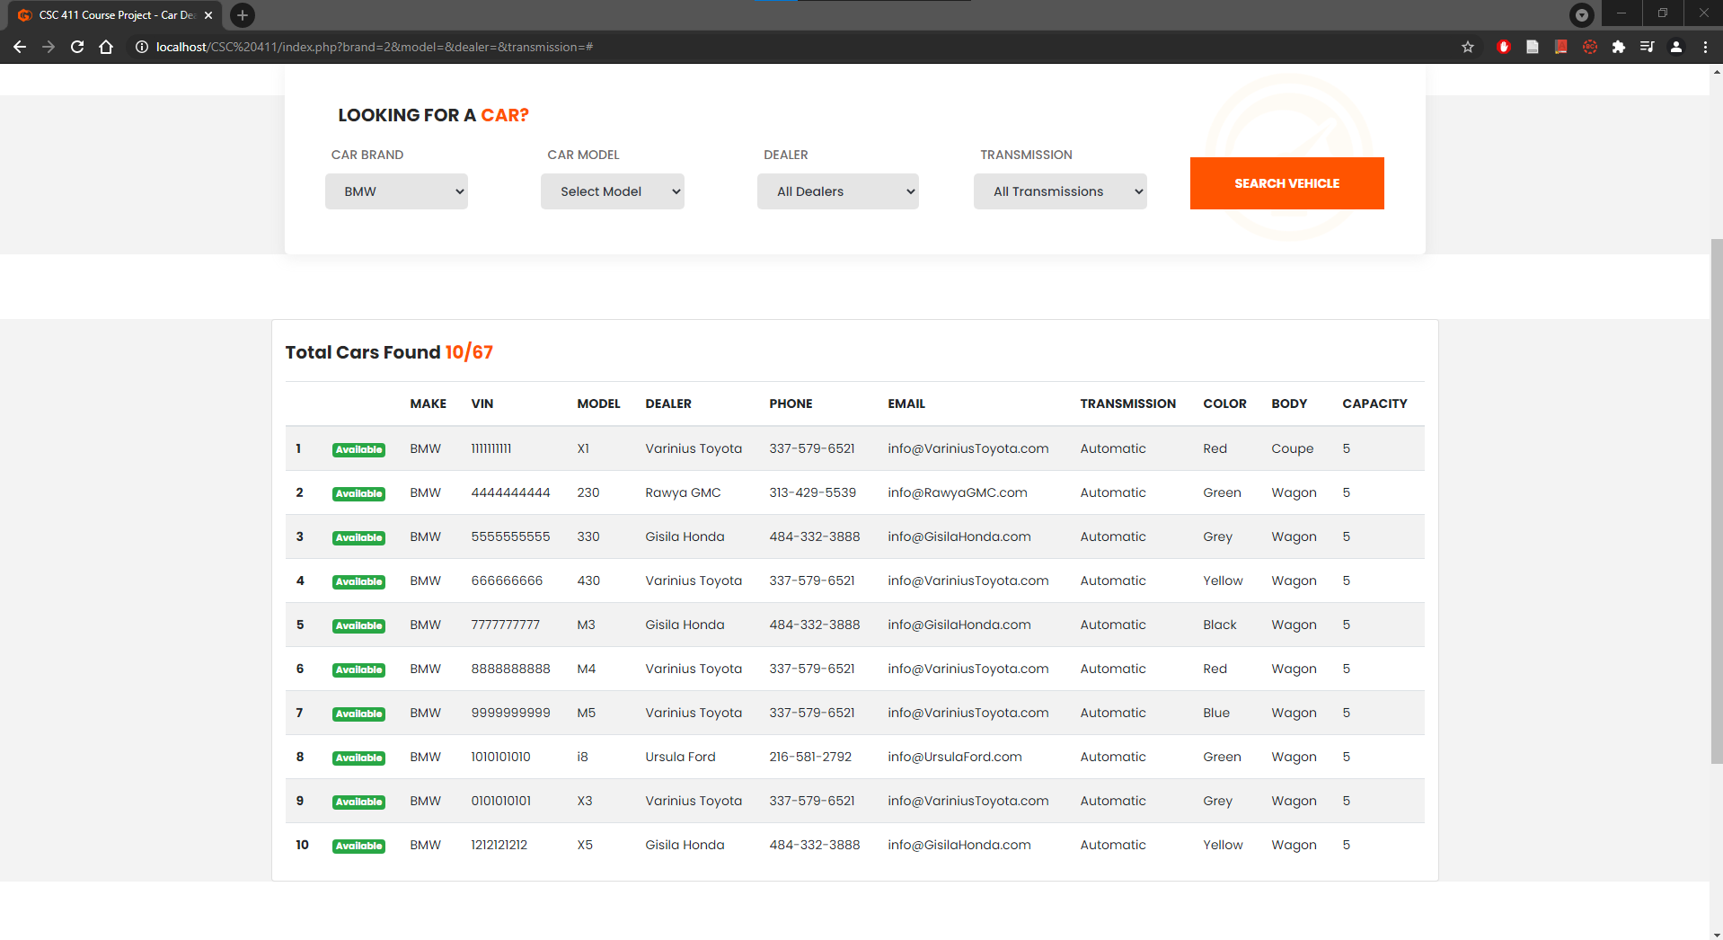

Figure 4 are the results, after searching for a brand, which displays all the current vehicles that matches the make, along with all the information the dealer or customer may need to know. It displays vehicle information like the make, model, VIN number, transmission type, color, and body. It also displays dealer information like the dealership name, phone number, and email. We fabricated made-up names, emails, and numbers for all of the dealer information, and also made up the VIN numbers on the vehicles. We used actual vehicle makes and models for the vehicle information.

**Conclusion:** The course project was very beneficial for all of us. We were able to implement what we have learned through a realistic experience as we were learning it in the course. While working on shorter assignments could help us too, this longer course project allowed us to work together as a team to create an actual database, along with a web interface. It especially helped us to learn E-R diagrams at the beginning of the course when we got to practice on our course project’s diagram, and send it to the instructor for potential feedback. This course project was a great experience that provided us with knowledge and skills which we could actually use in our future careers.