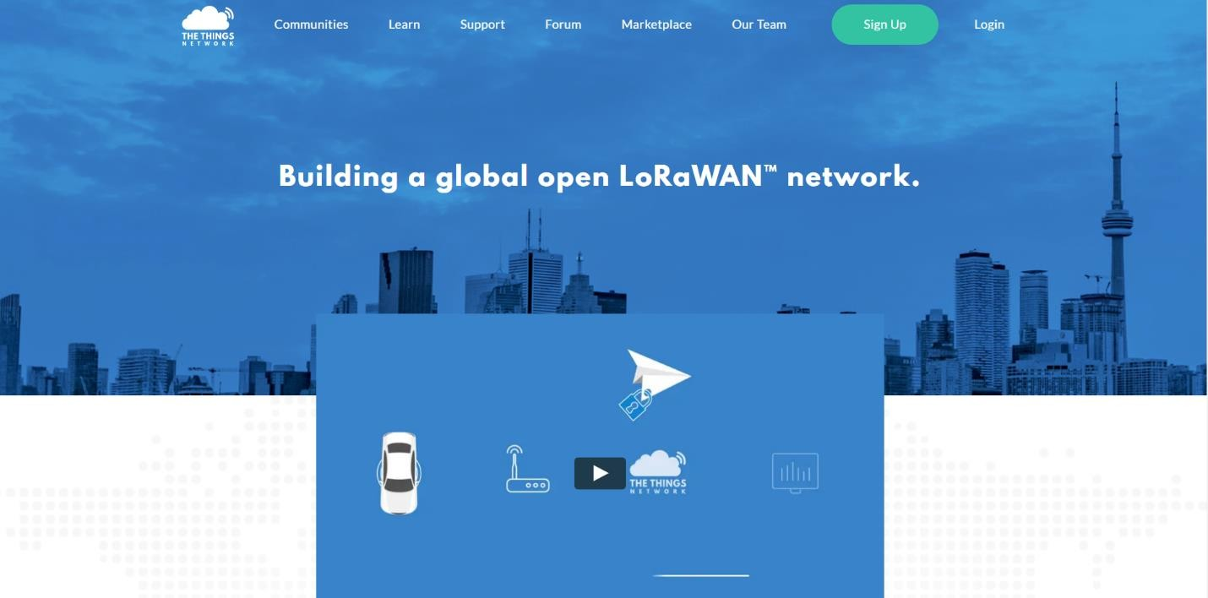

**Workshop 1: Building a Simple LoRaWAN Network for Beginners**

According to LoRaWAN 1.0.2, LoRaWAN network consists of 3 major components; node, gateway and servers. In order to use the network, node and gateway must be initially registered in the servers, and store required parameter, so the server can identify which devices are belong to their network.

The simple steps for developing LoRaWAN network are as below:

1. Choose and set up LoRaWAN servers

2. Choose and set up LoRaWAN gateway

3. Choose and set up LoRaWAN node

**Step 1: Choose and Set up Servers**

**In this manual, we use The Things Network (TTN)**

For network server and application server, users can choose to develop their own private servers, or subscribe LoRaWAN public cloud servers. The simple implementation for beginners is to use the public servers ex. The Things Network (TTN). For TTN, users can choose free plan and develop simple network applications.

1) Go to https:[//www.thethingsnetwork.org/](http://www.thethingsnetwork.org/) and select “Sign Up” (figure 1)

Figure 1 Webpage for singing up account at TTN

2) Create Username / Email / password and confirm the creation via email (figure 2)

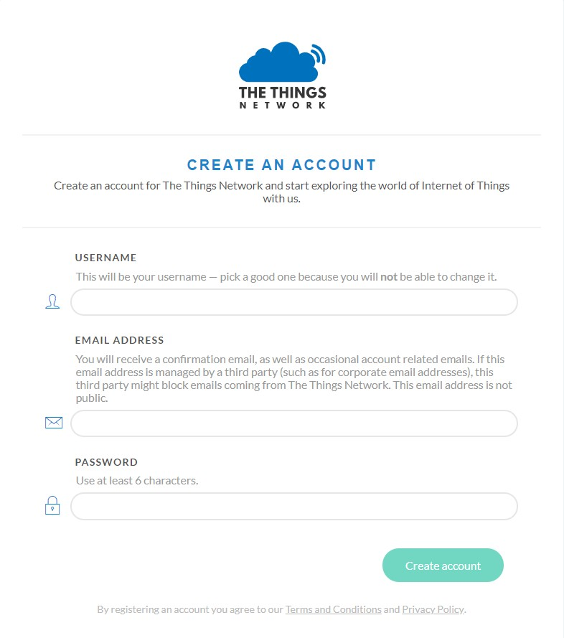

Figure 2 Webpage for creating an account at TTN

**Step 2: Choose and Set up Gateway**

**In this manual, we use Kerlink gateway**

1) Develop gateway with packet forwarder module to forward packet to TTN (please find more detail in Kerlink Wiki)

2) Register gateway with TTN

2.1) Login at TTN by using the registered account (figure 3)



Figure 3 Login page of TTN

2.2) Select “Console” (figure 4)

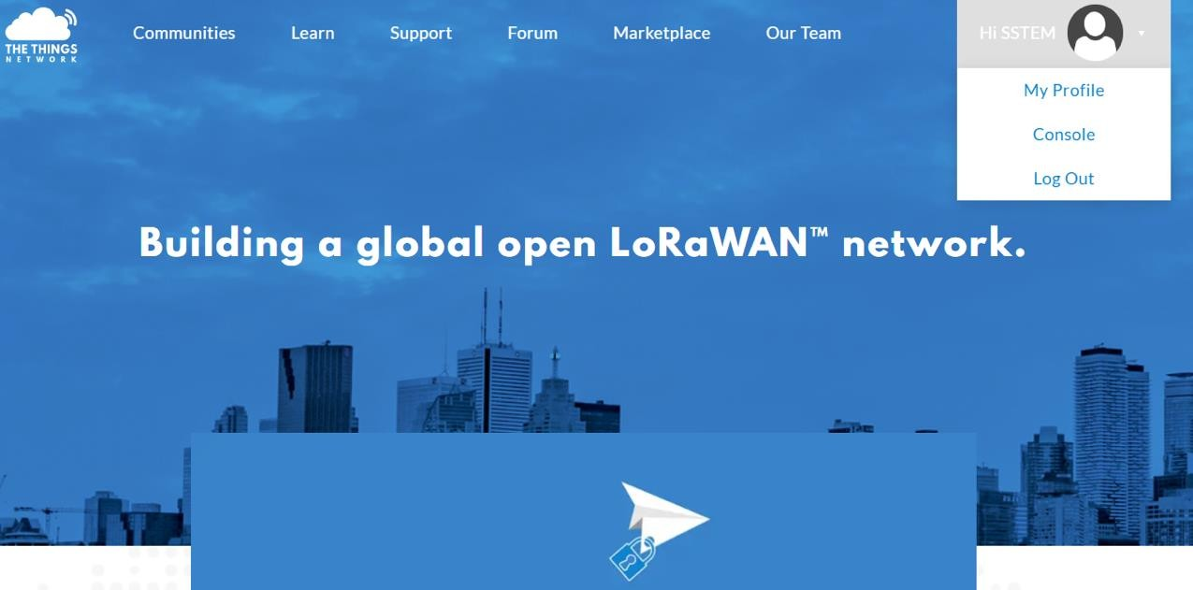

Figure 4 Webpage after login of TTN

2.3) Selecting “Gateways” as to go gateway registration webpage (figure 6)

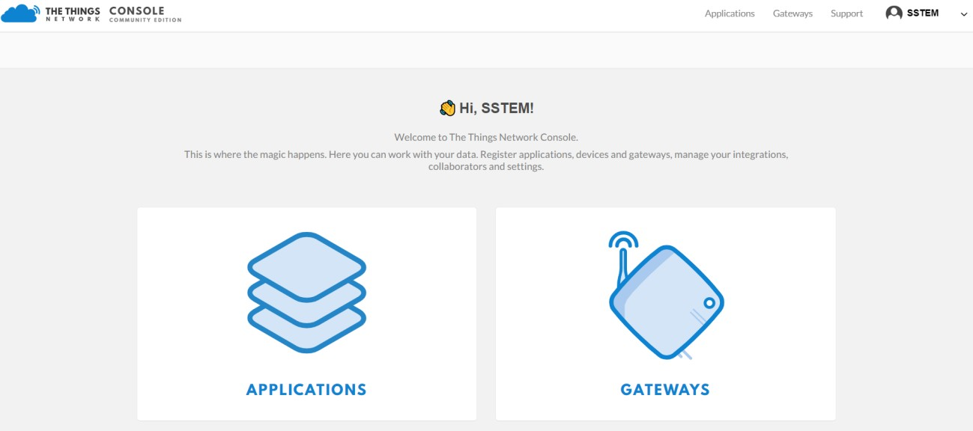

Figure 6 Console page of TTN

2.4) Register Gateway by selecting “register gateway” (figure 7)

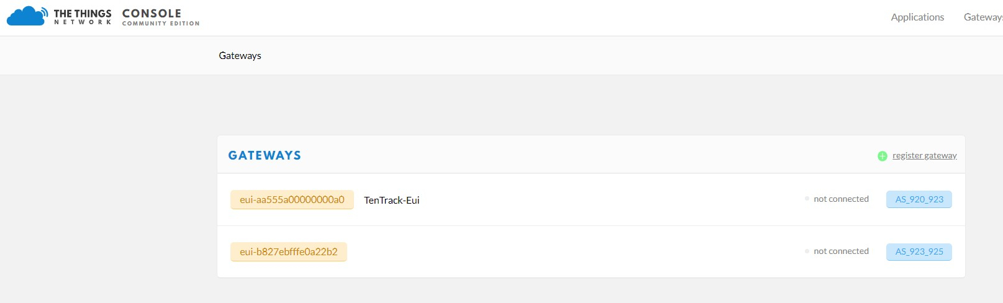

Figure 7 Gateways webpage of TTN

2.5) Fulfill information for gateway, and select “Register Gateway” (Figure 8):

- Gateway ID: Input EUI of gateway

- Description: Input description for your gateway (optional)

- I’m using the legacy packet forwarder: Tick the box

- Frequency Plan: Choose AS_923_925 for Thailand

- Router: Choose ttn-router-asia-se for Thailand

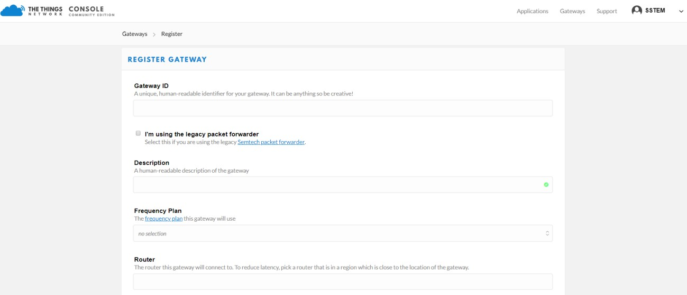

Figure 8 Webpage for registering gateway at TTN

2.6) After finish gateway registartion, the user can go back to gateway webpage by selecting “Gateways” (at right top corner of webpage), and choose any registered gateway to find more information. As from figure 7, the user can select “eui-aa555a00000000a0” to find more information of gateway “eui-aa555a00000000a0” as shown in figure 9. The information would be the same as the registration in 5). However, The Things Network also creates “Gateway key” to connect Node with Gateway. Moreover, the page also shows amount of received/transmitted messages and last seen time for the gateway.

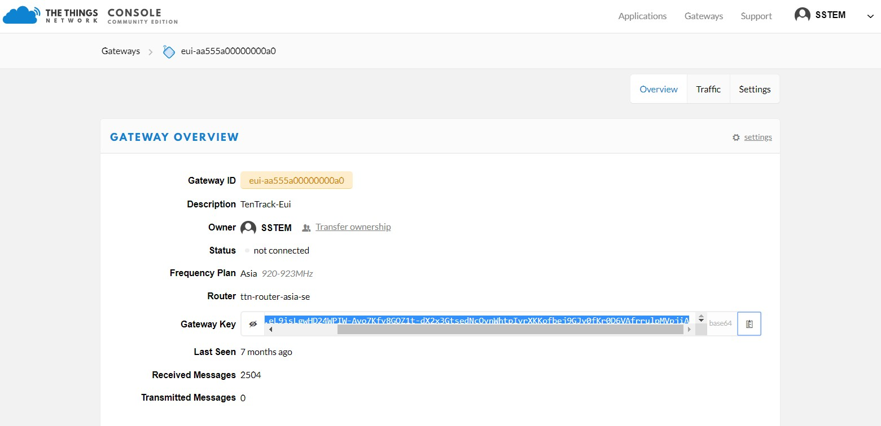

Figure 9 Details of registered gateway of TTN

**Step 3: Choose and Set up Node**

**In this manual, we use Arduino Uno with rfm95 module**

1) Register node at TTN

For TTN, node can be seperately added for each application which allows the user to manage their devices with different functions easily. The following steps show how to register the node:

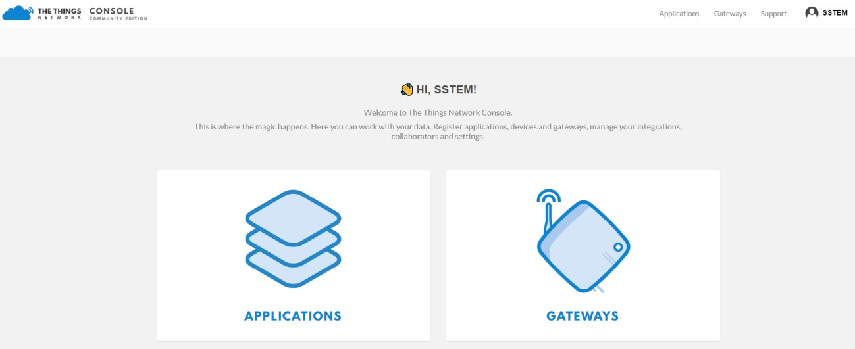

1.1) Select “console”, and then click “Application” (figure 10)

Figure 10 Console page of TTN

1.2) Add new application by selecting “add application” (figure 11)

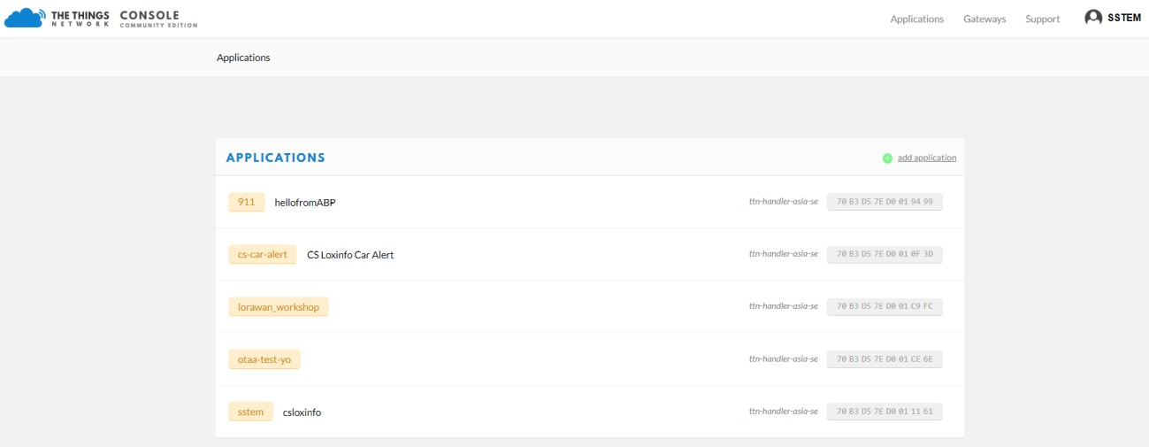

Figure 11 Application creation page

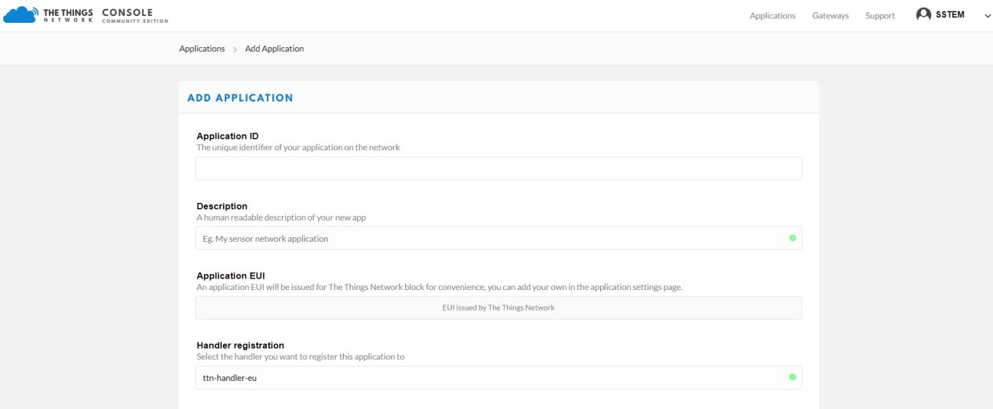

1.3) Fulfill the informaiton for new application (figure 12), then select “Add application”

- Application ID: Input any unique name

- Description: Input description for your gateway (optional)

- Application EUI: The Things Network automically generates the APP EUI for the user

- Handler registration: ttn-handler-asia-se for Thailand

Figure 12 Application creation page at TTN

1.4) After finish application creation, the user select “Applications” (at right top corner of webpage) and select any application to find more detail. As from figure 13, application id 911 has been chosen. The details will be shown as same as the registration information. Moreover, TTN also shows generated App EUI, creation time and registered devices for the application.

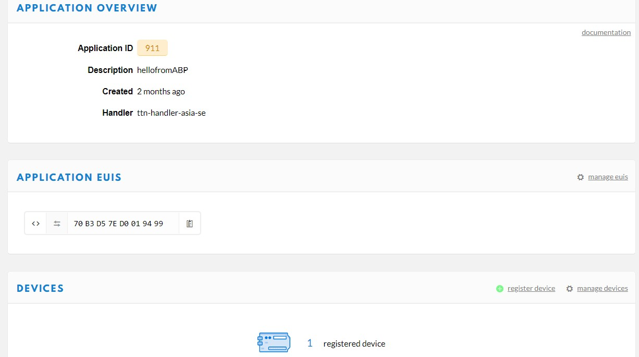

Figure 13 Application Overview page at TTN

1.5) Register node by selecting “register devices” (figure 13)

1.6) Fulfill node/device information, and select “Register” (figure 14)

- Device ID: Input any unique name

- Device EUI: Input MAC address of node or select to be automatically created by TTN

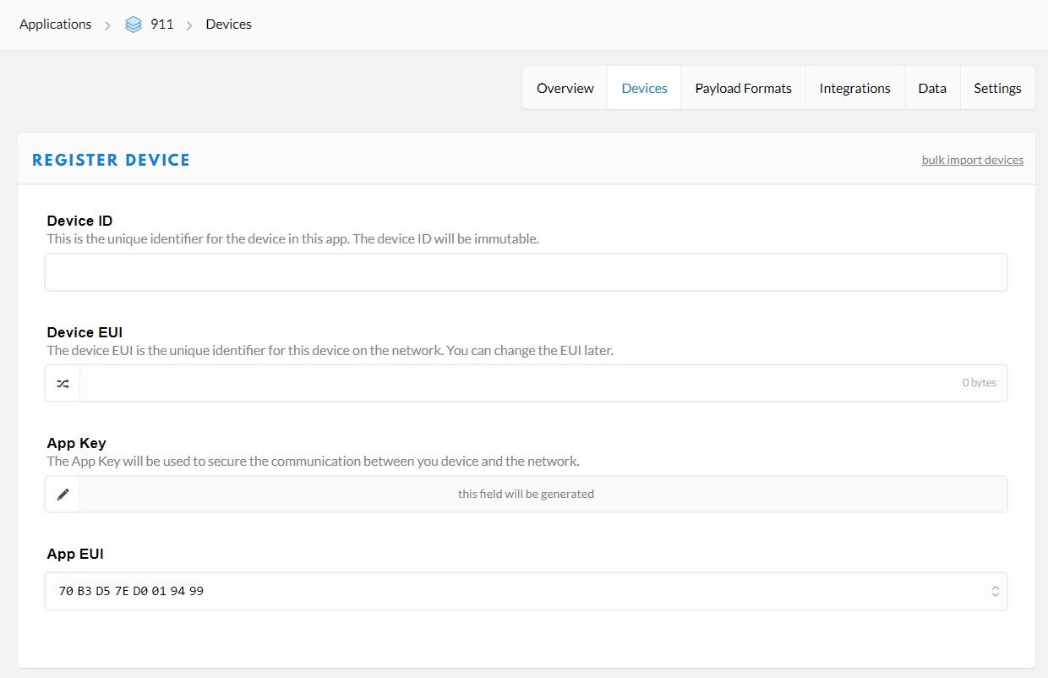

- App Key: this field will be generated by TTN

- App EUI: Automatically filled by TTN

Figure 14 Node Registration webpage for TTN

1.7) The user can go back to Application Overview page (figure 13), select the registered devices to find more details. The page will show device information as same as registration’s. TTN also generates and shows other necessary keys such as Device Address, Network Session key and App Session Key (figure 15). The value of each key can be seen by clicking . The default activation method for TTN is OTAA.



Figure 15 Device Overview webpage at TTN

1.8) The user can change the activation method from OTAA to ABP by selecting “Settings” (from figure 15), and select “General”, then click “ABP” at Activation Method part, and “Save” (figure 16).

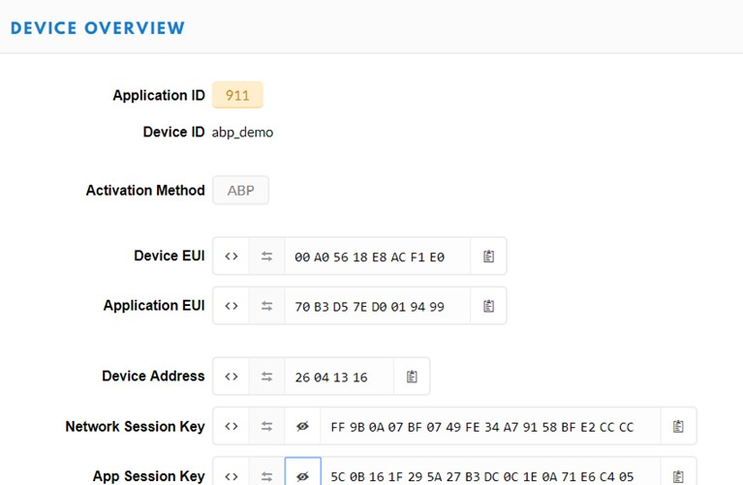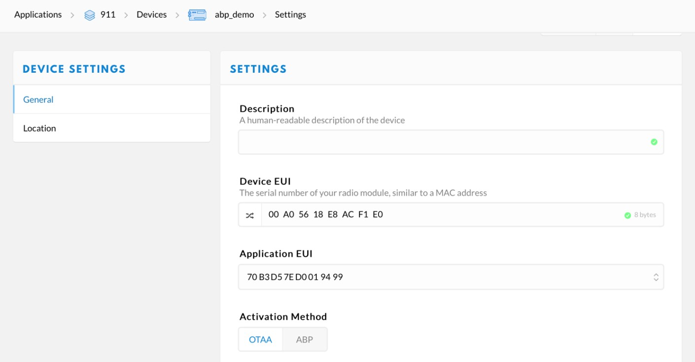

Figure 16 General information of registered device

2) Choose and develop node

2.1) Download library from <https://github.com/LoRaWAN-workshop/ICCE2019 by> clicking

“Clone or download” then click “Download ZIP” as shown in figure 17

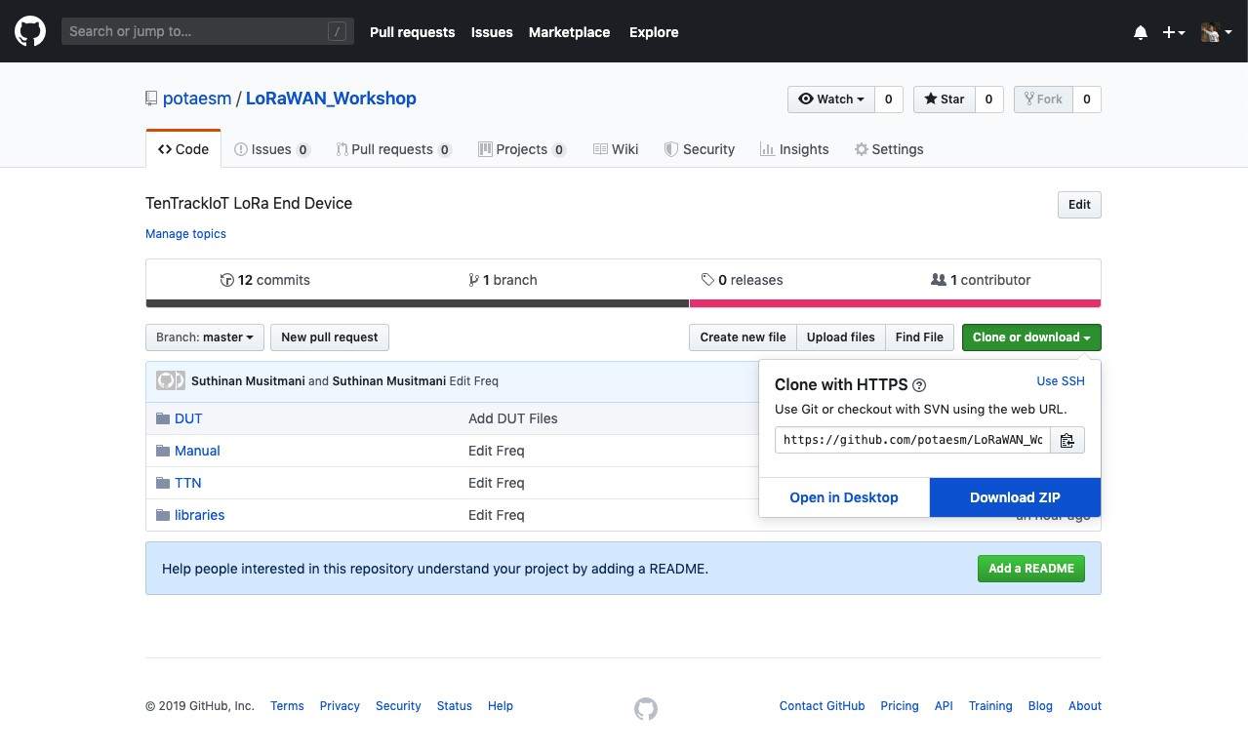

Figure 17 Webpage for downloading library

2.2) Download Arduino IDE for developing node from <http://bit.do/189IDE> (figure 18)

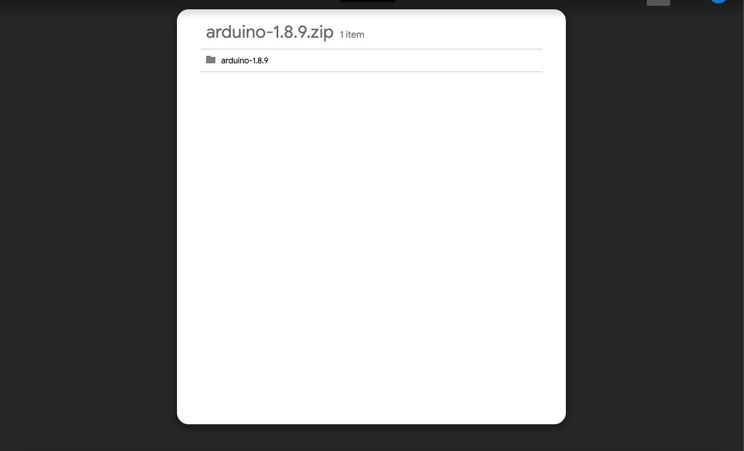

Figure 18 Webpage to download Arduino IDE

2.3) Extract LoRaWAN_Workshop-master.zip to Manual, TTN and libraries folders as shown in

figure 19

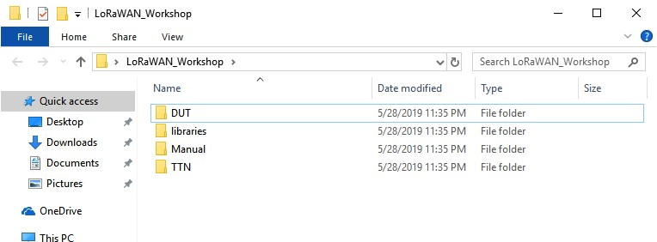

Figure 19 Folders after extracting LoRaWAN_Workshop-master.zip

2.4) Extract arduino-1.8.9.zip, and use the program by clicking “arduino.exe” (figure 20)

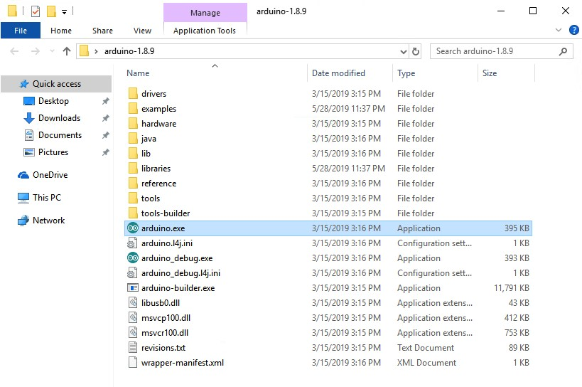

Figure 20 Folders after extracting arduino-1.8.9.zip

2.5) Compile and run program to node by:

a. Open Arduino IDE (arduino.exe)

b. Open simple LoRaWAN code by selecting Files > Examples > 12.TTN > TTN_ABP

(figure 21)

- The user has to modify Network session key, App session key and Device address to be the same as TTN’s by changing value of NWKSKEY, APPSKEY and DEVADDR, respectively (figure 22).

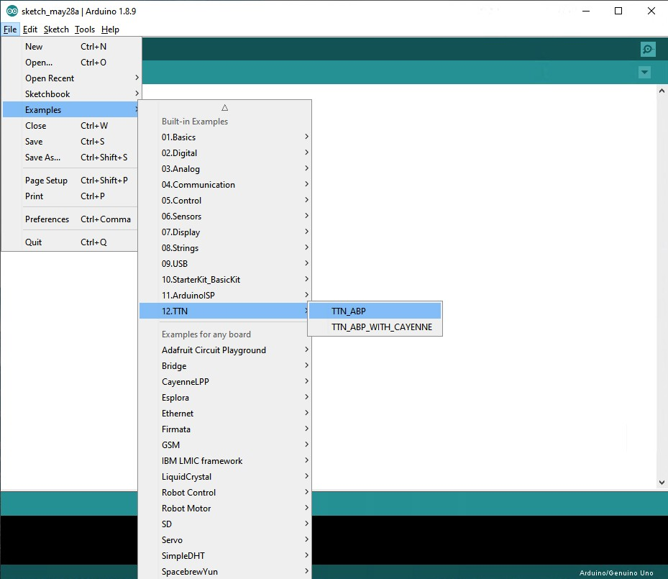

Figure 21 Way to open example’

Figure 22 TTN_ABP code c. Compile and run code to board by

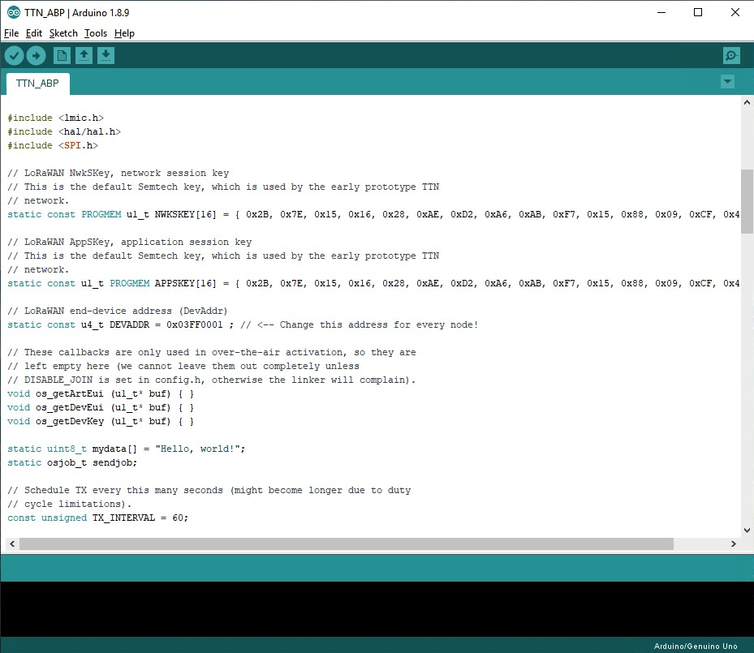

- Selecting board type: Tools > Board > Arduino/Genuino Uno

- Selecting port: Tools > Port > (*port connecting to UNO)*

Then, click



**Workshop 2: Integration with Dashboard**

TTN can be integrated with many dashboards. However, we use Cayenne which is easiest dashboard to be integrated with as an example.

1) Develop LoRaWAN node with Cayenne format by compiling and running

TTN_ABP_WITH_CAYENNE instead of TTN_ABP from Workshop 1 (figure 23)

- The user has to modify Network session key, App session key and Device address to be the same as TTN’s by changing value of NWKSKEY, APPSKEY and DEVADDR, respectively.

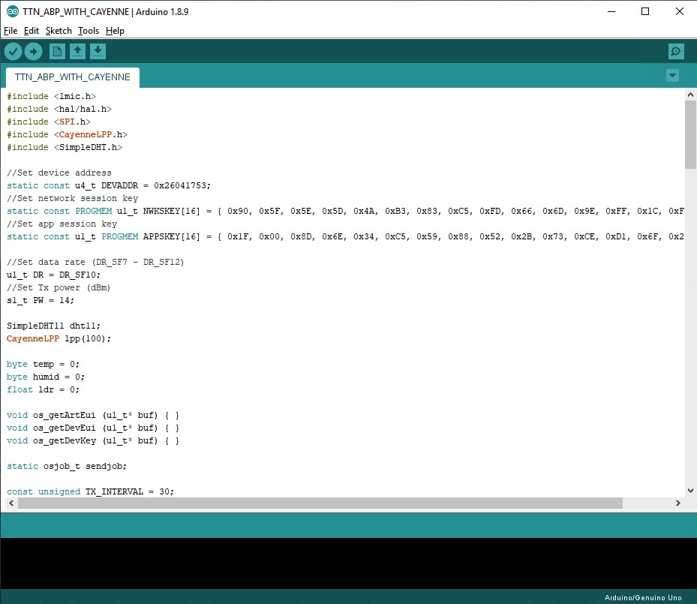

Figure 23 TTN_ABP_WITH_CAYENNE code

(Please find more information of Cayenne Low Power Payload(LPP) format from [http://mydevices.com/cayenne/docs/lora/#lora-cayenne-low-power-payload)](http://mydevices.com/cayenne/docs/lora/#lora-cayenne-low-power-payload)

2) Integrate TTN with Cayenne

2.1) Select the applications that you would like to integrate with Cayenne

(ex. Lorawan_workshop from figure 24)

Figure 24 Applications Page of TTN

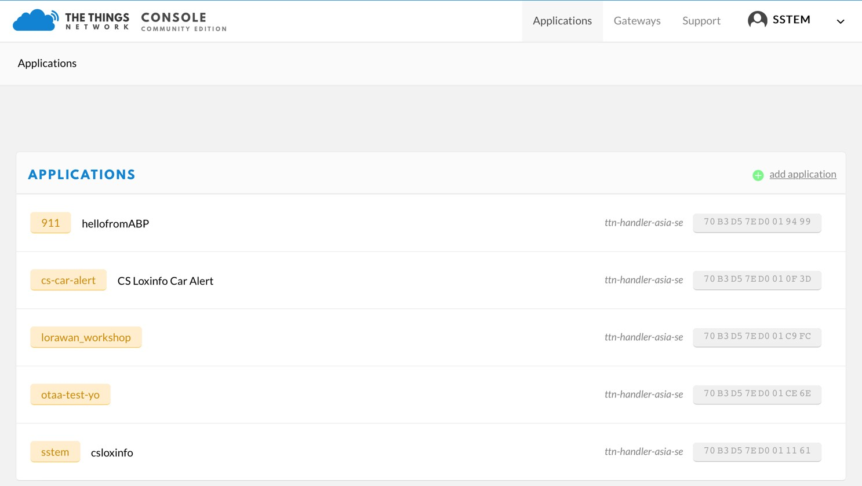

2.2) Then, select “Integrations” > add integration for Integrating with Dashboard (figure 25)

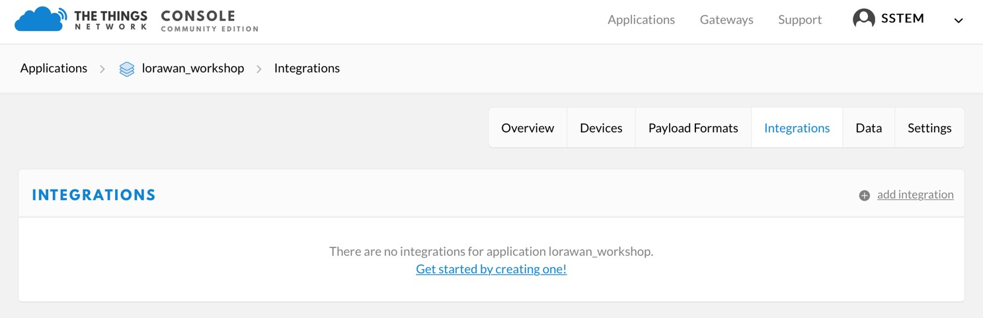

Figure 25 Integrations Page of TTN

2.3) Select “MyDevices” to integrate with Cayenne (figure 26)

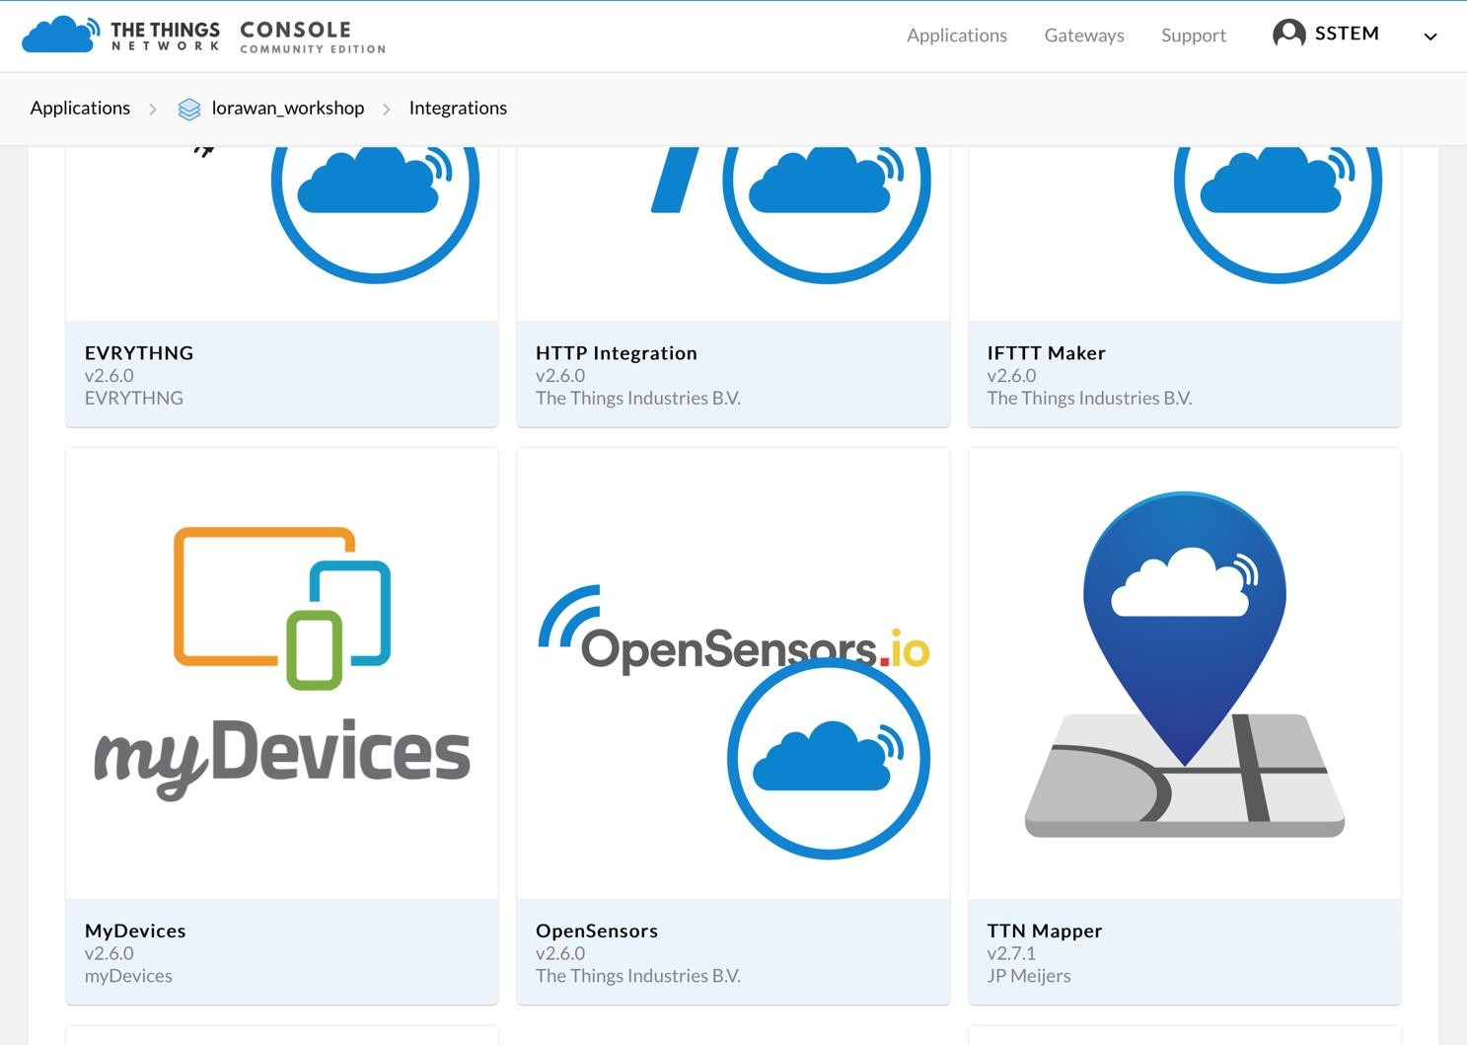

Figure 26 Applications and Dashboards for integration with TTN

2.4) Fulfill information for Integration, then select “Add Integration” (figure 27)

- Process ID: Input unique name

- Access Key: Select Default Key

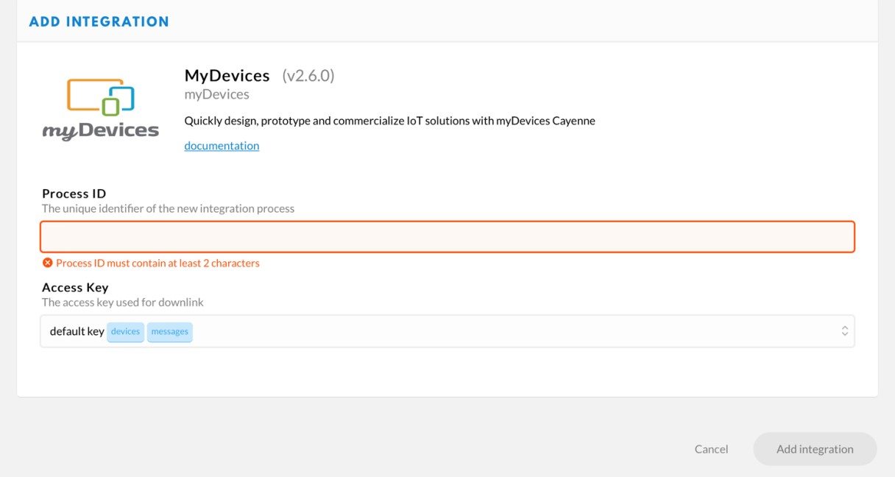

Figure 27 Webpage to Integrate TTN with Cayenne

3) Create Dashboard at Cayenne

3.1) Go to [https://cayenne.mydevices.com/ and](https://cayenne.mydevices.com/) sign up by clicking “SIGN UP” (figure 28)

Figure 28 Sign up page at Cayenne

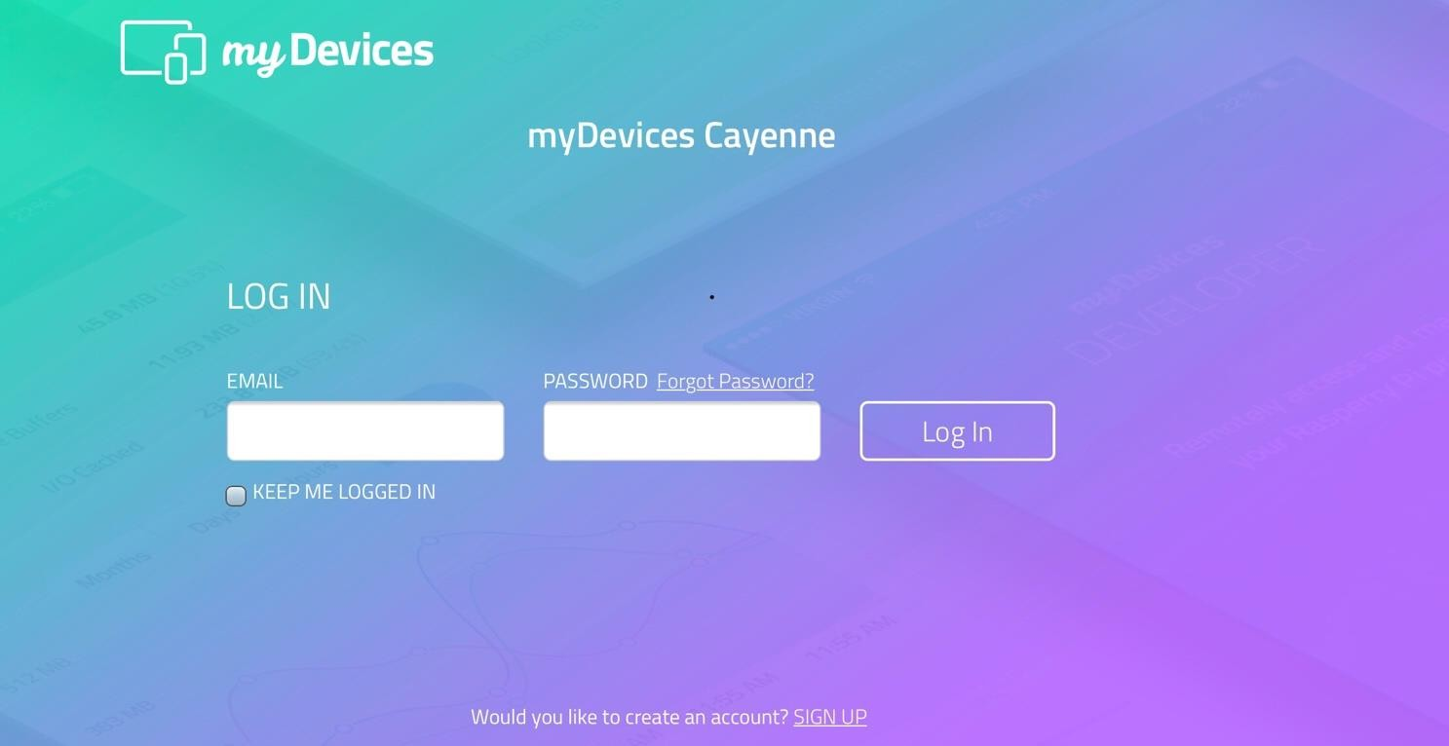

3.2) Fulfill the form then click Next to finish the registration (figure 29)

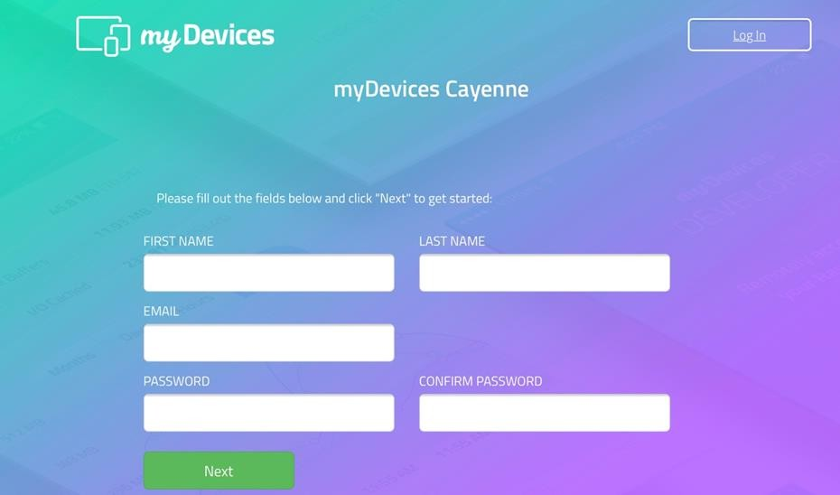

Figure 29 Page to fill sign up information at Cayenne

3.3) Create LoRaWAN Dashboard by selecting LoRa (figure 30) > The Things Network >

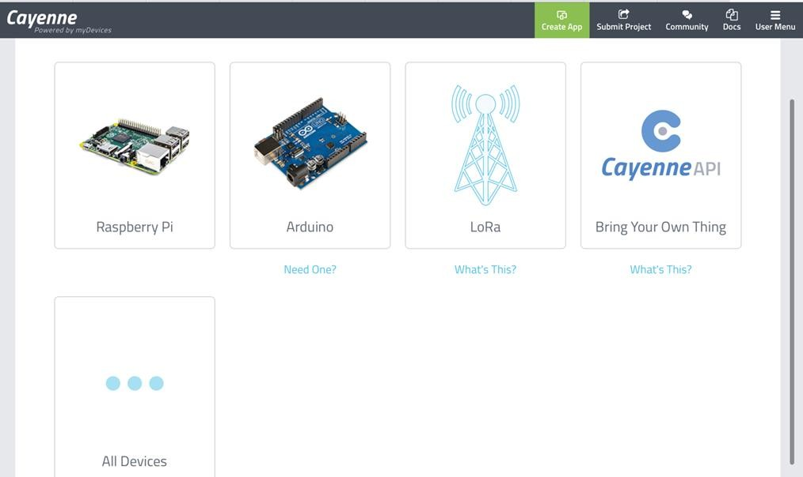

Cayenne LPP

Figure 30 Integration page at Cayenne

3.4) Fulfill information of Cayenne LPP node, then click “Add device” (figure 31)

- Name: Input any names that you would like to use

- DevEUi: Input the same value with TTN’s

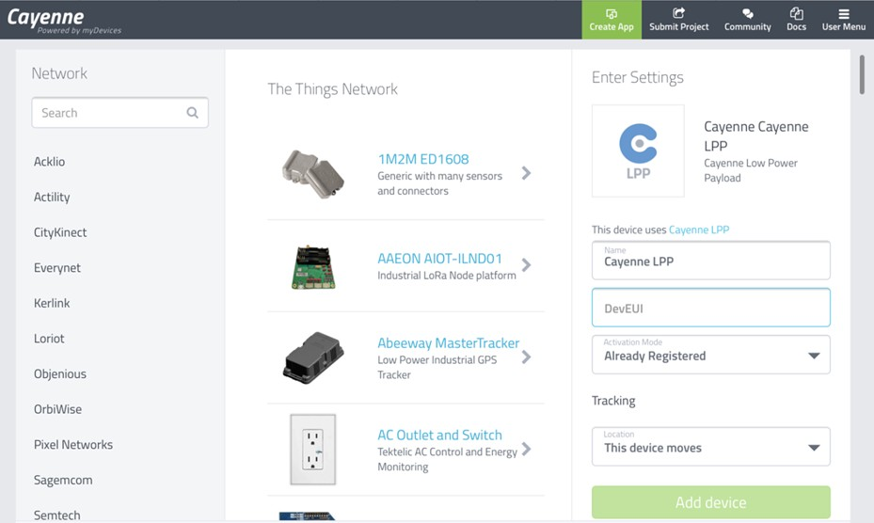

Figure 31 Page to integrate LoRa Cayenne LPP with Cayenne

3.5) When nodes send data via The Things Network, Dashboard will be shown automatically

(figure 32)

Figure 32 Dashboard of integrated node

