Progress Doc
Table of Contents
Date: 18/05/2026 2
Date: 22/05/2026 4
Date: 23/05/2026 6
Date: 01/06/2026 8

Date: 18/05/2026
I made a folder and created sub folders inside it to work with; I downloaded 3 different Datasets from ONS:
a) Regional Youth Unemployment (London vs. Northeast). (Dataset_1)
b) Regional GDP. (Dataset_2)
c) UK Inflation (CPI). (Dataset_3)
For each dataset I cleaned it manually in the beginning to fix the headers and stuffs.
1) Regional Youth Data
In this data I have only got the excel file not the csv file. In that excel file there was data of unemployment for all the regions (Northeast, NorthIst, Scotland etc) since I needed data for only London and Northeast (lon_p and neast_p). I exported this data into csv and renamed the headings. It contained data in 2 half’s, 1st half was renamed as Level (the raw number of unemployed people, measured in thousands) and 2nd half was named as Rate (the percentage of the economically active population that is unemployed). I did this for both the csv's.
I have also figured out that * symbol indicates that the data has been suppressed. This happens when the sample size for a specific age group in a specific region during that quarter was too small to be statistically reliable
2) Regional GDP
For this data as Ill, I have only got the excel file. So, this excel file includes a lot of cover sheets (Correction, Information, Contents, and Notes) which I have not used. This dataset contains various type of tax spreadsheets (Table 1 to Table 13). For this project I only wanted table-10 (Real GDP in £ millions). First, I created a copy of the table and isolated the data. Then I removed the heading string, any unnecessary symbols from the table. After this I performed a very crucial stem to build dashboards with the data, i.e., unpivot the years column. I used PoIr Query Editor in Excel to unpivot the values of all the year from 1998 to 2023 and exported the final file in csv.

3) UK Inflation (CPI)
Fortunately, I have got the csv file of the dataset. But the dataset was very messy. Problems in the dataset Ire: The dataset was very wide (So, I created an empty sheet and copied columns with Date). Later I searched for specific CDID code, D7G7 (CPI Annual Rate %) and D7BT (CPI Index). I copied these two columns in the sheet as Ill. Later I identified that the Date data contained overlapped data (year, quarter and months). To segregate this data into month wise I used (=LEN()) formula. Which categorized year into 4 characters, quarters into 7 and month into 8. We then filtered only data with month to get a cleaner data file.

Challenge
- Unemployment Data: Is a rolling 3-month average reported every single month (e.g., Jun-Aug, Jul-Sep).
- GDP Data: Is reported annually (e.g., 2001).
- Inflation Data: Is reported monthly (e.g., 2001 JAN).
To feed this into Facebook Prophet, we need one clean, unified timeframe. We will standardize everything to Quarterly (Q1, Q2, Q3, Q4).

Date: 22/05/2026
I studied the data I have received and tried solving the real world challenges stated before. Since we are using Polars rather than pandas it created a different story while preparing the master_dataset.csv. While merging the 4 different sheets into one single data. We made src/ingestion.py to fix the challenges faced in the previous phase we used polars which processes the data to calculate quarterly GDP and inflation.
- Unemployment Dataset
We first divide it into quarters (March, June, September, and December). Then we extract the year and map the quarter to a date. Then we added Region column and cleaned the dataset.
- GDP Dataset
Since the GDP is recorded annually we need to prepare it for quarterly interpolation. We added Region name as Region, Year was casted as Utf8 and GDP_Value_£m was casted Float64 in the beginning.
- Inflation Dataset
In this we loaded the monthly inflation data and averaged it into quarters. We dropped the nulls which has no data and then Mapped the quarter back to the Date string. We grouped dates and calculated the quarterly average of inflation.
Later for creating a combined dataset, we joined the Unemployment and Inflation dataset using Left Join using Date. And, joined GDP with that using Year and Region (Left Join). After this we dropped the Year column and sorted it using Region and Date.
We also encountered 2 errors while preparing ingestion script.
- Type interference Crash (Integer vs Float)
Polars are known for speed. When it reads our unemployment file it scanned the first 100 rows quickly and saw only whole numbers (like 15, 16). And then promised the system that the column only contains integers but in the file there was decimals as well. Which caused error.
To solve this problem we added infer_schema_length = 10000. This simply tells Polars that read the first 10000 rows to check before making any promises.
- Type Casting Crash (String vs Integer)
In the inflation function, we created a column containing the numbers 1,2,3 and 4 which represents business quarters. Polars labelled them as integer. In the very next step we tried replacing number 1 with a text string “-03-31”. Which caused the error.
To fix this problem we added .cast(pl.Utf8) which told polars to transform the integer column into text before we attempted to swap the numbers for date strings.
After creating this master dataset, we shifted our focus to select the features for our Dataset. Since, we will be using prophet, ARIMA and XgBoost. We have 196 rows and 3 variables which will be sufficient for prophet and ARIMA. But XgBoost will require more variables for which we will do a bit of feature engineering.

Date: 23/05/2026
I figured out something new. And now I will be recreating my master_dataset because I want to add 2 new variables and 1 more feature to give powerful LLM response and stuff.
The dataset we want to add now is:
- Vacancies by Industries (Which gives us official UK Job vacancies data)
- The Interest Rate (official cost of borrowing in the UK, which dictates corporate hiring budgets)
Now for master dataset we did all the steps for the previous 3 sheets same. But added 2 new data as.
- Vacancies Dataset
In this we renamed the vacancies column and filtered it to strict quarters. Just like unemployment, we extracted the year and mapped the quarter prefixes to exact end-of-quarter dates, and then dropped the nulls.
- Bank of England Rate Dataset
Since the base rate changes on irregular dates (like "18 Dec 25"), we parsed these custom strings into proper dates. We sorted them ascending and renamed the rate column to prepare it for a time-based merge.
While merging the sheets into one single data, we matched exact dates for Inflation and Vacancies, and matched GDP by Year and Region. For the Bank Rate, we used an ASOF join with a backward strategy this looks at the quarter end date and safely grabs the Bank Rate that was active at that exact time.
Now our data is much more efficient and a bit complete. Now our data looks like:
- The Target (Youth_Unemployment_Rate): What we are trying to predict.
- The Output (GDP_Value_£m): Is the economy actually growing or shrinking?
- The Squeeze (Inflation_Rate): How much pressure are consumers and businesses under?
- The Demand (UK_Vacancies_Thousands): "Ghosting" proxy. Are companies actually trying to hire, or are the job boards dead?
- The Budget (BoE_Base_Rate): Is it cheap for companies to borrow money to expand, or are high rates forcing them into hiring freezes?

Using these data variables, we will be having a very rich data to feed into our RAG-LLM model as well. To give better and more accurate explanations.
Challenges Now:
We can clearly observe few missing values in the master_dataset. What should we do with them? And how to tackle them? (e.g., dropping, forward-filling, or using a moving average). To make the decision we need to visualise them.

Date: 01/06/2026
I have figured out 2 lines in the master_dataset with 2 missing values:
1) The "14" and "13.5" Rows: If we try to remember from our earlier logs, these are the rows with the corrupted date 0192-03-31. Because the year is listed as 192 AD, there is obviously no Inflation or GDP data to match with it!
2) The 17 Missing GDP Rows: The ONS calculates GDP annually, meaning the official 2024 and 2025 GDP figures haven't been fully released or reconciled yet. Therefore, the tail end of has dataset has NaN for GDP

We have also plot 3 graphs for the eda purpose:
Plot 1: Missing Value Heatmap
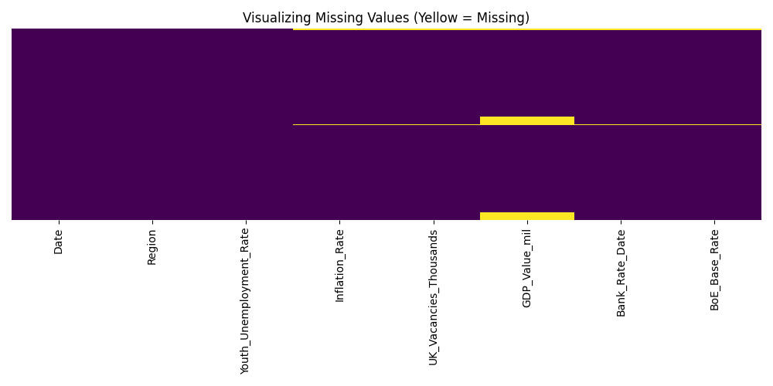
Which confirms that your features (Inflation, Vacancies, and Bank Rates) are perfectly populated across almost the entire timeframe. The yellow bands are strictly concentrated at the very top (the timestamp mismatch row) and the very bottom of the GDP_Value_mil column, showing the macro-economic reporting delay for recent quarters.
Plot 2: Youth Unemployment Timeline
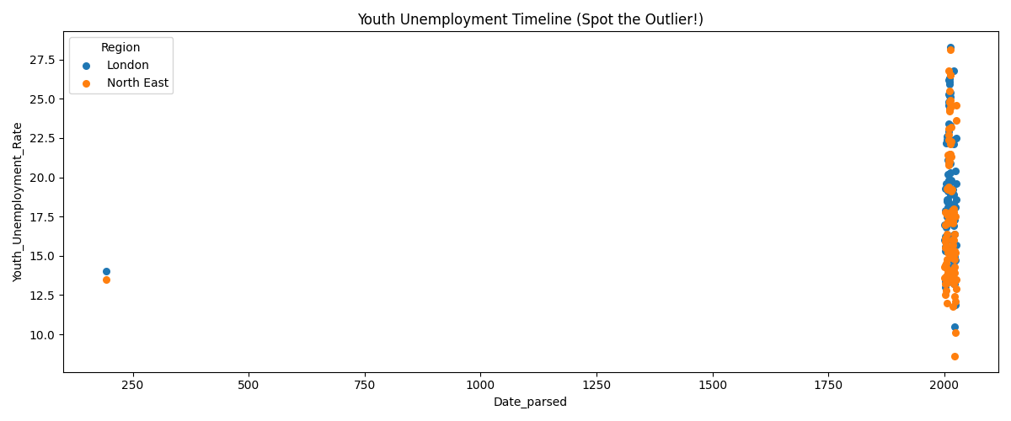
This clearly shows the extreme anomaly on the far left. The typo year 0192 compresses your entire genuine 2001–2026 timeline into a single unreadable cluster on the right.
Plot 3: Regional GDP growth overtime
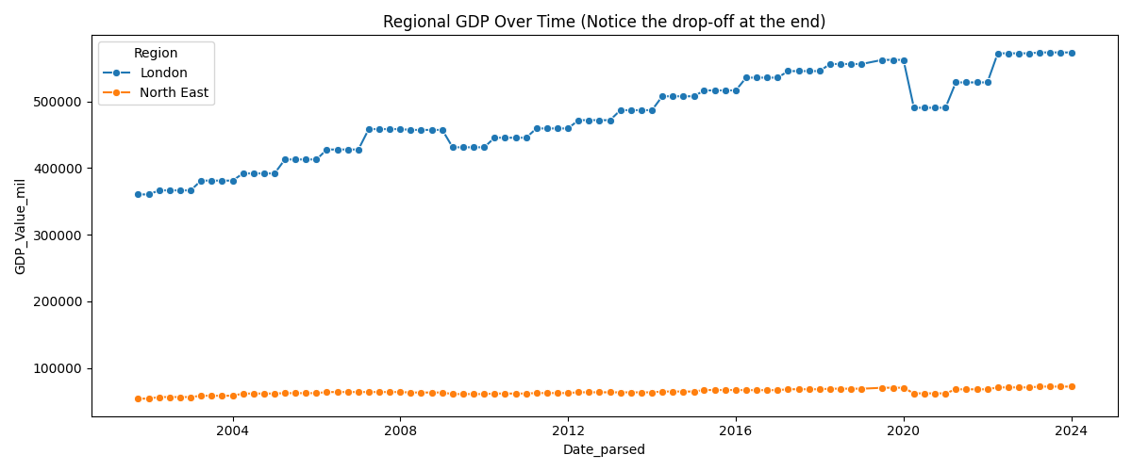
This displays a healthy, upward structural trajectory for both London and the North East. However, the lines abruptly truncate as we hit the recent 17 quarters where annual regional GDP data has not yet been finalized and published by the ONS.

Now when we were preparing the EDA script we encountered several issues which caused trouble with the plots initially. The issues were:

Problem 1 — Dates were being misread. The original script just called pd.to_datetime(df['Date']) with no extra instructions. Since most of your dates were written in the British DD/MM/YYYY style (day first, then month), pandas was guessing the format and getting it wrong. The fix was adding dayfirst=True and format='mixed' — this tells pandas "these dates are British-style, and the format varies across rows, handle each one carefully." Think of it like telling someone "when you see 03/07, read it as the 3rd of July, not March 7th."
Problem 2 — Plots were being handed the wrong column. The original script created a nicely parsed Date_parsed column but then forgot to use it — the scatter plot and line plot were still pointing at the old raw text Date column. That's like preparing a clean translated document but handing the original foreign-language version to the reader. The fix was making sure every plot uses Date_parsed instead.
Problem 3 — The GDP plot filter was wiping out all the data. The original filter said "only keep rows where the year is after 1990." Sounds reasonable — but because of Problem 1, all the dates were being misread as years in the 100s AD. So the filter threw away literally every single row, leaving nothing to plot. The fix was that once Problem 1 was solved and dates parsed correctly, year > 1990 now works perfectly and only removes the one typo row (year 192 AD).
Problem 4 — The heatmap had an extra uninvited column. When Date_parsed was created as a working column, it quietly got included in the heatmap alongside your real data columns. The fix was adding one line — cols_to_plot = [c for c in df.columns if c != 'Date_parsed'] — which simply says "plot everything except Date_parsed." Clean and surgical.
Problem 5 — The scatter plot x-axis labels were unreadable. Multiple attempts to format the datetime axis using matplotlib's date formatters all failed because matplotlib kept treating the axis as raw numbers rather than dates. Rather than keep fighting it, the fix sidestepped the problem entirely — a new Year_num column was created by extracting just the year as a plain number, and that was used as the x-axis instead. No datetime axis, no formatting headaches, just clean year numbers from 192 to 2025.

After performing this EDA, we have finally encountered the challenge of how to handle the missing values.
For the 0192 Rows: We will Drop them completely. They represent a single malformed historical artifact from a formatting error and removing them has zero negative impact on our continuous time series.
And for the other GDP values we had few options.
First we came across 2 methods: Last Observation Carried Forward (LOCF) and Linear Interpolation/Extrapolation.
Though these were good methods it has their drawbacks:
- LOCF (Forward-Fill): This was the safest way to prevent artificial variance, but it inherently assumes exactly 0% growth. Over a three-year span (2024 to 2026), this will systematically understate the size of developing economies and artificially flatten post-inflationary recoveries. Which means you are telling your model the economy flatlined at exactly 0% growth for three years.
- Linear Extrapolation: This is generally better than LOCF because it carries the historical growth trend forward. However, it is "blind" to recent macroeconomic realities it will completely ignore the impact of recent global interest rate cycles, localized recessions, or trade shifts that occurred between 2023 and 2026. Which means that you are telling your model the economy grew on a perfectly smooth, straight line with zero bumps.
Both of those are lies. The economy is bumpy, Now to solve these problems and to give our models a real world touch we will be implementing Institutional Growth Rate Splicing. Apart from this we also came across the method known as Nowcasting but we don’t require it for our project as it is a very over engineered method for this. As we don't need high-frequency, minute-by-minute GDP tracking to forecast broad structural unemployment.

Think of IGRS like this: instead of trying to build a complex algorithm to guess the missing GDP numbers or drawing a lazy straight line through the missing years, we are just going to steal the smart kid's homework.
Institutions like the IMF (International Monetary Fund) or the UK’s OBR (Office for Budget Responsibility) have teams of PhDs whose entire job is to predict how much the economy will grow or shrink each year. They publish these predicted growth rates publicly. IGRS simply means taking our last actual GDP number and multiplying it by their predicted percentages to fill in our blanks.

It will be calculated as:
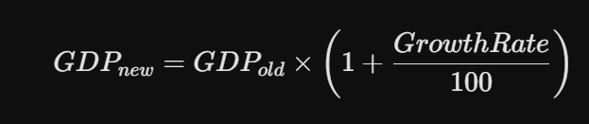

Also, because we just added "The Squeeze" (Inflation) and "The Budget" (BoE Base Rate), we have a built-in overlap: the Bank of England raises rates specifically because inflation is high. Since these two variables move together by design, they might confuse the model or artificially inflate our standard errors.
Challenge Now:
We can now have problem of multicollinearity? How we will solve it?

