Keep your Distance

Giacomo Sguotti 10667547

# **Project overview**

# **TinyOS**

# **Cooja**

# **Node-RED**

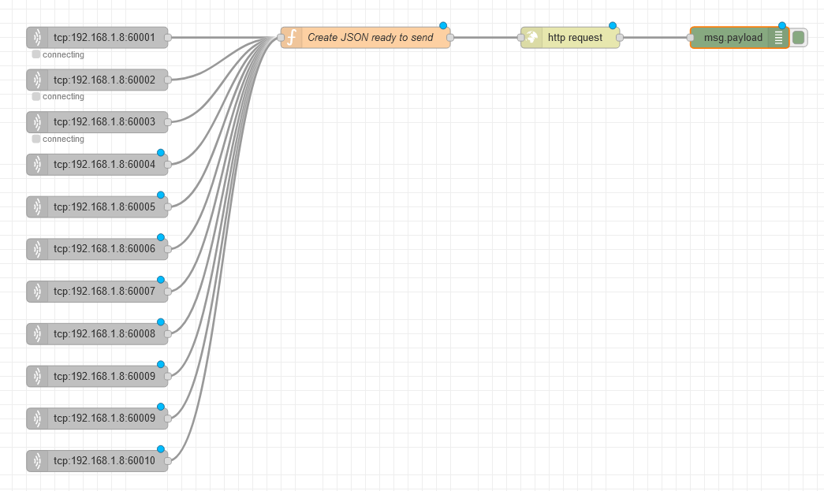Node-RED is used to interface the motes in Cooja with IFTT Applet. The flow used in this project is shown in the Figure below.

Figure : Node-RED Flow

Used nodes:

* **tcp in** node: used to connect and retrieve data generated by Cooja sockets. Each tcp in node connects to a single mote in Cooja.
* **function** node contains a javascript script which extracts sender and receiver IDs from the and creates a JSON file in the following form

{ "value1" : "<receiverID>", "value2" : "<senderID>" }

as required by WebHooks service in IFTTT described in IFTT section.

* **http request** node performs a POST request to <https://maker.ifttt.com/trigger/mote_alarm/with/key/b8tv-8GQocm3YB3g-XSmyB> with JSON created before as body, where mote_alarm is the event and b8tv-8GQocm3YB3g-XSmyB is the personal API key provided by the service.
* **debug** node for debugging purposes.

# **IFTT**

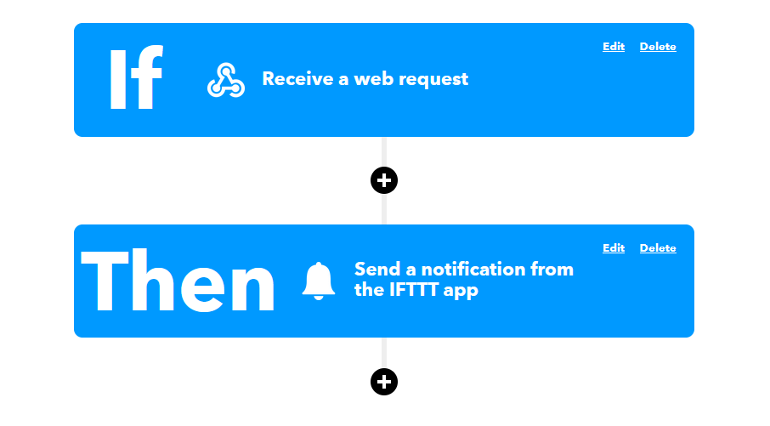I decided to use a WebHooks event to integrate node-RED with IFFT. In particular, the applet used in this project sends a notification to my mobile phone upon a reception of a HTTP POST at <https://maker.ifttt.com/trigger/mote_alarm/with/key/b8tv-8GQocm3YB3g-XSmyB> , the POST request contains a JSON body of the following form { "value1" : "", "value2" : "" } where value1 and value2 are the mote IDs of motes that triggered the alarm.

Figure : IFTT Applet