**BGY1 FC IT IDF 1 BOOK**

Table of Contents

1 General 4

1.1 Document purpose 4

1.2 Document revisions 4

1.3 Document distribution 4

1.4 Document owners 4

1.5 Local IT contacts 5

1.6 Local engineering contacts 5

1.7 BGY1 FC other contacts 5

1.8 Regional contacts 5

2 Fiber connection 6

3 IDF Location 6

4 General information 6

4.1 IDF Breakers 6

4.2 Key location 6

4.3 Inside cabinet Layout 6

4.4 Switch 7

4.5 Remote access the switch 7

4.6 UPS 7

5 Critical devices/services 7

5.1 Cameras 7

5.2 Access Points 7

5.3 KWS Base stations 8

5.4 Vendornet 8

6 UPS 8

6.1 UPS Documentation 8

6.2 UPS Start up 8

6.3 UPS Failure Procedures 8

6.4 UPS Reset Procedures 9

6.5 UPS Bypass Procedure 9

6.6 APC UPS Battery Installation and setup: 9

6.7 Emergency Power off (EPO): 9

# General

## Document purpose

There are 19 IDFs located around BGY1 FC. The layout and configuration of each IDF have to be documented.

This document gives technical details about the cabinet named IDFXX located in *COLUMN*.

## Document revisions

|  |  |  |  |
| --- | --- | --- | --- |
| **Login** | **Date** | **Version number** | **Change reason / Description** |
|  |  | 1.0 | Publishing first release |
|  |  |  |  |
|  |  |  |  |
|  |  |  |  |
|  |  |  |  |
|  |  |  |  |
|  |  |  |  |
|  |  |  |  |
|  |  |  |  |
|  |  |  |  |

## Document distribution

This document is primarily written for BGY1-IT and FC Infra Ops staffs within Amazon Group and will be made available in its final version via:  
<https://share.amazon.com/sites/fc-infra/FCStandards/FCIT%20MDF%20Books/Forms/AllItems.aspx>

This document is also printed and made available in the following locations:

* IT Office/IT Manager
* MDF
* Inside referenced IDF

The original version of this document is stored here:

**[\\ant\dept-eu\BGY1\Support\IT\04 - Infrastructure\IDF\IDF Books](\\\\ant\\dept-eu\\BGY1\\Support\\IT\\04 - Infrastructure\\IDF\\IDF Books)**

## Document owners

This document is owned by BGY1 IT department. The following table lists the contacts for recommendations and questions:

|  |  |  |  |
| --- | --- | --- | --- |
| **Name** | **Role** | **Phone** | **E-mail** |
| Beccalli Matteo | IT Engineer | +39-344-010-5581 | [mbbeccal@amazon.it](mailto:mbbeccal@amazon.it) |
| Previti Domenico | IT Engineer | +39-45-114-8975 | [doniko@amazon.com](mailto:doniko@amazon.com) |
| Proserpi Leonardo | IT Engineer | +39-345-724-4929 | [leoprose@amazon.com](mailto:leoprose@amazon.com) |
| Toro Gaetano | IT Engineer | +39-342-997-9174 | [gaettoro@amazon.it](mailto:gaettoro@amazon.it) |
| Zani Arber | IT Engineer | +39-347-630-5809 | [arzani@amazon.com](mailto:arzani@amazon.com) |

## Local IT contacts

|  |  |  |  |
| --- | --- | --- | --- |
| **Name** | **Role** | **Phone** | **E-mail** |
| Mario Trovato | IT Manager | +39-340-735-9231 | [mttrovat@amazon.it](mailto:mttrovat@amazon.it) |
| Beccalli Matteo | IT Engineer | +39-342-775-8389 | [mbbeccal@amazon.it](mailto:mbbeccal@amazon.it) |
| Previti Domenico | IT Engineer | +39-342-760-8782 | [doniko@amazon.com](mailto:doniko@amazon.com) |
| Proserpi Leonardo | IT Engineer | +39-342-071-9068 | [leoprose@amazon.com](mailto:leoprose@amazon.com) |
| Toro Gaetano | IT Engineer | +39-346-188-7635 | [gaettoro@amazon.it](mailto:gaettoro@amazon.it) |
| Zani Arber | IT Engineer | +39-348-406-1124 | [arzani@amazon.com](mailto:arzani@amazon.com) |
| Carpinato Matteo | IT Technician | +39-342-863-3236 | [mcarpina@amazon.it](mailto:mcarpina@amazon.it) |
| Conti Sebastiano | IT Technician | +39-344-034-9301 | [sebconti@amazon.com](mailto:sebconti@amazon.com) |
| Dimilito Nicola | IT Technician | +39-349-702-4817 | [dimilito@amazon.com](mailto:dimilito@amazon.com) |
| Fontana Enrico | IT Technician | +39-349-769-2381 | [enricofo@amazon.com](mailto:enricofo@amazon.com) |
| Iannotti Raffaele | IT Technician | +39-345-970-2079 | [iannotr@amazon.it](mailto:iannotr@amazon.it) |

Oncall:  <https://oncall.corp.amazon.com/#/view/bgy1-opstechit/schedule>

Organization: <https://fcinfra.amazon.com/site_details/index/BGY1>

## Local engineering contacts

|  |  |  |  |
| --- | --- | --- | --- |
| **Role** | **Name** | **Phone** | **E-mail** |
| RME Manager | Luciano Caligiuro | +39-344-075-2280 | [lucaligi@amazon.it](mailto:lucaligi@amazon.it) |
| RME Area Manager | Alessandro Ziliani | +39-342-832-5751 | [alezilia@amazon.com](mailto:alezilia@amazon.com) |
| RME Area Manager | Federico Simone |  | [federisi@amazon.it](mailto:federisi@amazon.it) |
| Automation engineer | Alessandro Beltramelli | +39-346-119-1250 | [alebtr@amazon.it](mailto:alebtr@amazon.it) |
| Automation engineer | Luca Pirotta | +39-349-440-7872 | [lucapiro@amazon.it](mailto:lucapiro@amazon.it) |
| Automation engineer | Roberto Teli | +39-347-141-4793 | [robiteli@amazon.com](mailto:robiteli@amazon.com) |

## BGY1 FC other contacts

|  |  |  |  |
| --- | --- | --- | --- |
| **Role** | **Name** | **Phone** | **E-mail** |
| GM | Silvano Soloperto | +39 344-210-3794 | [silvanos@amazon.it](mailto:silvanos@amazon.it) |
| LP Manager | William Di Santo | +39-342-648-9578 | [santows@amazon.it](mailto:santows@amazon.it) |
| Security | Security Desk | +39-036-323-3001 | [bgy1-security@amazon.com](mailto:bgy1-security@amazon.com) |
| Reception | Same as Security | +39-036-323-3001 |  |

## Regional contacts

|  |  |  |  |
| --- | --- | --- | --- |
| **Role** | **Name** | **Phone** | **E-mail** |
| Regional IT Manager | Giovanni Vacca | +39-340-125-8071 | [gvvacca@amazon.it](mailto:gvvacca@amazon.it) |

# Fiber connection

|  |  |  |
| --- | --- | --- |
| **OPTICAL MULTIMEDIA (OM)** | **CORES** | **LENGTH** |
| Nexans N164.MBUN24-YB  LANmark-OF Micro-Bundle Universal 24x Singlemode OS2 LSZH B2ca Yellow | 12 | 417m |

# IDF Location

The square on the site layout below indicates the exact location of the IDF:

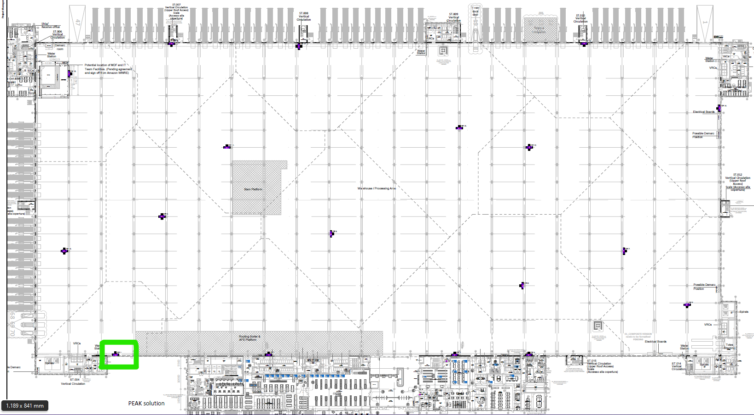

Hall 3 Hall 4

# General information

## IDF Breakers

|  |  |  |  |
| --- | --- | --- | --- |
| **Panel** | **FAN+UPS** | **230V sockets** | **Location of the panel** |
| DB/DL1.1 | N37 | N32 | L1 ‐ C1 |

## Key location

Each member of the IT team has a key of the IDF cabinet. An additional one is stored in the key box.

## Switch

## Aggregators

# Critical devices/services

## Cameras

## Access Points

# UPS

There is a UPS system installed inside the IDF. The UPS is equipped with a network card, connected to the LAN and monitored ([IT Monitoring - UPS](https://it-monitoring.amazon.com/BGY1/status?Query=ups)). Access to the management interface of the UPS is done via:

## UPS Documentation

Full documentations of UPS and inside network card are available at the following location:

<https://policy.amazon.com/procedure/4510>

<https://policy.amazon.com/procedure/2257>

## UPS Start up

1. Connect Devices to the power outlets at the back of the UPS

2. Connect UPS to Building Power

3. Press the ON/OFF button on the front panel of the UPS to power the unit and all connected equipment.

## UPS Failure Procedures

In the event that an IDF UPS fails please do the following:

* A Trouble Ticket will be created if the UPS fails as all of the Switches in that IDF will power off
* Update the ticket to state that you are going to the IDF to investigate the failure and that you have the UPS bypass device
* Check the display for an error message (see the troubleshooting issues with UPS section)
* Reset the UPS and monitor to ensure power is now being supplied to the switch stack (reset button on back of UPS above input power. Also documented on the next page)
* In the event that the UPS does not recover or this is the second unit failure within 14 days then  go to the bypass process documented in this document
* Once power is restored to the switches get the on-call or on-site IT Engineer to monitor the switches coming back up and making sure all switches are showing in the stack
* When all of the devices in the IDF are back operational put the ticket to a Sev 5 and pending verification of fix
* We should contact APC and let them know the device has failed. They will require the serial number and model type of this device. APC will ask lots of questions regarding the UPS and the environment it is working in.
* Once APC Has been contacted update the ticket with the current status i.e. they will replace the device or they will repair it and when
* If the APC unit is being replaced these actions will require a CM

## UPS Reset Procedures

If the UPS has failed we need to reset the circuit breaker to do this we should

1. Open the back of the IDF cabinet
2. Press the Reset button on the circuit breaker (this is located above the input power socket)

## UPS Bypass Procedure

In the event that an IDF UPS fails please do the following:

* In the event that the UPS has failed and is failing to recover or this is the second unit failure within 14 days then  proceed with the bypass process: -
  + Disconnect all the switches from the **UPS**
  + Plug all the switches into the bypass (direct power from the building) and monitor the switches
* Once power is restored to the switches get the on-call or on-site IT Engineer to monitor the switches coming back up and making sure all switches are showing in the stack

Update the ticket noting that this device is now in place bypassing the UPS and that further checks into the UPS will be done. Change the ticket severity level to a 5

* We should contact APC and let them know the device has failed. They will require the serial number and model type of this device. APC will ask lots of questions regarding the UPS and the environment it is working in.
* Once APC Has been contacted update the ticket with the current status i.e. they will replace the device or they will repair it and when
* If the APC unit is being replaced these actions will require a CM

## APC UPS Battery Installation and setup:

* First, remove the front Bezel
* Then, loosen the thumbscrew either by hand or with a Philips head screw driver.
* The battery door can then be removed and set aside.
* Next, Grasp the pull tab on the battery and slide it out.
* Replace with a new battery, close front door and reinstall the front bezel.
* Reset the date of battery installation into the UPS   
  Menu-> Configuration-> Date of last battery replacement
* Dispose-off old battery properly.
* This will finish the Battery installation process.

## Emergency Power off (EPO):

The Emergency Power off (EPO) option is a safety feature that will immediately disconnect all the connected equipment from utility power. The UPS will immediately shut down and will not switch to battery power. The UPS must be manually re-started to re-apply power to connected equipment and to the UPS.

Press ON/OFF on the front panel of the unit.

## Troubleshooting issues with UPS

Problem and Possible Cause Solution

Q: The UPS will not turn on or there is no output  
A: The unit has not been turned on. Press the ON button once to turn on the UPS.

Q: The UPS is not connected to utility power.  
A: Ensure that the power cable is securely connected to the unit and to the utility power supply.

Q: The input circuit breaker has tripped.  
A: You may have a faulty device connected to the UPS which is causing it to trip ask an electrician for advice on this

Q: The unit shows very low or no input utility voltage.  
A: Get an Electrician to test the circuit feeding the UPS

Q: The battery connector plug is not securely connected.  
A: Ensure that all battery connections are secure.

Q: There is an internal UPS fault. The Fault indicator is lit and the UPS displays a fault message and emits a constant beeping sound Internal UPS fault.  
A: Do not attempt to use the UPS. Unplug the UPS and have it serviced immediately. Use the UPS by-Pass Procedure documented in this document

Q: The UPS is operating on battery, while connected to input utility power  
A: The input circuit breaker has tripped. You may have a faulty device or circuit breaker get the electrician to advice on this and also call APC and inform them of this. If this is un-able to be resolved quickly then connect up the UPS by-pass (seek manager’s approval if you have time to do this)

Q: There is very high, very low, or distorted input line voltage.  
A: Have an electrician test this and if they cannot provide a fix you may want to reduce the sensitivity of the UPS slightly

Q: UPS is emitting an audible beeping sound  
A: The UPS is in normal operation. None. The UPS is protecting the connected equipment.

Q: UPS does not provide expected backup time  
A: The UPS battery is weak due to a recent outage or is near the end of its service life. Charge the battery. Batteries require recharging after extended outages and wear out faster when put into service often or when operated at elevated temperatures. If the battery is near the end of its service life, consider replacing the battery even if the replace battery indicator is not yet illuminated.

Q: The UPS is overloaded.   
A: Check the UPS load display. Unplug unnecessary equipment and have an electrician check the load of the switches versus the UPS and if the UPS is at fault contact APC

Q: Display interface indicators flash sequentially  
A: The UPS has been shut down remotely through software or an optional accessory card. None. The UPS will restart automatically when utility power returns.

Q: All indicators are illuminated and the UPS is plugged into a wall outlet  
A: The UPS has shut down and the battery has discharged from an extended outage. The UPS will return to normal operation when the power is restored

Q: The replace battery indicator is illuminated  
A: The battery has a weak charge. Allow the battery to recharge for at least four hours. Then, perform a self-test. If the problem persists after recharging, replace the battery.

Q: The replacement battery is not properly connected.  
A: Ensure that the battery connector is securely connected.

Q: The display interface has a Site Wiring Fault message  
A: Wiring faults detected include missing ground, hot-neutral, polarity reversal, and overloaded neutral circuit. If the UPS indicates a site wiring fault, have a qualified electrician inspect the building wiring.