Calculating within and between distances using MegaX

# Download Mega-X software

Mega can be downloaded from <https://www.megasoftware.net/>. The current version at time of writing is MegaX.

# Prepare sequences

When working in Mega, sequences will need to be partitioned to do the diversity calculations. Mega imports the sequences in the same order as they are listed in the fasta, making it relatively easy to apply annotations in the program. To minimize error and aid in quickly identifying the different groups, it is recommended to append an annotation to the def line of the fasta. For the purpose of this diversity analysis, I tacked the information onto the end.

>Cambodia/22-2107200509/2021|unvax

>Cambodia/779299/2021|vax

# Loading sequences into Mega-X

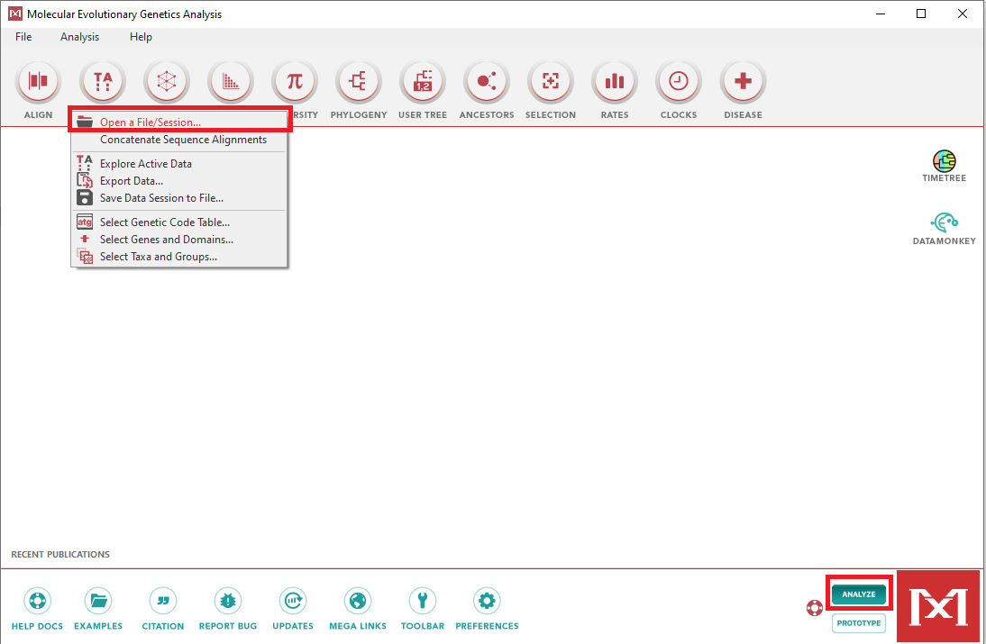

In analyze mode, navigate to open a file, and open the relevant alignment. The alignment should be opened for analysis, not alignment.

# Partitioning taxa and groups

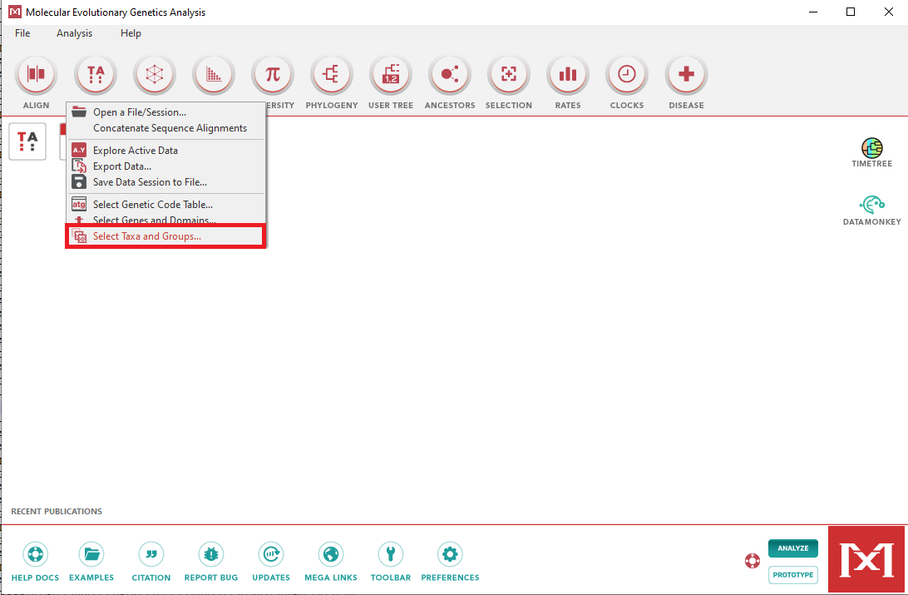

Goto Data > Select Taxa and Groups. Create a new group for each partition.

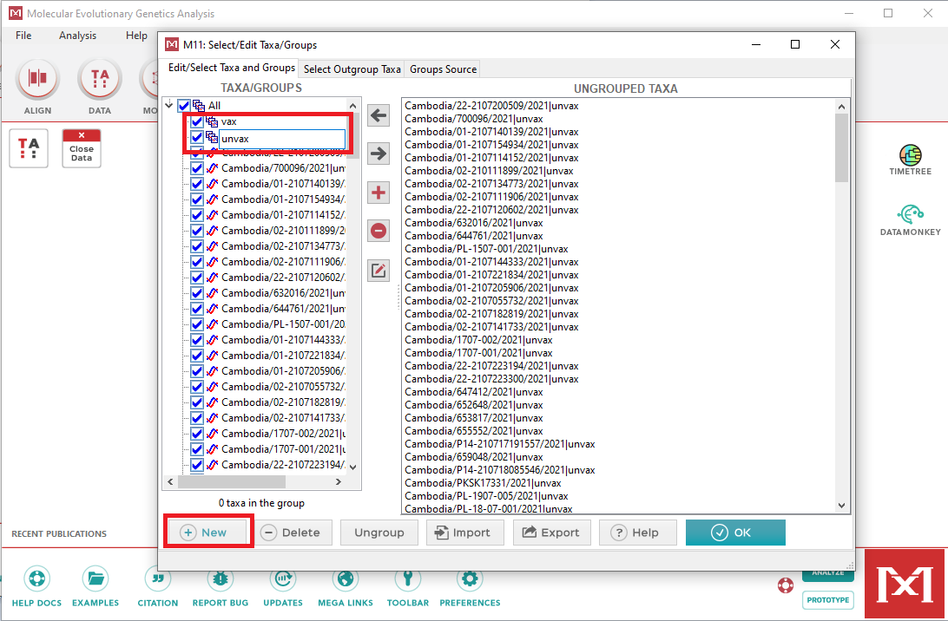

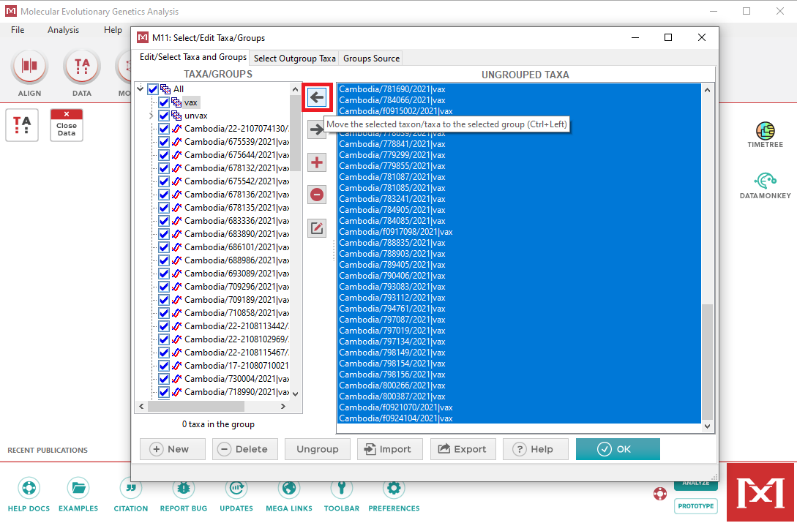

Move the relevant taxa over.

# Computer within and between distances

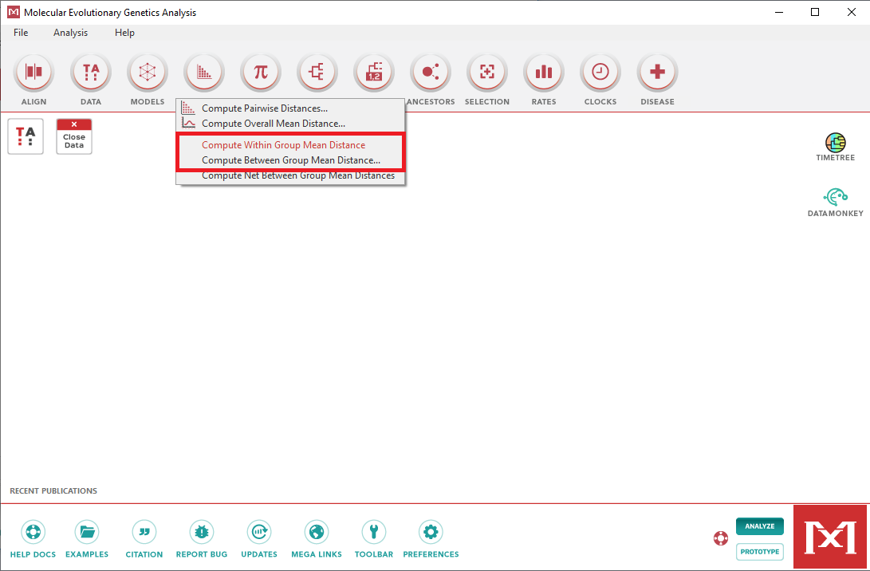

Distance calculations can be found under the Distances option.

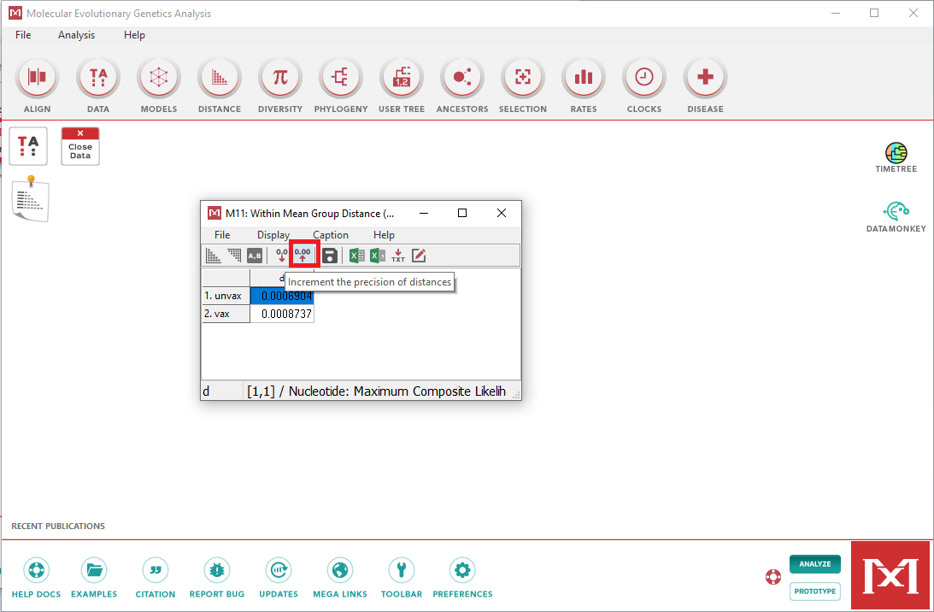

If more decimals are needed, the placements can be increased. How the calculations for these distances are performed are not explained very well within the Mega manual.

# Additional diversity calculations

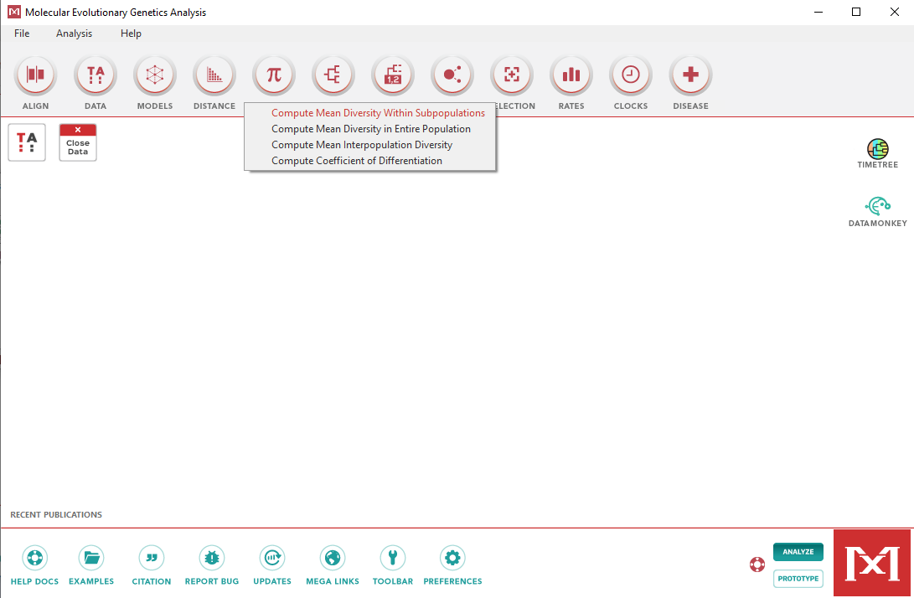

Additional diversity calculations can be performed by Mega as needed.