

An-Najah National University
Faculty of engineering
Computer Engineering Department

Distributed and Operating Systems
Instructor: Dr. samer arandi
Studant :
حلا فائق حبش 12112591
لؤى محمد عوايص 12111992

Lab 1: Bazar.com: A Multi-tier Online Book Store

Introduction
Bazar.com is a web multi-layer bookstore with a microservices-based architecture. PHP and the Lumen micro-framework are employed in the system to handle book queries and buying requests efficiently. SQLite is used for storing persistent data to achieve light and easily maintainable operations. The project is containerized with Docker for easy deployment and sharing across various environments.

System Architecture
The system follows a two-tier microservices architecture comprising three core components:
- Front-End Service : a communication layer between the front-end system and two core back-end services: the Catalog Service and the Order Service.
- Catalog Service: Maintains book inventory, pricing, and categorization.
- Order Service: Processes purchase requests and updates stock levels accordingly.

Microservices Communication
RESTful APIs over HTTP are used by all microservices to communicate, guaranteeing scalability and modularity. Every service makes available specific endpoints for carrying out particular tasks.

Implementation Details
- Programming Language: PHP
- Framework: Lumen
- Database: SQLite
- Containerization: Docker

Process Flow
First we create project contain 3 services we builds each service usng cmd:
composer create-project --prefer-dist lumen/lumen
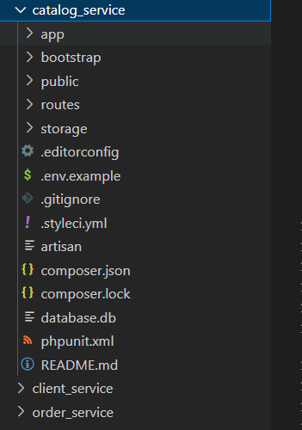
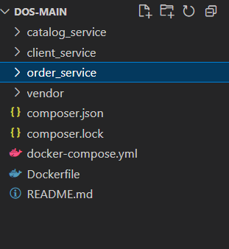

Start write the code for each components inside app\Http\Controllers for each one
(the code in githup)(link for the githup : https://github.com/LoaaAwayes/Dos).
In catalog_service\app\Http\Controllers\CatalogController.php ,We implement these functions :
- searchByTitle
- getItemDetails
- updateItem

and for each function we define routes as follows in catalog_service\routes\web.php:
$router->get('search/topic/{title}', 'CatalogController@searchByTitle');
$router->get('item/{id}', 'CatalogController@getItemDetails');
$router->put('book/{id}', 'CatalogController@updateItem');

in order_service\app\Http\Controllers\OrderController.php , we implement these functions:
- purchase

and we define routes as follows in order_service\routes\web.php:
$router->post("purchase/{id}",'OrderController@purchase');
$router->put('purchase/{id}','OrderController@purchase');
In client_service\app\Http\Controllers\ClientController.php:
We implement same function in OrderController and CatalogController but it was take the request from browser and send it to OrderController and CatalogController then take response and send it to the browser .
and we define routes as follows in client_service\routes\web.php:
$router->get('/client/{any:.*}', 'ClientController@handleFront');

Then we test it using postman and web browser .

After tat we moved in the docker we implement the docker file and the docker-compose in the project root . and to build the images and containers we use cmd :
docker-compose up --build -d
The command rebuilds the Docker images, starts the containers in the background, and runs the services defined in the docker-compose.yml file
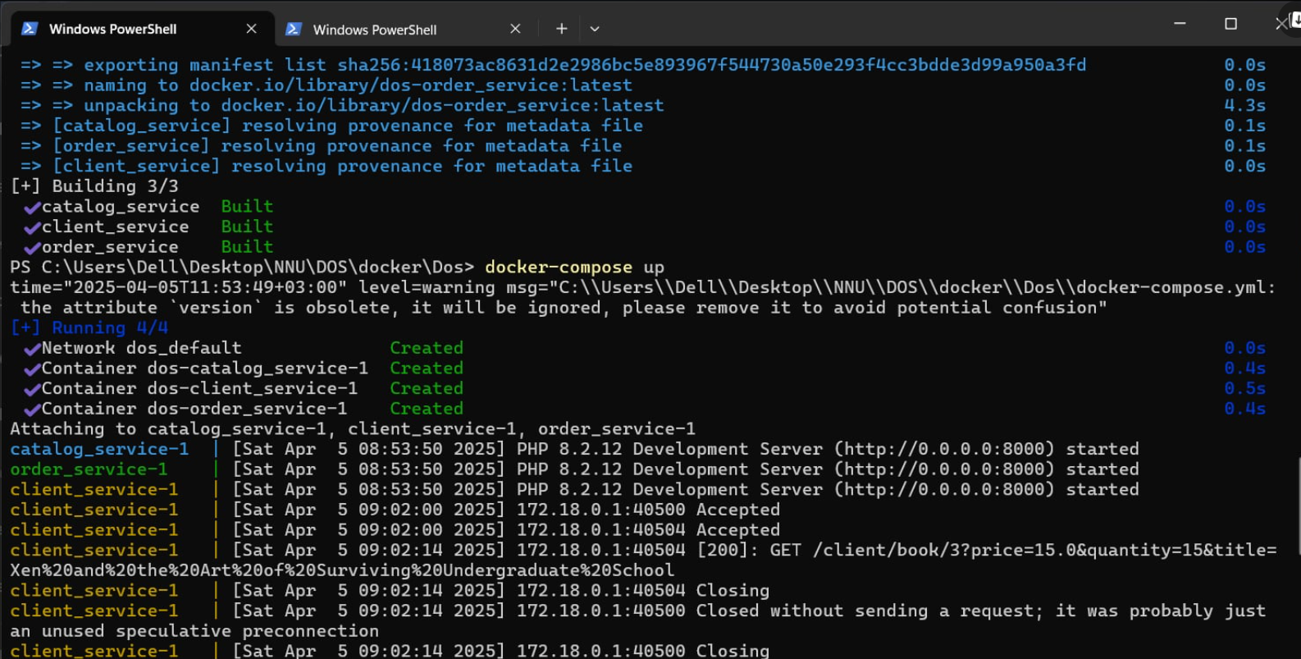
After this we test the database if it work an the program :
The database :
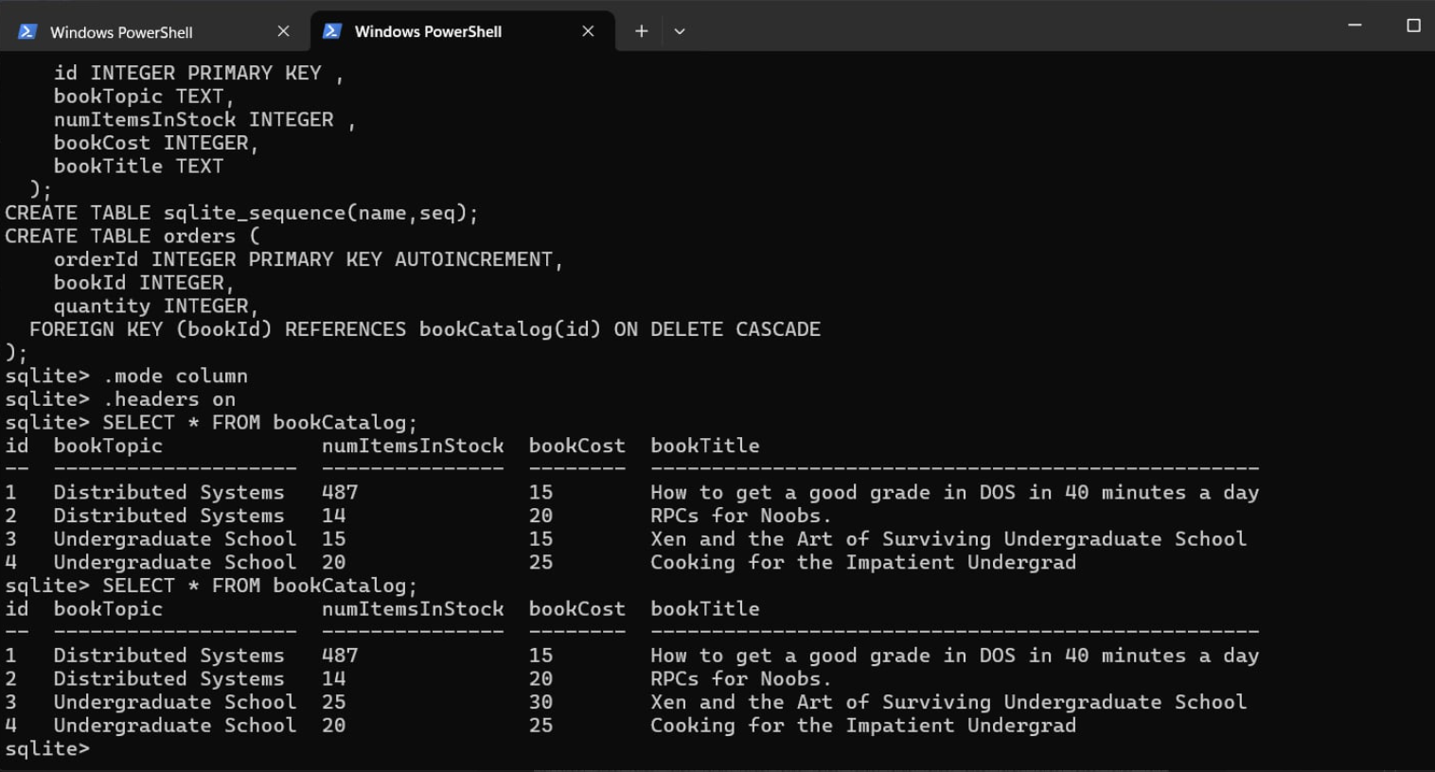

then we tested some operations :
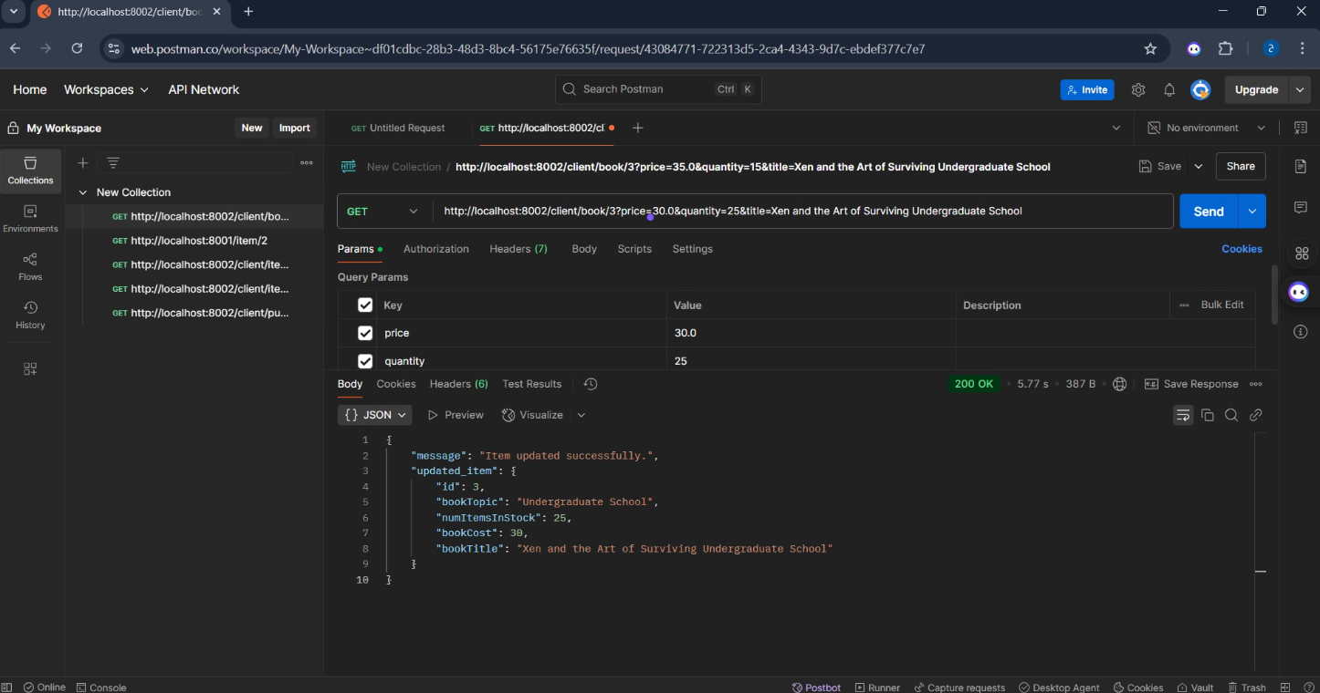

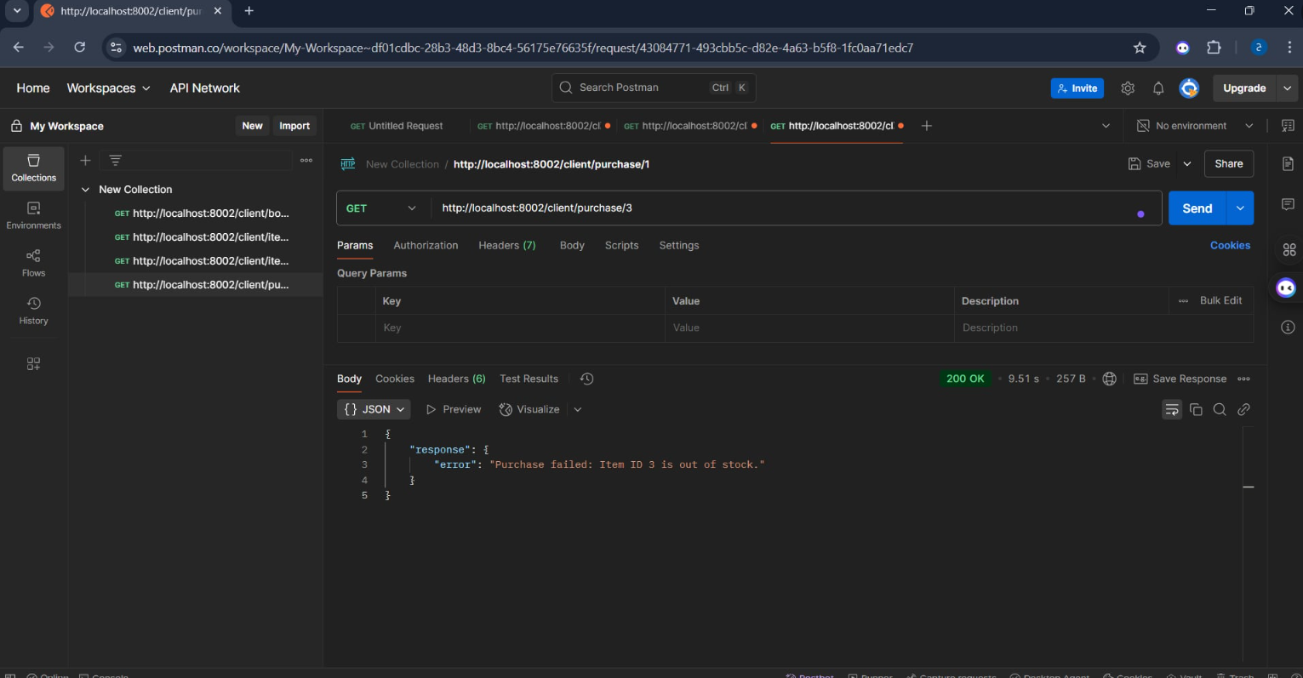
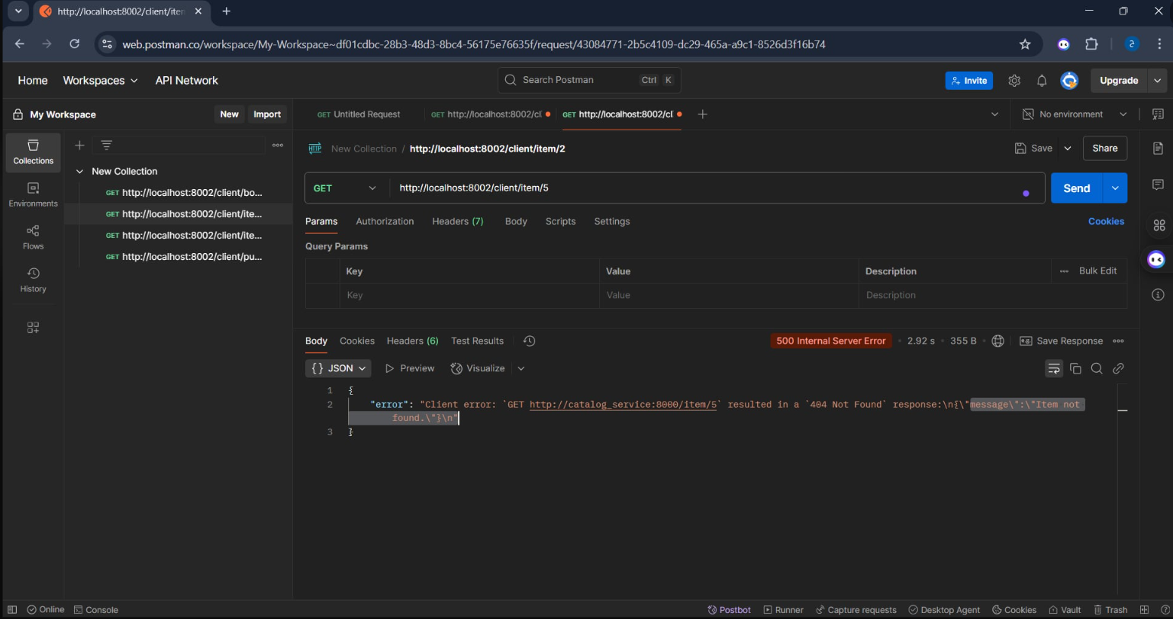

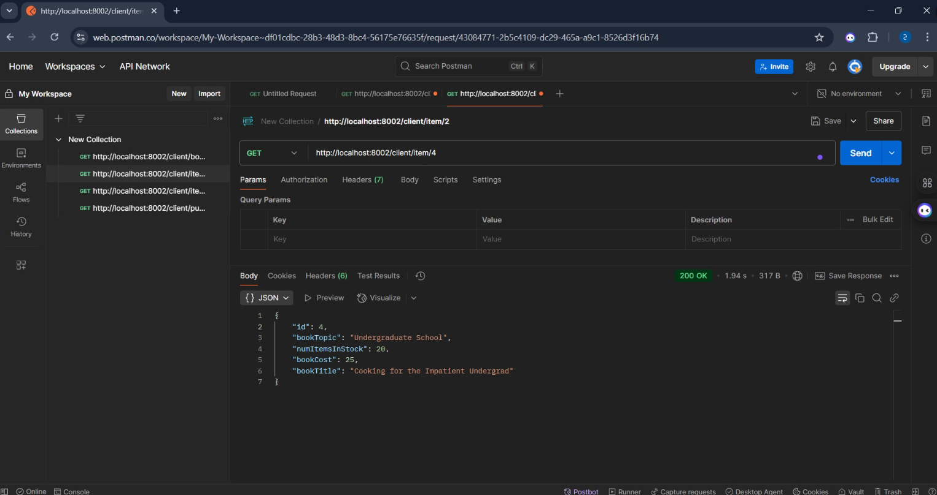

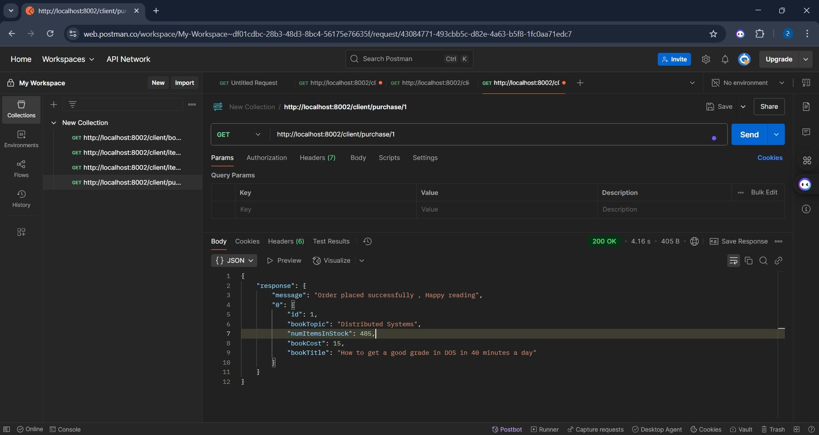

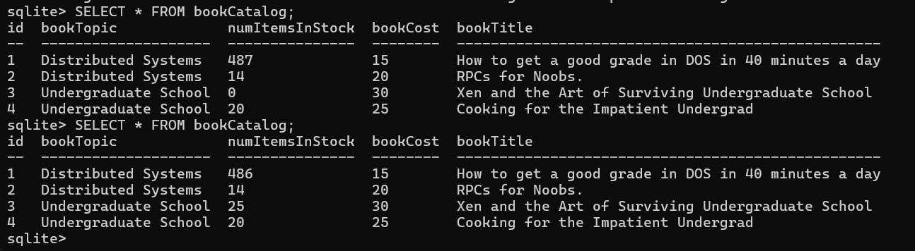
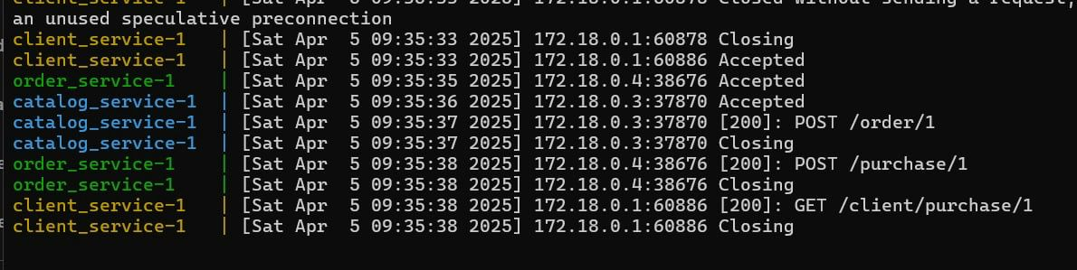

Development Challenges:
During the development of the system, one of the key challenges faced was the repetition of files and logic across the three microservices. Initially, separate codebases were created for the front-end, catalog, and order services. This resulted in redundant files and duplicated logic, which increased maintenance overhead and the potential for inconsistencies. To address this issue in future iterations, the repeated files and logic can be moved into shared libraries or components that can be imported and reused across all services

Conclusion:
Bazar.com effectively illustrates the application of microservices architecture to an online bookstore. Based on the powers of Lumen, PHP, and SQLite, the system reaps the benefits of simplicity, modularity, and efficient handling of data. Portability and scalability are further enriched by containerization via Docker, making it an adaptive solution for future growth.

