# Model 5

## Descriptive research and modeling(描述性研究与建模)

**When there are different degrees of variation in the local environment, the decomposition ability of different fungal populations and the importance and role of fungi for biodiversity.**

**（**在当地环境中存在不同程度的变异时，不同真菌种群的生物多样性的重要性和作用。**）**

We initially wanted to use the population competition model established previously to determine the overall efficiency of fungal community diversity on litter decomposition. However, considering the simple superposition of fungi in the context of population competition model and deciduous decomposition model, the simple is not representative of fungi under natural conditions. Therefore, we collected a large amount of information and data on fungal diversity and related biological functions under natural conditions from the paper given by the question’s paper and other related papers. The influence of fungal species analyzed above on decomposition efficiency was added into the judgment index, and other data from the paper reviewed were added to describe the importance and effect of fungal diversity on biodiversity.

（我们最初想利用之前建立的种群竞争模型来确定真菌群落多样性对凋落物分解的整体效率。但是，考虑到真菌在种群竞争模型和落叶分解模型背景下的简单叠加，这种简单并不能代表自然条件下的真菌。因此，我们从问题的论文和其他相关论文中收集了大量的自然条件下真菌多样性和相关生物功能的信息和数据。将上述分析的真菌种类对分解效率的影响添加到判断指标中，并加入综述文献中的其他数据来描述真菌多样性对生物多样性的重要性和作用。）

## The conclusions obtained by this model

1.

When there were more species of fungi, the effect of population competition would reduce the decomposition efficiency of fungi to dead leaves. The answer can be found in a previously established model of population competition. It can be found from the population competition model that S fungus has a strong population competition activity. In the case of the 7 species of fungi we are divided into, so S fungus will take a great advantage in the end. However, the decomposition ability of S fungus to dead branches and leaves is not high, so the decomposition ability will be decreased in the case of more fungal species.

(当真菌种类较多时，种群竞争效应会降低真菌对枯叶的分解效率。答案可以在先前建立的人口竞争模型中找到。从种群竞争模型中可以发现S菌具有较强的种群竞争活动。在我们将真菌分为7种的情况下，最终S真菌将获得很大的优势。但S菌对枯枝枯叶的分解能力不高，当真菌种类较多时，其分解能力会降低。)

2.

From the data and conclusions given in the literature cited below, it can be concluded that fungi are very important to a biological system. Whether it is other species, the chemical composition of the environment in which the fungus lives, or even the chemical substances secreted by other species, all affect the ability of the fungus to decompose and its biological activity. However, due to the complex environmental factors of fungi and the wide distribution of the seven fungi we have classified, we cannot accurately understand the roles and functions of these fungi in the biological systems they live in. Even the literature on fungal biological environment is extremely lacking, and we can only draw useful conclusions from a few of them, and the details we get can be seen below.

(从下面引用的文献中给出的数据和结论，可以得出真菌对生物系统非常重要的结论。无论是其他物种，真菌生存环境的化学成分，甚至是其他物种分泌的化学物质，都影响着真菌的分解能力和生物活性。然而，由于真菌的环境因素复杂，我们所分类的7种真菌分布广泛，我们无法准确地了解这些真菌在其所生活的生物系统中的作用和功能。甚至关于真菌生物环境的文献也极其缺乏，我们只能从其中的少数几个得出有用的结论，我们得到的细节如下。)

But we still extracted useful information from these few papers. First, fungi parasitize more species from herbaceous plants than shrubs. It is possible that herbaceous plants have a high demand for decomposition due to their rapid metabolism and thus attract a large number of different species of fungi. Second, Forest fungi can shape the diversity and composition of herbivorous insect species. Forest fungi provide nutrients to insects by breaking down things like leaves. But the underlying molecular mechanisms are poorly understood because of these community-level effects. Third, Temperature may alter the pattern of plant litter in streams during fungal decomposition. Different plant litter decomposition capacity of fungi can affect the mass flow of other heterotrophic resources by changing substrate composition and nutrient utilization.

(但我们仍然从这几篇论文中提取了有用的信息。首先，真菌寄生在草本植物上的种类多于灌木。草本植物由于其快速的新陈代谢，对分解的要求很高，因此吸引了大量不同种类的真菌。其次，森林真菌可以塑造草食性昆虫种类的多样性和组成。森林真菌通过分解树叶等物质为昆虫提供营养。但由于这些社区水平的影响，潜在的分子机制尚不清楚。第三，温度可能改变溪流中植物凋落物在真菌分解过程中的格局。真菌不同的凋落物分解能力可以通过改变基质组成和养分利用来影响其他异养资源的质量流动。)

Detail:

1. The transition from native shrubs to non-native herbaceous plants may reduce the abundance and abundance of some symbiotic fungi in soil taxa. The role of these potentially high relative abundances of parasitic fungi in the grass may be a density-dependent result, considering that the density of invasive grasses is higher than that of shrubs.

2.1 In this part of details, the molecular, physiological, chemical, biochemical and ecological interactions of tree fungi are discussed, and the current research progress on direct and indirect effects of tree fungi on insects is summarized, which leads to a better understanding of fungus-tree-insect interactions to see how fungi contribute to biodiversity under these conditions.

2.2 Table1

<../接下来的语文建模可能会用到的真菌多样性相关论文/友还是敌人寄生在树叶上的真菌病原体和内生真菌在树虫相互作用中的作用.pdf>

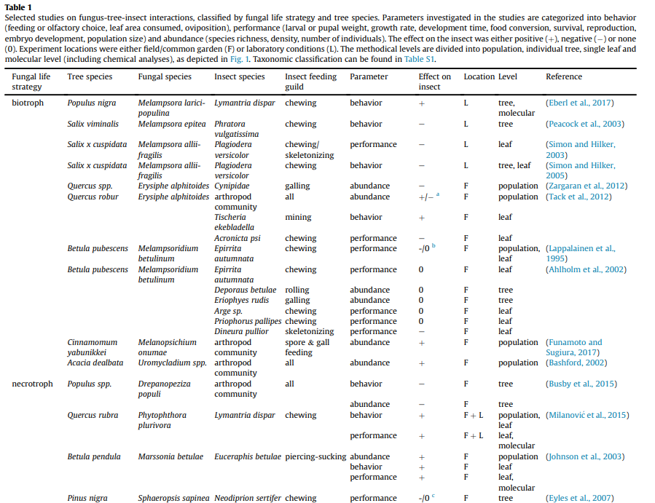

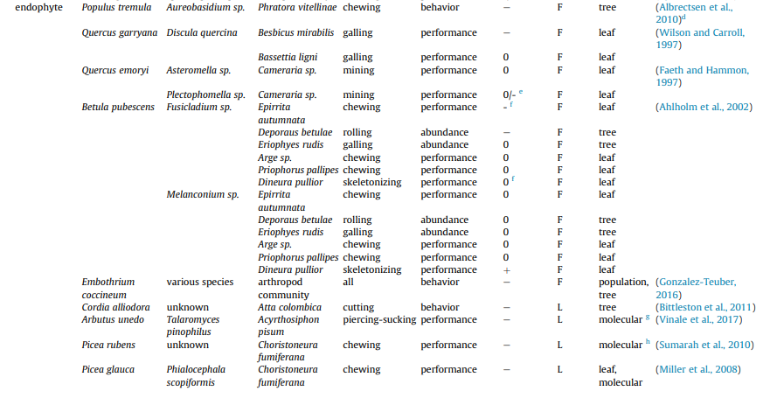

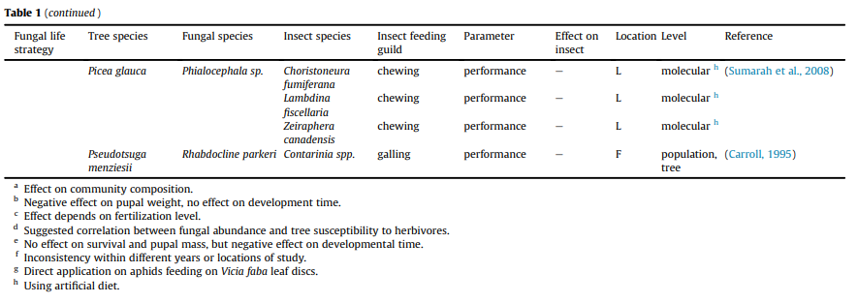

Current knowledge on the direct and indirect effects of arboreal fungi on herbivorous insects is summarized. Finally, some suggestions on the future research direction are put forward. The effects of plant parasitic fungi on herbivorous insects can be directly from fungi to insects or indirectly through fungi to change the host. Plants can induce direct effects by ingesting fungal tissues or by producing compounds from fungi. Insects can directly benefit from fungi by supplying tissues with nitrogen, hydrolase, choline, sterols, or B vitamins. Parasitic fungi can directly or indirectly affect plant-insect interactions by producing compounds or altering the metabolism of the host plant. Descriptive studies have shown that current forest fungi can shape the diversity and composition of herbivorous insect species but the underlying molecular mechanisms are poorly understood because of these community-level effects.

While the interactions of individual species with immature trees do not reflect the true picture, we believe it helps us to understand the overall mechanism.

3. Mixed forests show higher diversity than coastal redwoods and shrubs, while fungal diversity may be related to this higher diversity of plant hosts and available substrates. In addition to that, fungi in shrubs have characteristics that enable spores to survive and spread in harsh, dry and open environments.

4.1 By analyzing the reaction changes of the four hydrophilic bacteria in four of the same fungal environments to temperature (you can refer to the fig 4.2), we can roughly obtain the data changes of different surrounding fungi and humid environment. Then the influence of fungal diversity on the surrounding environment was obtained.

The growth of fungi increased with the increase of fungal diversity in the optimal temperature range, but decreased with the increase of fungal diversity outside the optimal temperature range. If this happens in nature, temperature, in addition to affecting the performance of individual species, may also be a key factor in determining interspecific relationships of aquatic fungi, leading to the dominance of migratory species. This could change the genetic pattern of plant litter during fungal decomposition in rivers. Because fungi are the main decomposers of leaves and microorganisms. Different plant litter decomposition capacity of fungi can affect the mass flow of other heterotrophic resources by changing substrate composition and nutrient utilization. Finally, since invertebrate scavengers like to feed on the leaves parasitized by certain fungi, species interactions at elevated temperatures may also decouple energy flows, nutrient cycles, and nutrient interactions in food webs in freshwater sediments.

4.2<../接下来的语文建模可能会用到的真菌多样性相关论文/温度对水生真菌的种间关系的影响.pdf>

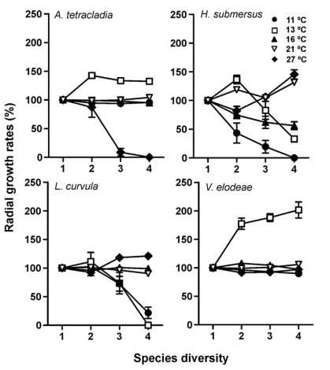

----Effects of temperature on the radial extension rates of fungal species in multiculturism of up to four species. Extension rates of each species in multiculturism were expressed as % of that of each species in monoculture. Mean ± SEM, n = 4.