The basic form of multiple linear regression is as follows.
The population regression is
And the sample regression model is
(e是随机误差)
The sample observations were substituted into the population regression model
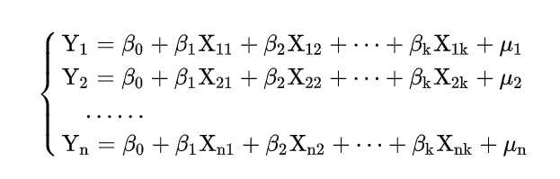
Then we get the matrix of the sample regression model is expressed as
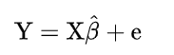

This model can well describe the relationship between independent variables such as growth rate, temperature, humidity and the dependent variable, decomposition rate.
In order to gain the necessary parameters of multiple linear regression, we determine to use the least square method to estimate.
The residual sum of squares of the model is
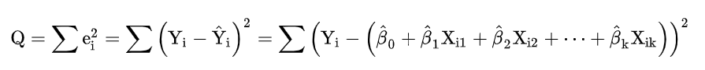
Take the partial derivative of the parameter and set it equal to 0 to get the normal equation,
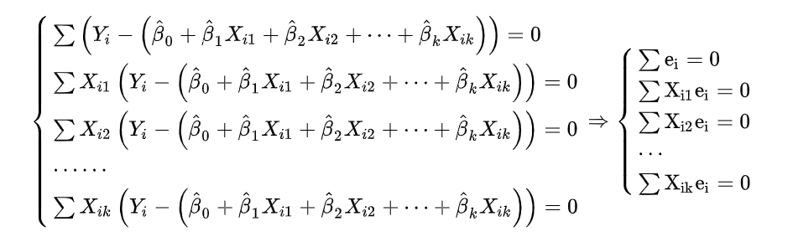
Here we use a matrix to represent the normal equation as 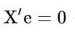
For the sample equation is described in matrix form: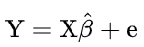
Multiply both sides of this equation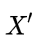
We get the equation: 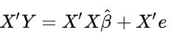
then combine the normal equation,
we get 