REGISTERED REPRESENTATION SHEET
Applicant: Wagh Sarthak Rajan
Title of Article: Adaptive Streetlight Controller

Sheet No.: 1 No. of Sheets: 7

FRONT VIEW

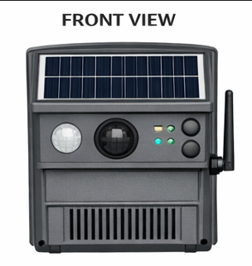
Novelty resides in the shape, configuration, and surface ornamentation of the Adaptive Streetlight Controller as illustrated.
No claim is made by virtue of this registration in respect of any mechanical or other action of the mechanism or in respect of any mode or principle of construction.
No claim is made by virtue of this registration to any right to the exclusive use of words, letters, numbers, colours, trademarks, or extraneous matter appearing in the representation.

Dated this 31 day of December 2025

Sheet No.: 2 No. of Sheets: 7

PERSPECTIVE VIEW

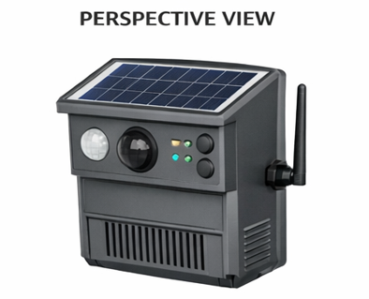
Novelty resides in the shape, configuration, and surface ornamentation of the Adaptive Streetlight Controller as illustrated.
No claim is made by virtue of this registration in respect of any mechanical or other action of the mechanism or in respect of any mode or principle of construction.
No claim is made by virtue of this registration to any right to the exclusive use of words, letters, numbers, colours, trademarks, or extraneous matter appearing in the representation.

Dated this 31 day of December 2025

Sheet No.: 3 No. of Sheets: 7

BACK VIEW

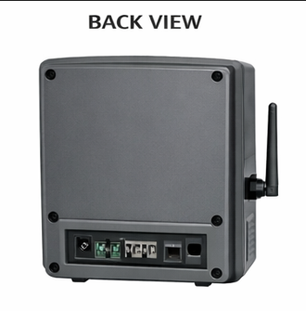
Novelty resides in the shape, configuration, and surface ornamentation of the Adaptive Streetlight Controller as illustrated.
No claim is made by virtue of this registration in respect of any mechanical or other action of the mechanism or in respect of any mode or principle of construction.
No claim is made by virtue of this registration to any right to the exclusive use of words, letters, numbers, colours, trademarks, or extraneous matter appearing in the representation.

Dated this 31 day of December 2025

Sheet No.: 4 No. of Sheets: 7

TOP VIEW

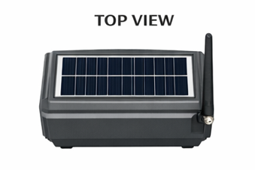
Novelty resides in the shape, configuration, and surface ornamentation of the Adaptive Streetlight Controller as illustrated.
No claim is made by virtue of this registration in respect of any mechanical or other action of the mechanism or in respect of any mode or principle of construction.
No claim is made by virtue of this registration to any right to the exclusive use of words, letters, numbers, colours, trademarks, or extraneous matter appearing in the representation.

Dated this 31 day of December 2025

Sheet No.: 5 No. of Sheets: 7

BOTTOM VIEW

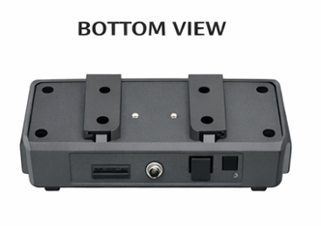
Novelty resides in the shape, configuration, and surface ornamentation of the Adaptive Streetlight Controller as illustrated.
No claim is made by virtue of this registration in respect of any mechanical or other action of the mechanism or in respect of any mode or principle of construction.
No claim is made by virtue of this registration to any right to the exclusive use of words, letters, numbers, colours, trademarks, or extraneous matter appearing in the representation.

Dated this 31 day of December 2025

Sheet No.: 6 No. of Sheets: 7

LEFT SIDE VIEW

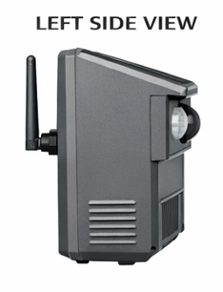
Novelty resides in the shape, configuration, and surface ornamentation of the Adaptive Streetlight Controller as illustrated.
No claim is made by virtue of this registration in respect of any mechanical or other action of the mechanism or in respect of any mode or principle of construction.
No claim is made by virtue of this registration to any right to the exclusive use of words, letters, numbers, colours, trademarks, or extraneous matter appearing in the representation.

Dated this 31 day of December 2025

Sheet No.: 7 No. of Sheets: 7

RIGHT SIDE VIEW

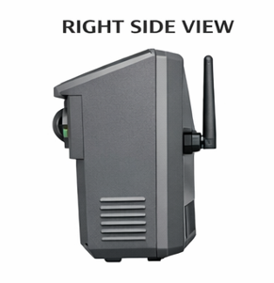
Novelty resides in the shape, configuration, and surface ornamentation of the Adaptive Streetlight Controller as illustrated.
No claim is made by virtue of this registration in respect of any mechanical or other action of the mechanism or in respect of any mode or principle of construction.
No claim is made by virtue of this registration to any right to the exclusive use of words, letters, numbers, colours, trademarks, or extraneous matter appearing in the representation.

Dated this 31 day of December 2025

Applicant Signature: ____________________________

