Draft No Objection Certificate (NOC) Format

NO OBJECTION CERTIFICATE

To, Date: 02/01/2026
Head of office, Copyrights Office Delhi
Bouddhik Sampada Bhawan, Plot No. 32, Sector 14, Dwarka, New Delhi-110078
Subject: No Objection for Registration/Ownership of Software Worl titled Ride- Hailing Price Companies by Sarthak Rajan Wagh, Aditya Shivaji Zaware, Ayush Harish Wani, Ashwin Narayan Ughade, Vedika Chandrakant Yende.
Dear Sir/Madam,
I, Sarthak Rajan Wagh, son/daughter of Rajan Chandrakant Wagh residing at Metro Life Maxima Phase -1, Tathawade, Chinchwad, Pune, and holding Indian Nationality, do hereby solemnly affirm and declare as follows:
- That I am the original author and sole creator of the Computer Software, specifically titled: Ride-Hailing Price Comparison (Hereinafter referred to as "the Work").
- That the Work was created by me on or about 02/01/2026.
- That I have, by way of a formal agreement / assignment / employment contract dated 02/01/2026, legally transferred/assigned/vested all my Copyright in the said Work to: Sarthak Rajan Wagh, Student, Metro Life Maxima, Tathawade, Chinchwad,
- I hereby confirm that I have no objection to Sarthak Rajan Wagh applying for and obtaining the registration of Copyright for the aforementioned Work in their name before your esteemed office.

- I further confirm that I shall not raise any claim, dispute, or objection regarding the ownership or registration of the intellectual property rights in the said Work by Sarthak Rajan Wagh at any point in the future.
- This No Objection Certificate is being issued voluntarily and for the purpose of facilitating the smooth registration/transfer of rights of the Work to Sarthak Rajan Wagh.
I declare that the information provided above is true and correct to the best of my knowledge and belief.
Sincerely,
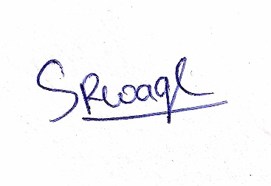

(Signature of Author)
Sarthak Rajan Wagh
Contact Details:
Phone: 7385183953
Email: sarthakwagh107@gmail.com

Disclaimer:
Please Note: This draft No Objection Certificate (NOC) is provided for sample purposes only and should not be considered as legal advice. It is a general template and may not be suitable for all situations or jurisdictions. It cannot be used as evidence in a court of law or for any official legal proceeding without proper customization and validation by a qualified legal professional. Always consult with an attorney to ensure your specific document meets all legal requirements and accurately reflects your particular circumstances. The creator of this sample is not liable for any actions taken based on its content.

