|  |
| --- |
| Cute yellow robot |
| AI Written Code Assessment  A1_T2 |
| |  |  | | --- | --- | | Loai Hataba 20230553  Abdullah Mohammed 2023231  Hossam Abdelaziz 20230121 | CS213-OOP | |  |  | |

**AI-Written Code Assessment**

**Introduction**

* **AI Models Used**: Chat-GPT (4o mini) / Claude (3.5 Sonnet)
* **Initial Prompt**: Both Ai models were prompted with the same prompt

***“You’re a senior programmer with a lot of knowledge in C++, I want you to complete this class … (provide the header file)”***

One of the most important aspects of a good prompt is the persona, where you tell the ai model who it should be so it has a clearer path of where to search and which information to provide; so by telling the models that they’re programmers who are knowledgeable in C++ that would potentially help the results be better than just asking them to complete the class.

* **Modifications/Reprompting**: Both Models have been prompted more than once (with nearly the same prompts) to get somewhat of an acceptable result that matches the desired outcome.

**1. Correctness**

* **Chat-GPT:** 
  + Overall, the code was acceptable, the code works well in most normal cases in most operations, and the code seems to cover a lot of edge cases.
  + Yet when met with cases such as polynomials with complex it fails.
  + The get root function was a complete disaster even after a couple of tries to correct its code the model completely ruined the code making it unusable.
  + **Error Handling**: The model didn’t add any type of input checking or safeguarding the code, whenever an invalid input the program either runs forever and needs to be force closed or the there’s some kind of segmentation error or logical that forces the program to completely quit
  + The model could sometimes slip up and forget very basic and easy stuff that would seem not that important but every detail matters, and sometimes it ignores some of your request
    - Example: when provided the model to make the get root value give back multiple roots if exists and set default values for the parameters it failed to comply with the requests and yielded the code nearly as it is, even a bit worse, not adding the multiple roots feature nor setting the default parameters and removing the input asking the user for the guess and tolerance values, it had to be reminded again that it didn’t do what it was asked to do.
  + **Rating: 70%**
* **Claude:**
  + **!!**
  + **!!!**
  + **!!!!**
  + Error Handling: Assess whether the code handles possible errors gracefully (e.g., invalid inputs, exceptions).!!!
  + **Rating: !!!**

**2. Efficiency**

* **Time Complexity**: Both of the models had O(n) time in most of the methods averaging for about 4-8 microseconds (using chrono library) with the longest being O(n*m) where there’s two inputs
* **Space Complexity**: Again, both of them used minimal storage where they just used variables and vectors.
* Both Models achieved very well in terms of speed and resource allocation in the best ways possible
* **Rating: 100%** (Both)

**3. Elegance**

* **Chat-GPT:**
* Code elegance is definitely one of gpt’s strengths where using its huge training sets it figures out the best most elegant solution for a problem.
* The code overall didn’t take up a lot of coding space with a total of 470 lines of code (very acceptable).
* The model uses brilliant and efficient algorithms and techniques to solve problems and the tasks in as little coding space as it can possibly can, it achieves its goal with minimal, clear lines of code**.**
* **Rating: 85%**
* **Claude:**
  + !!!
  + !!!

**4. Cleanliness**

* **Chat-GPT:**
* Despite the class being relatively not small, GPT wrote most code in clean and very human readable way with proper variable naming conventions and indentations.
* The model uses comments quite on point where it knows where a comment would be necessary to explain that line of code.
* A plus would be the color coding and code snapshots that the model uses to present the code, and also providing very detailed explanations under the code for what every part of the code does.

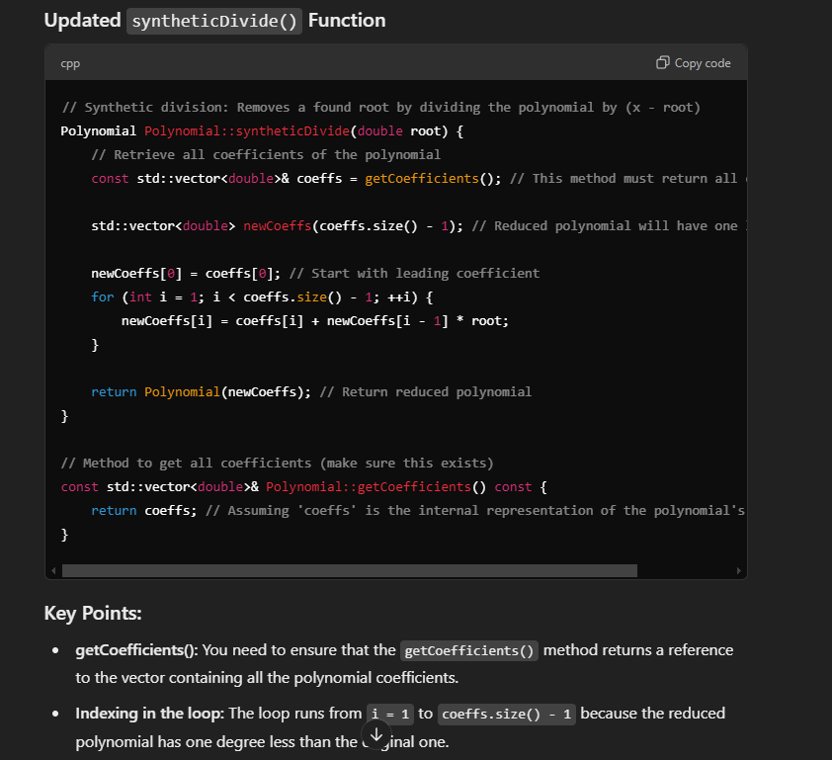

* **Rating: 80%**
* **Claude:**
  + !!!!
  + !!!!

**5. Summary:**

* **Chat-GPT:** 
  + Overall, the model did a fairly decent job in completing roughly the main idea of having a polynomial class with several methods
  + Yet aside from simple subtraction, addition, and simple integration the code is vulnerable to bugs and total program shutdowns
  + The experience using the model and having a conversation with it was definitely an easy task, perhaps a bit frustrating when you’re literally asking the model for something and it completely ignores it and responds with “of course here’s your updated code” and the code isn’t changed a single bit; another point is when the model gives you a fix for a problem but it completely obliterates another part of the code, where sometimes maybe the model can fix it or it maybe can’t and then you have no choice but to pray that you had some backup for your previous code.
  + We would give the model an overall rating of **75%**
* **Claude:**
  + !!!

**Links:**

-Chat-GPT conversation 1(class implementation): <https://chatgpt.com/share/670fd569-b568-8011-8501-c96948df8a49>

-Chat-GPT conversation 2(menu): <https://chatgpt.com/share/670fd5cd-ee64-8011-98e0-78e1dd90b984>

-Claude conversation 1: <https://claude.ai/chat/9eb78b11-cfd2-475a-8ed1-b93ae5c3155e>

-Claude conversation 2: <https://claude.ai/chat/70a67b7d-6719-4ba7-b29a-60b2665016fa>

-Claude conversation 3: <https://claude.ai/chat/4ddd0f76-8837-4db3-b5bc-3b30d3c1d2e0>

-Claude conversation 4(get root fix): <https://claude.ai/chat/80922f3e-7e1c-4e0b-8654-d6357522f834>