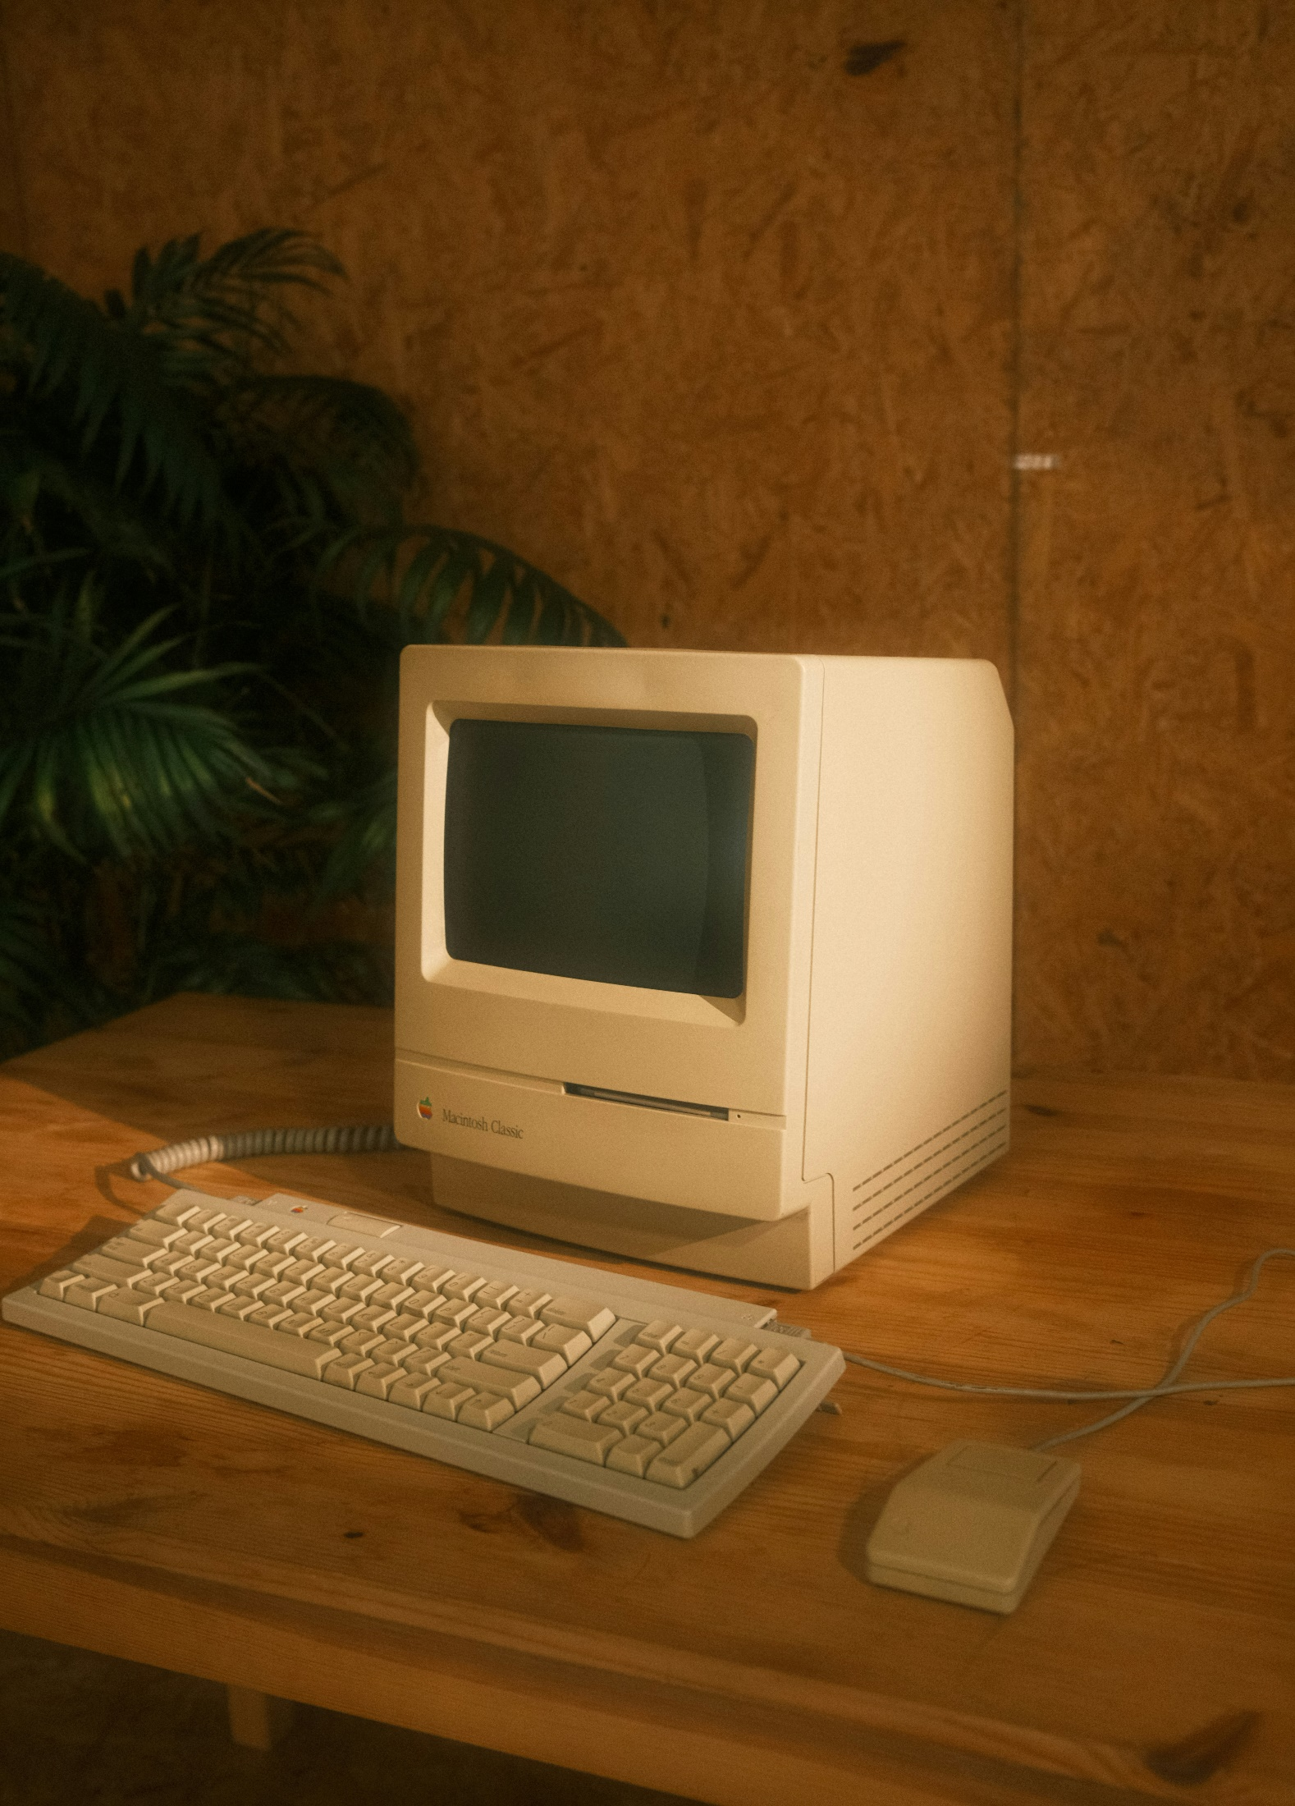

**CS213**

**Vole Machine Simulator**

|  |  |
| --- | --- |
| Loai Hataba | 20230553 |
| Abdullah Mohammed | 20230231 |
| Hossam Abdelaziz | 20230121 |

UML System Design

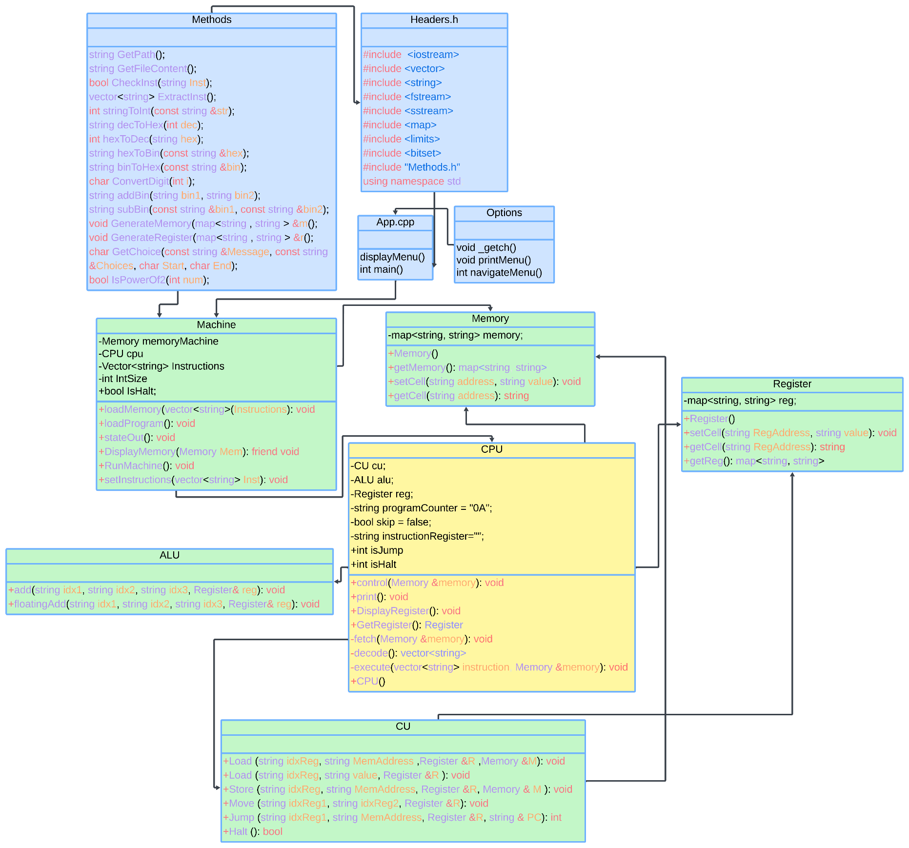

Workload Split:

* App (Loai, Abdullah, Hossam)

The Main app that handles menu display and input.

* Machine (Loai, Abdullah, Hossam)

Extracts instructions from file and stores it in memory and calls out the CPU to handle programs.

* Memory (Abdullah)

The Main memory where the programs are stored.

* Register (Abdullah)

The random-access memory where programs processes are stored in.

* CPU (Loai)

The Processing Unit which calls the needed resources and processes to execute the command.

* CU (Abdullah)

The Computation unit which handles the processes such as storing in the registers and memory and skipping instructions.

* ALU (Hossam)

The Arithmetic unit which handles the mathematical operations.

* Headers.h (Abdullah)

All C++ necessary libraries iostream, string, ...etc.

* Methods (Loai, Abdullah, Hossam)

Some commonly used functions in the machine system.

* Options (Loai)

Allows the user to use keyboard keys to navigate through the menu.

GitHub Repo:

