Assignment 1

CS251

Dr. Mohammed elramly



Loai Hataba 20230553 Loaiwleed2005@hotmail.com

abdullah mohammed 20230231 abdallamohammmed649@gmail.com

hossam abdelaziz 20230121 hossamabdelaziz2295@gmail.com

**Languages:**

Loai → Java

Abdullah → Java

Hossam → Java

**Learning:**

|  |  |  |
| --- | --- | --- |
| Name | Duration | Sources |
| Loai | 8 Hours | <https://youtube.com/playlist?list=PLJhTWoCm8I6DXaq7XECfyGKtsq4Z6fWZr&si=w_PmOmUhKEH6EyCl>  <https://youtu.be/drQK8ciCAjY?si=cmx5cv4of_BQn4k5> |
| Abdullah | 4 Days | <https://www.tutorialspoint.com/java/index.htm>  <https://www.youtube.com/watch?v=mNvJipMTKSM&list=PLCInYL3l2AajYlZGzU_LVrHdoouf8W6ZN> |
| Hossam |  |  |

**Food Alternative (App 1 Loai):**

Main Function:

Scanner scanner = new Scanner(System.in);

// Load food from JSON

String jsonPath = "food/foodDictionary.json";

List<FoodItem> foodList = GsonTool.loadFood(jsonPath);

while (true){

            printBanner();

            int menu = optionsMenu(scanner);

            switch(menu)

            {

                // Alternative Food

                case 1:

                    foodMenu(scanner, foodList);

                    int ans = continueApp(scanner);

                    if (ans == 0){

                        scanner.close();

                        System.exit(0);

                    }

                    break;

                //Add new Food

                case 2:

                    addFood(scanner, foodList, jsonPath);

                    int ans2 = continueApp(scanner);

                    if (ans2 == 0){

                        scanner.close();

                        System.exit(0);

                    }

                    break;

                // Delete Food

                case 3:

                    deleteFood(scanner, foodList, jsonPath);

                    int ans3 = continueApp(scanner);

                    if (ans3 == 0){

                        scanner.close();

                        System.exit(0);

                    }

                    break;

                case 4:

                    prinInfoBanner();

                    int ans4 = continueApp(scanner);

                    if (ans4 == 0){

                        scanner.close();

                        System.exit(0);

                    }

                    break;

                case 5:

                    System.out.println("\nGoodbye!!");

                    scanner.close();

                    System.exit(0);

                    break;

            }

        }

    }

Screenshots:

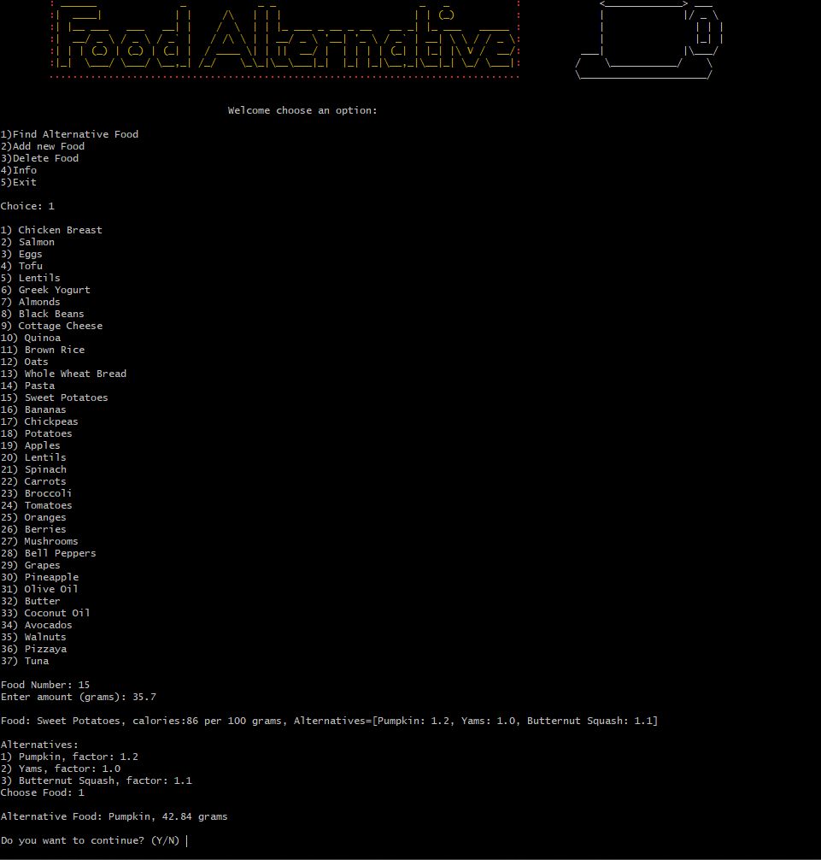

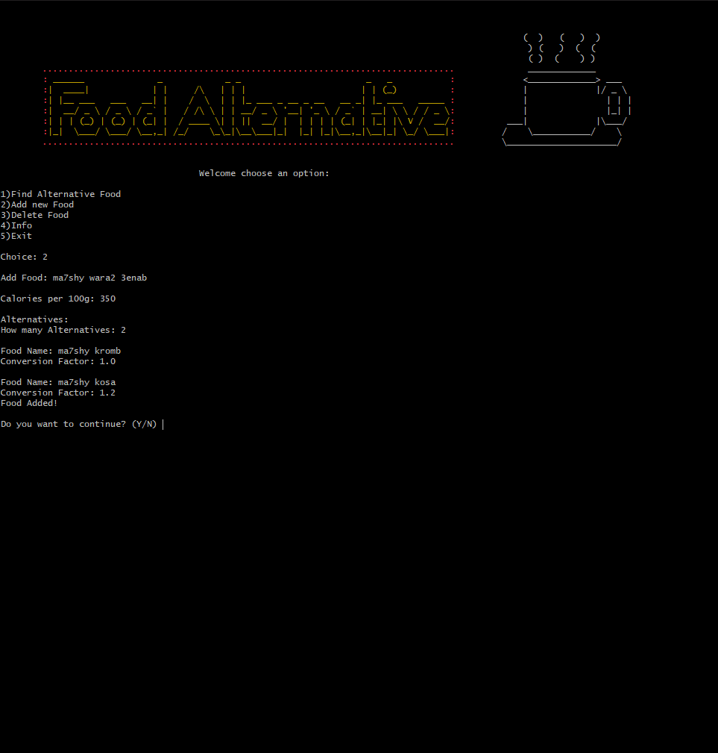

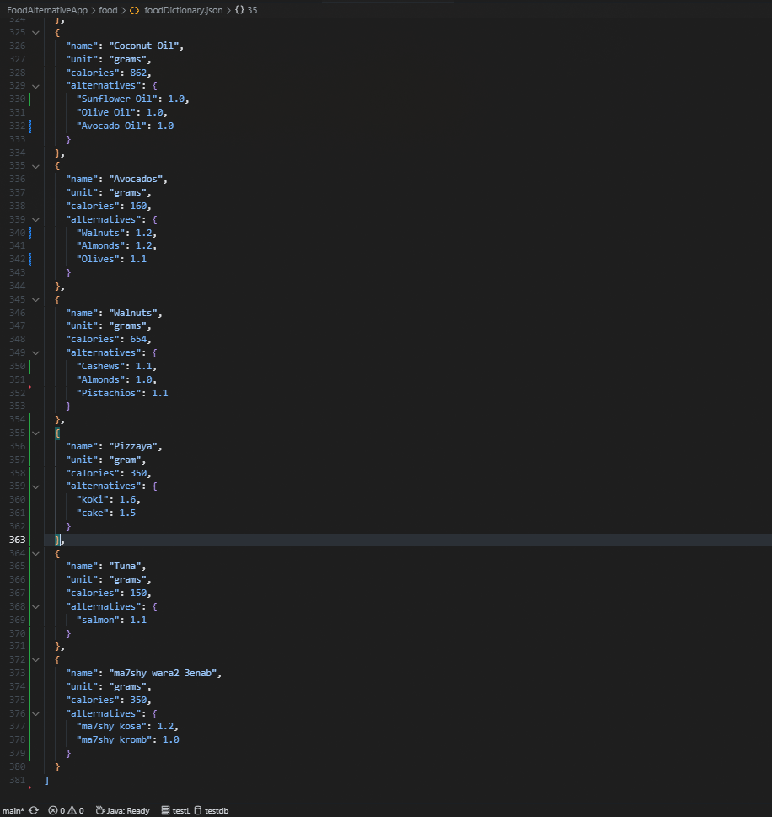

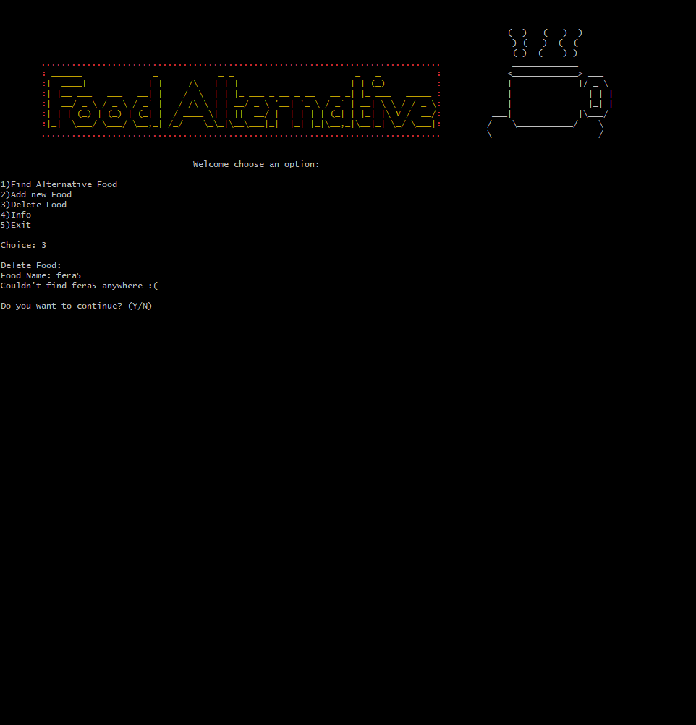

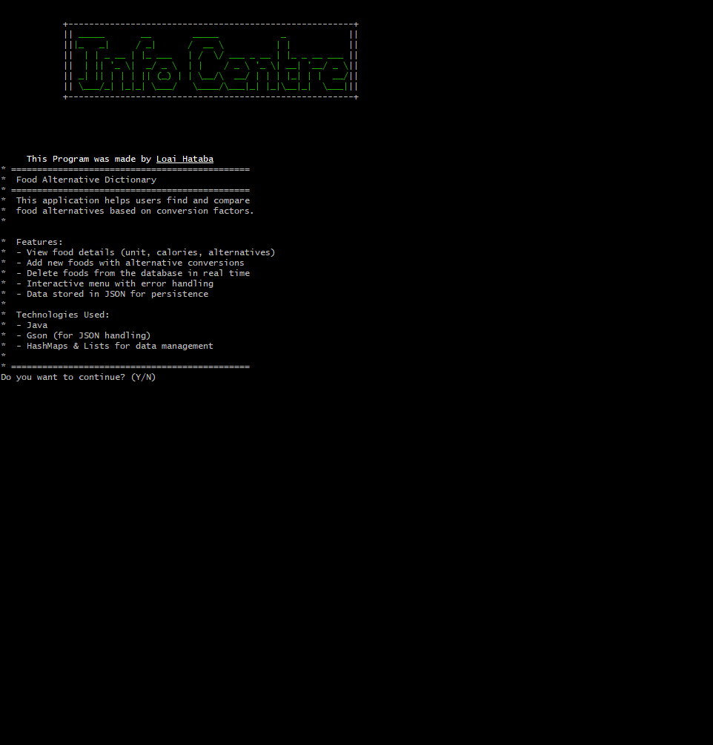

Video Link:

<https://drive.google.com/file/d/17hZjf0I-YBnwHZ371pdMD7uhwbIYaQP3/view?usp=sharing>

**Budget Tracker (App 2 Abdullah):**

Main Function:

System.out.println(

" ***Welcome to the Expenses Manager App***");  
 System.out.println(

" =========================================\n");  
 // Create an instance of the expenses list   
 final ExpensesList myExpenses = new ExpensesList();  
 //The app menu :   
 while (true) {  
 System.out.println("\n Main Menu ");  
 System.out.println(" ===================\n");  
 // Main menu options :   
 // 1 Adding an expense :   
 System.out.println("1. Add a new expense ");  
 // 2 removing an expense :  
 System.out.println("2. Remove an expense ");  
 // 3 Display the expenses list :  
 System.out.println("3. Display the expenses list ");  
 // 4 Sort the expenses list :   
 System.out.println("4. Sort the expenses list ");  
 // 5 Export the expenses list to a file :  
 System.out.println("5. Export the expenses list to a file ");  
 // 6 Exit the app :  
 System.out.println("6. Exit the app ");  
 //read the user choice :  
  
 final int choice = validInput.getValidInt("\nYour Choice is ( 1 -> 6 ) : ", "Error : Invalid Choice !!", 1, 6);  
 switch (choice) {  
 case 1 ->  
 myExpenses.addExpense();  
 case 2 ->  
 myExpenses.removeExpense();  
 case 3 ->  
 myExpenses.displayExpenses();  
 case 4 ->  
 myExpenses.sortExpenses();  
 case 5 ->  
 myExpenses.exportExpenses();  
 case 6 -> {  
final int ch = validInput.getValidInt("Do you want to saving before closing ?\n1)Yes\n2)No ", "Error : Invalid Choice !!", 1, 2);  
 if (ch == 1) {  
 myExpenses.exportExpenses();  
 }  
 System.out.println("Terminating the program :(");  
 return;  
 }  
 default ->  
 throw new AssertionError();  
 }  
 }

Screenshots:

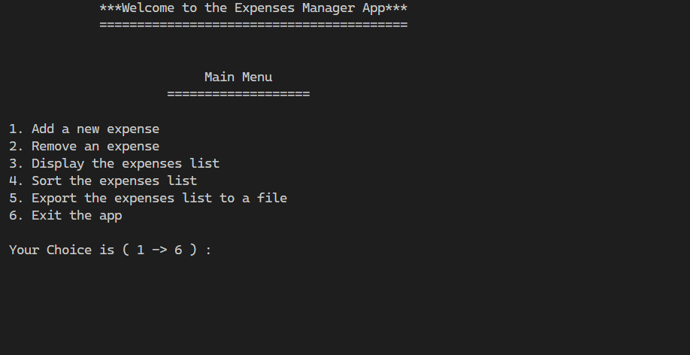

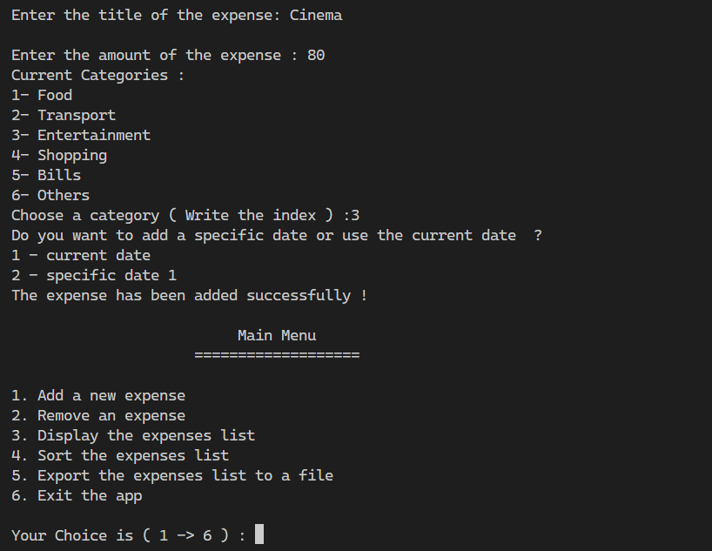

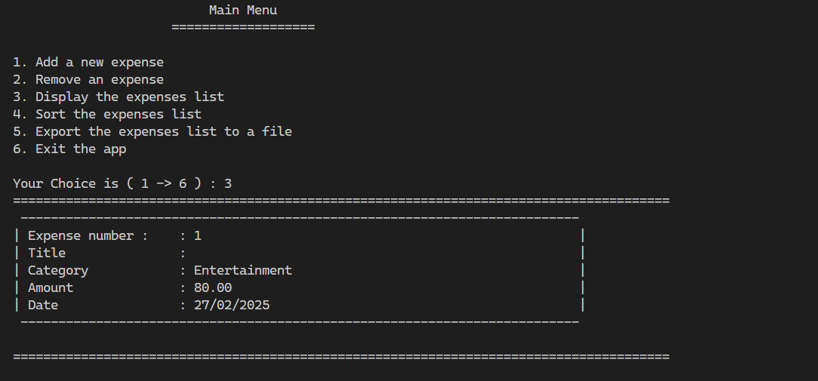

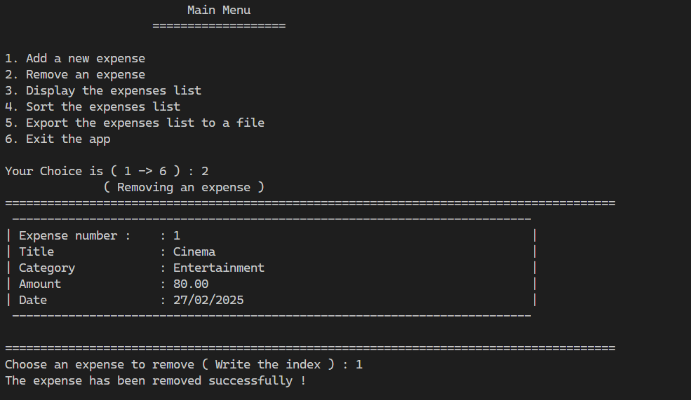

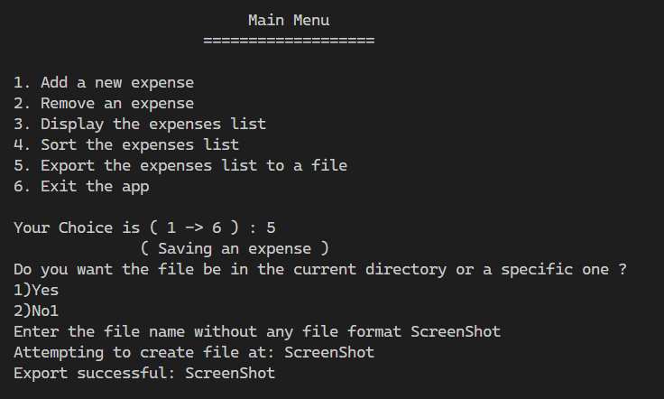

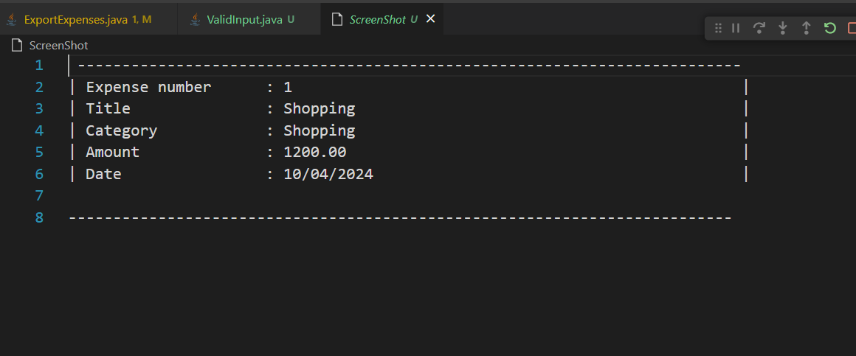

Video Link:

<https://drive.google.com/file/d/1_kMyuxn59d8yfKYCnpGyDzSnsc1SPGdx/view?usp=drive_link>

**Parking System (App 3 Hossam):**

Main Function:

Screenshots:

Video Link:

Link 😉

**LCNC Analysis: (AppGyver vs Glide)**

**1. Introduction**

Low-code and no-code development platforms have gained popularity for enabling non-developers and businesses to create applications with minimal coding.

Among these platforms, **AppGyver** and **Glide** stand out as powerful tools for building apps efficiently. This report analyzes AppGyver’s and Glide’s usability, benefits, and system quality while comparing them to determine their strengths and suitability for different use cases.

**2. Evaluation of AppGyver**

**Overview**

AppGyver is a professional-grade no-code development platform that allows users to create web and mobile applications without writing traditional code. It is particularly known for its flexibility and extensive customization options.

**Usability and Features**

* **Drag-and-Drop Interface**: Offers an intuitive builder for designing app layouts and functionalities.
* **Extensive Components**: Provides pre-built UI elements and logic modules.
* **Data Integration**: Supports REST APIs, databases, and third-party services.
* **Multi-Platform Deployment**: Applications can be deployed on web, iOS, and Android.
* **Logic and Automation**: Allows users to define workflows and dynamic logic visually.

**Benefits and System Quality**

* **Customization**: Unlike many no-code tools, AppGyver enables deep customization, making it ideal for complex applications.
* **Performance**: Apps built with AppGyver are optimized for high performance, especially on mobile devices.
* **Scalability**: Supports scalable applications, making it suitable for startups and enterprises.
* **Security**: Provides robust authentication and data security features.

**Impact on Developers' Roles**

While no-code platforms like AppGyver simplify application development, they are unlikely to replace traditional developers entirely. Instead, they serve as **enhancement tools** that allow developers to prototype faster and focus on more complex backend logic. Additionally, organizations can leverage no-code platforms for internal tools without needing a dedicated development team.

**3. Evaluation of Glide**

**Overview**

Glide is a no-code development platform that specializes in creating simple, data-driven applications using Google Sheets as a backend. It is widely used for lightweight business applications, internal tools, and prototypes.

**Usability and Features**

* **Google Sheets Integration**: Data is dynamically synced with Google Sheets, making data management straightforward.
* **Pre-Built Templates**: Provides templates to accelerate app creation.
* **Mobile-First Design**: Optimized for mobile applications with responsive design.
* **Drag-and-Drop Builder**: Users can easily add and arrange elements without coding.
* **Limited Logic & Automation**: Basic workflows can be set up, but advanced logic is limited.

**Benefits and System Quality**

* **Ease of Use**: Designed for non-technical users, making app creation accessible to a wide audience.
* **Speed of Development**: Apps can be created and deployed in minutes with minimal effort.
* **Cloud-Based**: Eliminates the need for complex hosting or deployment.
* **Data Management**: Real-time updates with Google Sheets ensure seamless synchronization.

**Impact on Developers' Roles**

Glide significantly lowers the barrier for app creation, allowing businesses to create internal tools without needing a development team. However, its **limited customization and scalability** mean that traditional developers are still essential for building feature-rich, enterprise-level applications. Glide is best suited for rapid prototyping and simple, data-driven applications rather than complex business solutions.

**4. Comparison of AppGyver and Glide**

|  |  |  |
| --- | --- | --- |
| Feature | AppGyver | Glide |
| Ease of Use | Moderate learning curve | Very beginner-friendly |
| Customization | High (supports complex logic and UI design) | Limited (focuses on simplicity) |
| Scalability | Suitable for enterprise applications | Best for small projects and internal tools |
| Pricing | Free for solo developers; enterprise pricing available | Free tier with premium plans for business features |
| Integrations | REST API, third-party services, external databases | Google Sheets, Airtable, Zapier, and limited API support |

**5. Sample To-Do List App**

As part of this comparison, we created a **To-Do List App** using Glide. The application enables users to:

* Add new tasks with descriptions.
* Mark tasks as completed.
* Store and retrieve data using Google Sheets.
* Access the app from both web and mobile devices.

Glide’s simplicity allowed for quick development, making it an excellent choice for basic applications.

**6. Conclusion**

AppGyver and Glide both offer unique advantages in the no-code development space. Glide is ideal for quick prototyping and simple applications, while AppGyver provides greater flexibility and customization for more complexprojects.

**7. References**

* AppGyver Documentation: [https://docs.appgyver.com](https://docs.appgyver.com/)
* Glide Documentation: [https://docs.glideapps.com](https://docs.glideapps.com/)