|  |  |
| --- | --- |
| Hossam Abdelaziz | 20230121 |
| Loai Hataba | 20230553 |
| Abdullah Mohamed | 20230231 |
| Nourhan Sayed | 20221186 |
| Mariam Sharnoubi | 20230398 |
| Ahmed Mohamed | 20230773 |

**S17, TA Nehal Akram**

**Intro to Database Systems**

**Movie Rental Management System**

Entity Relation Diagram

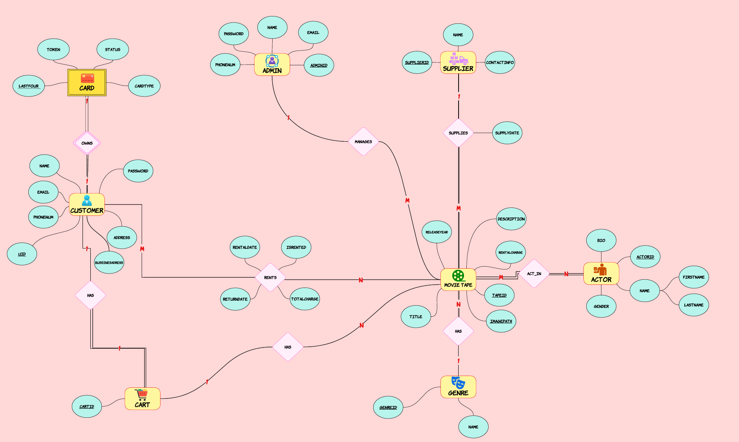

Functional Requirements:

Physical ERD

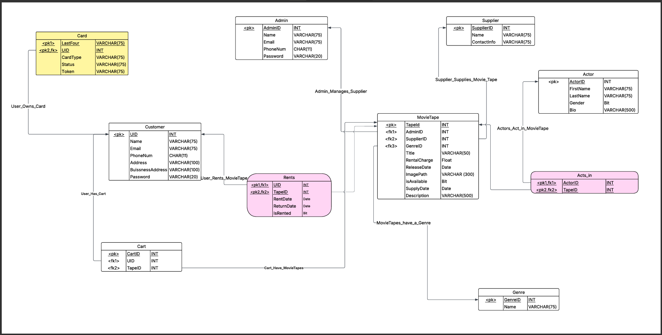

A Movie Rental Management System can include the following functionalities:

|  |  |
| --- | --- |
| Functional Requirement # | Requirement |
| FR1 | * **User Registration and Authentication**   + Users and admins can sign up by filling in required details.   + Registered users can log in to access their accounts. |
| FR2 | * **Movie Browsing**   + Users can browse a comprehensive list of available movies. |
| FR3 | * **Genre-Based Navigation**   + Users can browse movies by selecting specific genres. |
| FR4 | * **Movie Search and Filtering**   + Users can search for movies using filters such as title, genre, release year or price. |
| FR5 | * **Admin Movie Management**   + Admins can add new movies (tapes), edit existing entries, or remove them from the system. |
| FR6 | * **Cart Management**   + Users can add one or more movies to their cart. |
| FR7 | * **Checkout and Payment**   + Users can proceed to checkout and complete their payment securely via credit or debit card. |
| FR8 | * **User Profile Management**   + Users can view and update their profile information. |
| FR9 | * **Rented Movies History**   + Users can view a list of their previously rented movies within their profile. |