1ere experiences

* Fresh dataset
* 🡪 le model se perd lorsque Aucun depart / destination. Phrases hors sujet

* Mise a jour du dataset

2863 données

Model 2 : (0.1 split, 2577, 286)

accuracy: 99.69802555168408

precision: 0.9969981989468708

recall: 0.9969802555168409

f1: 0.9969840385610287

Model 3 : (split 0.2, 2290, 573)

accuracy: 99.39499709133217

precision: 0.9939685889694423

recall: 0.9939499709133217

f1: 0.99394713175872

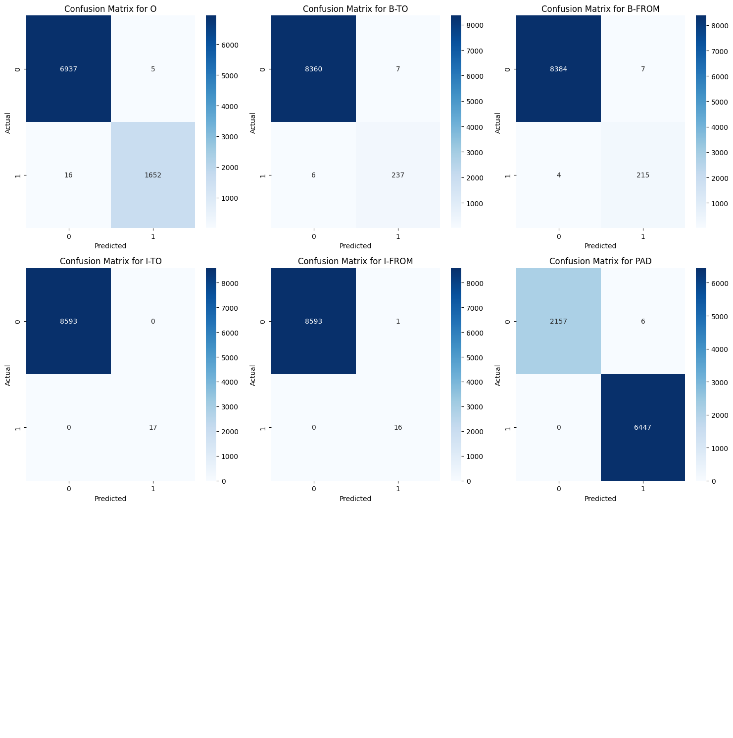

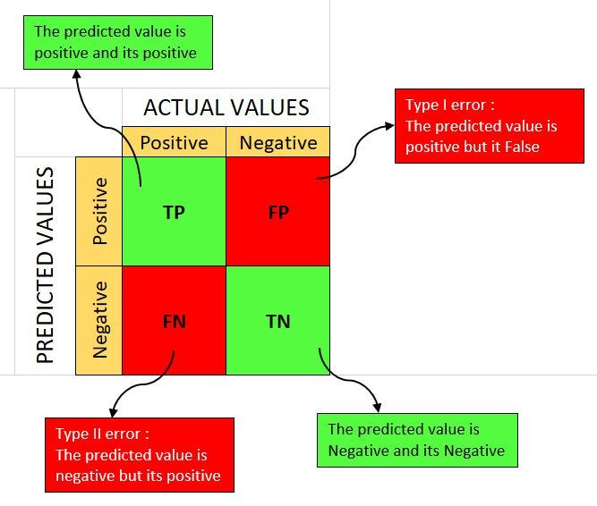

Experiments 3 :

accuracy: 98.6960933536276

precision: 0.9870869557076685

recall: 0.986960933536276

f1: 0.9867194084761743

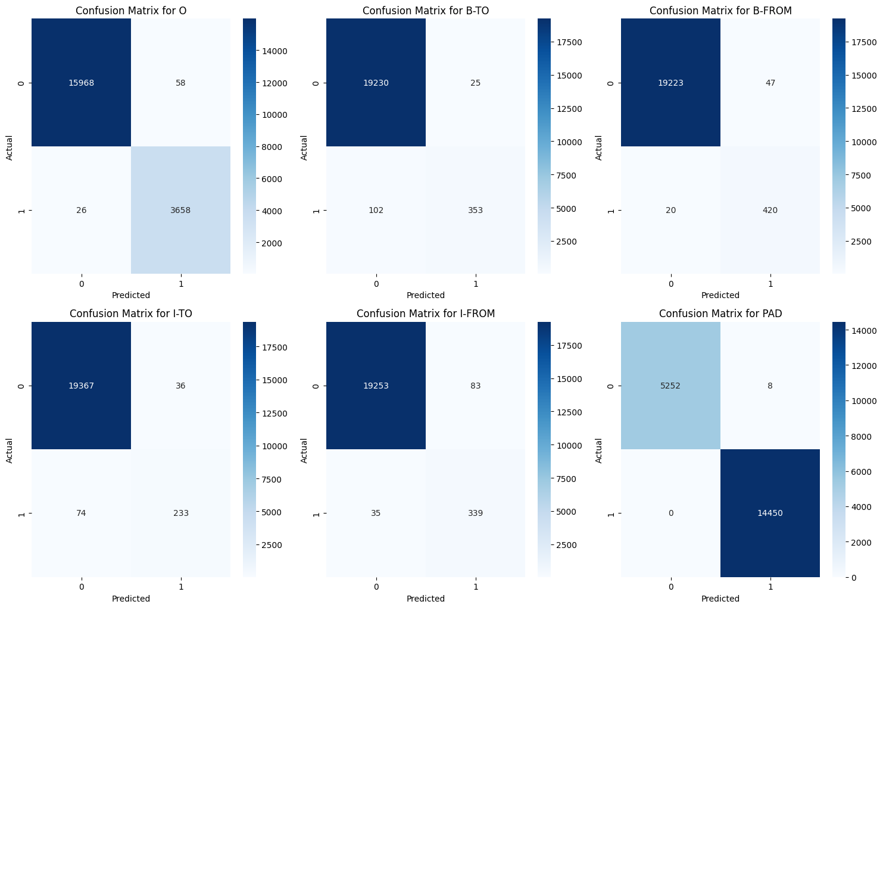

Model bidirectionnal :

accuracy: 98.9041095890411

precision: 0.9888771217156808

recall: 0.989041095890411

f1: 0.9888600257108574

Model Camembert:

accuracy: 73.37392186707255

precision: 0.5383732410155267

recall: 0.7337392186707256

f1: 0.6210544644981876

