**Abstract (Arial narrow bold , 22)**

Subheader ( Calibri light , 18)

Paragraph text( Calibri body , 12)

**Simulation Parameters and Experiment design**

Methodology

Our approach for running the simulations is to run the sim file on frame values between 1000 and 5000 with a step of 1000 . This means that we run the simulations at values 1000 , 2000 , 3000 , 4000 and 5000 respectively. Its is assumed that the range at which the page fault rate plateaus is the range at which the memory need of the program in question lies.

Our second run would aim to determine what replacement policy is most efficient for systems with a low frame number . For that purpose we ran the simulation on values from 100 to 1000 with 100 increments. Twice one for each policy (lru and mmu).

In the sections below we show eight graphs. Each pair shows the simulation results when ran on a particular trace file. The first graph shows the results for value between 1000 to 5000 as described above. The second graph shows values

**Simulation results**

SixPack

At the low end our graph displays a steep decrease at for each policy . At the low end , it seems clear that lru is the peforms marginally better than clock and significantly better than rand. This is evident in the fact that lru's fault rate curve is lower than the two other ploicies. The page fault rate curve flattens between 1000 to 2000. We can deduce from the curve flattening that the memory need for bzip is between 1000 and 2000 .

Bzip

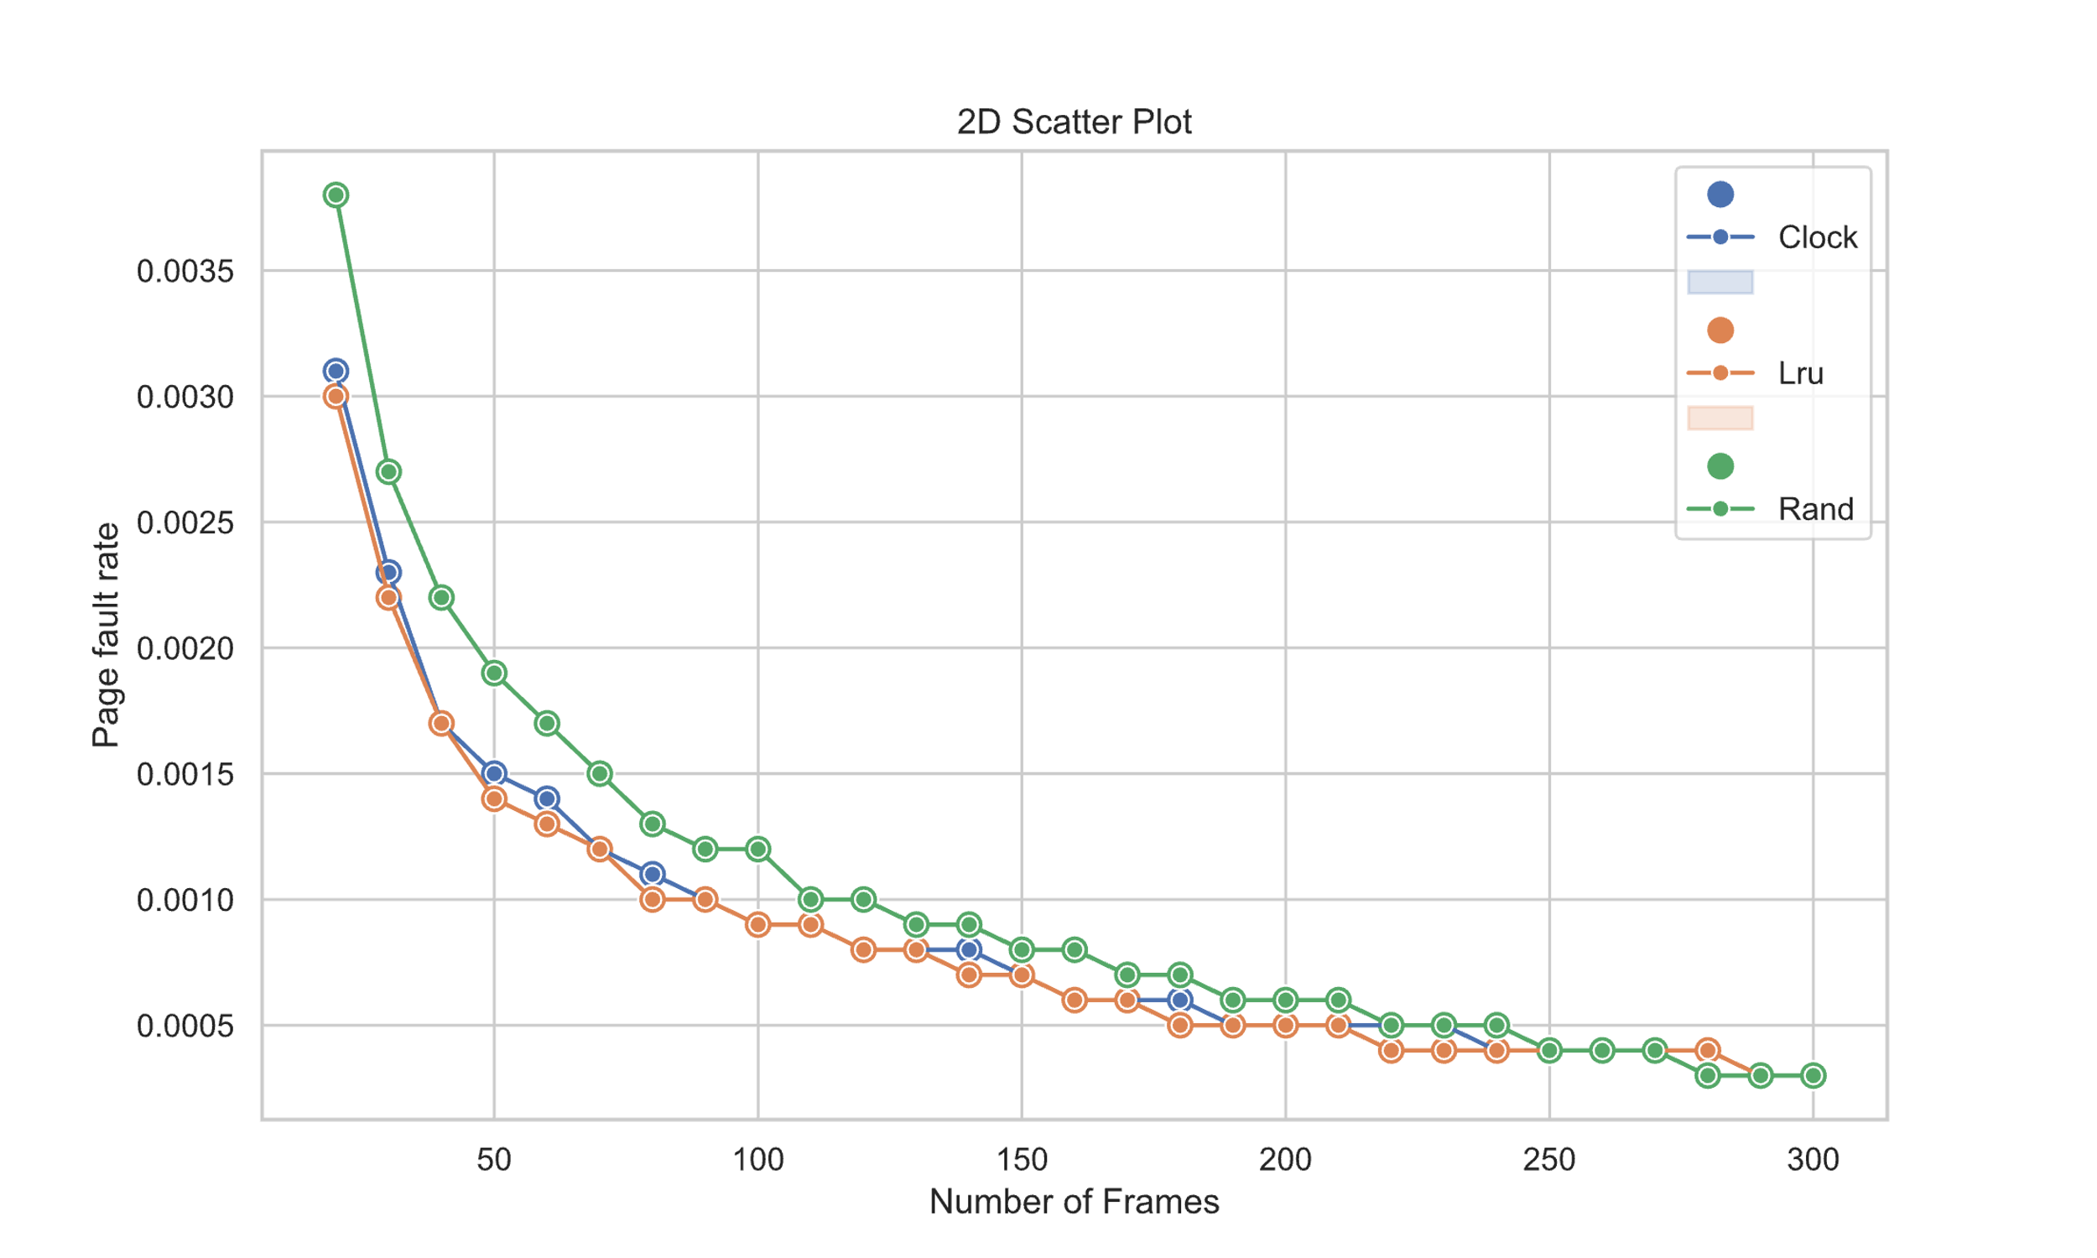

The page fault rate curve for this application is very steep. The graph flattens at 300 frames. This is quite low compared to the other applications simulated in this report. The Lru and Clock replacement policies seem to perform equally well with bzip at low frame rates, as indicated by there equal page fault rate. The Rand policy performs significantly worse. From the graph we deduce that the memory need for Bzip is very low standing between 200 and 300 frames. An addiional figure was created for bzip to further determine the performance of different policies at ultra low frame rates. The additional simulation data produced shows that the original hypothesis holds true . The figure shows clearly that both lru and clock outperform rand while there is no clear distinction between both in terms of efficeincy at very low frame rates.

**Results analysis**

**gConclusion**