Cairo University CHS – Team3
Faculty of Engineering
Computer Engineering Department
CMP N202
Introduction to Database Systems
< Hospital Management Database System (HMDS) >

< ER-Diagram Phase2>

Team Members:
- Loay Mohamed Hamed (1170067)
- Osama Yehia Hamdi (1170141)
- Adham Mahmoud Taha (1170115)
- Kareem Mohamed Ahmed (4180299)
<06/11/2019>
Contact info:
loaymohamed1999@gmail.com

Problem Definition:
With the advancement in technology in the world day after day and the growing population that their information needs to be stored, “File-System” became old-fashioned and inefficient in storing information due to the redundancy of information.
In Egypt, we still use the “File-System” to store medical records of patients until now, and due to the fact that “File-System” is not the best way to access information easily, medical records are rarely used, this causes a lot of problems in treatment and adds obstacles that makes it difficult to the doctor to both: diagnose and treat the patient properly, so by introducing Hospital Management Database System and Electronic Health Record doctors can easily access the patient’s medical record with ease anywhere using an application with a friendly user interface, in addition to other functionalities like making an appointment, communicating with other hospitals and others.

System Users:
- Patient:
  - Check his medical record for medical information.
  - Make an appointment with a specific doctor for treatment.
  - Make a complaint or suggestion about anything that bothers him.

- Doctor:
  - Update a patient’s medical record.
  - Check a patient’s medical record using his ID.
  - Decline or Accept an appointment with a patient.

- Nurse:
  - Add or Update an existing medical record.
  - Prescribe a certain medicine to a patient.

- Hospital Manger:
  - Get statistics about the hospital like number of patients, departments, etc...
  - Receive suggestions and complaints from patients.

- Admin:
  - Add or delete a hospital in the system.
  - Get statistics about all the hospitals he manages in the database.

Entities:
- Hospital; it is our most important entity, which is related to almost all other entities either directly or indirectly, because it is mainly the thing that we build our database on.
- Patient; it is one of the most important entities as it represents our main client “The patients” that we want to help, as it mainly represents all the data that our patient could need in his treatment process.
- Doctor; it is one of the most important entities as it represents “The Doctors” and all the functionalities they could have and do, in addition to all the data they could need.
- Nurse; it represents “The Nurses” and all the functionalities they could have and do, in addition to all the data they could need.
- Manager; this entity plays a vital role in our database, because this entity has an attribute called Type which has two values either ‘A’ which stands for Admin; which is our Admin that supervises all the managers and all the data, and the other value is ‘M’ which is a normal Manager, who manages a specific hospital with all of its data.
- Department; it is the entity which is mainly responsible for storing the departments data in our database.
- Medicine; it is the entity that is mainly responsible for all the medicines data that the patients will need in their treatment process.
- Ambulance; it is responsible for the ambulance or any smaller vehicles data that the hospital could have.
- Equipment; it is responsible for all the equipment data that the hospital could have in each department.
- Room; it is a weak entity because to be defined we must related to its specific hospital, which is responsible for all the needed data about any rooms; either its type or availability and so on.
- Medical Record; it is a weak entity because to be defined we must related to its specific patient, and it is so important as it represents all the records that any doctor at any hospital could need or add to the patient’s medical record.

Relations:
1-Manage:
- This show the relation between manager and hospital where there is at least only one manager who can manage the hospital and the hospital can be managed with only one manager.
2-Works in:
- The relation between nurse and hospital: nurse can work only at one hospital and the hospital can have many nurses working on it.
- The relation between doctor and hospital: doctor can work at many hospitals and the hospital can have many doctors working on it.
3-Belongs:
- The relation between room and hospital: the room belongs to only one hospital of course the room can’t belong to many hospitals at the same time and the hospital can have many rooms on it.
- The relation between medical record and hospital: medical record at least belongs to one hospital and the hospital may have zero medical records when it’s new.
- The relation between medical record and patient: the hospital may have 0 medical records which belong to any patient when its new and hospital may have many medical records for many patients after that and the patient have only on medical record when he join the hospital only one and we add any information about the patient health on this medical record.
- The relation between hospital and equipment: equipment may belong to 0 hospital may this hospital don’t have this equipment or the equipment may belong to many hospitals where this equipment exist on many hospitals and the hospital may have no equipment when its new and can have many.
- The relation between doctor and department: doctor can only belong to one department such that the orthopedist can’t work on the neurology and surgery department and the department may have many doctors which belong to it or may be this department has only one doctor belongs to it.
- The relation between department and hospital: department which belong to the hospital may be one or more for example nephrology, neurology, oncology, ophthalmology and orthopedics departments and the hospital may have many departments or only one department.
- The relation between ambulance and hospital: ambulance belongs to only one hospital only one it can’t belong to many hospitals at the same time and the hospital may have on or more ambulance belong to it.
4- Alter:
- The relation between doctor and medical records: doctor can alter the medical record of a patient but he may not alter on any medical record before and medical records can be altered by one doctor or many where the patient had many surgeries before.

5-Take:
- The relation between medicine and patient: patient may take a lot of medicines or may not take any one and the medicine (the same medicine) may many patient take it or no patient uses this medicine

ER Diagram:
- The entities and the relationships between all the entities:

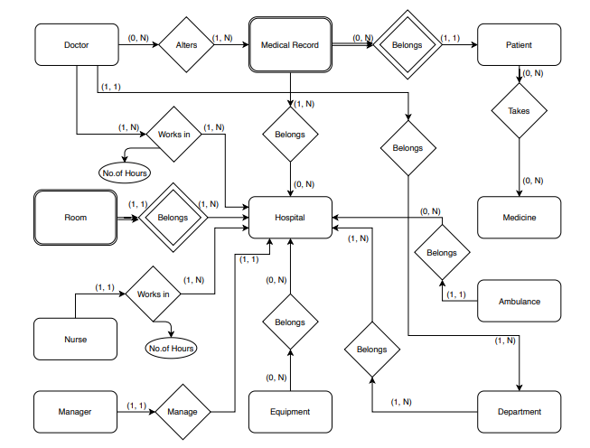

- The attributes of each entity:
