Cairo University CHS – Team3
Faculty of Engineering
Computer Engineering Department
CMP N202
Introduction to Database Systems
< Hospital Management Database System (HMDS) >
Team3
< Schema Phase2>

Team Members:
- Loay Mohamed Hamed (1170067)
- Osama Yehia Hamdi (1170141)
- Adham Mahmoud Taha (1170115)
- Kareem Mohamed Ahmed (4180299)
<26/11/2019>
Contact info:
loaymohamed1999@gmail.com
ER Diagram: (After Very Small Edit!!)

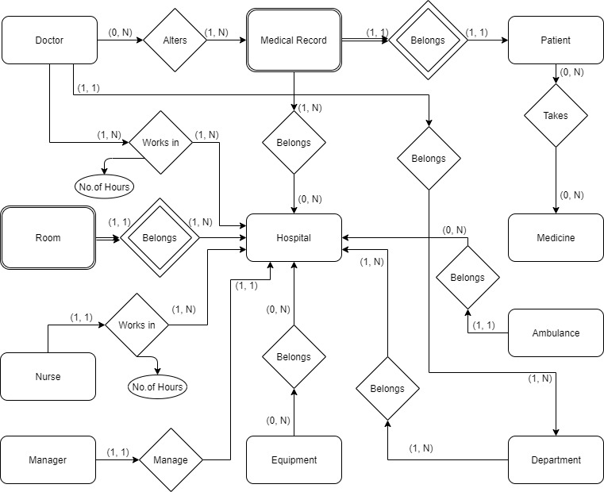

Schema:

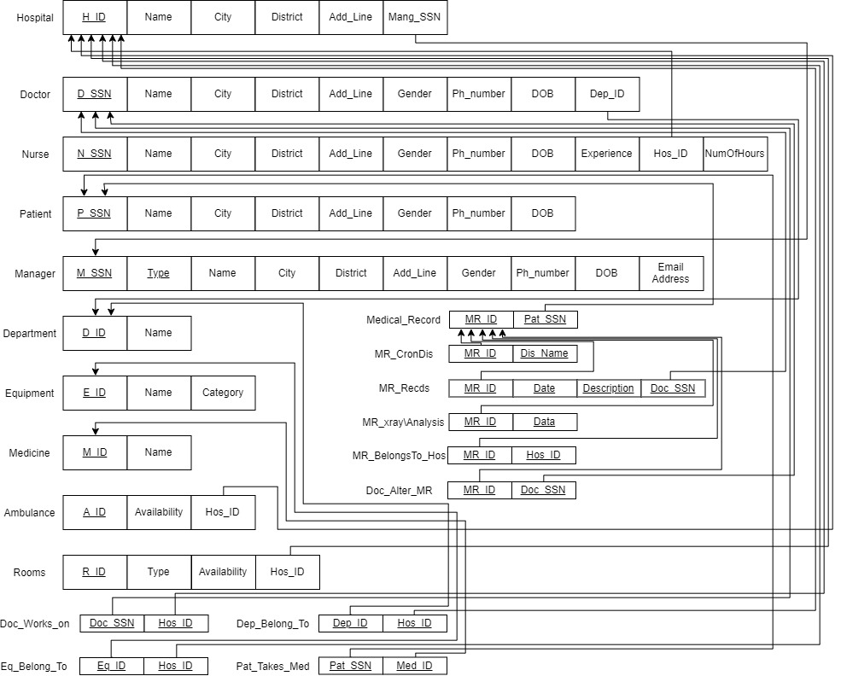

Database Constraints:
1. Unique Constraint:
- All our PKs and MRID of the medical record, which is considered a partial key.
2. Not Null Constraint:
- All the attributes can’t be null except the unnecessary things like: address, city, Ph_number, district.
3. Primary key Constraint:
- Value(s) in specified column(s) must be unique for each row in a table and not be NULL; normally each table in our database should have a primary key - it is used to identify individual records.
4. Foreign key Constraint:
- Value(s) in specified column(s) must reference an existing record in another table (via its primary key or some other unique constraint).
5. Check Constraint:
- NOT decided yet!! OR to be more accurate we could use this constraint in our implementation process but we aren’t sure yet.

