Cairo University CHS – Team3
Faculty of Engineering
Computer Engineering Department
CMP N202
Introduction to Database Systems
< Hospital Management Database System (HMDS) >

< User’s UIs >

Team Members:
- Loay Mohamed Hamed (1170067)
- Osama Yehia Hamdi (1170141)
- Adham Mahmoud Taha (1170115)
- Kareem Mohamed Ahmed (4180299)
<06/11/2019>
Contact info:
loaymohamed1999@gmail.com

Login:
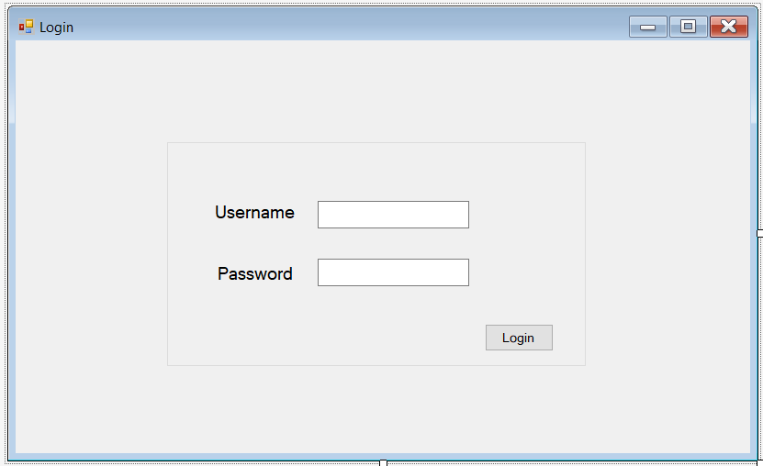
After Login according to the username and his type a new form will appear:
If “Patient”:
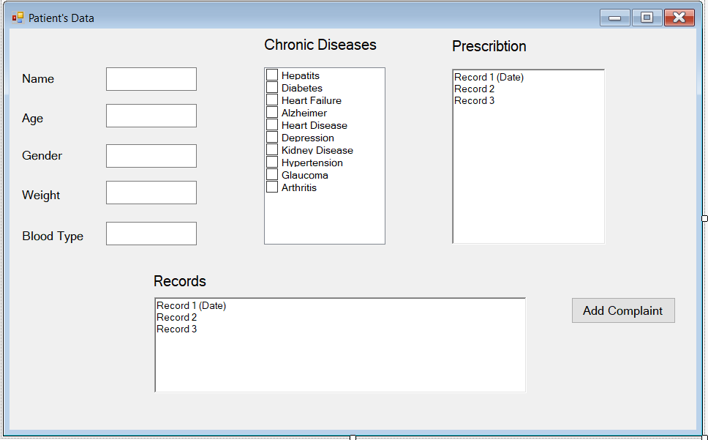
When “Add Complaint” button is clicked: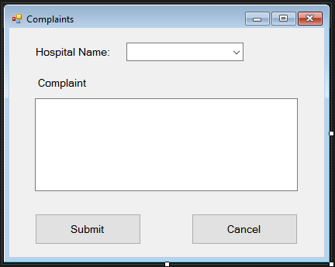
If “Doctor”: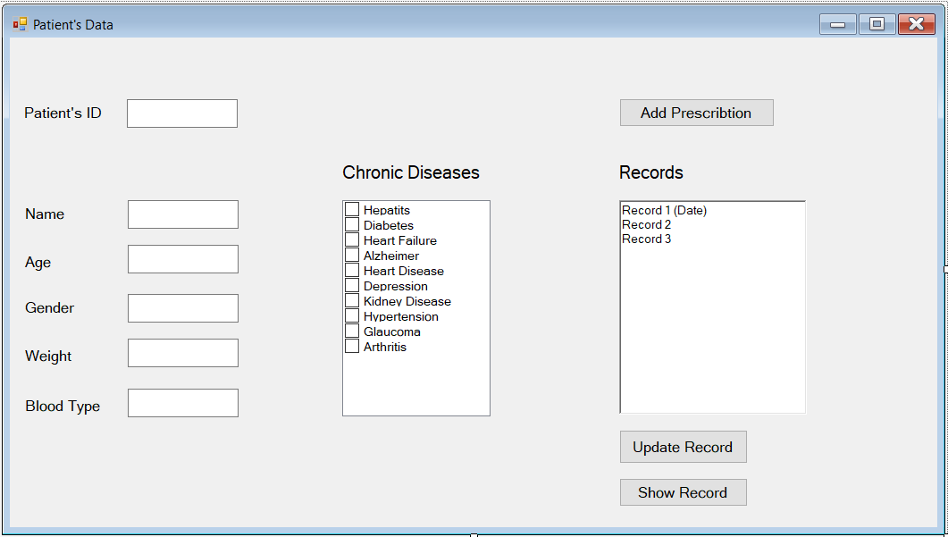
-After the Doctor insert the Patient’s ID and clicked enter, the entire patient Info and some chronic diseases in check box appears to him.
-When “Show Record” button is clicked the Records Rich Textbox will appear.
-When “Add Record” button is clicked:
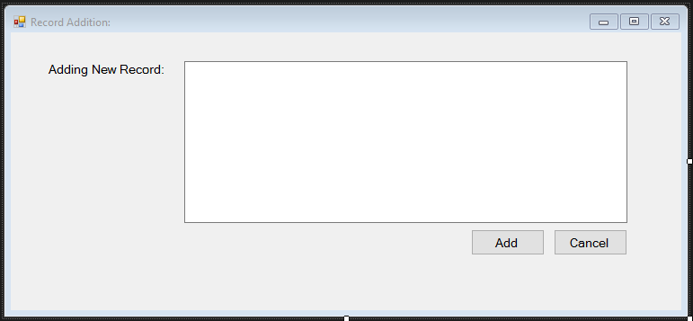

When “Add Prescription” button is clicked:
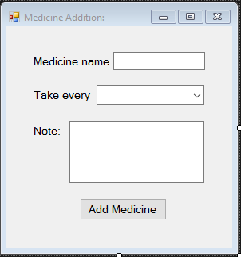
If “Nurse”:
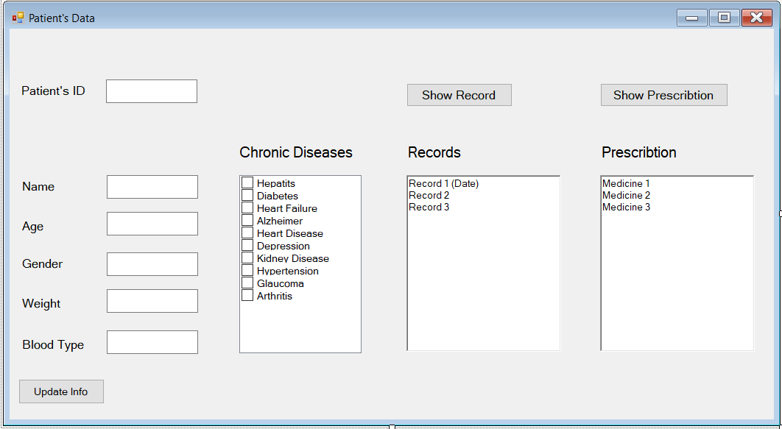

-After the Nurse insert the Patient’s ID and clicked enter, the entire patient Info and some chronic diseases in check box appears to her.
-When “Show Record” button is clicked the Records Rich Textbox will appear.
-When “Show Prescription” button is clicked the Prescription Rich Textbox will appear.

-When “Update Info” button is clicked:
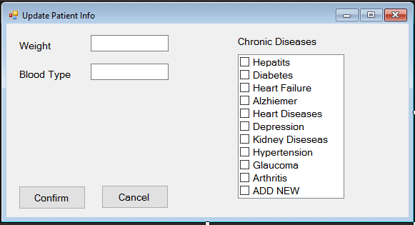
**********************************************************
Now let’s talk about the IT Managers and their head the “ADMIN”!!
IT Manager UI:
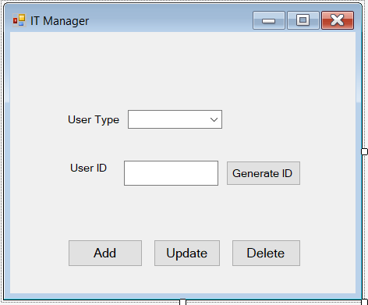
Then if the IT Manager needs to add/update a User:
“Generate ID” button is only used in Add new user to get the next unique ID from the database. Then:
If the user type is “Patient”:
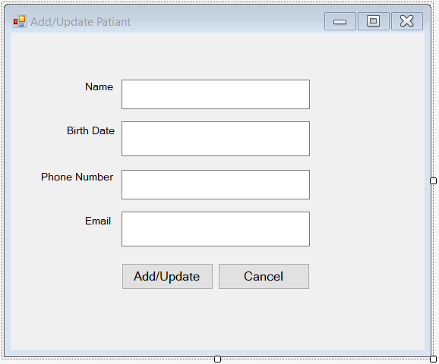
If the user type is “Doctor”:
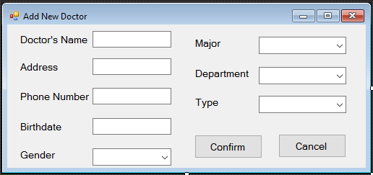
If the user type is “Nurse”:
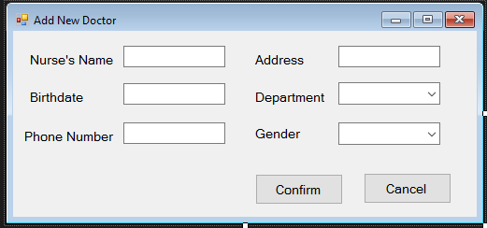
Now the “ADMIN”:
