***Multimedia Project***

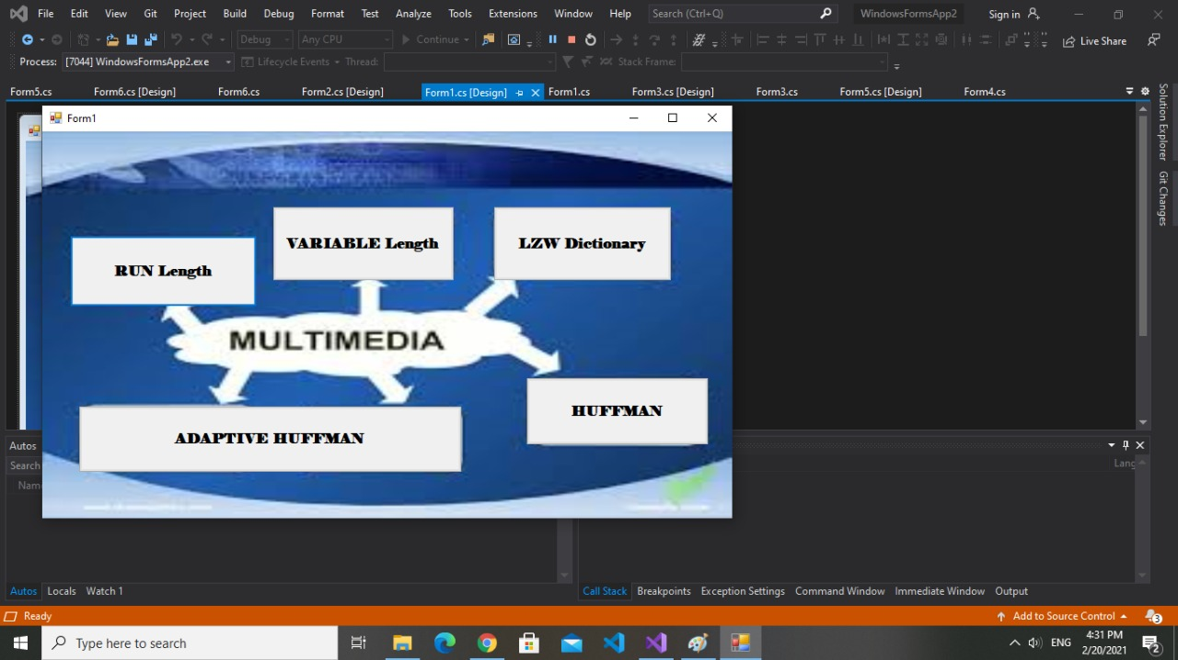

***Prepared by***

***Ibrahem Mamdouh Moatamed***

***Loay omar Mohamed***

***Run Length***

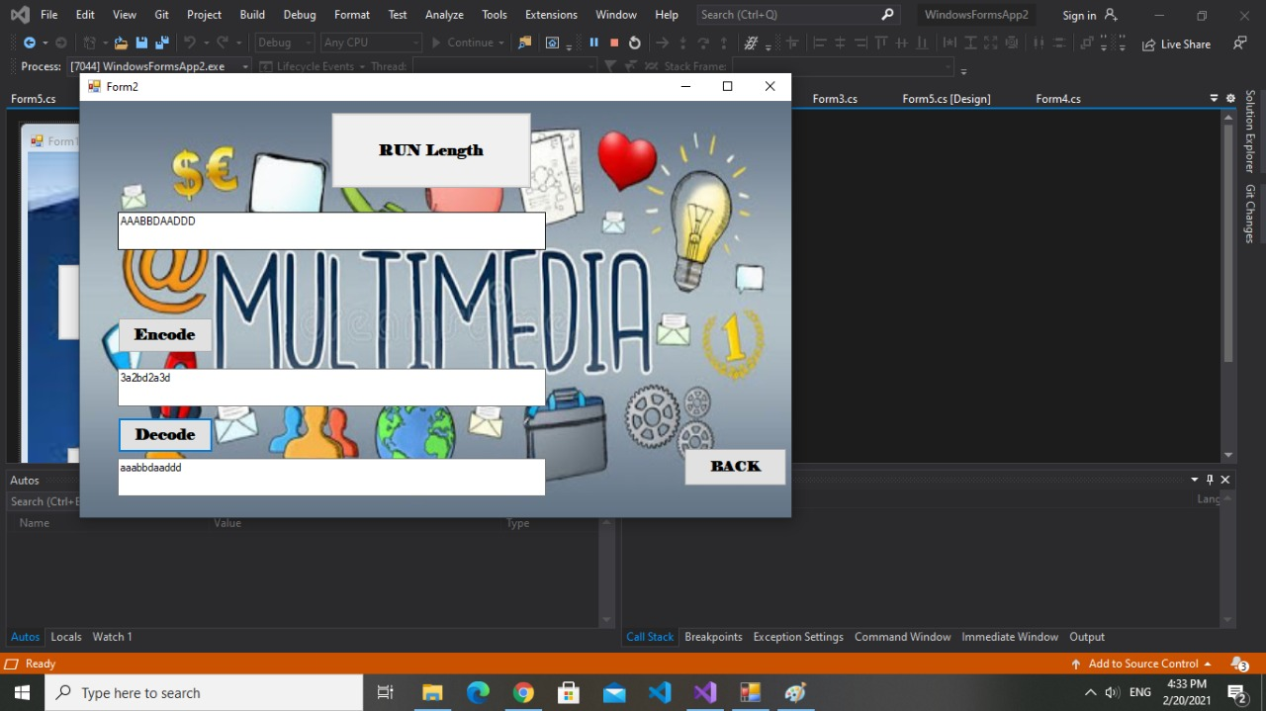

***Explanation:***

***We will give the program the sequence, that we want to make encode and decode by using RUN LENGTH ALGORITHM.***

***Variable length***

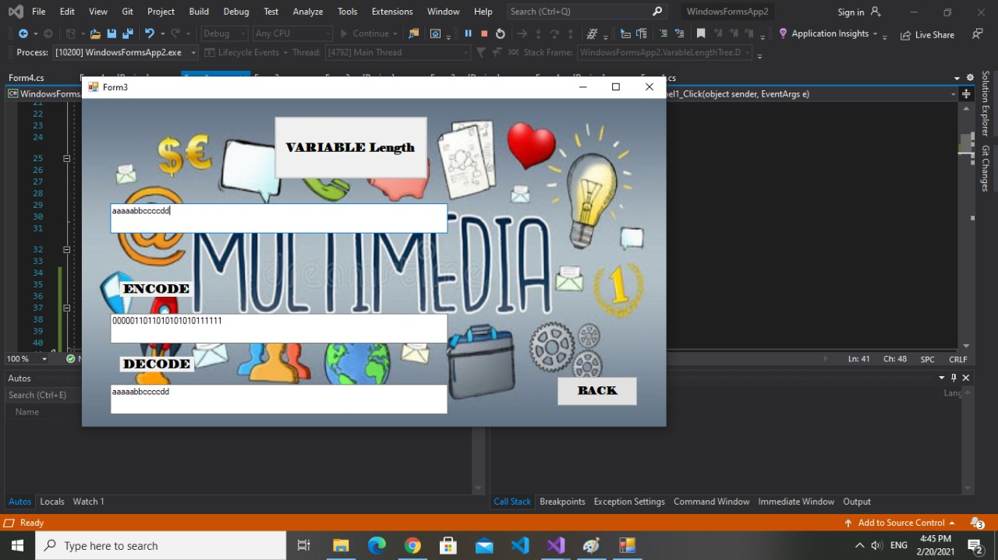

***Explanation:***

***We will give the sequence for the program to make compression and decompression like Run length, but we have some different between them.***

* ***Different length for each symbol***
* ***The code depand on bits, but we can use byte by making convert between them.***

***Huffman Coding***

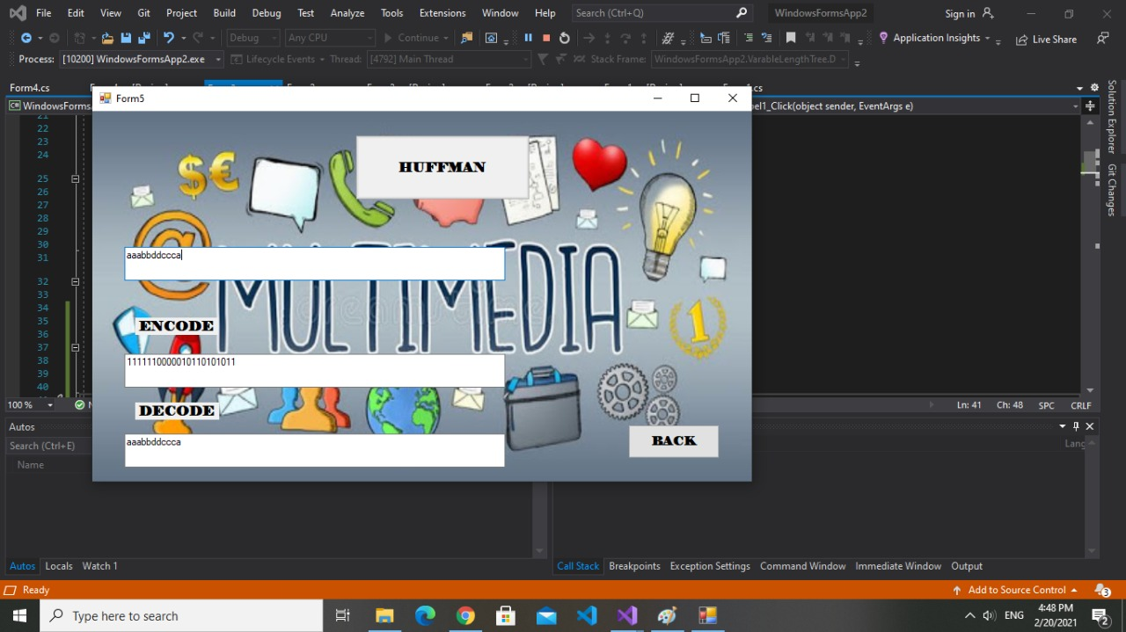

***Explanation:***

***We put the sequence in the text in the program to make encode and decode, put all symbols on list sorted according to frequency, from the list pick two symbols with the lowest frequency, then form the Huffman tree.***

***Some properties of Huffman coding:***

* ***Unique prefix property***
* ***Minimum redundancy code***

***Adaptive Huffman***

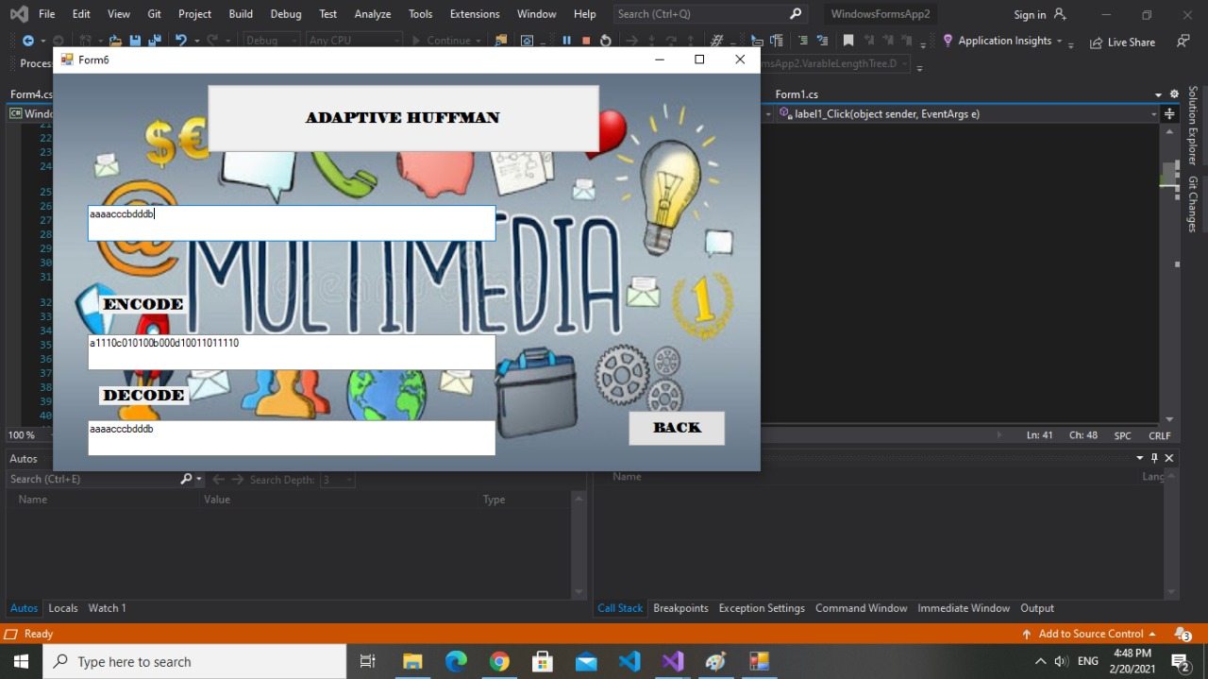

***Explanation:***

***We give the sequence to the program to make encode and decode. Give initial code for each symbol.***

***LZW Dictionary***

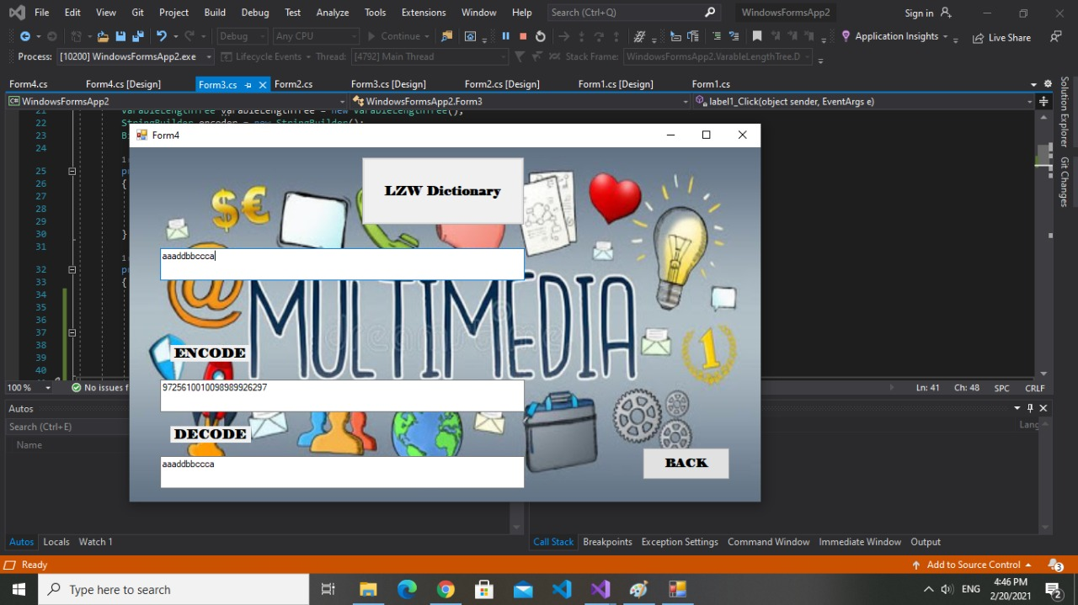

***Explanation:***

***We will give the program our sequence to make compression and decompression.***