**2. Responsive Web Design Practice with FreeCodeCamp**

* + Enhance your skills in responsive web design by completing the Basic CSS exercises on FreeCodeCamp. Start your practice by following this link: [Learn Basic CSS by Building a Cafe Menu](https://www.freecodecamp.org/learn/2022/responsive-web-design/#learn-basic-css-by-building-a-cafe-menu).

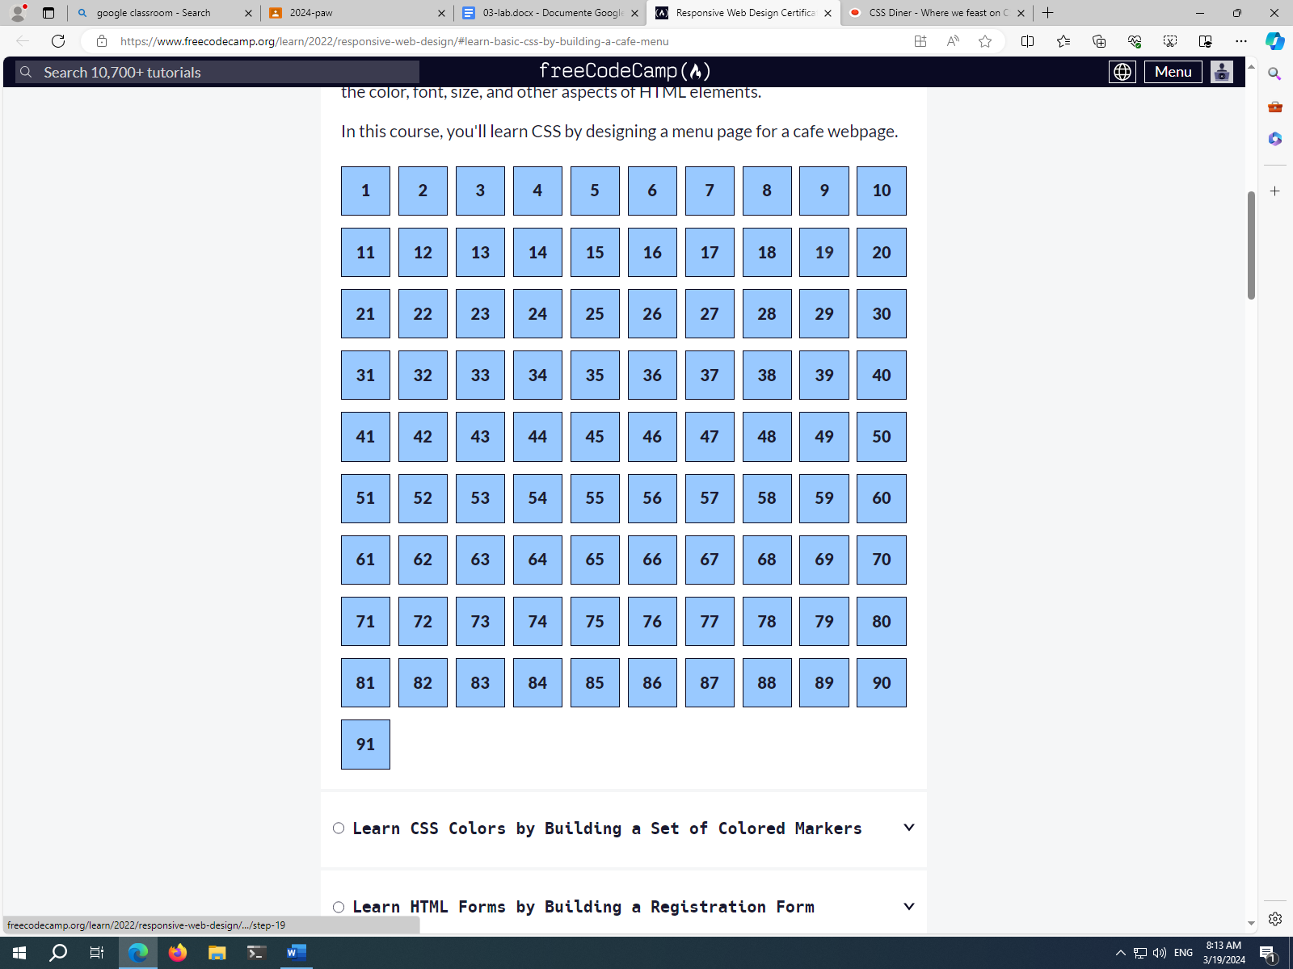

**3 CSS Selectors Practice**

* + Focus on practicing CSS selectors by completing exercises 1-14 and 27-32 at Flukeout's CSS Selector game. Begin your exercise session by visiting: [CSS Diner](https://flukeout.github.io/).

