ECE 435

2 April 2018

Homework 7

**Illegal Access Granted**

If someone without clearance was able to view private data, there would be a security issue. The password could not be working or be released to those uncleared. By not creating a more secure password (or simply changing it), data can be illegally accessed.

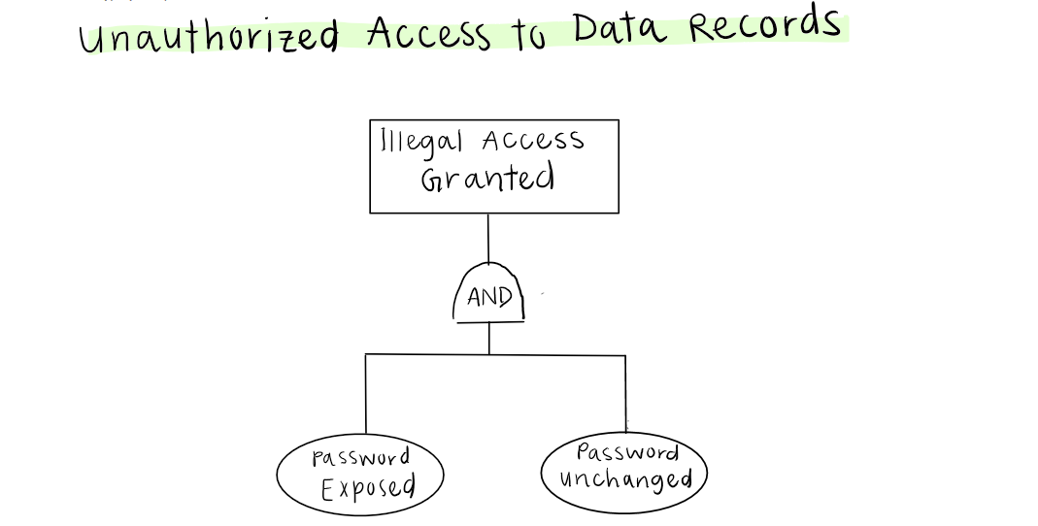

**Poorly Written Code**

By easily making an error, like forgetting a global variable that needs to be private, such as allowing users to edit and change the application, even though they do not have authorization. Errors happen easily an can be avoided to an extent. Otherwise, the developer could write spaghetti code that doesn’t filly protect the editing aspects, only the password.

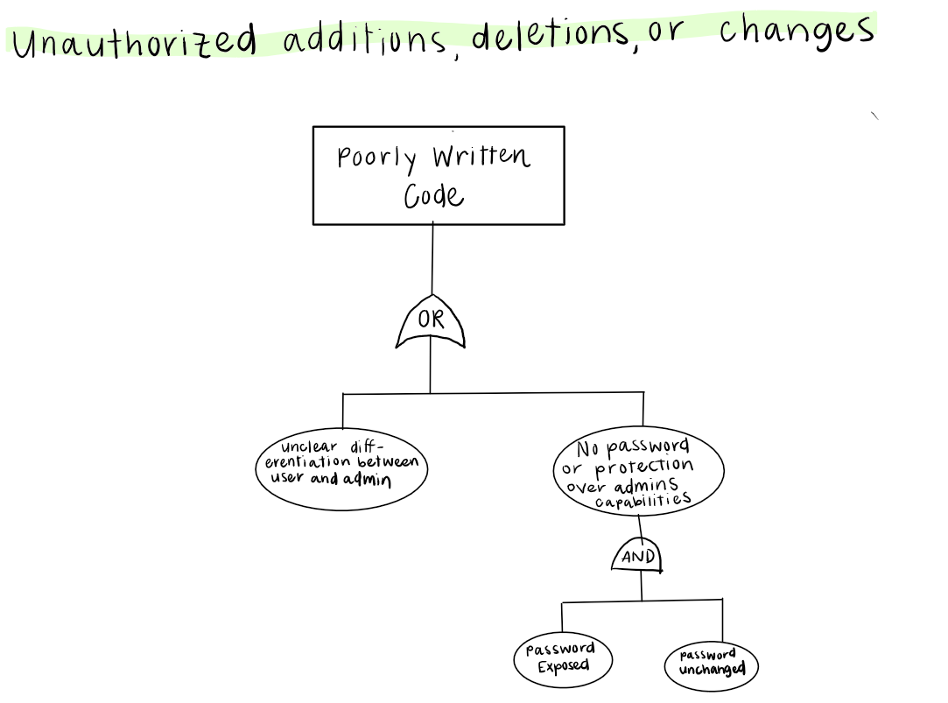

**Automatically Approve “Time Off” Request**

This is a “worst-case” scenario: If the application did this automatically, the hospital could potentially be understaffed. This could be caused by a bug in the code – the class that approves the first two could work, but the function that says to move to the next class that does not immediately approve could be broken. The developers could also be using a new programming language, or they could have a poor understanding of how to execute such a task.

