Software Engineering 435: Quiz 1

**Notes**

A system can be viewed as a group of objects related to a set of activities and enclosed by a boundary.

Solving a Problem – Analyze: breaking things down to small pieces, or synthesis (the opposite), building things up. Thus, any problem technique must have two parts: analyzing the problem to determine its nature, and then synthesizing a solution based on our analysis.

Method/Technique is a procedure for producing a result.

Tool is an instrument for accomplishing something in a better way.

Procedure is like a recipe: a combination of tools and techniques that produce something.

Paradigm is a cooking style, it represents an approach or philosophy for building software.

ALL OF THE ABOVE help enhance our software.

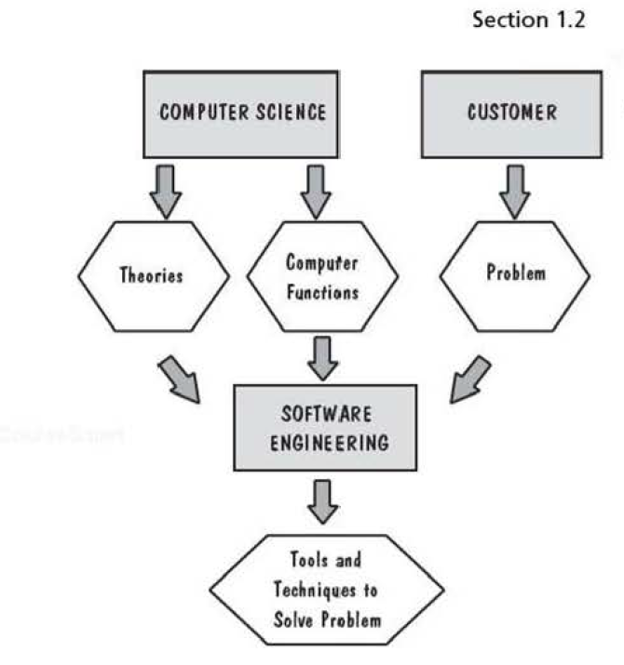

Questions from quiz:

1. Which of the following are software development process guidelines that are used to grade an organizations internal processes?
   1. CMM
   2. MIL-STD-883
   3. MIL-STD-1553
   4. SPICE
   5. ISO 9000
2. A software product that meets all of its functional requirements will always be considered high-quality software.
   1. True
   2. False
3. Referring to McCall’s quality model, indicate whether the following relate to the User’s external view of the system, or to the developer’s internal view.
   1. Usability
   2. Interoperability
   3. Integrity
   4. Access Control
   5. Simplicity
   6. Modularity
4. Unanticipated use of a software system should be considered throughout software design activities
   1. True
   2. False
5. Users and Developers may judge a given software product’s quality differently.
   1. True
   2. False