Which method delivers a full system at the very beginning and then changes the functionality of each subsystem with each new release?

|  |  |  |
| --- | --- | --- |
|  |  | Waterfall |
|  |  | Iterative |
|  |  | Incremental |
|  |  | Scrum |

In an incremental software development process, which function should the developers consider implementing first?

|  |  |  |
| --- | --- | --- |
|  | A. | The function voted on by the development team. |
|  | B. | The most well understood function |
|  | C. | The easiest function to implement. |
|  | D. | The function with the most risk. |

An Agile method is used when:

|  |  |  |
| --- | --- | --- |
|  |  | The requirements are changing and may not be fully defined. |
|  |  | The customer will not be part of the team. |
|  |  | The project is process oriented. |
|  |  | Detailed documentation is important. |

In a software development lifecycle, list the order in which the following activities should occur.



System delivery (deployment)



Testing: unit, integration, system



Program (detailed/procedural) design



Requirements analysis and definition



System (architecture) design



Writing programs (coding/implementation)

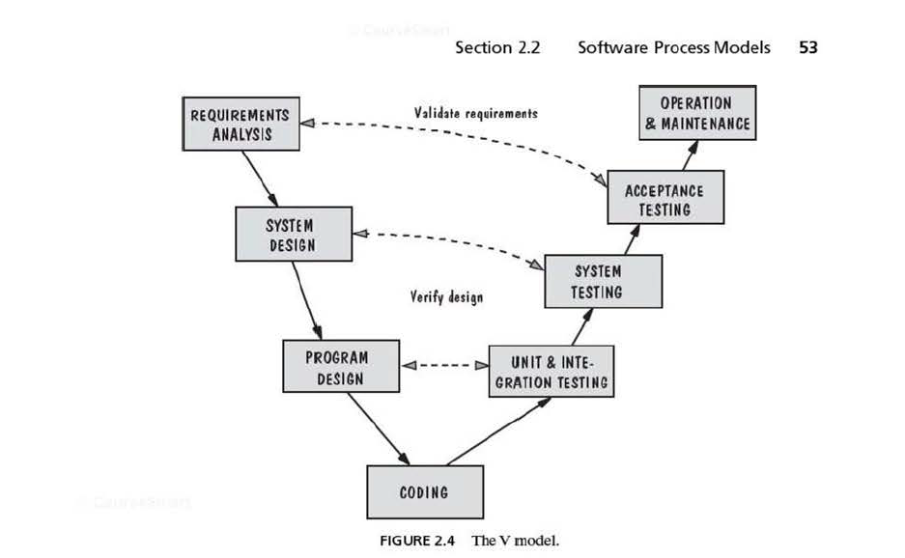

What is the motive of waterfall model with prototyping?

|  |  |  |
| --- | --- | --- |
|  |  | To ensure requirements are feasible. |
|  |  | To give the developers insight into how the users interact with the system. |
|  |  | All of the above. |
|  |  | To help designers assess alternative strategies. |