Table of Contents
1. Author 2
2. Theory 2
2.1. Question 1 2
2.2. Question 2 2
2.3. Question 3 2
2.4. Question 4 3
2.5. Question 5 3
2.6. Question 6 3
2.7. Question 7 3
2.8. Question 8 4
2.9. Question 9 4
3. Class diagram 5
4. PlantUML AI prompt 5
4.1 Code PlantUML 5
4.2 Prompt 10

1. Author
-Full name: Nguyễn Thành Lộc
-Student number: DE180158
-Class: SE18D05
Github: https://github.com/Loc20904/SWD392_PT2

2. Theory

2.1. Question 1
Analyze the difference in Lifecycle:
- Between Guest and Booking: The relationship is Aggregation. A Guest exists independently of a Booking. A guest can exist without having any active bookings, and historically, a booking record might need to be retained even if the guest profile is archived (depending on business rules), but generally, the Guest is the independent entity initiating the action.
- Between Hotel and Room: The relationship is Composition. The prompt states: "If the Hotel stops operating, the Rooms also disappear from the system." This indicates that the Room does not have a lifecycle independent of the Hotel. The Hotel owns the Room exclusively.

2.2. Question 2
Why must the BookingService class implement the IBookingService Interface instead of the BookingController calling BookingService directly? This follows the Dependency Inversion Principle. By using an interface (IBookingService), the BookingController is decoupled from the specific logic implementation in BookingService. This allows for:
- Flexibility: You can easily swap BookingService with a new implementation without changing the Controller code.
- Testability: It is easier to mock the service when unit testing the Controller.

2.3. Question 3
Based on the description "A Booking can include one or more Rooms", write the multiplicity for the two ends of the relationship between Booking and Room.
- Booking Side: 0..* (A room can be associated with zero or many bookings over time).
- Room Side: 1..* (A specific booking instance must have at least one room, and the source text says "one or more Rooms").

2.4. Question 4
List at least 3 parameters necessary for the makeReservation method in the BookingController class. To create a reservation, the system minimally needs:
- guestId (Who is booking?)
- roomId or roomIds (Which room(s)?)
- checkInDate / startDate (When does it start?)
- checkOutDate / endDate (When does it end?)

2.5. Question 5
In the calculateTotal method, which classes does BookingService need to interact with? To calculate the total, the service likely needs to depend on:
- Room (to get the specific room details).
- RoomType (to get the base price).
- Possibly Guest (if loyalty discounts apply). Which arrow represents this? This should be represented by a Dependency (..>) arrow. The service uses these entities temporarily to perform a calculation but does not necessarily hold a permanent reference to them as attributes.

2.6. Question 6
If the requirement changes: "When deleting a Guest, old Booking information must be kept for revenue statistics." Does the design need changing? If the original design used Composition for Guest-Booking, it must be changed to Association or Aggregation. However, based on standard interpretation of "A Guest can make many Bookings", the relationship is usually an Association. If so, the design does not need structural changes, but the database foreign key constraints must be set (e.g., ON DELETE SET NULL or no cascading delete) to ensure Bookings survive the Guest's deletion.

2.7. Question 7
Why does separating IBookingRepository into an Interface make the system more flexible when switching from SQL to NoSQL (MongoDB)? This follows the Repository Pattern. The BookingService relies only on the abstract IBookingRepository. If you switch to MongoDB, you only need to create a new class (e.g., MongoBookingRepository) that implements the interface. The Service code remains untouched because it doesn't care how the data is stored, only that the interface methods (save, query) exist.

2.8. Question 8
For the feature: "Each Booking must have at least one Invoice. If the Booking is deleted, the Invoice must be kept for tax reports." What relationship is this? This should be Aggregation (or simple Association).
- Reason: The Invoice has an independent lifecycle from the Booking. The prompt explicitly states that if the Booking is deleted, the Invoice "must be kept." Composition would imply the Invoice is destroyed with the Booking, which violates the requirement.

2.9. Question 9
For the "Online Payment" feature, where do you add the Payment entity? The Payment entity should be associated with the Booking.
Should the relationship between Booking and Payment be Composition or Association? It should be Composition.
- Reason: The prompt states: "if a booking is completely deleted... payment records also have no independent value." This strict dependency where the part (Payment) dies with the whole (Booking) defines Composition.

3. Class diagram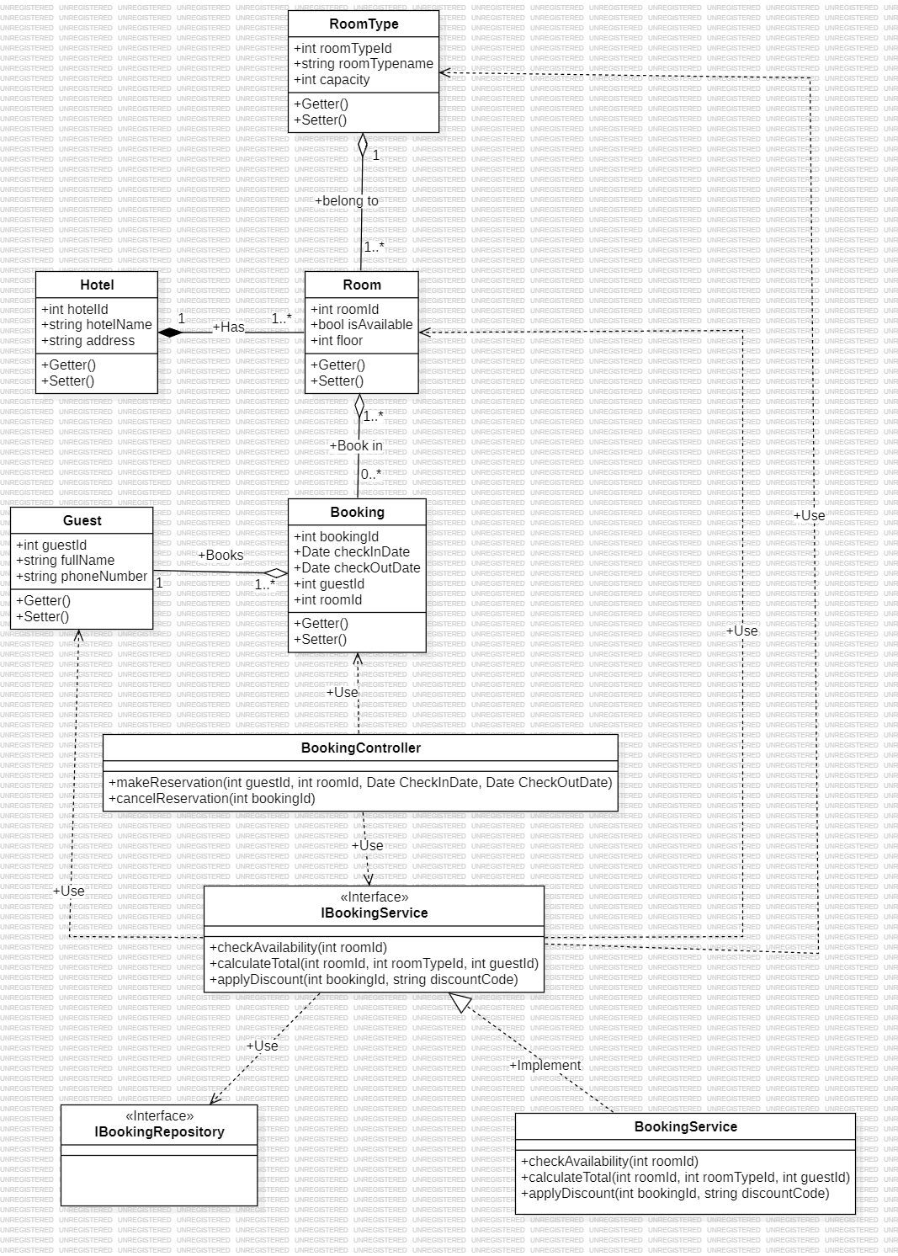

4. PlantUML AI prompt

4.1 Code PlantUML
@startuml

' --- CẤU HÌNH GIAO DIỆN ---
skinparam linetype ortho
skinparam classAttributeIconSize 0
skinparam handwritten false
skinparam monochrome false

' --- LỚP CONTROLLER ---
package "Controllers" {
class BookingController <<Controller>> {
- requestDate : Date
- currentUserIP : String
- sessionToken : String
+ makeReservation(bookingInfo : BookingDTO, clientLang : String) : boolean
+ cancelReservation(bookingId : int, reason : String) : boolean
+ getBookingDetails(bookingId : int) : BookingDTO
}
}

' --- LỚP SERVICE ---
package "Services" {
interface IBookingService <<Interface>> {
+ checkAvailability(roomId : int, checkIn : Date, checkOut : Date) : boolean
+ calculateTotal(bookingId : int, currency : String) : double
+ applyDiscount(bookingId : int, code : String) : void
}

class BookingService <<Service>> {
- serviceConfig : Config
- discountRate : float
- logger : Logger
+ checkAvailability(roomId : int, checkIn : Date, checkOut : Date) : boolean
+ calculateTotal(bookingId : int, currency : String) : double
+ applyDiscount(bookingId : int, code : String) : void
}
}

' --- LỚP REPOSITORY ---
package "Repositories" {
interface IBookingRepository <<Repository>> {
- dbConnection : Connection
- tableName : String
- timeout : int
+ save(booking : Booking) : boolean
+ findById(id : int) : Booking
+ delete(id : int, softDelete : boolean) : void
}
}

' --- THỰC THỂ (ENTITIES) ---
package "Entities" {
class Hotel <<Entity>> {
- hotelId : int
- name : String
- address : String
+ getHotelInfo(language : String) : String
+ updateInfo(newName : String, newAddress : String) : void
+ checkOperatingStatus(queryDate : Date) : boolean
}

class Room <<Entity>> {
- roomId : int
- roomNumber : String
- floor : int
+ cleanRoom(staffId : int, notes : String) : void
+ maintenance(reason : String, durationHours : int) : void
+ getStatus(onDate : Date) : String
}

class RoomType <<Entity>> {
- typeId : int
- typeName : String
- basePrice : double
+ updatePrice(newPrice : double, effectiveDate : Date) : void
+ getDescription(languageCode : String) : String
+ checkFeatures() : List<String>
}

class Guest <<Entity>> {
- guestId : int
- fullName : String
- phoneNumber : String
+ register(email : String, pass : String, name : String) : boolean
+ login(email : String, passHash : String) : boolean
+ updateProfile(email : String, phone : String, addr : String) : void
}

class Booking <<Entity>> {
- bookingId : int
- checkInDate : Date
- checkOutDate : Date
+ confirmBooking(paymentMethod : String, transactionId : String) : void
+ cancelBooking(reason : String, refundRequested : boolean) : void
+ getDuration() : int
}
}

' --- ĐỊNH NGHĨA QUAN HỆ (RELATIONSHIPS) ---

' 1. Realization
IBookingService <|.. BookingService

' 2. Dependency
BookingController ..> IBookingService
BookingService ..> IBookingRepository

' 3. Composition
Hotel "1" *-- "0..*" Room

' 4. Aggregation
Booking "0..*" o-- "1..*" Room

' 5. Association
Guest "1" --> "0..*" Booking
Room "0..*" --> "1" RoomType

@enduml

4.2 Prompt
**Role:**
Act as a Senior Software Architect and UML Expert.

**Task:**
Please analyze the provided requirements for the "Hotel Booking System" (Booking Module). I need you to complete the assignment, translate all answers into English, and format the output so it can be directly copied into a Microsoft Word document.

**Input Data:**
[Paste the content of your file here, or refer to the context if already uploaded]

**Requirements:**
**Part 3: PlantUML Implementation (Crucial)**
Write the PlantUML code for IntelliJ IDE. The code must strictly follow these technical standards:
* **Architecture:** Use `package` to separate 3 layers: Controller, Service, and Repository.
* **Stereotypes:** Use `<<Controller>>`, `<<Service>>`, `<<Repository>>`, `<<Entity>>`, `<<Interface>>`.
* **Content:** Every class must have at least 3 attributes and 2 methods.
* **Style:** Use `skinparam linetype ortho` for clean lines. Show visibility modifiers (+/-).
* **Relationships & Arrows (Strict Compliance):**
* Realization: `BookingService` implements `IBookingService` (`<|..`).
* Dependency: Controller uses Service; Service uses Repository (`..>`).
* Composition: Hotel owns Room (`*--`); Booking owns Payment (`*--`).
* Aggregation: Booking includes Room (`o--`); Booking has Invoice (`o--`).
* Association: Guest makes Booking (`-->`); Room has RoomType (`-->`).
* **Multiplicity:** Clearly label all ends (e.g., `1`, `0..*`, `1..*`).

**Output Format:**
Please structure the response clearly and wrap the PlantUML code in a code block.

**Important**
Please all function with enough parameter.

