Họ và tên: Nguyễn Tấn Lộc

MSSV: 102220155

Nhóm: 22Nh11

Bài 1.

Đề:

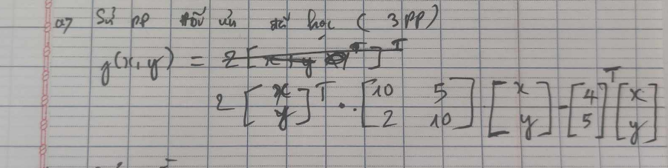

Source code:

#include <iostream>

#include <vector>

#include <cmath>

#include <iomanip>

#define e 10e-5

using namespace std;

double hamMucTieu(double *x*, double *y*)

{

    return 20 * *x* * *x* + 14 * *x* * *y* + 20 * *y* * *y* - 4 * *x* - 5 * *y*;

}

vector<double> daoHam(double *x*, double *y*, double *h* = 1e-5)

{

    double dfdx = (hamMucTieu(*x* + *h*, *y*) - hamMucTieu(*x* - *h*, *y*)) / (2 * *h*);

    double dfdy = (hamMucTieu(*x*, *y* + *h*) - hamMucTieu(*x*, *y* - *h*)) / (2 * *h*);

    return {dfdx, dfdy};

}

vector<vector<double>> hessian(double *x*, double *y*, double *h* = 1e-5)

{

    double d2fdx2 = (hamMucTieu(*x* + *h*, *y*) - 2 * hamMucTieu(*x*, *y*) + hamMucTieu(*x* - *h*, *y*)) / (*h* * *h*);

    double d2fdy2 = (hamMucTieu(*x*, *y* + *h*) - 2 * hamMucTieu(*x*, *y*) + hamMucTieu(*x*, *y* - *h*)) / (*h* * *h*);

    double d2fdxdy = (hamMucTieu(*x* + *h*, *y* + *h*) - hamMucTieu(*x* + *h*, *y* - *h*) - hamMucTieu(*x* - *h*, *y* + *h*) + hamMucTieu(*x* - *h*, *y* - *h*)) / (4 * *h* * *h*);

    return {

        {d2fdx2, d2fdxdy},

        {d2fdxdy, d2fdy2}};

}

void phuongPhapNewtonRaphson(double *x*, double *y*, double *tol*, int *max_iter*)

{

    int iter = 0;

    while (iter < *max_iter*)

    {

        vector<double> grad = daoHam(*x*, *y*);

        vector<vector<double>> hess = hessian(*x*, *y*);

        double det = hess[0][0] * hess[1][1] - hess[0][1] * hess[1][0];

        if (fabs(det) < 1e-6)

            break;

        vector<vector<double>> inv_hess = {

            {hess[1][1] / det, -hess[0][1] / det},

            {-hess[1][0] / det, hess[0][0] / det}};

*x* -= inv_hess[0][0] * grad[0] + inv_hess[0][1] * grad[1];

*y* -= inv_hess[1][0] * grad[0] + inv_hess[1][1] * grad[1];

        if (sqrt(grad[0] * grad[0] + grad[1] * grad[1]) < *tol*)

            break;

        iter++;

    }

    cout << "Ket qua phuong phap newton: x = " << *x* << ", y = " << *y* << "\n f(x, y) = " << hamMucTieu(*x*, *y*) << endl;

}

void phuongPhapMauGoc(double *x*, double *y*, double *learning_rate*, double *tol*, int *max_iter*)

{

    int iter = 0;

    while (iter < *max_iter*)

    {

        vector<double> grad = daoHam(*x*, *y*);

*x* -= *learning_rate* * grad[0];

*y* -= *learning_rate* * grad[1];

        if (sqrt(grad[0] * grad[0] + grad[1] * grad[1]) < *tol*)

            break;

        iter++;

    }

    cout << "Ket qua voi phuong phap gradient descent:\n x = " << *x* << ", y = " << *y* << "\n f(x, y) = " << hamMucTieu(*x*, *y*) << endl;

}

void phuongPhapMauGocVoiMomen(double *x*, double *y*, double *learning_rate*, double *momentum*, double *tol*, int *max_iter*)

{

    double vx = 0, vy = 0;

    int iter = 0;

    while (iter < *max_iter*)

    {

        vector<double> grad = daoHam(*x*, *y*);

        vx = *momentum* * vx - *learning_rate* * grad[0];

        vy = *momentum* * vy - *learning_rate* * grad[1];

*x* += vx;

*y* += vy;

        if (sqrt(grad[0] * grad[0] + grad[1] * grad[1]) < *tol*)

            break;

        iter++;

    }

    cout << "Ket qua phuong phap gradient descent voi momentum:\n x = " << *x* << ", y = " << *y* << "\n f(x, y) = " << hamMucTieu(*x*, *y*) << endl;

}

int main()

{

    double x = 0.0, y = 0.0, rate = 0.01, momentum = 0.9;

    int max = 10000;

    cout << "f(x, y) = 20x^2 + 14xy + 20y^2 - 4x - 5y\n";

    phuongPhapNewtonRaphson(x, y, e, max);

    phuongPhapMauGoc(x, y, rate, e, max);

    phuongPhapMauGocVoiMomen(x, y, rate, momentum, e, max);

    return 0;

}

Kết quả:

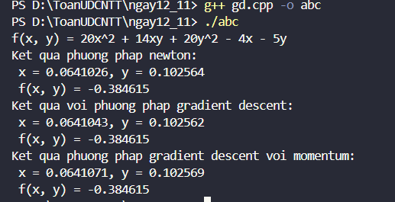

Bài 2:

Đề:

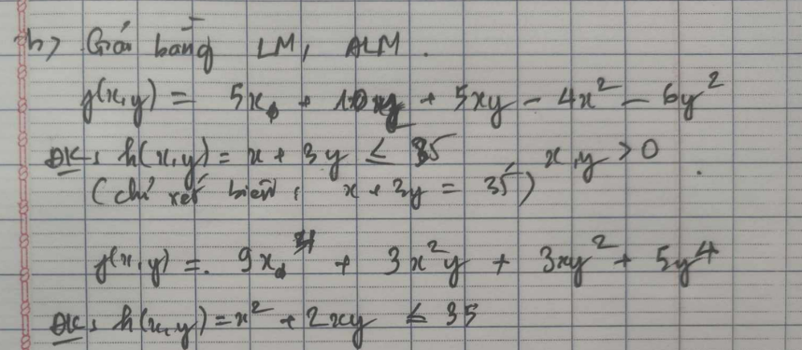

a)

Source code:

#include <iostream>

#include <cmath>

using namespace std;

double f(double *x*, double *y*)

{

    return 5 * *x* + 10 * *y* + 5 * *x* * *y* - 4 * *x* * *x* - 6 * *y* * *y*;

}

double g(double *x*, double *y*)

{

    return *x* + 3 * *y*;

}

void toiUuKKT(double (\**f*)(double, double), double (\**g*)(double, double))

{

    double x = 0, y = 0, lambda = 0;

    double buoc = 0.00001;

    double tol = 0.0001;

    int max_iter = 1000;

    int iter = 0;

    while (iter < max_iter)

    {

        double df_dx = 5 + 5 * y - 8 * x;

        double df_dy = 10 + 5 * x - 12 * y;

        double dg_dx = 1;

        double dg_dy = 3;

        cout << "Lan lap " << iter << ": g(x, y) = " << *g*(x, y)

             << ", df_dx = " << df_dx << ", df_dy = " << df_dy << endl;

        if (fabs(*g*(x, y) - 35) < tol)

        {

            double mau = dg_dx * dg_dy - df_dx * df_dy;

            if (fabs(mau) > 1e-8)

            {

                lambda = (df_dx * dg_dy - df_dy * dg_dx) / mau;

            }

            else

            {

                lambda = 0;

            }

        }

        else

        {

            lambda = 0;

        }

        double x_moi = x - buoc * (df_dx - lambda * dg_dx);

        double y_moi = y - buoc * (df_dy - lambda * dg_dy);

        if (fabs(x_moi - x) < tol && fabs(y_moi - y) < tol)

        {

            break;

        }

        x = x_moi;

        y = y_moi;

        iter++;

    }

    cout << "f(x) = 5x + 10y + 5xy - 4x^2 - 6y^2" << endl;

    cout << "Dieu kien: x + 3y <= 35" << endl;

    cout << "Ket qua tim duoc sau " << iter << " lan lap:\n";

    cout << "x = " << x << ", y = " << y << ", lambda = " << lambda << endl;

    cout << "Gia tri ham muc tieu f(x, y) = " << *f*(x, y) << endl;

}

int main()

{

    toiUuKKT(f, g);

    return 0;

}

Kết quả:

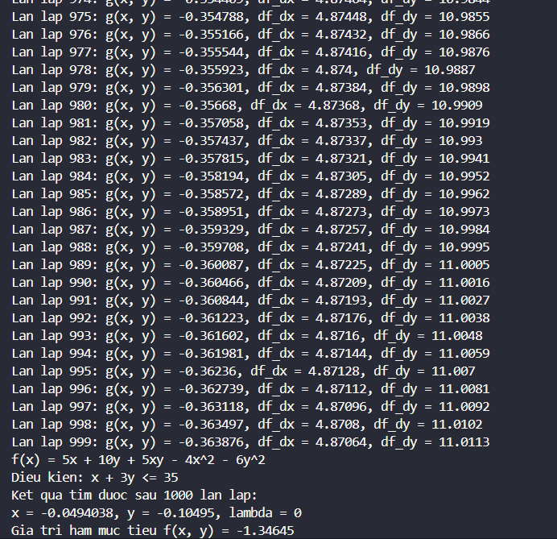

b)

Source code:

#include <iostream>

#include <cmath>

using namespace std;

// Updated objective function f(x, y)

double f(double *x*, double *y*)

{

    return 9 * pow(*x*, 4) + 3 * *y* * pow(*x*, 2) + 3 * *x* * pow(*y*, 2) + 5 * pow(*y*, 4);

}

// Constraint function g(x, y)

double g(double *x*, double *y*)

{

    return *x* + 3 * *y*;

}

// Modified optimization function with the new derivatives

void toiUuKKT(double (\**f*)(double, double), double (\**g*)(double, double))

{

    double x = 1, y = 1, lambda = 0;

    double buoc = 0.00001;

    double tol = 0.0001;

    int max_iter = 1000;

    int iter = 0;

    while (iter < max_iter)

    {

        // Partial derivatives of the new f(x, y)

        double df_dx = 36 * pow(x, 3) + 6 * y * x + 3 * pow(y, 2);

        double df_dy = 20 * pow(y, 3) + 3 * pow(x, 2) + 6 * x * y;

        double dg_dx = 1;

        double dg_dy = 3;

        cout << "Lan lap " << iter << ": g(x, y) = " << *g*(x, y)

             << ", df_dx = " << df_dx << ", df_dy = " << df_dy << endl;

        if (fabs(*g*(x, y) - 35) < tol)

        {

            double mau = dg_dx * dg_dy - df_dx * df_dy;

            if (fabs(mau) > 1e-8)

            {

                lambda = (df_dx * dg_dy - df_dy * dg_dx) / mau;

            }

            else

            {

                lambda = 0;

            }

        }

        else

        {

            lambda = 0;

        }

        double x_moi = x - buoc * (df_dx - lambda * dg_dx);

        double y_moi = y - buoc * (df_dy - lambda * dg_dy);

        if (fabs(x_moi - x) < tol && fabs(y_moi - y) < tol)

        {

            break;

        }

        x = x_moi;

        y = y_moi;

        iter++;

    }

    cout << "f(x) = 9x^4 + 3x^2y + 3xy^2 + 5y^4" << endl;

    cout << "Dieu kien: x + 3y <= 35" << endl;

    cout << "Ket qua tim duoc sau " << iter << " lan lap:\n";

    cout << "x = " << x << ", y = " << y << ", lambda = " << lambda << endl;

    cout << "Gia tri ham muc tieu f(x, y) = " << *f*(x, y) << endl;

}

int main()

{

    toiUuKKT(f, g);

    return 0;

}

Kết quả:

