TECHNICAL REPORT
8-Bit 5-Stage Pipelined RISC Processor
Design, Verification, Simulation and FPGA Synthesis in Verilog HDL

Item | Detail
Student name | Lam Duy Loc
Student ID | SE190907
Project | 8-bit RISC Processor, 5-Stage Pipeline (IF - ID - EX - MEM - WB)
Language / Tools | Verilog HDL; Xilinx Vivado (XSim behavioral simulation, RTL elaboration, synthesis)
Target clock | 100 MHz (10.000 ns period)
Synthesis part (in screenshots) | xc7vx485tffg1157-1
Report date | October 2026

Table of Contents
1. Introduction
2. Project Overview and Source Organization
3. Instruction Set Architecture (ISA)
4. Pipeline Microarchitecture
5. Module-Level Design
6. Hazard Detection and Resolution
7. Verification Strategy
8. Simulation Results and Analysis
9. Synthesis Results and Resource Analysis
10. Design Review: Findings and Recommendations
11. Conclusion
Appendix A. Control Unit Truth Table
Appendix B. Complete Instruction Encoding of the Test Program

List of abbreviations
Term | Meaning
ALU | Arithmetic Logic Unit
CPI / IPC | Cycles Per Instruction / Instructions Per Cycle
FF | Flip-Flop (slice register)
LUT | Look-Up Table (FPGA logic cell)
ISA | Instruction Set Architecture
PC | Program Counter
RAW | Read-After-Write data hazard
WNS | Worst Negative Slack (timing)
XDC | Xilinx Design Constraints file
Z / C | Zero flag / Carry (borrow) flag

1. Introduction

1.1 Purpose of the project
This report documents the complete design flow of a compact 8-bit RISC processor core with a classic five-stage pipeline (Instruction Fetch, Instruction Decode, Execute, Memory access, Write-Back). The core was written in synthesizable Verilog HDL, verified with a self-checking testbench in the Vivado XSim simulator, and then elaborated and synthesized in Vivado to obtain a resource-utilization profile for a 100 MHz target clock.
Pipelining raises throughput by overlapping the execution of several instructions, but it also introduces hazards: situations in which an instruction needs a result that has not yet been produced (data hazards) or in which the next instruction to fetch is not known yet (control hazards). A major part of this project is therefore the hardware that detects and resolves hazards - an operand-forwarding network, a load-use stall mechanism and a pipeline-flush mechanism for taken branches.

1.2 Objectives
- Define a small but complete 16-bit instruction format with 16 opcodes (arithmetic, logic, shift, immediate, load/store, jump/branch, halt).
- Implement the datapath as separate, reusable Verilog modules (alu, control_unit, regfile, imem, dmem, hazard_unit) integrated by the top module risc8_5stage_core.
- Resolve RAW data hazards by forwarding at distances 1, 2 and 3, and by a one-cycle stall for the load-use case.
- Resolve control hazards by flushing wrong-path instructions when a jump or branch is taken in the EX stage.
- Verify functional correctness with a self-checking testbench that runs an assembly-level test program and checks nine architectural results.
- Synthesize the design in Vivado and report logic utilization to judge the hardware cost of the design.

1.3 Scope and sources of evidence
All statements in this report are derived from the submitted project package: the seven Verilog design files, the testbench tb_risc8_5stage.v, the constraint file risc8.xdc, and six Vivado screenshots (project sources, waveform, Tcl console log, elaborated schematic, synthesized schematic, and utilization report). Numerical results (cycle counts, utilization figures) are quoted directly from those screenshots. Where this report offers an interpretation or an estimate that is not directly shown in the screenshots, it is explicitly marked as such.

2. Project Overview and Source Organization

2.1 Key design features
Table 1. Summary of the processor's main architectural parameters
Parameter | Value
Data width | 8 bits
Instruction width | 16 bits (fixed length)
Number of opcodes | 16 (4-bit opcode field, bits [15:12])
General-purpose registers | 8 x 8-bit (R0..R7); R0 is an ordinary register, not hard-wired to zero
Program counter | 8 bits, addresses 256 instruction words
Instruction memory | 256 x 16-bit ROM, asynchronous read, pre-loaded with the test program
Data memory | 256 x 8-bit RAM, synchronous write, asynchronous read
Status flags | Z (zero) and C (carry / borrow / shift-out)
Pipeline | 5 stages: IF, ID, EX, MEM, WB; each instruction carries a valid bit
Hazard handling | EX/MEM and MEM/WB forwarding, register-file write-through, 1-cycle load-use stall, branch flush
Branch resolution | In EX stage (2-cycle penalty when taken)
Debug outputs | halted, pc_out[7:0], flags_out[1:0], instr_done
Target clock | 100 MHz (10.000 ns), defined in risc8.xdc

2.2 File inventory
Table 2. Source files in the submitted package
File | Module | Lines | Role
sources/risc8_5stage_core.v | risc8_5stage_core | 399 | Top level: PC, pipeline registers, stage interconnect, flush / stall / halt priority logic, output ports
sources/alu.v | alu | 86 | Combinational 8-bit ALU with 8 operations and Z / C flag generation
sources/control_unit.v | control_unit | 170 | Hard-wired decoder: 4-bit opcode to 14 control signals
sources/regfile.v | regfile | 40 | 8 x 8-bit register file, 2 asynchronous read ports, 1 synchronous write port with write-through
sources/imem.v | imem | 64 | 256 x 16 instruction ROM containing the verification program
sources/dmem.v | dmem | 41 | 256 x 8 data RAM for LD / ST
sources/hazard_unit.v | hazard_unit | 81 | Forwarding-select logic and load-use stall detection
sim/tb_risc8_5stage.v | tb_risc8_5stage | 137 | Self-checking testbench, cycle monitor, performance counters
constrs/risc8.xdc | - | 23 | 100 MHz clock constraint and (commented) Basys-3 pin map

2.3 Design hierarchy
The top module risc8_5stage_core instantiates six sub-modules, matching the "(6)" shown next to the top module in the Vivado Sources window (Figure 1):
risc8_5stage_core
+-- u_imem : imem (instruction ROM, stage IF)
+-- u_ctrl : control_unit (decoder, stage ID)
+-- u_regfile: regfile (register file, stages ID / WB)
+-- u_hazard : hazard_unit (forwarding + stall, stages ID / EX)
+-- u_alu : alu (stage EX)
+-- u_dmem : dmem (data RAM, stage MEM)

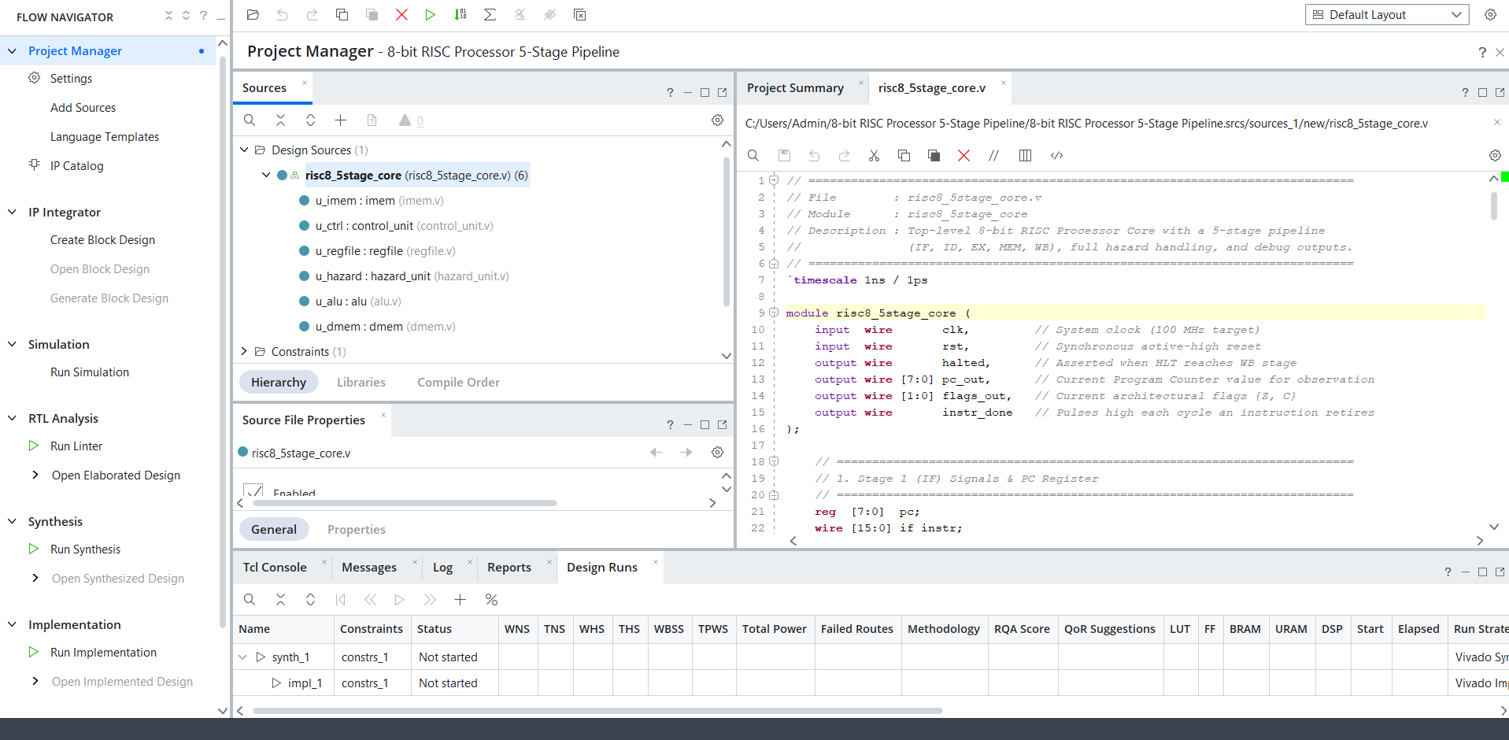
Figure 1. Vivado Project Manager showing the design hierarchy of `risc8_5stage_core` with its six sub-modules.
The project is named "8-bit RISC Processor 5-Stage Pipeline" in Vivado. At the time of the screenshot, one constraint set (constrs_1) is attached and both synth_1 and impl_1 runs are listed, with synthesis not yet started in this particular view.

3. Instruction Set Architecture (ISA)

3.1 Architectural state
- Registers: eight 8-bit general-purpose registers R0-R7. Because R0 is a normal register, any register can hold a loop counter, address or data.
- Program counter: 8-bit, word-addressed (one count = one 16-bit instruction); reset value 0x00.
- Flags: Z is set when an ALU result equals zero; C holds carry-out for ADD/ADDI, borrow (a < b) for SUB, and the bit shifted out for SHL/SHR. Logic operations clear C. Flags are updated only by instructions whose flag_we control bit is 1.
- Memories: separate instruction ROM (256 x 16) and data RAM (256 x 8), i.e. a Harvard organization. Data memory is byte-addressed by the 8-bit value of a register.

3.2 Instruction formats
All instructions are 16 bits wide. The opcode occupies bits [15:12] and the destination field rd occupies bits [11:9] for every instruction that has one. The fields rs1, rs2 and imm8 are decoded in the ID stage directly from the instruction register (ifid_instr).
Table 3. Instruction formats (bit fields)
Format | Field layout | Used by
R-type | [15:12] opcode | [11:9] rd | [8:6] rs1 | [5:3] rs2 | [2:0] unused | ADD, SUB, AND, OR, XOR (SHL / SHR ignore rs2)
I-type | [15:12] opcode | [11:9] rd | [8] unused | [7:0] imm8 | LDI, ADDI
Memory | [15:12] opcode | [11:9] rd | [8:6] rs1 | [5:0] unused | LD (rd <- Mem[rs1]), ST (Mem[rs1] <- rd)
Control | [15:12] opcode | [11:8] unused | [7:0] target address | JMP, BZ, BNZ
Special | [15:12] opcode | [11:0] unused | NOP, HLT
Two details of this encoding are worth noting. First, the 8-bit immediate overlaps the rs1 / rs2 fields; this is harmless because I-type and control instructions never read those register fields (except ADDI, which reads rd through port A). Second, branch targets are absolute 8-bit addresses, not PC-relative offsets, so the target can be loaded straight into the PC without an adder.

3.3 Instruction set summary
Table 4. Complete instruction set (opcodes from `control_unit.v`)
Opcode | Mnemonic | Syntax | Operation | Flags updated
0x0 | NOP | NOP | No operation (all control signals 0) | -
0x1 | ADD | ADD rd, rs1, rs2 | R[rd] <- R[rs1] + R[rs2] | Z, C (carry-out)
0x2 | SUB | SUB rd, rs1, rs2 | R[rd] <- R[rs1] - R[rs2] | Z, C (borrow)
0x3 | AND | AND rd, rs1, rs2 | R[rd] <- R[rs1] & R[rs2] | Z, C = 0
0x4 | OR | OR rd, rs1, rs2 | R[rd] <- R[rs1] | R[rs2] | Z, C = 0
0x5 | XOR | XOR rd, rs1, rs2 | R[rd] <- R[rs1] ^ R[rs2] | Z, C = 0
0x6 | SHL | SHL rd, rs1 | R[rd] <- R[rs1] << 1 (logical); C <- old bit 7 | Z, C
0x7 | SHR | SHR rd, rs1 | R[rd] <- R[rs1] >> 1 (logical); C <- old bit 0 | Z, C
0x8 | LDI | LDI rd, imm8 | R[rd] <- imm8 | none
0x9 | ADDI | ADDI rd, imm8 | R[rd] <- R[rd] + imm8 | Z, C
0xA | LD | LD rd, [rs1] | R[rd] <- Mem[R[rs1]] | none
0xB | ST | ST rd, [rs1] | Mem[R[rs1]] <- R[rd] | none
0xC | JMP | JMP addr | PC <- addr (unconditional) | none
0xD | BZ | BZ addr | if (Z = 1) PC <- addr | none
0xE | BNZ | BNZ addr | if (Z = 0) PC <- addr | none
0xF | HLT | HLT | Stop fetching; assert halted when HLT reaches WB | none

4. Pipeline Microarchitecture
Figure 2 shows the organization of the datapath. Each stage is separated from the next by a pipeline register (grey) that is written on every rising clock edge. The hazard unit observes the registers of the ID, EX, MEM and WB stages and drives the two forwarding multiplexers and the stall signal. A taken branch is detected in EX and redirects the PC (orange path).
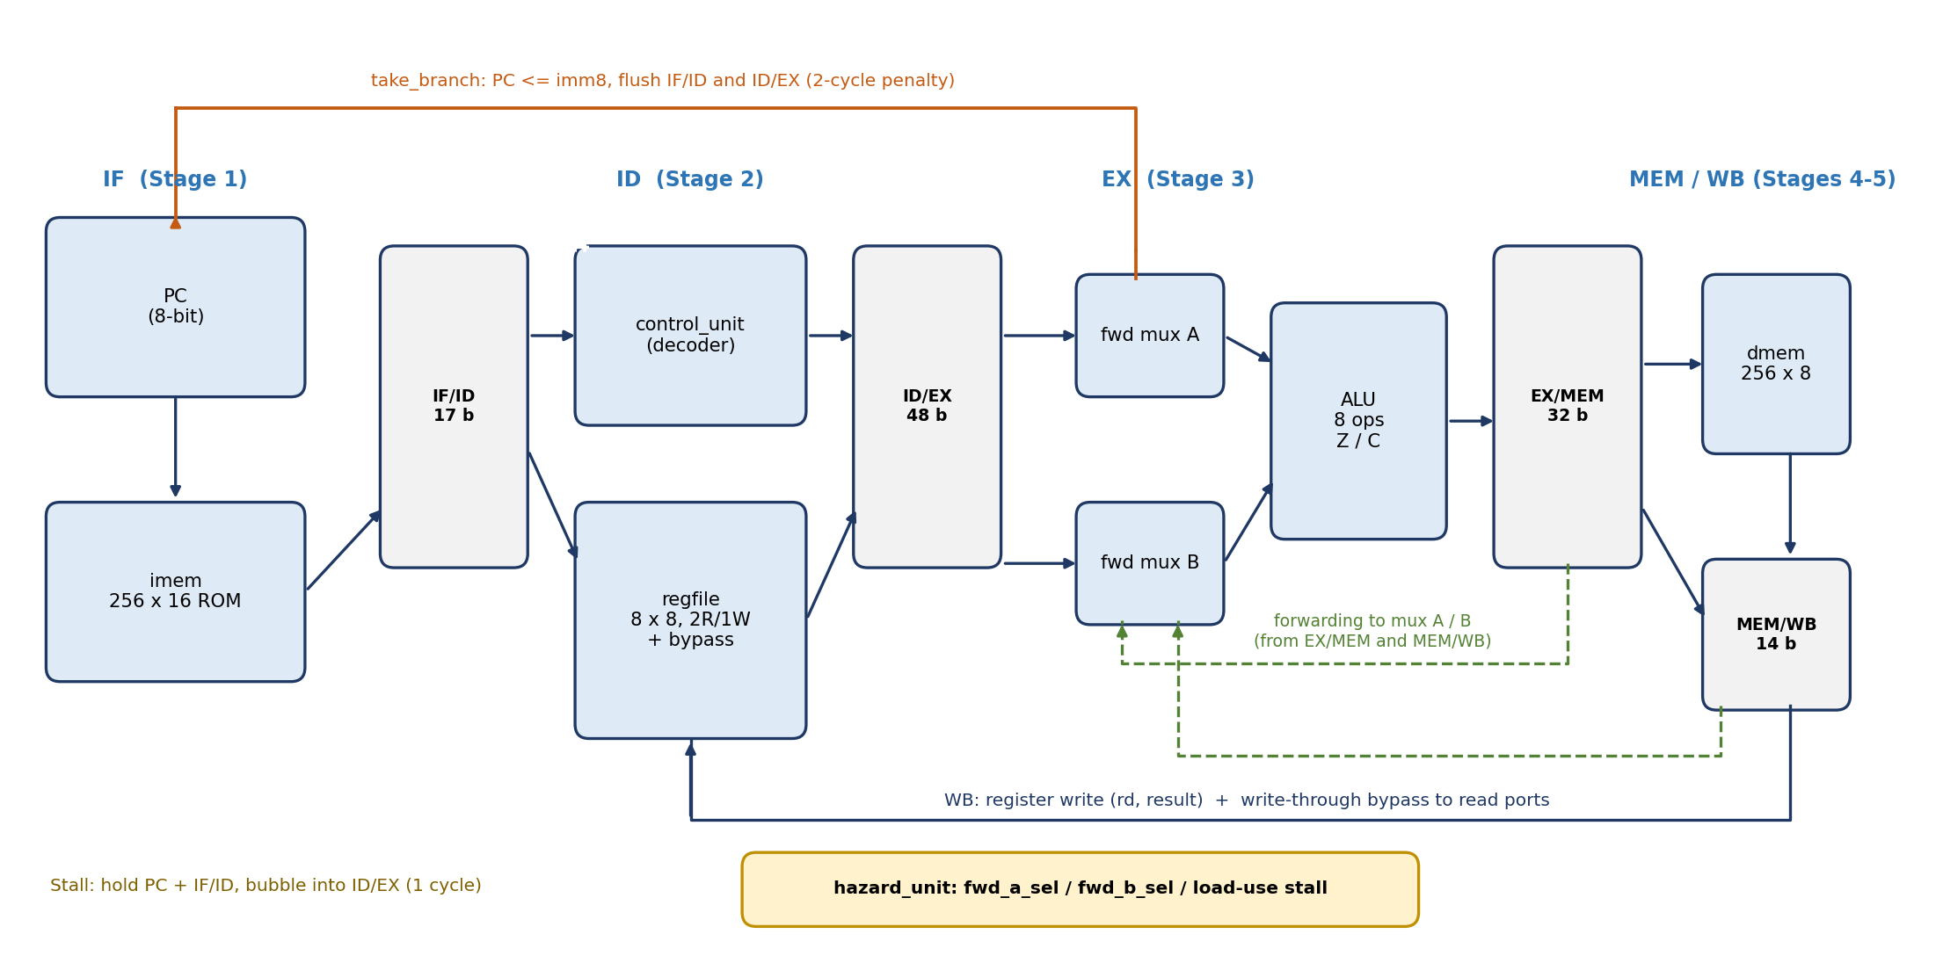
Figure 2. Block diagram of the 5-stage pipeline with forwarding (green), branch redirect (orange) and hazard unit (yellow). Reconstructed from the Verilog source.

4.1 Stage-by-stage description

Stage 1 - Instruction Fetch (IF)
The 8-bit program counter pc addresses the asynchronous instruction ROM imem. In normal operation the PC increments by one each cycle and the fetched word is latched into ifid_instr together with ifid_valid = 1. The PC is overwritten with idex_imm8 when a branch is taken, and held when the pipeline stalls or a HLT is in flight.

Stage 2 - Instruction Decode (ID)
control_unit decodes the opcode into 14 control signals. Two multiplexers choose the register indices that are sent to the register file: id_ra = ra_is_rd ? rd : rs1 (ADDI reads its own destination as operand A) and id_rb = rb_is_rd ? rd : rs2 (ST reads the register to be stored on port B). The register file returns both operands in the same cycle (asynchronous read). Everything is then latched into the ID/EX register. If the IF/ID entry is invalid, if a stall is requested, or if a branch/halt flush is active, a bubble (all-zero control, valid = 0) is inserted instead.

Stage 3 - Execute (EX)
Two forwarding multiplexers select operand A and B from one of three sources: the ID/EX register itself, the ALU result held in EX/MEM, or the write-back value held in MEM/WB. A second multiplexer selects between the forwarded register-B value and the 8-bit immediate (alu_src_imm). The ALU computes the result and the Z/C flags; the flags are written into the architectural flag registers when idex_valid && idex_flag_we. Branch conditions are also evaluated here: take_branch = idex_valid && (jump || (br_z && flag_z) || (br_nz && !flag_z)). The memory address (exmem_addr) and the store data (exmem_st_data) are taken from the forwarded operands A and B respectively.

Stage 4 - Memory Access (MEM)
The data RAM is written when exmem_valid && exmem_mem_we && !halted. Reading is asynchronous, so the loaded byte is available in the same cycle and is selected by mem_result = exmem_mem_to_reg ? mem_rdata : exmem_alu_result.

Stage 5 - Write-Back (WB)
The value held in memwb_result is written into register memwb_rd when memwb_valid && memwb_reg_we && !halted. The same write is also visible immediately on the register file's read ports through a write-through bypass (Section 5.2). instr_done is simply memwb_valid, so it pulses high each cycle in which a real instruction retires.

4.2 Pipeline registers
Table 5. Contents and size of each pipeline register
Register | Bits | Contents
IF/ID | 17 | instruction (16) + valid (1)
ID/EX | 48 | valid, alu_op[2:0], alu_src_imm, uses_a, uses_b, reg_we, mem_to_reg, mem_we, flag_we, jump, br_z, br_nz, halt (15 control bits); rd, ra, rb (9 bits); rdata_a, rdata_b, imm8 (24 bits)
EX/MEM | 32 | valid, reg_we, mem_to_reg, mem_we, halt (5); rd (3); alu_result, addr, st_data (24)
MEM/WB | 14 | valid, reg_we, halt (3); rd (3); result (8)
Other state | 11 | pc (8), flag_z, flag_c (2), halted_reg (1)
Total | 122 | Architectural pipeline / control state counted from the RTL (excludes the register file and RAM)

4.3 Priority of pipeline control
The sequential always @(posedge clk) block in the top module implements the following priority, which is stated in the source comments and verified by the simulation:
- Reset - clears PC, flags, all pipeline registers and the halted state.
- Halted freeze - once halted is asserted nothing in the pipeline changes (else if (!halted)).
- Branch flush - if take_branch, load PC with the target and insert bubbles into IF/ID and ID/EX.
- Halt squash - if a HLT is in EX, MEM or WB (halt_in_pipe), stop fetching and squash younger instructions.
- Stall - on a load-use hazard hold the PC and IF/ID and insert a bubble into ID/EX.
- Normal flow - fetch the next instruction and advance all stages.

4.4 Halt mechanism
HLT is decoded in ID and carried down the pipe by the halt bit. When it reaches EX, halt_in_pipe stops further fetching and squashes the instruction behind it, so no younger instruction can modify architectural state. When HLT is in MEM, halted_reg is set; the output halted is (memwb_valid && memwb_halt) || halted_reg, which is therefore asserted as soon as HLT reaches WB and stays high. The testbench uses this signal to decide when to stop and check results. The register file and data-memory write enables are additionally gated by !halted.

5. Module-Level Design

5.1 Instruction memory (imem)
A 256-entry array of 16-bit words, initialised in an initial block: every location defaults to NOP (0x0000) and then the 24 words of the test program are written (addresses 0x00-0x17). The read is purely combinational (assign instr = rom[addr]), so the instruction is available in the same cycle in which the PC changes - this keeps the IF stage to a single cycle without needing an extra pipeline stage for a synchronous memory.

5.2 Register file (regfile)
Eight 8-bit registers with two asynchronous read ports and one synchronous write port. A synchronous reset clears all registers. The read ports contain a write-through bypass:
assign rdata_a = (we && (waddr == raddr_a)) ? wdata : regs[raddr_a];
assign rdata_b = (we && (waddr == raddr_b)) ? wdata : regs[raddr_b];
When the instruction in WB writes the very register that the instruction in ID is reading in the same cycle, the new value is passed straight through. This covers the RAW hazard at distance 3 and means that the forwarding network in EX only has to handle distances 1 and 2.

5.3 Arithmetic Logic Unit (alu)
The ALU is purely combinational. Default assignments (result = 0, c_flag = 0) are made at the top of the always @(*) block to prevent unintended latch inference. The zero flag is derived concurrently as z_flag = (result == 0). Addition is performed on a 9-bit wire so that the carry-out is available as bit 8.
Table 6. ALU operations
alu_op | Name | Result | Carry flag
0 | ADD | a + b | carry-out of the 9-bit sum
1 | SUB | a - b | (a < b) - borrow
2 | AND | a & b | 0
3 | OR | a | b | 0
4 | XOR | a ^ b | 0
5 | SHL | {a[6:0], 1'b0} | a[7] (bit shifted out)
6 | SHR | {1'b0, a[7:1]} | a[0] (bit shifted out)
7 | PASSB | b | 0 (used by LDI to pass the immediate)

5.4 Control unit (control_unit)
A purely combinational decoder. All outputs default to 0 so that unknown opcodes behave as a safe NOP. The control word has 14 signals; their meaning is summarised below, and the complete truth table for all 16 opcodes is given in Appendix A.
Table 7. Control signals
Signal | Meaning
alu_op[2:0] | Selects the ALU operation (Table 6)
alu_src_imm | 1: ALU input B is imm8 (LDI, ADDI) instead of register B
ra_is_rd | 1: read port A uses field rd (ADDI)
rb_is_rd | 1: read port B uses field rd (ST - the register to be stored)
uses_a, uses_b | Tell the hazard unit which read ports the instruction really needs, so false dependencies are not detected
reg_we | 1: instruction writes register rd in WB
mem_to_reg | 1: write-back data comes from data RAM (LD)
mem_we | 1: write data RAM in MEM (ST)
flag_we | 1: update Z and C in EX (ADD, SUB, AND, OR, XOR, SHL, SHR, ADDI)
jump, br_z, br_nz | Unconditional jump / branch if Z=1 / branch if Z=0
halt | 1: HLT

5.5 Data memory (dmem)
A 256 x 8-bit RAM with a synchronous write (ram[addr] <= wdata when we) and an asynchronous read (assign rdata = ram[addr]). All locations are cleared in an initial block and also by the synchronous reset. The asynchronous read lets a loaded byte reach the MEM/WB register at the end of the MEM cycle. The synthesis consequences of this coding style are discussed in Section 9.3.

6. Hazard Detection and Resolution
Table 8 summarises every hazard class that the design handles and the mechanism that resolves it.
Table 8. Hazard handling summary
Hazard | Situation | Resolution | Penalty
RAW, distance 1 | Producer in MEM, consumer in EX (e.g. LDI R4 then ST [R4]) | Forward exmem_alu_result (select 01) | 0 cycles
RAW, distance 2 | Producer in WB, consumer in EX | Forward memwb_result (select 10) | 0 cycles
RAW, distance 3 | Producer in WB, consumer in ID | Register-file write-through bypass | 0 cycles
Load-use | LD in EX, consumer in ID needs the loaded register | Hold PC and IF/ID one cycle, insert bubble in ID/EX; then forward from MEM/WB | 1 cycle
Control (taken branch) | JMP / BZ / BNZ taken in EX | PC <- idex_imm8; flush IF/ID and ID/EX | 2 cycles
Halt | HLT in EX / MEM / WB | Stop fetch, squash younger instructions, freeze pipeline when halted | -

6.1 Operand forwarding
For each EX operand the hazard unit compares the consumer's source register with the destination register of the instructions in MEM and WB. Only registers that the instruction really reads (idex_uses_a / idex_uses_b) and only valid, register-writing producers are considered. The EX/MEM stage has priority over MEM/WB because it holds the more recent value:
if (idex_valid && idex_uses_a) begin
if (exmem_valid && exmem_reg_we && !exmem_mem_to_reg && (exmem_rd == idex_ra))
fwd_a_sel = 2'b01; // newest result from EX/MEM
else if (memwb_valid && memwb_reg_we && (memwb_rd == idex_ra))
fwd_a_sel = 2'b10; // older result from MEM/WB
end
Note the term !exmem_mem_to_reg: when the producer in MEM is a load, its data is not yet in exmem_alu_result (it appears only in memwb_result one cycle later), so forwarding from EX/MEM is suppressed and the load-use stall takes over. Operand B uses identical logic with idex_rb.

6.2 Load-use stall
The stall condition is evaluated in ID:
wire match_a = id_uses_a && (id_ra == idex_rd);
wire match_b = id_uses_b && (id_rb == idex_rd);
assign stall = ifid_valid && idex_valid && idex_mem_to_reg && (match_a || match_b);
Because the stall holds the dependent instruction in ID for one extra cycle and inserts a bubble into EX, the load reaches WB just as the consumer enters EX, where the value is forwarded from MEM/WB. Figure 3 shows exactly this sequence for the instructions at addresses 0x10-0x14 of the test program, which the simulation log confirms (Section 8.3).
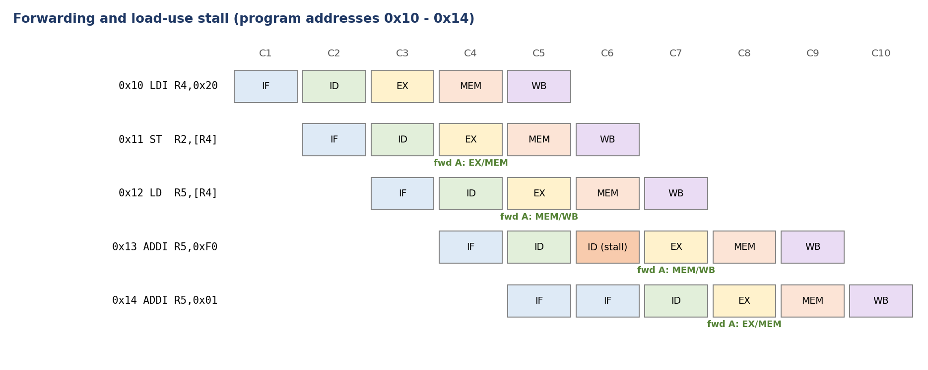
Figure 3. Pipeline timing of the memory section of the test program. The stall is asserted in C5 (LD in EX, ADDI in ID); the dependent ADDI therefore executes in C7 with the loaded data forwarded from MEM/WB. Green labels show forwarding events on operand A.

6.3 Control hazards
Branches and jumps are resolved in the EX stage. By the time the branch is in EX, the two following sequential instructions have already been fetched (one in ID, one in IF). When take_branch is asserted the design therefore discards both: IF/ID is overwritten with a bubble, the ID/EX bubble is inserted, and the PC is loaded with the target. The penalty of every taken branch is two cycles. Not-taken branches cost nothing, because fetch simply continues sequentially.
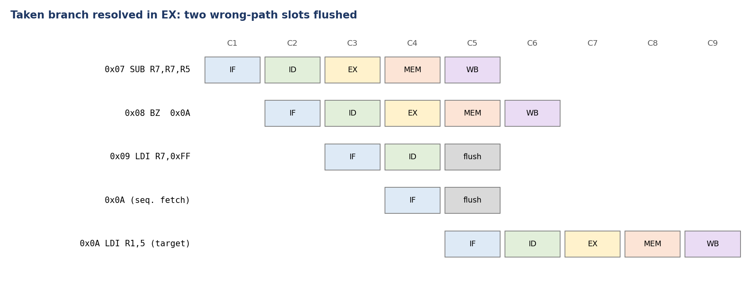
Figure 4. A taken BZ at address 0x08 flushes the wrong-path instruction 0x09 (in ID) and the sequential fetch in IF; the target at 0x0A is fetched in C5.
The Z flag used by BZ / BNZ is the registered flag. A flag-setting instruction immediately before a branch works without extra hardware: the flag is written at the end of the producer's EX cycle, and the branch reaches EX in the next cycle, where it reads the new value. This is exercised by SUB R7,R7,R5 followed by BZ (addresses 0x07-0x08) and by SUB R1,R1,R3 followed by BNZ in the loop (0x0E-0x0F).

7. Verification Strategy

7.1 Test program
Rather than testing each module in isolation only, the project verifies the integrated processor with one carefully designed assembly program stored in imem. The program (Table 9) exercises every instruction group, all three forwarding distances, the load-use stall, taken and not-taken branches, an arithmetic loop, 8-bit carry overflow, an unconditional jump and the halt mechanism. Two "poison" instructions (LDI R7,0xFF at 0x09 and 0x16) sit on the wrong path after a taken branch: if the flush logic were broken, R7 would end up as 0xFF instead of 0x00.
Table 9. Verification program (24 instructions, addresses 0x00-0x17)
Addr | Hex | Assembly | Purpose / expected effect
0x00 | 823C | LDI R1, 0x3C | R1 = 0x3C
0x01 | 840F | LDI R2, 0x0F | R2 = 0x0F
0x02 | 3650 | AND R3, R1, R2 | R3 = 0x0C; forwarding of R1 (dist. 2) and R2 (dist. 1)
0x03 | 4850 | OR R4, R1, R2 | R4 = 0x3F; register-file bypass / forwarding
0x04 | 5A50 | XOR R5, R1, R2 | R5 = 0x33
0x05 | 6D40 | SHL R6, R5 | R6 = 0x66, C = 0; forwards R5
0x06 | 7F80 | SHR R7, R6 | R7 = 0x33, C = 0; forwards R6
0x07 | 2FE8 | SUB R7, R7, R5 | R7 = 0x00, Z = 1; forwards R7
0x08 | D00A | BZ 0x0A | Taken branch #1
0x09 | 8EFF | LDI R7, 0xFF | Wrong path - must be flushed (R7 must stay 0)
0x0A | 8205 | LDI R1, 5 | Loop counter = 5
0x0B | 8400 | LDI R2, 0 | Accumulator = 0
0x0C | 8601 | LDI R3, 1 | Decrement = 1
0x0D | 1488 | ADD R2, R2, R1 | Loop body: R2 += R1
0x0E | 2258 | SUB R1, R1, R3 | R1 -= 1, sets Z
0x0F | E00D | BNZ 0x0D | Taken 4 times, not taken on the 5th pass
0x10 | 8820 | LDI R4, 0x20 | Memory address
0x11 | B500 | ST R2, [R4] | Mem[0x20] = 0x0F; forwards R4 (dist. 1)
0x12 | AB00 | LD R5, [R4] | R5 = 0x0F; forwards R4 (dist. 2)
0x13 | 9AF0 | ADDI R5, 0xF0 | R5 = 0xFF; load-use stall + forward
0x14 | 9A01 | ADDI R5, 0x01 | R5 = 0x00, Z = 1, C = 1 (8-bit overflow)
0x15 | C017 | JMP 0x17 | Taken branch #6
0x16 | 8EFF | LDI R7, 0xFF | Wrong path - must be flushed
0x17 | F000 | HLT | Stop the processor

7.2 Testbench architecture
tb_risc8_5stage is self-checking and contains the following elements:
- Clock and reset: a 100 MHz clock (forever #5 clk = ~clk) and a 20 ns reset pulse.
- Cycle monitor: on each rising edge after reset it prints one line showing PC, IF/ID content, the valid bits of ID/EX, EX/MEM and WB, and the stall, take_branch, fwd_a_sel and fwd_b_sel signals, accessed hierarchically through dut.*.
- Performance counters: cycle_count, instr_count (counts instr_done), stall_count, branch_count, and fwd_count (counts forwarded operands A and B for valid instructions).
- Automatic termination and checks: when halted is detected, the testbench waits 15 ns so the final write-back settles, then evaluates nine checks and prints PASS/FAIL for each, followed by a statistics summary and the final verdict.

7.3 Checks and expected values
Table 10. The nine self-checks
# | Item | Expected | Why this value
1 | R1 | 0x00 | Loop counter counted down 5 -> 0
2 | R2 | 0x0F | 5 + 4 + 3 + 2 + 1 = 15
3 | R3 | 0x01 | Loop decrement constant
4 | R4 | 0x20 | Memory address constant
5 | R5 | 0x00 | 0x0F -> 0xFF -> 0x00 (after wrap-around)
6 | R6 | 0x66 | 0x33 << 1 (SHL result)
7 | R7 | 0x00 | 0x33 - 0x33; proves the wrong-path LDI was flushed
8 | Mem[0x20] | 0x0F | Value stored by ST and read back by LD
9 | Flags {Z, C} | 11 | Final ADDI 0xFF + 0x01 = 0x100: result 0, carry out

8. Simulation Results and Analysis

8.1 Simulation setup
The behavioral simulation was run in Vivado XSim with tb_risc8_5stage as the top-level simulation module (Figure 5). The testbench called $finish at 540 ns, and XSim reported that the design snapshot tb_risc8_5stage_behav was loaded and ran for the configured 1000 ns window.
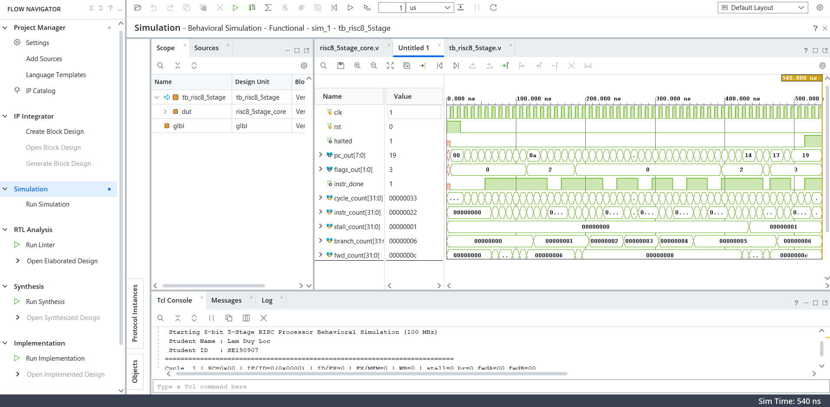
Figure 5. XSim waveform of `tb_risc8_5stage` (0-540 ns): clock, reset, halted, pc_out, flags_out, instr_done, and the five performance counters.

8.2 Waveform analysis
- Reset and start-up: rst is high for the first 20 ns; pc_out starts at 0x00 and flags_out is 0.
- Program flow: pc_out advances through 0x00 ... 0x0A (after the first taken branch) ... 0x14, 0x17 and finally settles at 0x19. The final PC is two words beyond the HLT at 0x17 because two sequential instructions were fetched before HLT reached EX and stopped fetching.
- Flags: flags_out shows Z=1 (value 2) after SUB R7,R7,R5, returns to 0 as non-zero results are produced in the loop, becomes 2 again when the loop counter reaches zero, and ends at 3 (Z=1, C=1) after the final ADDI R5,0x01 overflow, as expected by check #9.
- `instr_done`: the signal is low during the first four cycles (pipeline fill) and then shows gaps, which correspond to bubbles created by branches and by the stall reaching the WB stage.
- `halted`: rises just before 500 ns, when HLT reaches WB; all counters stop afterwards.
- Counters (hexadecimal in the waveform): cycle_count = 0x33 = 51, instr_count = 0x22 = 34, stall_count = 1, branch_count = 6, fwd_count = 0x0C = 12. These agree with the Tcl console summary.

8.3 Tcl console log
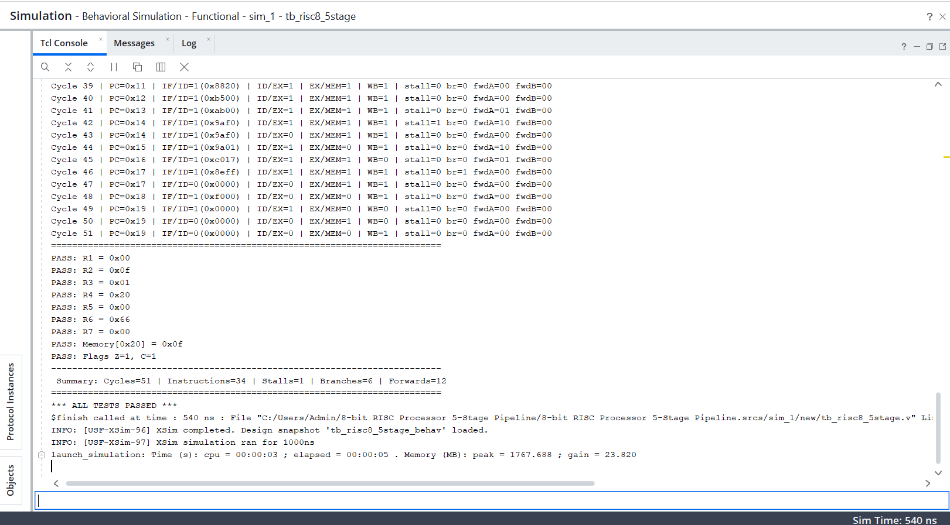
Figure 6. Tail of the Tcl console: the last cycle-by-cycle log lines, the nine PASS messages, the performance summary and the final verdict.
Table 11 interprets the cycles of the log that cover the memory section of the program. Cycle numbers are those printed by the testbench; they correspond to C1-C10 of Figure 3 shifted by 37.
Table 11. Annotated excerpt of the simulation log (cycles 41-48)
Cycle | PC | IF/ID | stall | br | fwdA | Interpretation
41 | 0x13 | 0xAB00 (LD) | 0 | 0 | 01 | ST in EX; R4 forwarded from EX/MEM
42 | 0x14 | 0x9AF0 (ADDI) | 1 | 0 | 10 | LD in EX; dependent ADDI in ID triggers stall; R4 from MEM/WB
43 | 0x14 | 0x9AF0 (ADDI) | 0 | 0 | 00 | PC and IF/ID held; bubble in ID/EX
44 | 0x15 | 0x9A01 (ADDI) | 0 | 0 | 10 | ADDI 0xF0 in EX; loaded value forwarded from MEM/WB
45 | 0x16 | 0xC017 (JMP) | 0 | 0 | 01 | ADDI 0x01 in EX; previous ADDI result forwarded from EX/MEM
46 | 0x17 | 0x8EFF (LDI) | 0 | 1 | 00 | JMP in EX: branch taken; wrong-path LDI R7 in IF/ID is flushed
47 | 0x17 | invalid (0x0000) | 0 | 0 | 00 | Bubble in IF/ID; target fetched
48 | 0x18 | 0xF000 (HLT) | 0 | 0 | 00 | HLT enters ID
The log therefore proves the following behaviours in hardware simulation: forwarding from EX/MEM (fwdA=01), forwarding from MEM/WB (fwdA=10), a single load-use stall with a bubble, and a taken-branch flush.

8.4 Functional verification result
All nine checks pass: R1 = 0x00, R2 = 0x0F, R3 = 0x01, R4 = 0x20, R5 = 0x00, R6 = 0x66, R7 = 0x00, Memory[0x20] = 0x0F, and flags Z=1, C=1. The console ends with the message *** ALL TESTS PASSED ***. In particular, R7 = 0x00 demonstrates that neither wrong-path LDI R7,0xFF instruction modified architectural state.

8.5 Performance analysis
Table 12. Simulation statistics (from the testbench summary)
Metric | Value | Comment
Total clock cycles | 51 | From reset release until halted (510 ns at 100 MHz)
Retired instructions | 34 | Dynamic count (24 static instructions)
Load-use stalls | 1 | Single LD -> ADDI dependency
Taken branches / jumps | 6 | 1 BZ + 4 BNZ + 1 JMP
Forwarded operands | 12 | Operand A and B counted separately
CPI | 1.50 | 51 / 34
IPC | 0.667 | 34 / 51
The 34 dynamic instructions are: 9 before the first branch (0x00-0x08), 3 loop-setup instructions, 15 loop instructions (3 x 5 iterations), 6 memory/flag instructions (0x10-0x15) and the final HLT. A pipeline that never stalled would need 34 + 4 = 38 cycles (4 cycles to fill the pipeline). The remaining 13 cycles are exactly accounted for by hazards:
Table 13. Cycle accounting
Component | Cycles | Share of 51
Useful work (retired instructions) | 34 | 66.7 %
Pipeline fill (cycles 1-4, nothing retires) | 4 | 7.8 %
Load-use stall (1 x 1) | 1 | 2.0 %
Taken-branch flush (6 x 2) | 12 | 23.5 %
Total | 51 | 100 %
The result shows that control hazards, not data hazards, dominate the loss of performance in this program: forwarding removed all data-dependency penalties except one unavoidable load-use cycle, whereas branch flushes consume almost a quarter of all cycles. Seven of the 34 dynamic instructions (20.6 %) are branches, which makes this a branch-heavy test and therefore a pessimistic CPI figure for typical code.

9. Synthesis Results and Resource Analysis

9.1 RTL elaboration
Vivado's "Open Elaborated Design" (Figure 7) shows the RTL netlist before technology mapping. It contains 267 cells, 14 I/O ports and 396 nets (263 leaf cells), and the sub-modules u_alu, u_ctrl, u_dmem, u_hazard and u_imem are visible in the netlist tree. The 14 I/O ports are exactly the ports of the top module: clk, rst, halted, instr_done, pc_out[7:0] and flags_out[1:0]. The status bar shows "Synthesis Complete" and the Design Runs table reports synth_1 as "synth_design Complete!" with an elapsed time of 00:00:39.
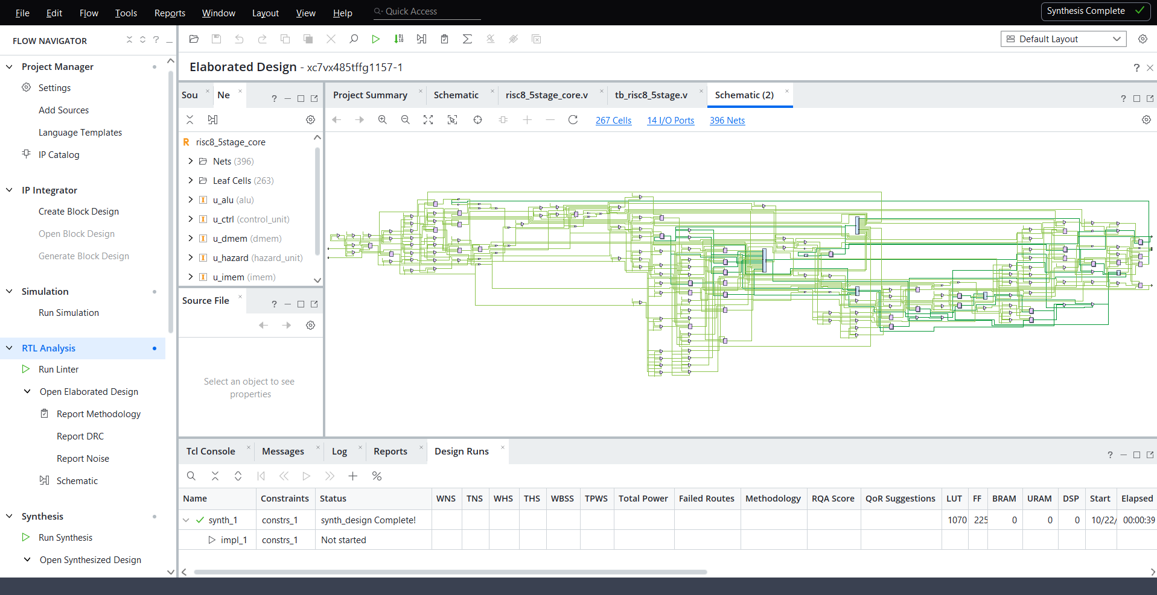
Figure 7. Elaborated (RTL) schematic of `risc8_5stage_core`: 267 cells, 14 I/O ports, 396 nets.

9.2 Synthesized netlist
After synthesis (Figure 8) the netlist is reduced to 223 cells, 14 I/O ports and 282 nets (222 leaf cells), because RTL constructs have been mapped onto FPGA primitives and constants / duplicated logic have been optimised. In the synthesized hierarchy only u_alu, u_dmem and u_regfile remain as separate entries; the logic of the instruction ROM, the control unit and the hazard unit has been merged into the top-level logic and is therefore accounted under the top row of the utilization table.
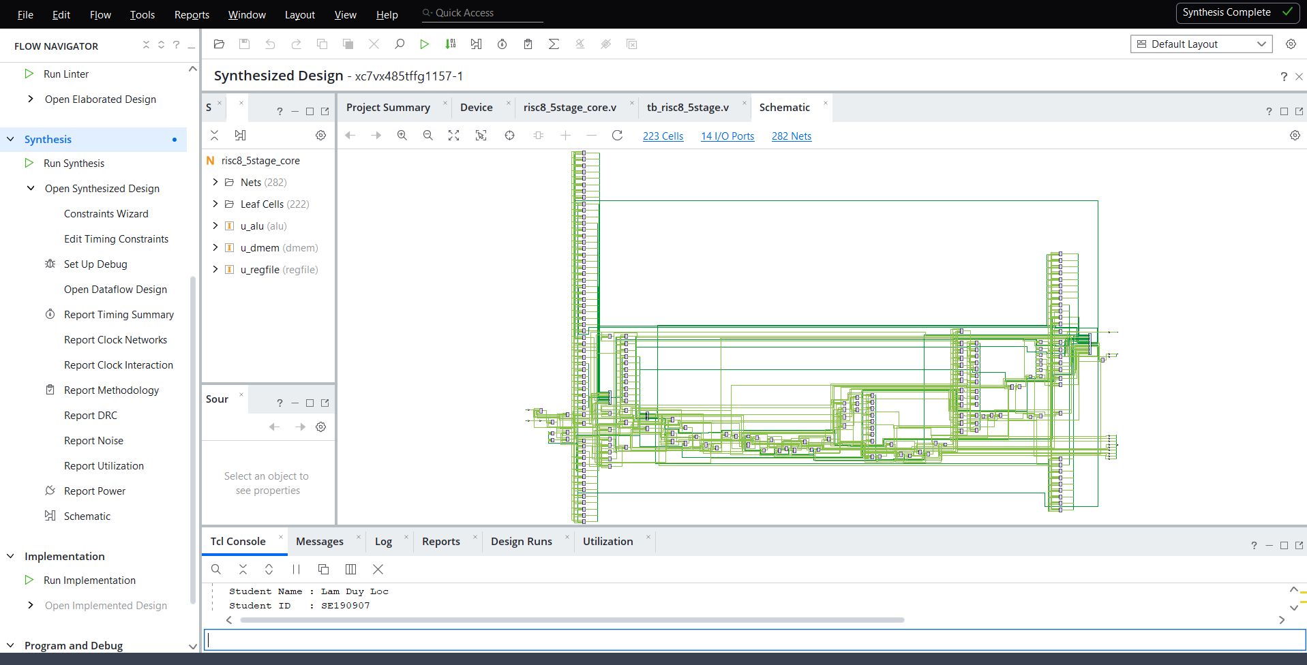
Figure 8. Synthesized schematic: 223 cells, 14 I/O ports, 282 nets.

9.3 Resource utilization
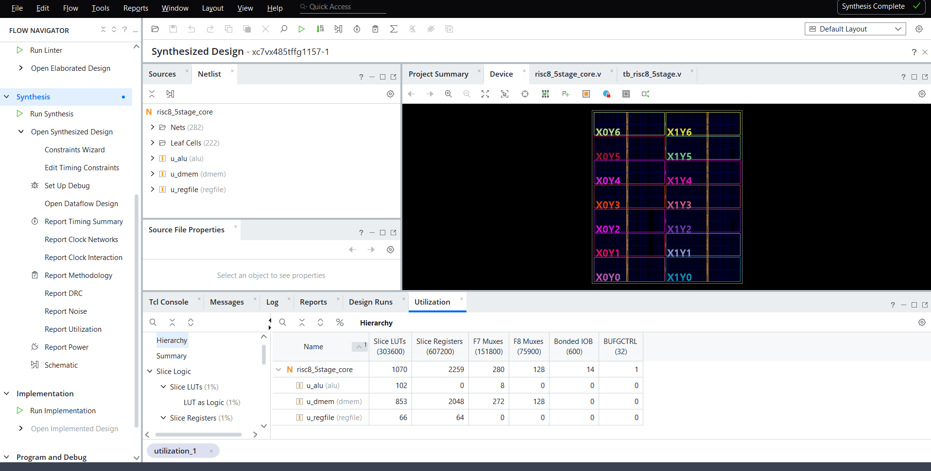
Figure 9. Vivado hierarchical utilization report and device view after synthesis.
Table 14. Overall utilization (device xc7vx485tffg1157-1, from the Vivado report)
Resource | Used | Available | Utilization | Note
Slice LUTs | 1,070 | 303,600 | 0.35 %
Slice registers (FF) | 2,259 | 607,200 | 0.37 %
F7 muxes | 280 | 151,800 | 0.18 %
F8 muxes | 128 | 75,900 | 0.17 %
Bonded IOB | 14 | 600 | 2.33 % | = top-level ports
BUFGCTRL | 1 | 32 | 3.13 % | = clock clk
Block RAM / URAM / DSP | 0 / 0 / 0 | - | 0 % | no hard blocks used
Percentages were computed from the used and available counts shown in the report (the Vivado GUI displays the LUT and register rows rounded to 1 %). The design is tiny relative to the Virtex-7 device. For orientation only, the same counts would occupy roughly 5 % of the LUTs (20,800) and 5 % of the flip-flops (41,600) of the Artix-7 xc7a35t on the Basys-3 board referenced in the XDC file - an estimate, since a separate synthesis for that part was not part of the submitted material.
Table 15. Hierarchical utilization
Module | Slice LUTs | Slice FFs | F7 mux | F8 mux | Share of LUTs
u_dmem (data RAM) | 853 | 2,048 | 272 | 128 | 79.7 %
u_alu | 102 | 0 | 8 | 0 | 9.5 %
u_regfile | 66 | 64 | 0 | 0 | 6.2 %
Top-level remainder* | 49 | 147 | 0 | 0 | 4.6 %
Total | 1,070 | 2,259 | 280 | 128 | 100 %
* Computed as total minus the three listed sub-modules; it contains the PC, pipeline registers, flags, forwarding multiplexers, branch logic and the merged imem / control / hazard logic.

9.4 Interpretation
- The data memory dominates the design. u_dmem uses 79.7 % of the LUTs and 90.7 % of the flip-flops. Its 2,048 flip-flops are exactly 256 x 8 bits. The 272 F7 and 128 F8 multiplexers are the typical signature of 256:1 read multiplexers built from LUTs and wide-mux primitives (128 F8 = 16 per data bit).
- Why it was not mapped to LUT-RAM: the source comment in dmem.v states that the array maps to distributed LUT-RAM, but the report shows otherwise. The synchronous reset clears all 256 words, and an array that can be reset in a single cycle cannot be implemented in Xilinx RAM primitives (they have no per-word reset). Vivado therefore builds the memory from individual flip-flops plus read multiplexers. This is functionally correct but wasteful (see Section 10).
- The register file is cheap: 64 flip-flops (8 x 8) and 66 LUTs for two asynchronous read ports with write-through bypass.
- The ALU is small: 102 LUTs, purely combinational (0 flip-flops), as intended for an 8-bit datapath.
- Pipeline state: counting the RTL, the pipeline and control registers hold 122 bits, and the top-level remainder in the report shows 147 flip-flops. The difference is an implementation detail of synthesis that was not analysed further here.
- No hard macros: zero BRAM, URAM and DSP blocks are used; the entire core is implemented in general slice logic.

9.5 Timing and implementation status
The XDC file defines a 10.000 ns clock (create_clock -period 10.000 -name clk -waveform {0.000 5.000} [get_ports clk]). However, the screenshots do not include a timing summary: the WNS, TNS, WHS and THS columns of the Design Runs table are empty and impl_1 shows "Not started". Therefore this report makes no claim that the 100 MHz constraint is met. Timing closure must be confirmed by running implementation and reading Report Timing Summary. As a qualitative remark, the longest combinational path in this design is likely to run from the ID/EX register through the forwarding multiplexers and the ALU into EX/MEM or into the branch decision, but this must be confirmed with real timing data.

10. Design Review: Findings and Recommendations
The following observations result from reading the source code together with the simulation and synthesis evidence. They are intended as constructive suggestions for future work.
Table 16. Findings and recommendations
# | Finding | Impact | Recommendation
1 | Taken branches are resolved in EX with a 2-cycle penalty. | 12 of 51 cycles (23.5 %) lost; CPI 1.50. | Resolve branches in ID (target is already an absolute immediate), add a static / 1-bit predictor, or add a branch target buffer.
2 | dmem is built from 2,048 flip-flops because of the full synchronous reset. | 90.7 % of all FFs and 79.7 % of LUTs. | Remove the reset loop (keep initial for simulation) so the array maps to distributed RAM or block RAM; if BRAM is used, add the extra read latency to the pipeline.
3 | imem and dmem use asynchronous reads. | Prevents block-RAM inference and lengthens paths for larger memories. | For larger programs use synchronous ROM/RAM and adjust the pipeline (e.g. move the data-memory read into WB).
4 | Timing results are not included; impl_1 not run. | 100 MHz closure unproven. | Run implementation, report WNS / TNS and power; add timing evidence to the report.
5 | XDC comments target Basys-3 (xc7a35tcpg236-1) but the screenshots show part xc7vx485tffg1157-1. | Constraints and chosen part are inconsistent. | Select the intended board part, then enable the pin assignments for clk, rst, pc_out, flags_out, instr_done, halted.
6 | Only two status flags (Z, C); no sign or overflow flag. | Signed comparison needs extra instructions. | Add N and V flags and signed branch instructions if signed arithmetic is required.
7 | Branch targets and the PC are 8 bits. | Program size limited to 256 instructions. | Extend the PC and the immediate/target field, or add relative branches.

10.1 Test coverage gaps
The single test program is well designed, but by inspecting its instructions the following behaviours are not exercised and could be added in a future test plan:
- BZ not taken (the only BZ in the program is taken; the not-taken path is covered only for BNZ).
- Carry/borrow set by shifts (both SHL and SHR in the program produce C = 0) and borrow from SUB (no SUB has a < b).
- A load-use hazard through the store-data operand (ST right after an LD into the stored register), which uses the match_b path of the stall logic.
- Back-to-back dependent loads, and writes to R0.
- Randomised or constrained-random instruction streams compared against a software reference model.

11. Conclusion
This project delivered a complete 8-bit RISC processor with a five-stage pipeline, from ISA definition through RTL design, hazard handling, self-checking verification and FPGA synthesis. The main results are:
- The processor implements a 16-instruction ISA with a clean 16-bit format and is partitioned into six well-defined Verilog modules plus a top-level integration module.
- Data hazards are fully resolved by forwarding (EX/MEM and MEM/WB), a write-through register file, and a single-cycle load-use stall; control hazards are resolved by flushing two wrong-path instructions.
- A 24-instruction verification program passed all nine self-checks in Vivado XSim (51 cycles, 34 retired instructions, 1 stall, 6 taken branches, 12 forwarded operands; CPI = 1.50).
- Synthesis in Vivado produced a compact design of 1,070 LUTs and 2,259 flip-flops, with no BRAM or DSP blocks. The data memory is the dominant consumer because it was implemented in flip-flops rather than RAM primitives.
- The most valuable next steps are earlier branch resolution, restructuring dmem for RAM inference, and completing implementation to obtain timing evidence for the 100 MHz target.
Overall, the design meets its functional goals and demonstrates the essential techniques of pipelined processor design: stage partitioning, valid-bit-based bubbles, operand forwarding, hazard detection and pipeline control.

Appendix A. Control Unit Truth Table
The table lists the output of control_unit for every opcode, derived directly from the case statement in control_unit.v. (The project package contains an empty folder named "Truth_Table"; this table was generated from the RTL to fill that gap.) Unlisted opcodes cannot occur because the opcode field is 4 bits wide and all 16 values are decoded.
Table 17. Control signals per opcode (alu_op in decimal; all other columns are single bits)
Opcode | Instr | alu_op | alu_src_imm | ra_is_rd | rb_is_rd | uses_a | uses_b | reg_we | mem_to_reg | mem_we | flag_we | jump | br_z | br_nz | halt
0x0 | NOP | 0 | 0 | 0 | 0 | 0 | 0 | 0 | 0 | 0 | 0 | 0 | 0 | 0 | 0
0x1 | ADD | 0 | 0 | 0 | 0 | 1 | 1 | 1 | 0 | 0 | 1 | 0 | 0 | 0 | 0
0x2 | SUB | 1 | 0 | 0 | 0 | 1 | 1 | 1 | 0 | 0 | 1 | 0 | 0 | 0 | 0
0x3 | AND | 2 | 0 | 0 | 0 | 1 | 1 | 1 | 0 | 0 | 1 | 0 | 0 | 0 | 0
0x4 | OR | 3 | 0 | 0 | 0 | 1 | 1 | 1 | 0 | 0 | 1 | 0 | 0 | 0 | 0
0x5 | XOR | 4 | 0 | 0 | 0 | 1 | 1 | 1 | 0 | 0 | 1 | 0 | 0 | 0 | 0
0x6 | SHL | 5 | 0 | 0 | 0 | 1 | 0 | 1 | 0 | 0 | 1 | 0 | 0 | 0 | 0
0x7 | SHR | 6 | 0 | 0 | 0 | 1 | 0 | 1 | 0 | 0 | 1 | 0 | 0 | 0 | 0
0x8 | LDI | 7 | 1 | 0 | 0 | 0 | 0 | 1 | 0 | 0 | 0 | 0 | 0 | 0 | 0
0x9 | ADDI | 0 | 1 | 1 | 0 | 1 | 0 | 1 | 0 | 0 | 1 | 0 | 0 | 0 | 0
0xA | LD | 0 | 0 | 0 | 0 | 1 | 0 | 1 | 1 | 0 | 0 | 0 | 0 | 0 | 0
0xB | ST | 0 | 0 | 0 | 1 | 1 | 1 | 0 | 0 | 1 | 0 | 0 | 0 | 0 | 0
0xC | JMP | 0 | 0 | 0 | 0 | 0 | 0 | 0 | 0 | 0 | 0 | 1 | 0 | 0 | 0
0xD | BZ | 0 | 0 | 0 | 0 | 0 | 0 | 0 | 0 | 0 | 0 | 0 | 1 | 0 | 0
0xE | BNZ | 0 | 0 | 0 | 0 | 0 | 0 | 0 | 0 | 0 | 0 | 0 | 0 | 1 | 0
0xF | HLT | 0 | 0 | 0 | 0 | 0 | 0 | 0 | 0 | 0 | 0 | 0 | 0 | 0 | 1

Appendix B. Complete Instruction Encoding of the Test Program
Binary decomposition of selected instructions of Table 9, illustrating the field layout of each format.
Table 18. Field decomposition of representative instructions
Address | Hex | Binary | Opcode | rd | rs1 / rs2 | Decoded
0x00 | 0x823C | 1000 001 0 0011 1100 | 8 (LDI) | 1 | imm8 = 0x3C | LDI R1, 0x3C
0x02 | 0x3650 | 0011 011 001 010 000 | 3 (AND) | 3 | 1 / 2 | AND R3, R1, R2
0x05 | 0x6D40 | 0110 110 101 000 000 | 6 (SHL) | 6 | 5 / - | SHL R6, R5
0x08 | 0xD00A | 1101 0000 0000 1010 | D (BZ) | - | target 0x0A | BZ 0x0A
0x11 | 0xB500 | 1011 010 100 000 000 | B (ST) | 2 | 4 / - | ST R2, [R4]
0x12 | 0xAB00 | 1010 101 100 000 000 | A (LD) | 5 | 4 / - | LD R5, [R4]
0x13 | 0x9AF0 | 1001 101 0 1111 0000 | 9 (ADDI) | 5 | imm8 = 0xF0 | ADDI R5, 0xF0
0x15 | 0xC017 | 1100 0000 0001 0111 | C (JMP) | - | target 0x17 | JMP 0x17
0x17 | 0xF000 | 1111 0000 0000 0000 | F (HLT) | - | - | HLT

