Exercise 3. Answer Sheet

Student's Name: ____Pham Xuan Loc ____ Student's ID: ____s1232006_____

Problem 1. (25 points) Consider the following adjacency matrix:
0 1 1 1 0 0
1 0 1 0 0 0
0 0 0 0 1 0
0 1 1 0 1 0
0 1 0 0 0 0
0 0 0 1 1 0

a) Draw a directed graph which corresponds to this adjacency matrix.
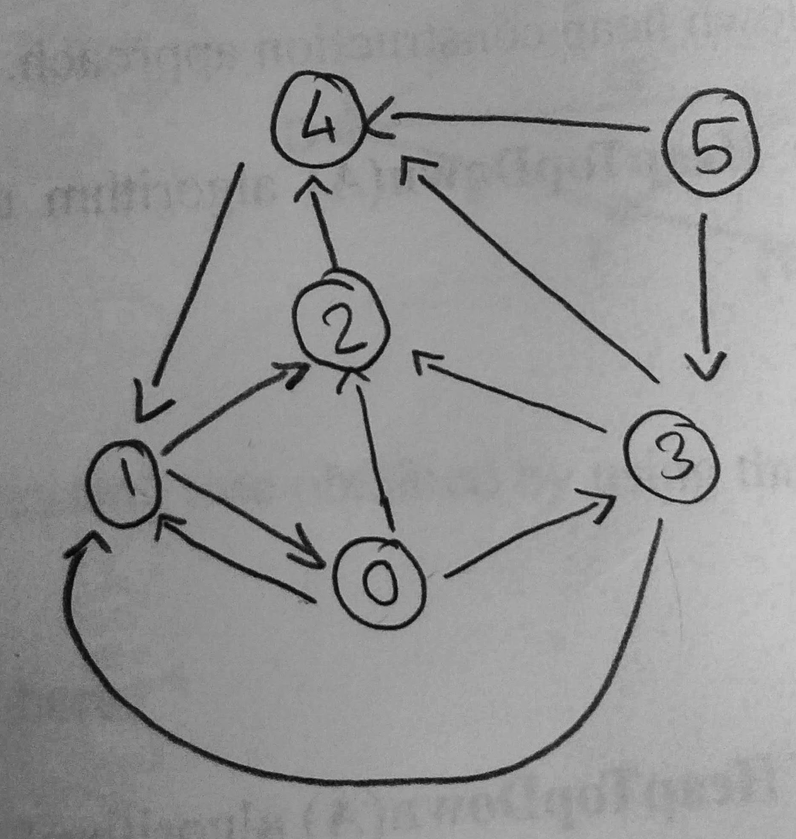

b) Write the adjacency list of the graph from a).
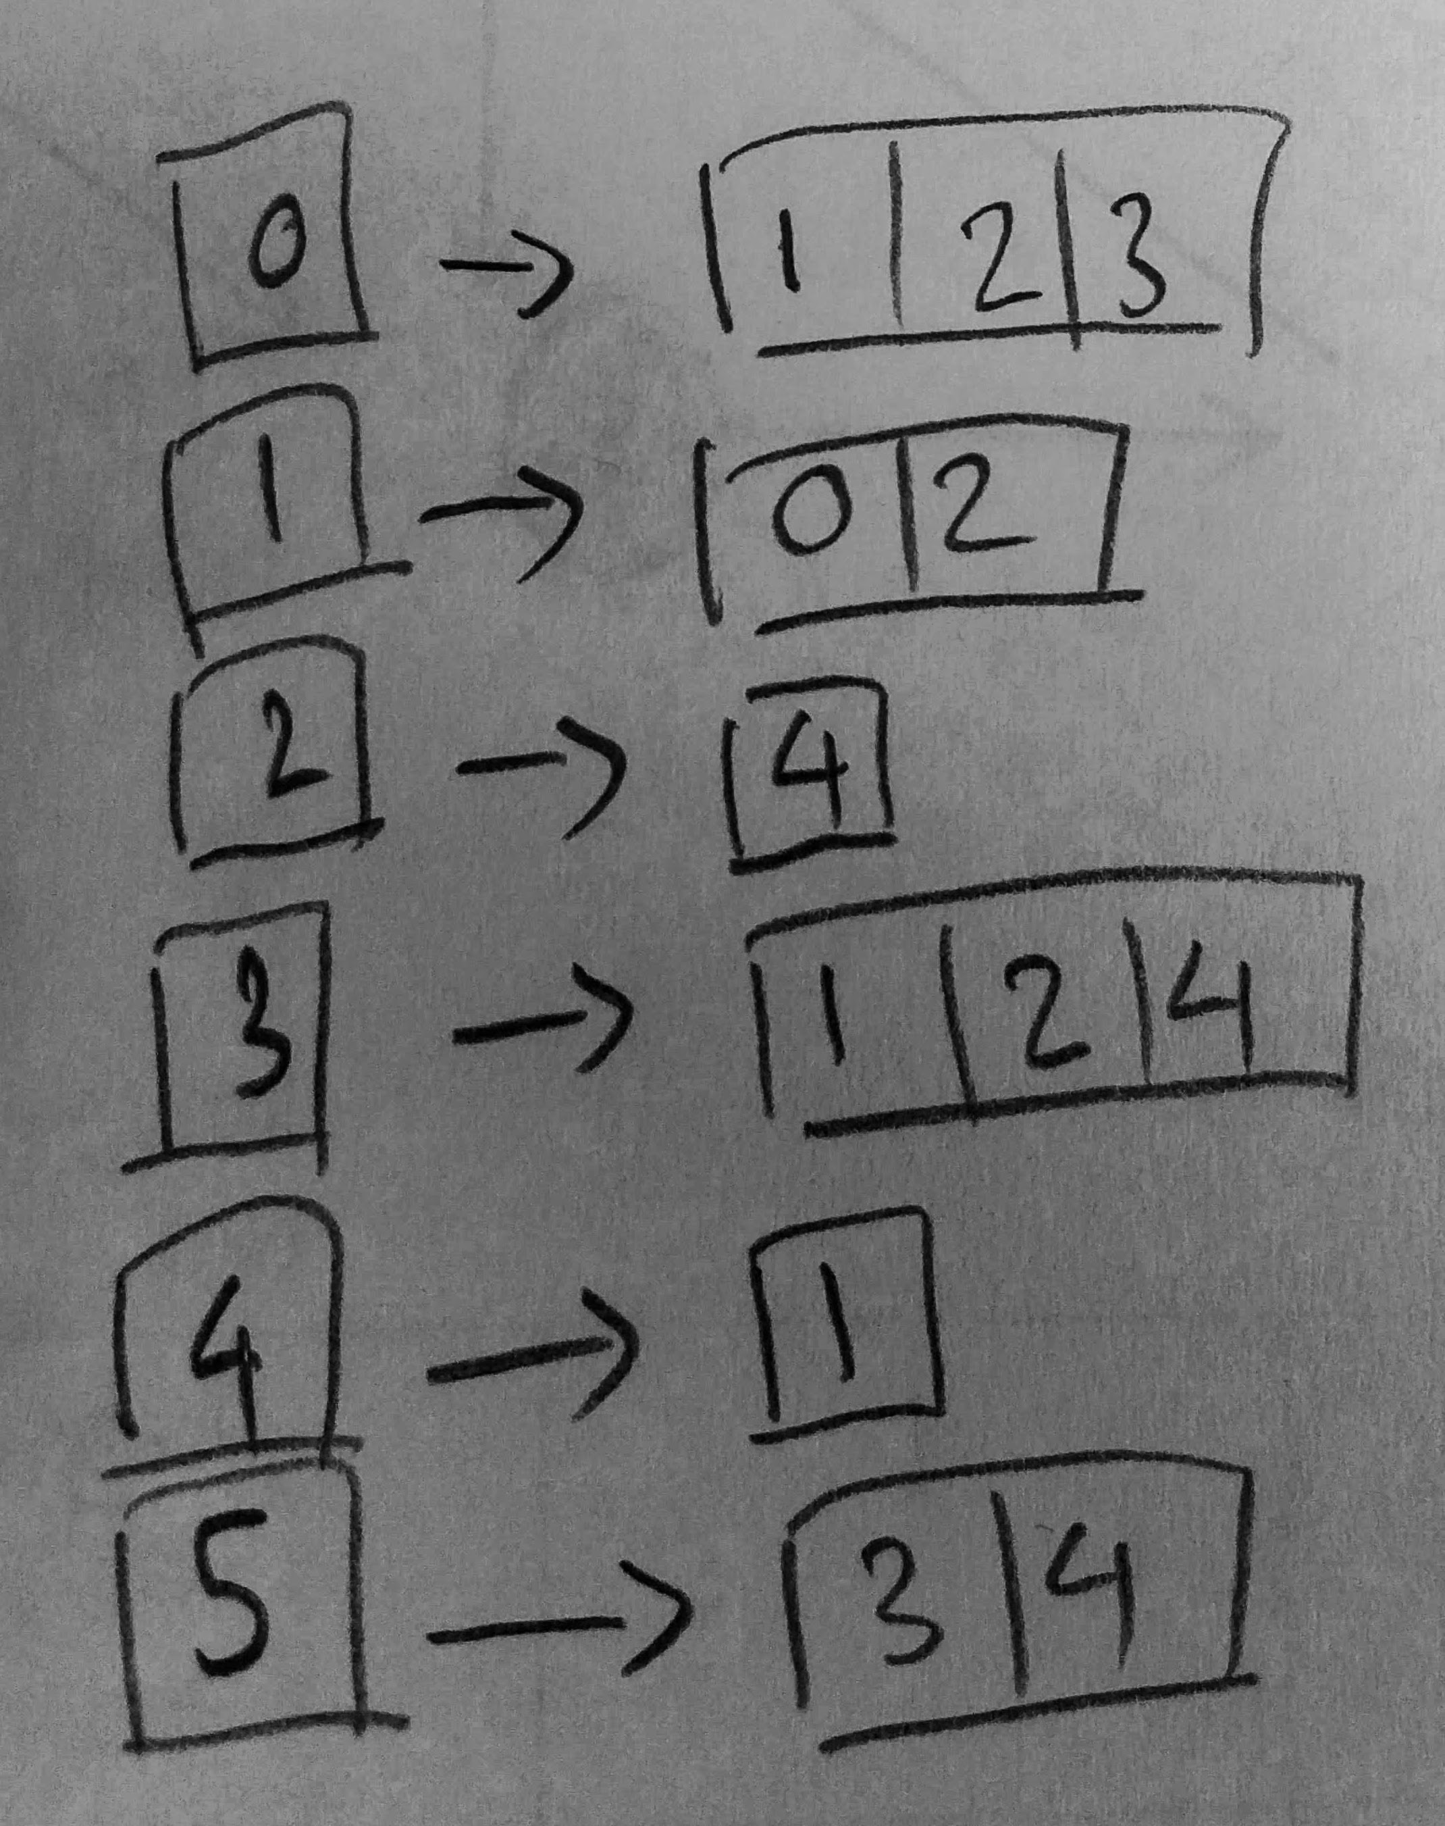

Problem 2. (25 points) Consider the following graph:

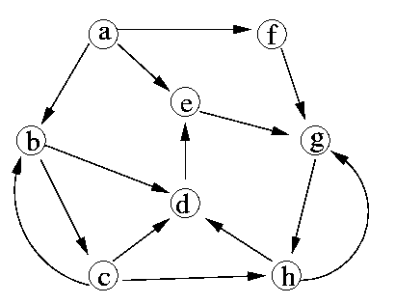

a) Starting from vertex a, in what order the Breath First Search algorithm will traverse the vertices
of this graph?

a → b → e → f → c → d → g → h

b) Starting from vertex a, in what order the Depth First Search algorithm will traverse the vertices of this graph?

a → b → c → d → e → g → h → f

Problem 3. (50 points) Based on the pseudo-code for Depth First Search algorithm given at the lecture, write a program implementing it. Given the following graph, starting from node 1, calculate the discovery and finishing time of each node and fill the table starting from node 1. (Don't forget to upload your program!)

1
2
3
4
5
6

Node | 1 | 2 | 3 | 4 | 5 | 6
Discovery time | 1 | 3 | 9 | 2 | 4 | 10
Finishing time | 8 | 6 | 12 | 7 | 5 | 11

Compile and run command: gcc DFS.c -o DFS && ./DFS

