Exercise 4. Answer Sheet

Student's Name: __Pham Xuan Loc___ Student's ID: __s1232006____

Problem 1. (50 points) Consider the following graph and assume node A as a root.
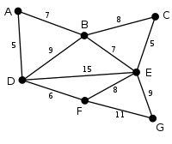

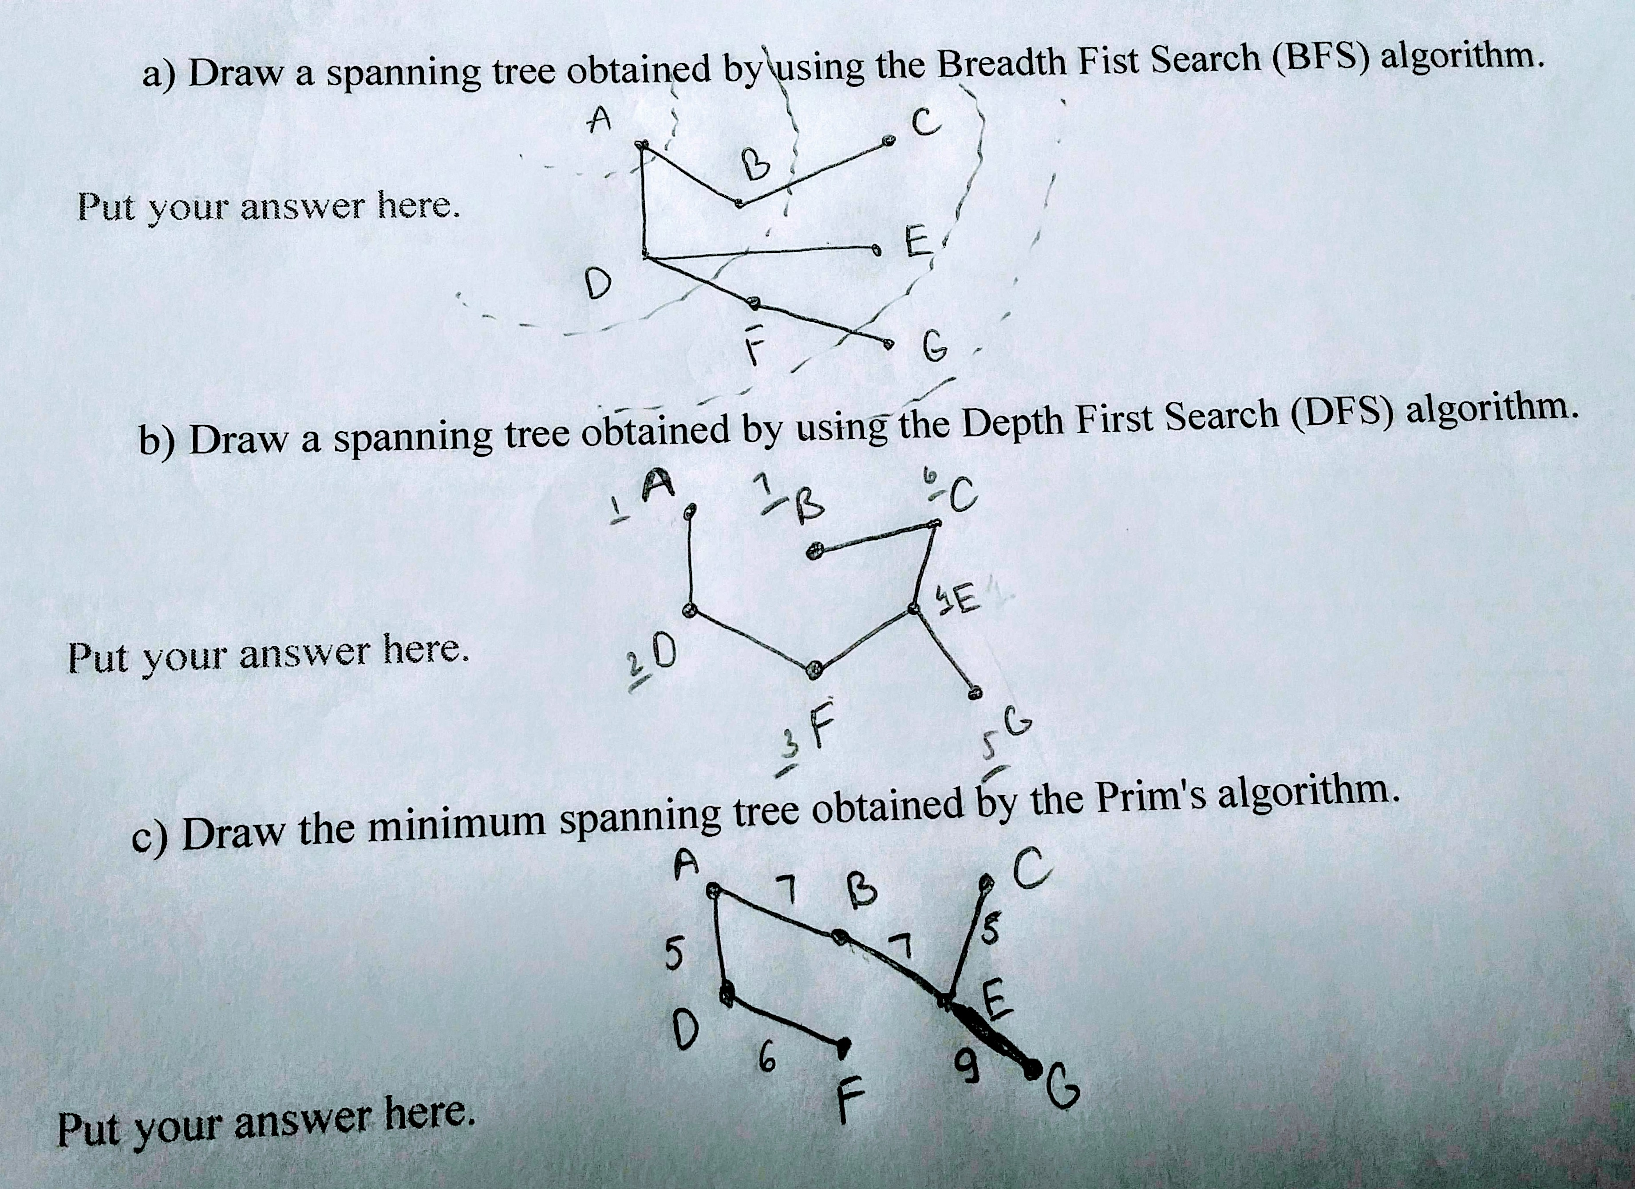

Problem 2. (50 points) Write a program implementing Kruskal's algorithm. Upload your source code. Show your input graph and the obtained MST in the space below.

Compile and run command: gcc Kruskal.c -o Kruskal && ./Kruskal
Input graph:

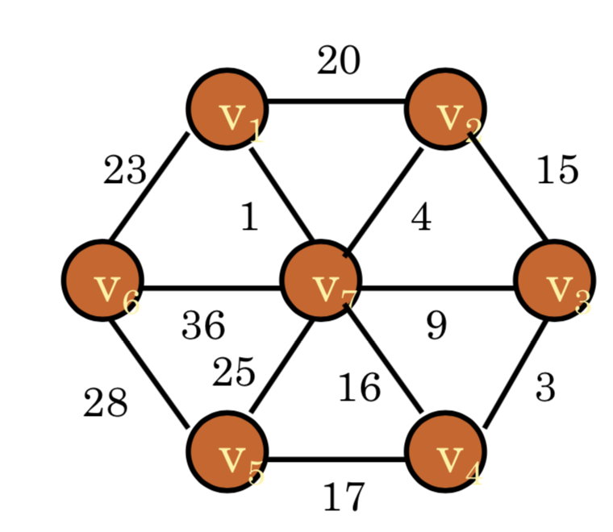

Output MST:
