Exercise 5. Answer Sheet

Student's Name: ___Pham Xuan Loc_____ Student's ID: ____s1232006______

Problem 1. (15 points) Consider the graph below.

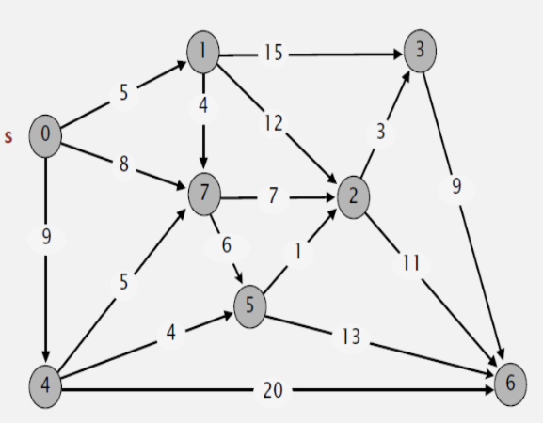
Draw a shortest path spanning tree with root at vertex s. Show the cost (weight) of paths to each vertex.

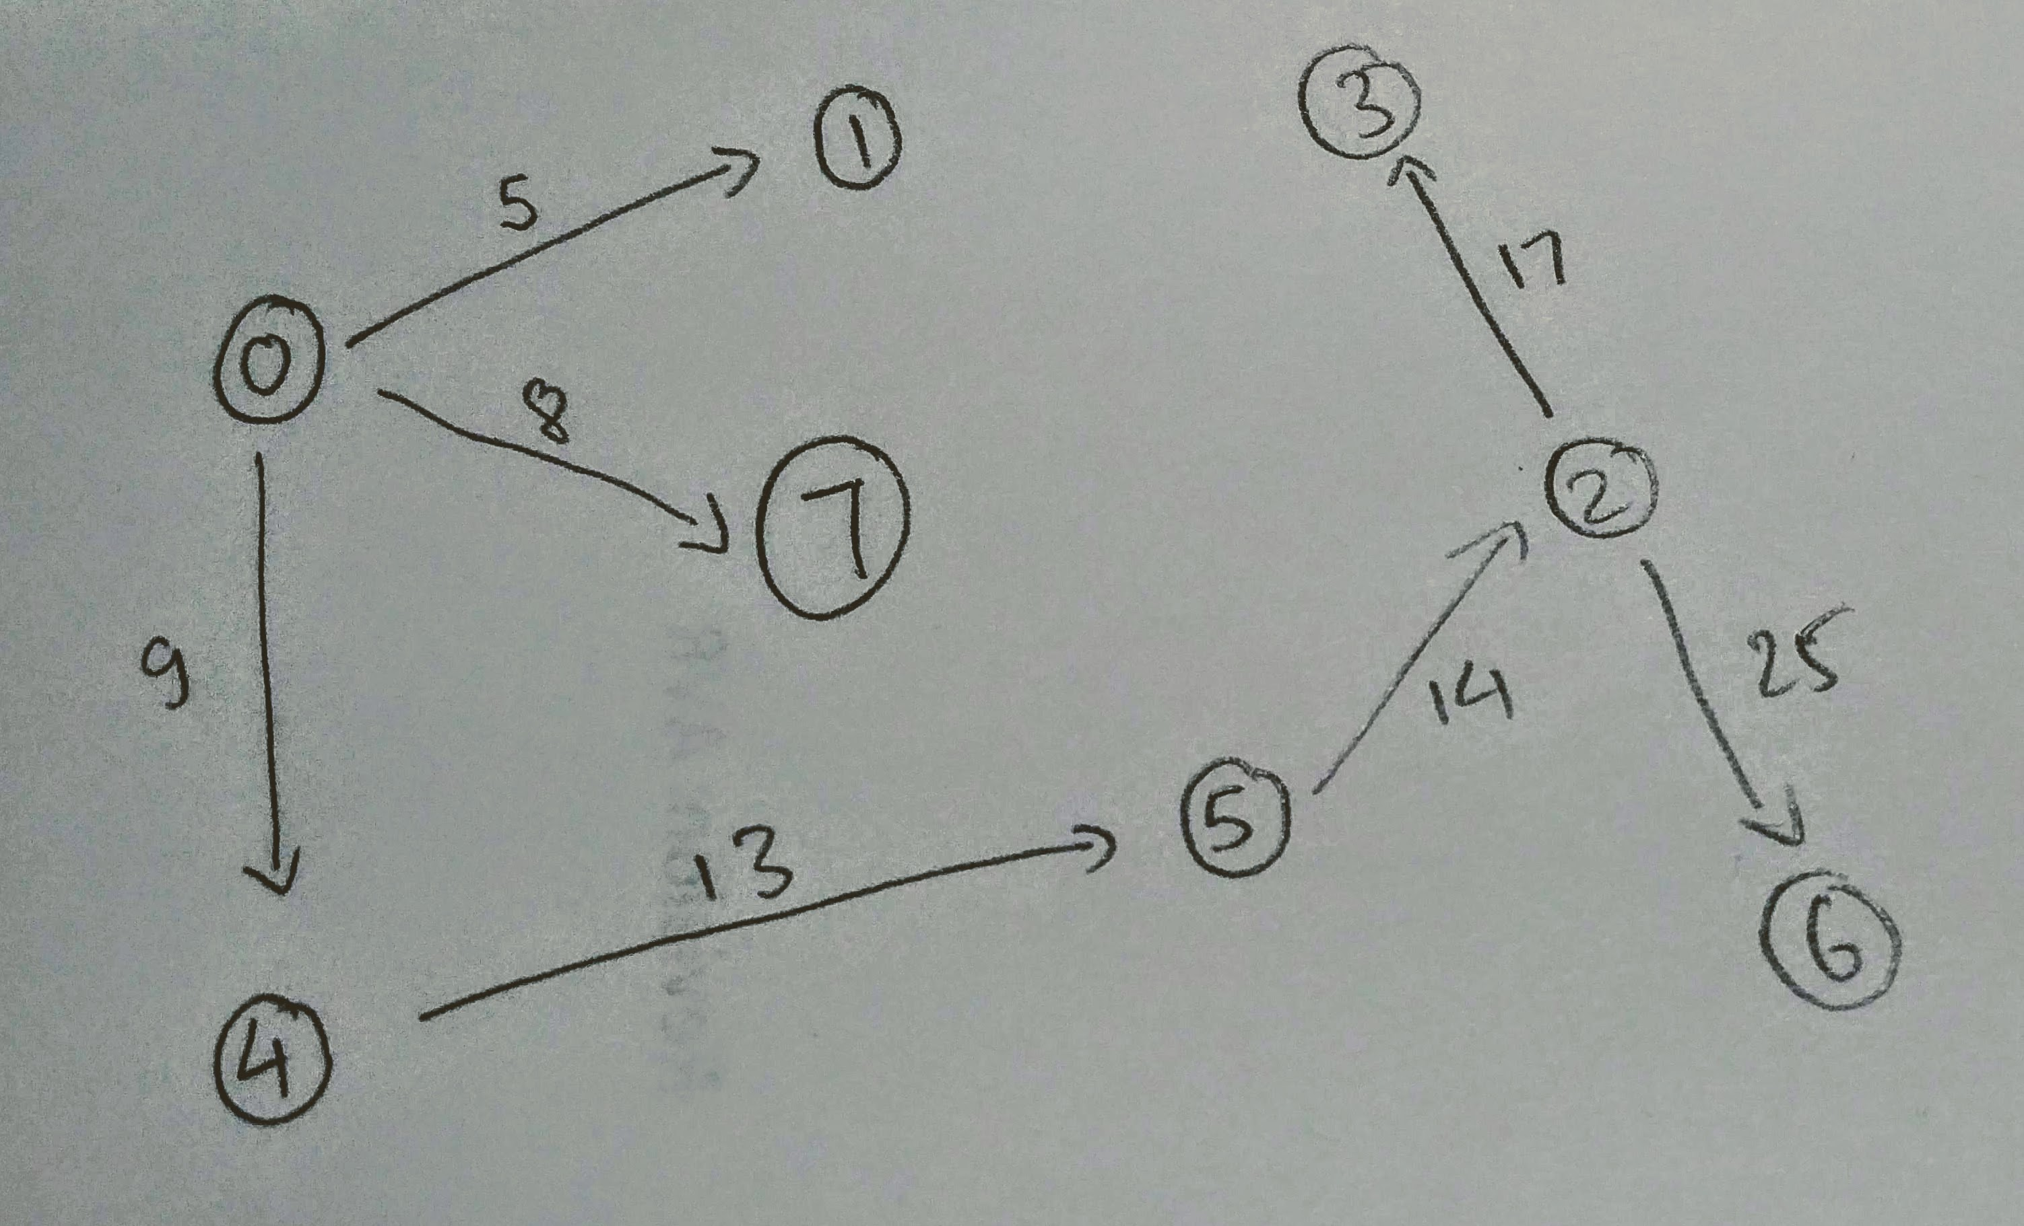

Problem 2. (15 points) Dijksta's algorithm cannot handle negative weights. Show an example and explain what happens.

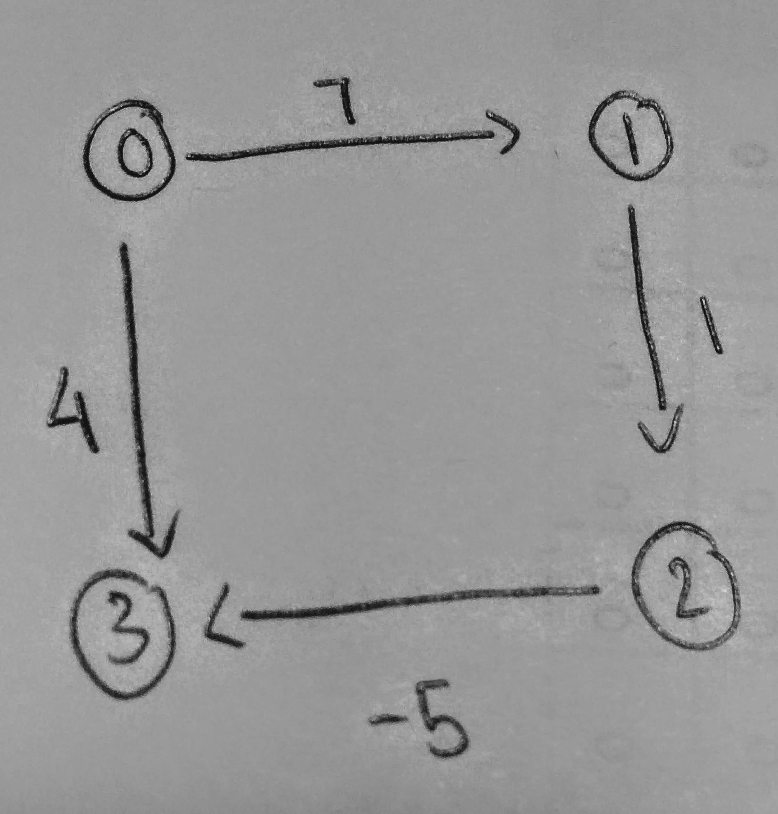

For example, in the graph in the left hand side, the shortest path from 0 to 3 is 0 → 1 → 2 → 3.
However, Dijkstra algorithm selects vertex 3 immediately after the root node 0 and therefore, results in wrong answer.

Problem 3. (20 points) Extend the pseudocode of the Bellman-Ford algorithm given at the lecture so it can detect negative cycles.

def Bellman-Ford-modified (G,s,w):
Init-SS (G,s)
for i=1 to |G.V|-1
for each edge (u,v) in G.E
RELAX (u,v,w)

// If any vertex is updated at G.Vth loop, there exists a negative cycle or bool = 1
for each edge (u,v) in G,E
if v.d > u.d + w(u,v)
{ bool = 1; break;}

Problem 4. (50 points) Write a program implementing Dijksta's algorithm. Upload your source code. Show your input graph and the obtained shortest path spanning tree in the space below.

Compile and run command: gcc Dijksta.c -o Dijksta && ./Dijksta

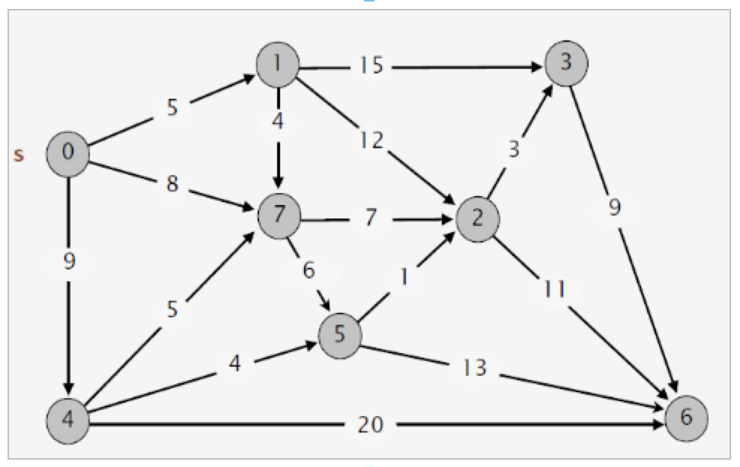
input output

