Exercise 7. Answer Sheet

Student's Name: ___Pham Xuan Loc____ Student's ID: __s1232006___

Problem 1. (20 point) Consider following sequence of letters:

ABBCACCEACBCCFABCDAFEABFFADBBC

a) (10 points) Construct Huffman encoding tree for the above sequence and show it below

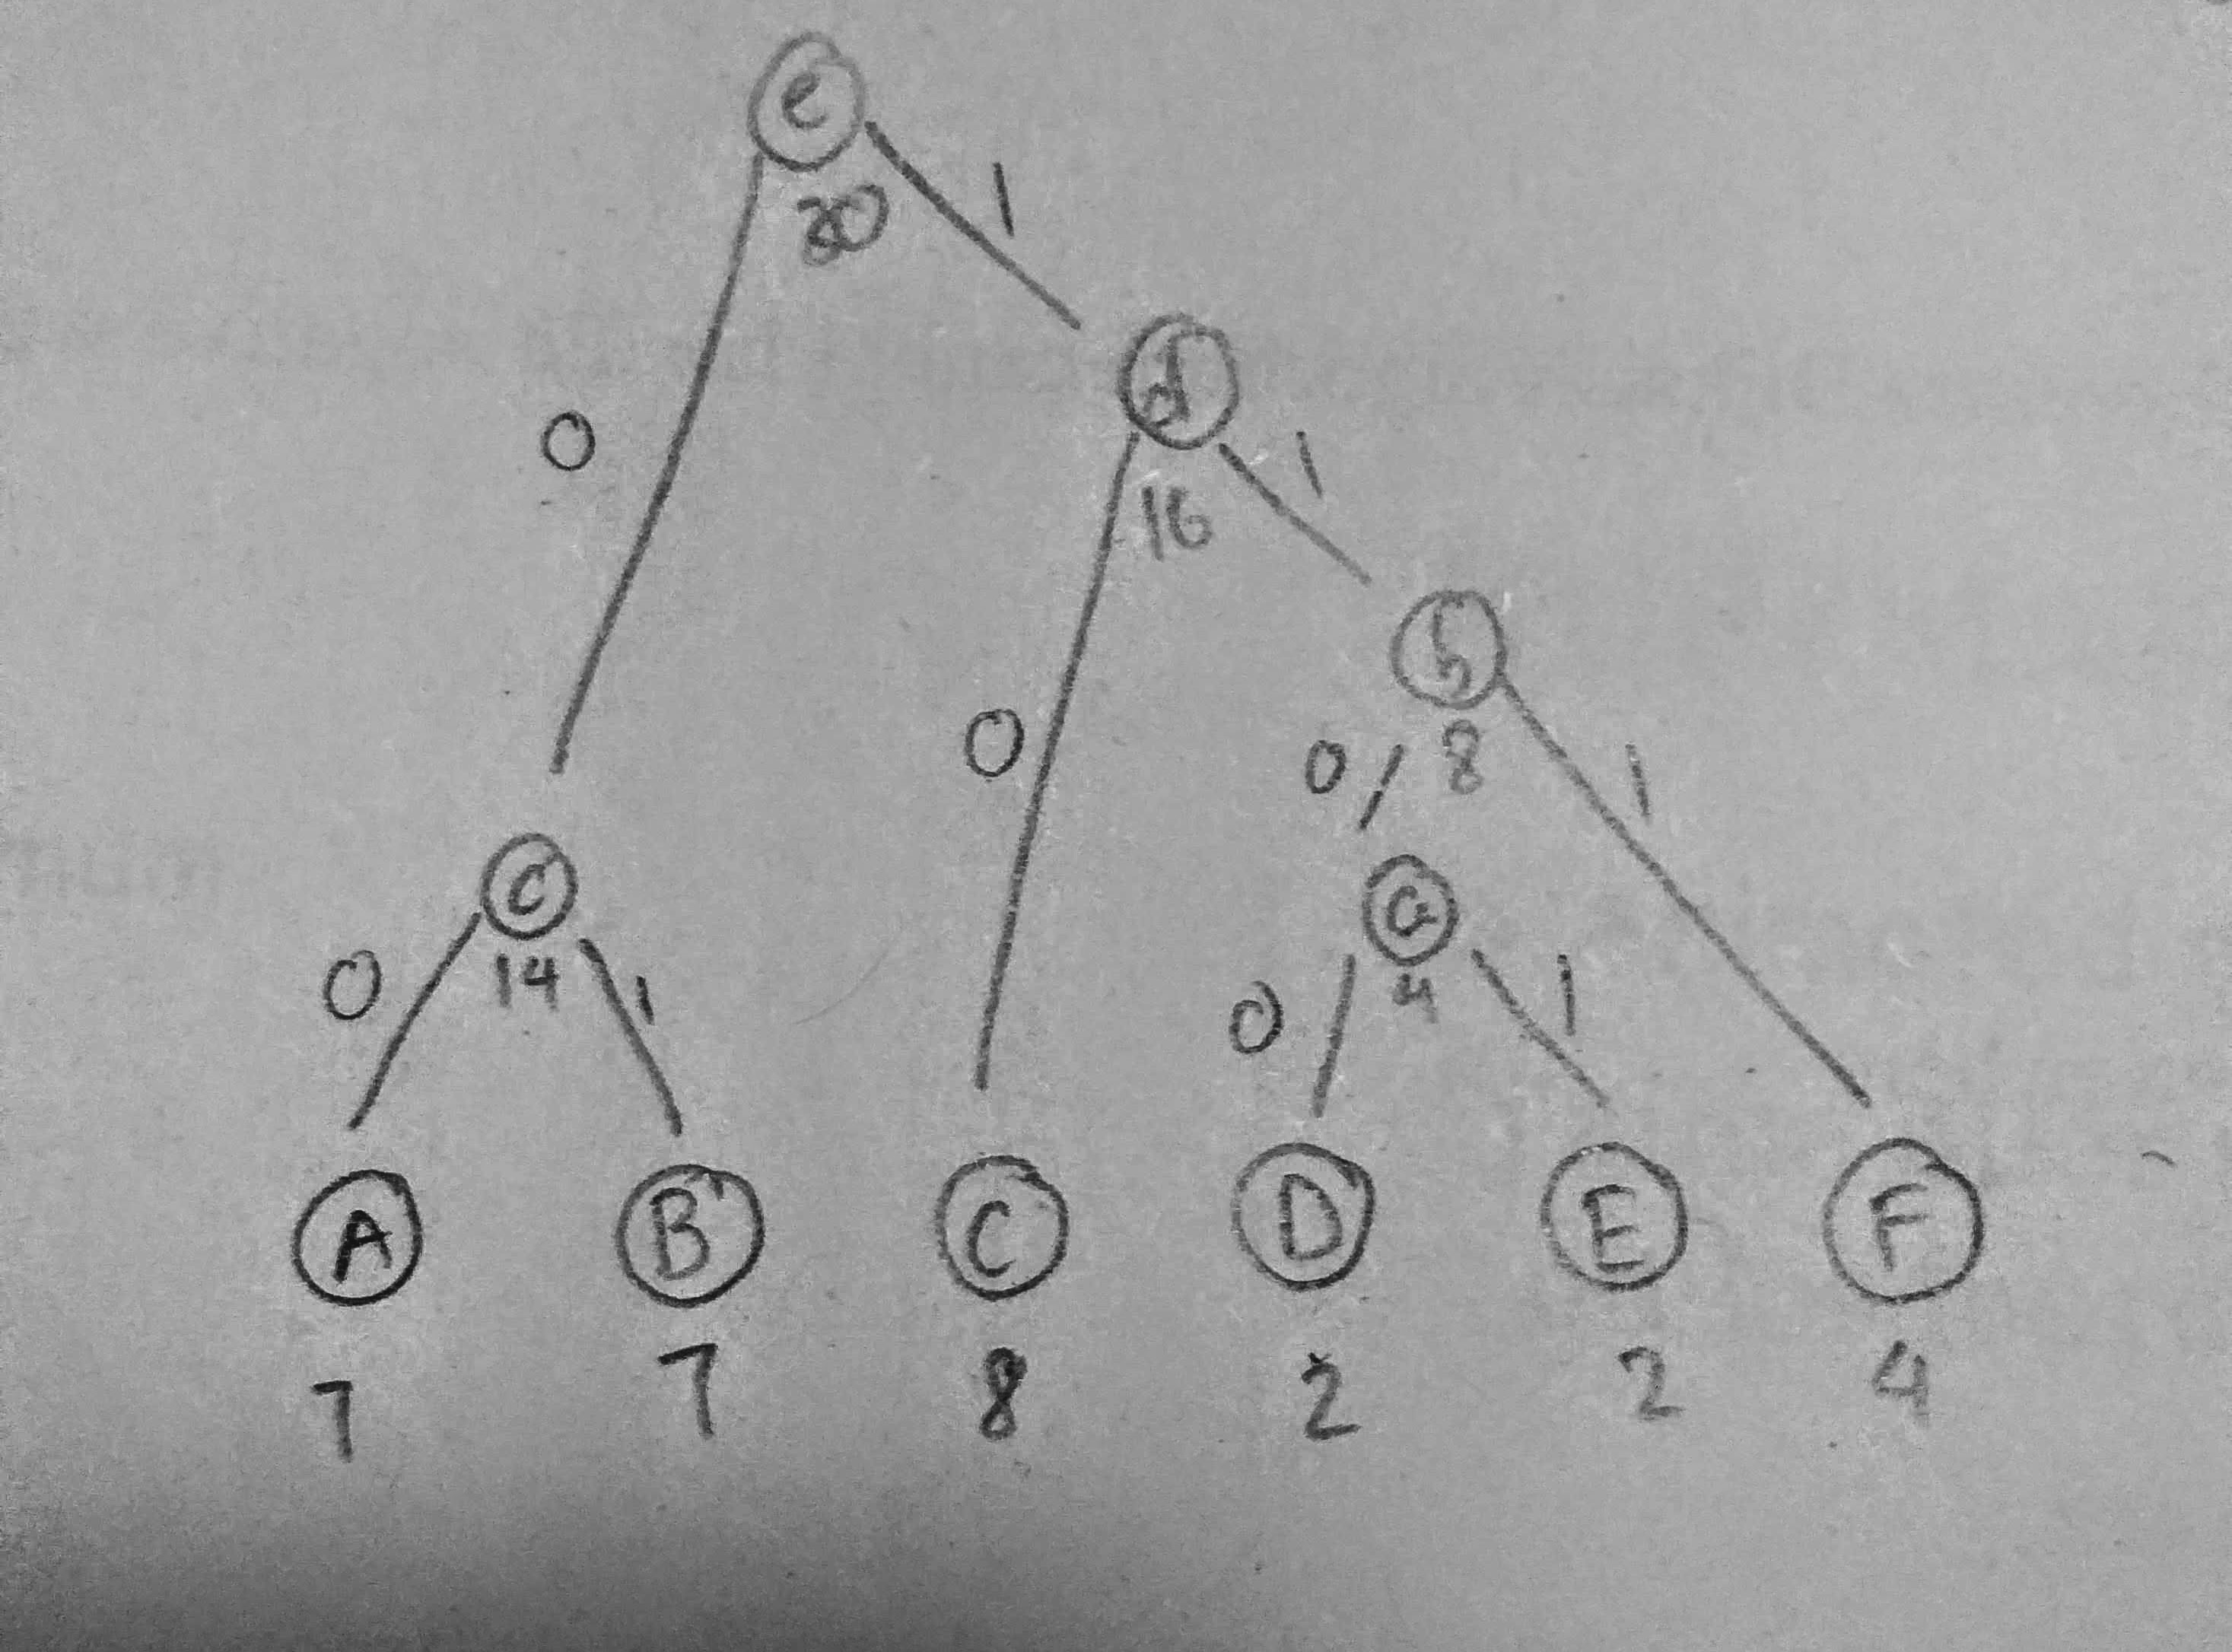

b) (10 points) What is the code for each letter:

A: 00
B: 01
C: 10
D: 1100
E: 1101
F: 111

Problem 2. (25 points) What is the Huffman code for the following set of frequencies, based on the first 8 Fibonacchi numbers?

A: 1, B: 1, C: 2, D: 3, E: 5, F: 8, G: 13, H: 21

A: 0000000
B: 0000001
C: 000001
D: 00001
E: 0001
F: 001
G: 01
H: 1

Problem 3. (15 points) Write your name in English letters and construct Huffman tree and code for it. Show your tree and code below.

Pham Xuan Loc

Code:
A 00
C 0100
H 0101
L 0110
M 0111
N 100
O 010
P 1100
U 1101
X 111

Tree:
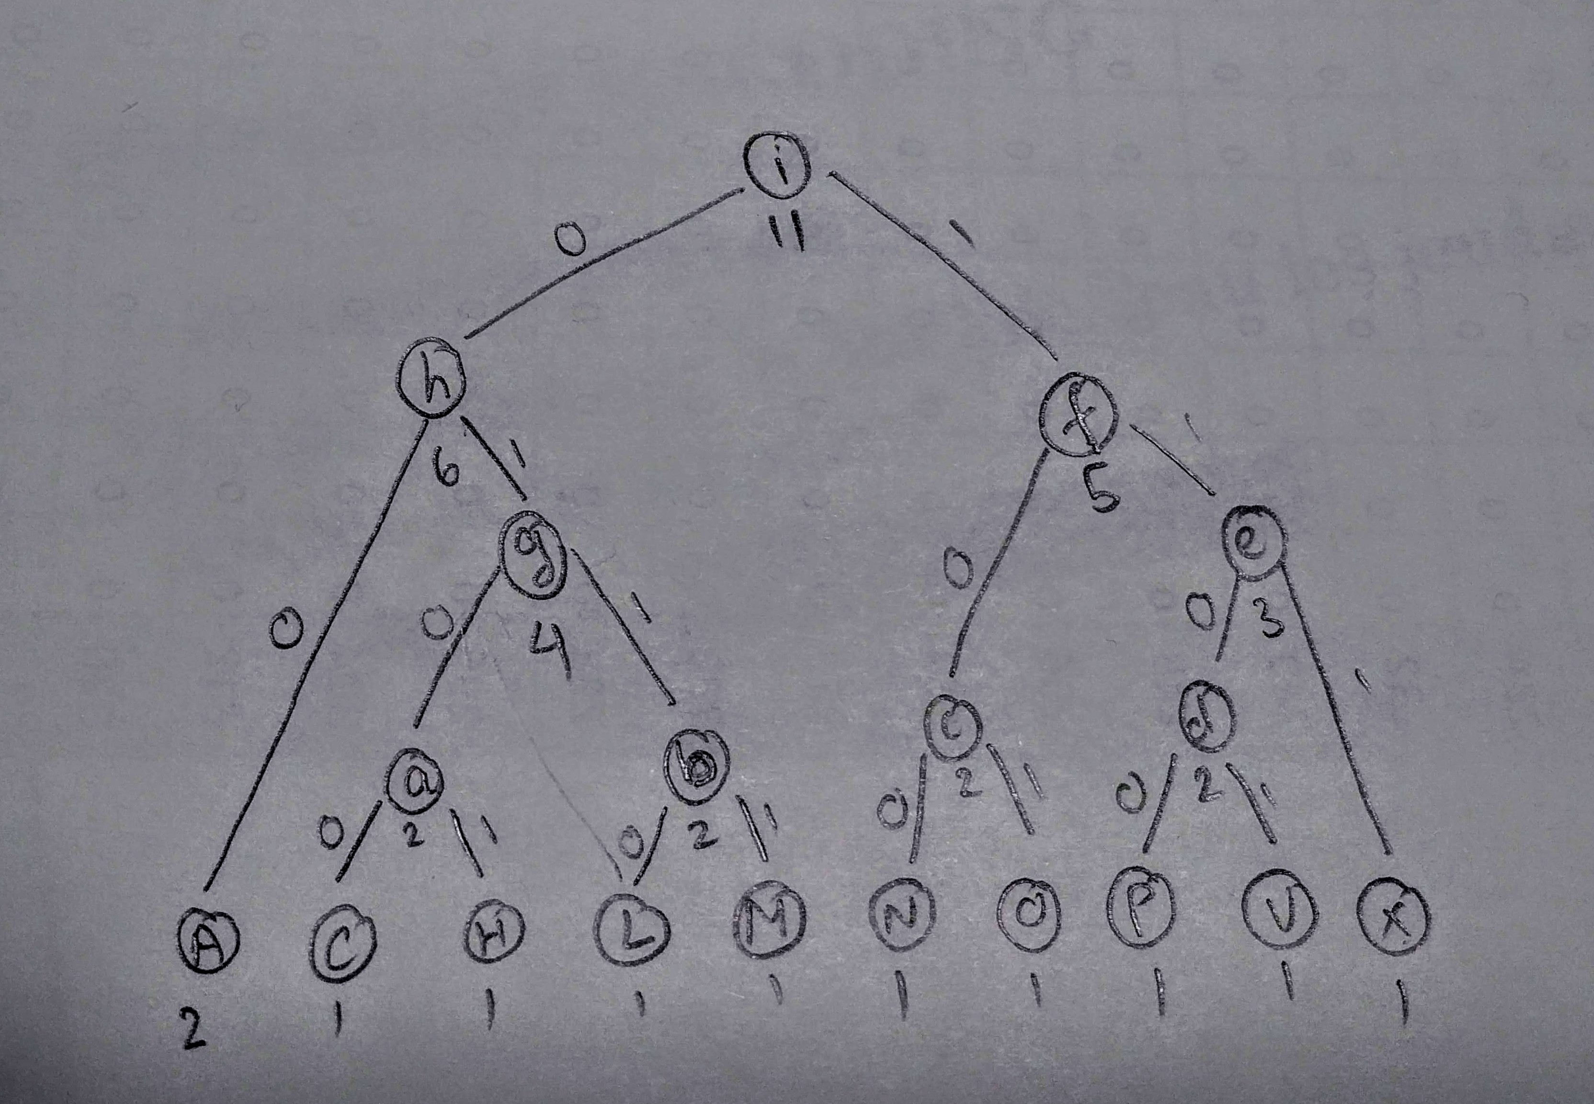

Problem 4. (40 points) Make a program implementing Huffman encoding. Upload your code with usage example.

Compile and run command: gcc Huffman.c -o Huffman && ./Huffman

Input :
ABBCACCEACBCCFABCDAFEABFFADBBC
Output:
B 00
A 01
F 100
D 1010
E 1011
C 11

