Exercise 8. Answer Sheet

Student's Name: ___Pham Xuan Loc__ Student's ID: ____s1232006___

Problem 1. Write pseudo-code for the Strassen's algorithm.

def Strassen(A,B,p):
n = A.rows
C = new (nxn) matrix
if n == 1: C[1][1] = A[1][1].B[1][1]
else:
Partition A into 4 blocks a11, a12, a21, a22
Partition B into 4 blocks b11, b12, b21, b22
Strassen(a11, b12-b22, p1)
Strassen(a11+a12, b22, p2)
Strassen(a21+a22, b11, p3)
Strassen(a22, b21-b11, p4)
Strassen(a11+a22, b11+b22, p5)
Strassen(a12-a22, b21+b22, p6)
Strassen(a11-a21, b11+b12, p7)

C[1][1] = p5 + p4 – p2 + p6
C[1][2] = p1 + p2
C[2][1] = p3 + p4
C[2][2] = p1 + p5 – p3 – p7

return C

Problem 2. Use Strassen's algorithm to compute the matrix product:

Show your work below:

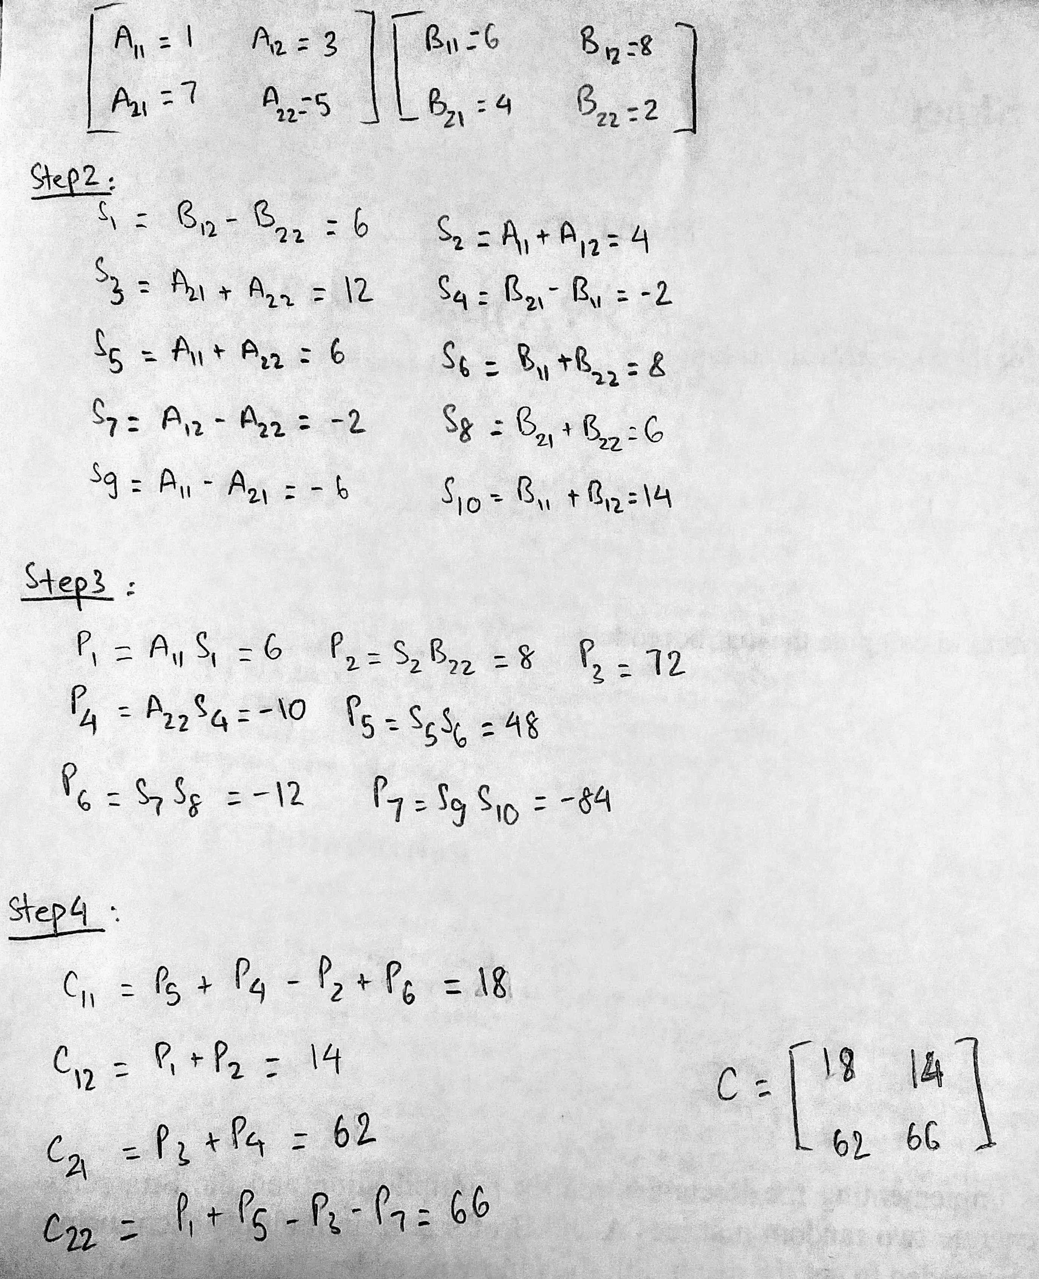

Problem 3. Make two programs implementing the Recursive matrix multiplication and the Strassen's algorithm. Upload your code. Generate two random matrices A and B of size n×n, multiply them using your programs and measure the time needed to get the result. Fill the following table:

Time needed to multiply two n×n matrices. (May depend on the programming language, computer, etc.)

Algorithm | n
Algorithm | 32 | 64 | 128 | 256 | 512 | 1024
Recursive (sec) | 0.002189 | 0.017237 | 0.134577 | 1.065847 | 8.480731 | 68.613789
Strassen (sec)

compile and run command:
gcc matrix_mult.c -o matrix_mult && ./matrix_mult

